Supporting Reading at St Stephen’s (KM) CE Primary School

SUPPORTING READING
A GUIDE FOR PARENTS AND HELPERS

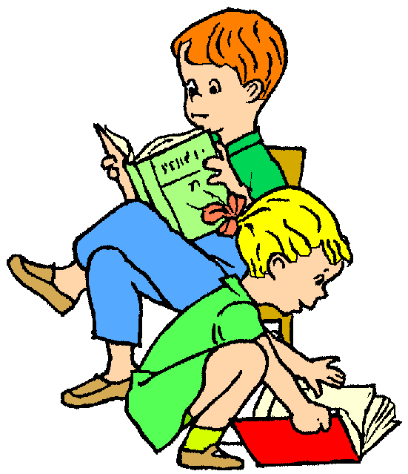
Reading is an essential part of all areas of learning and we hope this guide will give you some useful information about the teaching of reading in school and some useful ideas about how you can support your child to become a confident reader.
This is what WE do…
At St Stephen’s we use a range of approaches and resources to ensure that all our pupils move from being Early Readers to Confident and Experienced Readers:
In EYFS we use Essential Letters and Sounds (ELS), a systematic, synthetic phonics programme, children continue to use this phonics programme throughout Key Stage 1. The phrase for the scheme is ‘Keep-up, not catch-up’.
Our core Reading Scheme is Oxford University Press (EYFS/Y1) then Oxford Reading Tree. Certificates are awarded to pupils each time they move up to the next band.
Each week children have the opportunity to receive a remarkable reader ticket, if they have read at least four times that week. Further promoted by a ticket for every time they read during the holidays. At the end of a term they are in with a chance to win £20 to buy books.
Children have access to a wide range of fiction and non – fiction books in the school library and classrooms enhanced by project loans from Bolton Library Service.
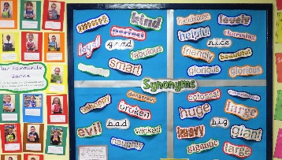
We have high quality reading volunteers including governors, who are assigned to a class. They come in to school on a weekly basis to listen and support individual children with their reading and comprehension.
Children are read high quality daily, in all classes, to promote the ‘Love of Reading’. The children are encouraged to discuss their favourite books and authors.
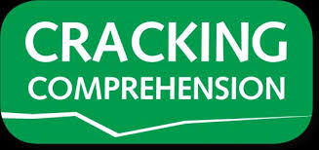
Classrooms provide a bright stimulating word rich environment which supports children in developing a wide, rich vocabulary to improve reading and writing skills.
Cracking Comprehension/Developing Reading Comprehension Skills – are used as part of regular curriculum work, the skills of reading comprehension are modelled by teachers to support children in developing higher order reading skills.
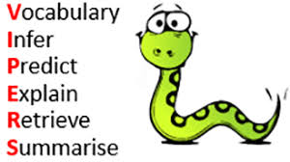
We use the VIPERS approach to teaching the key skills of comprehension (understanding what they read). Reading lessons will focus on children being able to use a wide range of higher order reading skills. This is further supported by information on children’s bookmarks featuring question stems for all VIPERS.
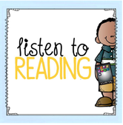
This is how YOU can help…
Try and make time to read with your child as often as you can. (We KNOW you’re busy but this is really important).
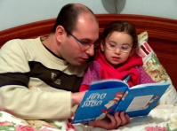
Find a comfortable and peaceful space (turn the TV off!) to listen to your child read. Make ‘reading time’ something to look forward to – with lots of encouragement and praise.
Read TO your children to model good reading – a bedtime story is a great way to get them to settle at the end of a busy day!
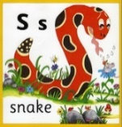
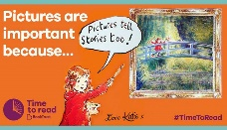
Encourage your child to decode any tricky words by breaking them down into a series of sounds and then blending the sounds together.
Encourage children to look at the pictures in the book to help them get a better understanding of the text.
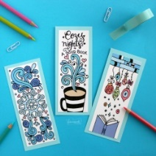
Ask some of the VIPERS questions from your child’s reading record to see how well your child is UNDERSTANDING what they are reading.
For example you could ask children to:
- Explain the meaning of selected words in the story
- Summarise what happened (and in what order)
- Draw pictures of scenes or characters from the book
- Tell the story in their own words
- Describe a character from the book, including the character’s feelings and thoughts
Make a NOTE of book titles and pages read, as well as comments on how well your child has read (including any tricky words and questions asked from the bookmarks) in the READING RECORD.
ANY time you can spend reading to (and with) your child will really help them to be successful in every aspect of their learning.
THANK YOU!

Useful Websites:
www.oxfordowl.co.uk (interactive books)
www.lovereading4kids.co.uk (for information)
www.booktrust.org.uk (for information)
www.literacytrust.org.uk (for information)
www.topmarks.co.uk (games and activities)
www.bbc.com/bitesize (games and activities)

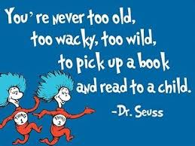
Storytime is a free APP from CBeebies for tablets and smartphones

