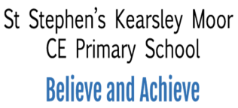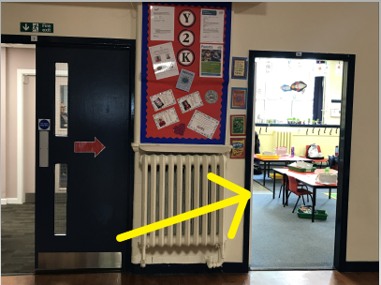

Hello,

We are Mrs Hall and Mrs Lomax, and we are the Year 2 Class teachers. We are really excited about the Year coming up. We are very lucky that Miss Clegg will be joining us too.

We have met with Mrs Faulkner and she has told me all about you. She has told me that you are a lovely hard working class.

We know you’ve all been in your new classroom before, but just in case anyone has forgotten it’s the door next to the office door.

In Year 2 we have lots of learning to do, but we will have a lot of fun too. We have lots of fun topics to cover in Year 2 that we know you will love. We will learn all about famous people from the past, The Great Fire of London and lots of Science! All this on top of making sure that everyone is an expert reader, writer and mathematician.

We know that a lot of you will be really excited to be coming back to school, which is great! However, some of you may feel a little worried and that is okay too. Please don’t worry too much, as we promise to help you settle back in.

We really can’t wait to meet you all and get to know you properly.

Mrs Hall and Mrs Lomax