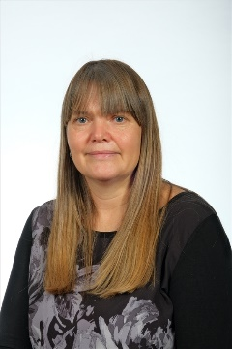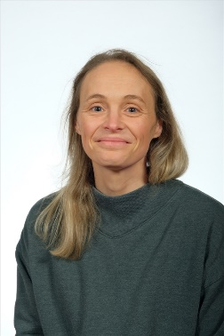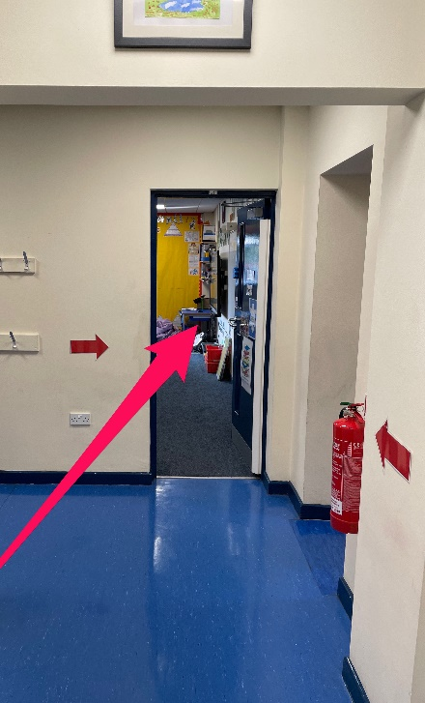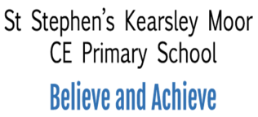

Hello,

My name is Miss Wilkins and I am going to be your class teacher. I am really excited to be joining the school this year, alongside Miss Clegg, who can’t wait to be with you again and complete our Y4 team.

I have heard great things about you all from both Mrs Hall and Mrs Lomax and I know that we are going to have a fantastic year together.

Your new classroom is opposite the Computer Suite.

In my class, I love making learning interesting, relevant and creative. I enjoy rewarding fantastic work or actions and both keeping active and getting creative in lots of different school subjects.

We have lots of fun topics to cover in Year 4 that I know you will love. We will learn all about The Blitz, The Romans, The U.K., States of Material, Circuits, Sounds, and Classifying Animals as well as doing lots of science experiments too. A big focus of Year 4 is learning all of your multiplication tables; we will play lots of fun games and activities to help you to learn them!

I know that a lot of you will be really excited to be coming back to school, which is great! However, some of you may feel a little apprehensive too and that is okay. Please don’t worry, as Miss Clegg and I will help you settle back in.

I really can’t wait to see you all and begin our Year 4 learning journey. I hope you have a super summer and I will see you in September.

Miss Wilkins