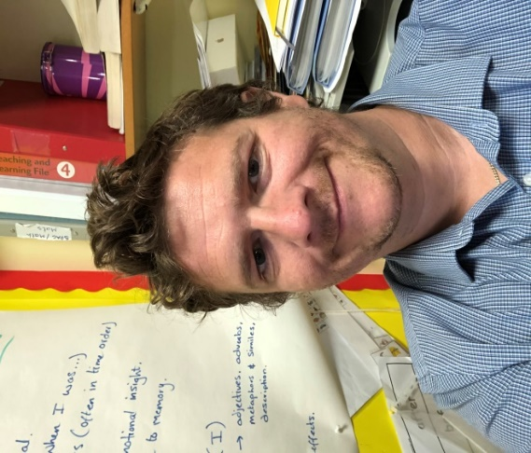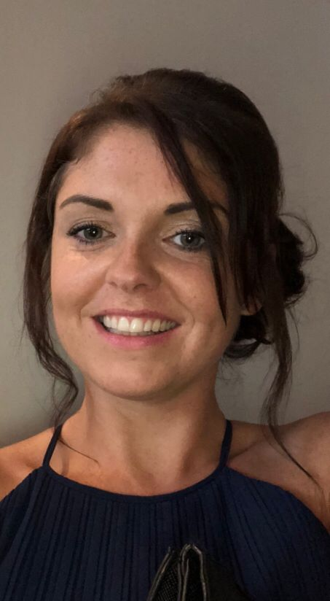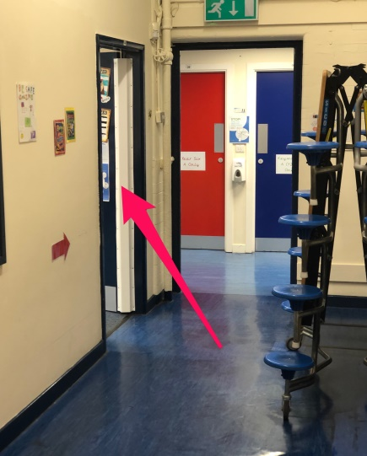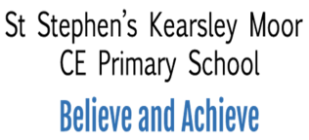

Hello,

My name is Mr Townsend and I am going to be your new class teacher. I am really excited for you to be back in school and to be in my class, as is Mrs Gregson, who completes the Y3 team.

I have met with Miss Stokes and she has told me all about you. She has told me that you are a fantastic, wonderful class and I know that we are going to have a great year together.

Your new classroom is at the top of the hall, on the left along the short corridor.

In my class, I love making learning fun, giving out rewards and keeping active by exercising and dancing. We have lots of fun topics to cover in Year 3 that I know you will love. We will learn all about Mexico, the industrial revolution, the stone age and plants as well as doing lots of science experiments too. A big focus of Year3 is learning all of your multiplication tables; we will play lots of fun games and activities to help you to learn them!

I know that a lot of you will be really excited to be coming back to school, which is great! However, some of you may feel a little worried and that is okay too. Please don’t worry too much, as I promise I will help you settle back in.

I really can’t wait to meet you all and get to know you properly. I hope you have a lovely summer and I will see you in September.

Mr Townsend