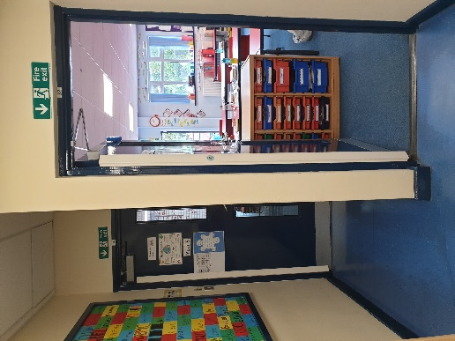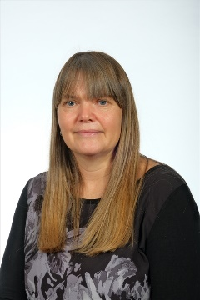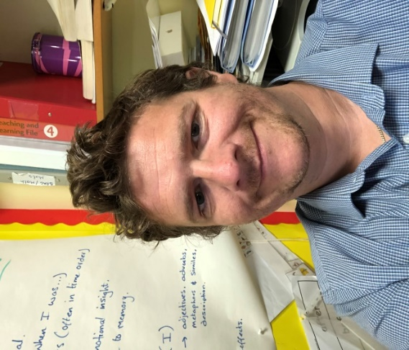

Hello,

My name is Mr Townsend and I am going to be your new class teacher. I am really excited for you to be back in school and to be in my class, as is Miss Clegg, who completes the Y5 team.

Your new classroom is at the far end of school next to the Year 6 classroom.

I have met with Miss Wilkins and she has told me all about you. She has told me that you are a fantastic, wonderful class and I know that we are going to have a great year together.

In my class, I love making learning fun, giving out rewards and keeping active by exercising and dancing. We have lots of fun topics to cover in Year 5 that I know you will love. We will learn all about Anglo-Saxons, Vikings, the Mayans, Rivers and mountains, and our solar system as well as doing lots of science experiments too. A big focus of Year 5 is learning all of your multiplication tables; we will play lots of fun games and activities to help you to learn them!

I know that a lot of you will be really excited to be coming back to school, which is great! However, some of you may feel a little worried and that is okay too. Please don’t worry too much, as I promise I will help you settle back in.

I really can’t wait to meet you all and get to know you properly. I hope you have a lovely summer and I will see you in September.

Mr Townsend