Wiggle Worship at St Stephen’s
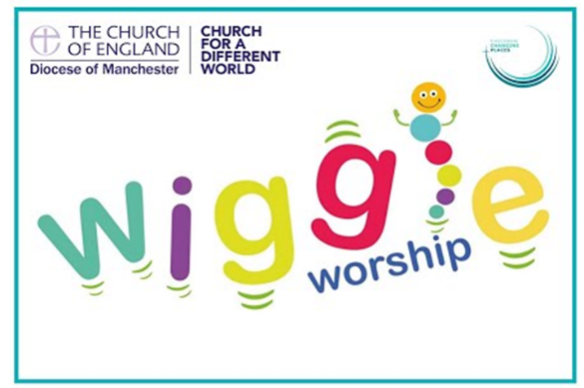
Wiggle Worship is aimed at KS1, reception-age children, toddlers and their families and is already having a wonderful impact in both Bolton and here at St Stephen’s.
What is Wiggle Worship?
- It aims to encourage or begin the faith journeys of younger children and their families in a fun and fresh way.
- It builds relationships between church and school.
- It supports school transition activity, welcoming children from Early Years into mainstream primary school.
- It creates an opportunity to develop a relationship with associated church-based toddler groups by inviting them to join in.
- It forms a new kind of worship and brings communities together.

Wiggle Worship Outline
Wiggle Worship was created by Steph Openshaw, a member of the Children Changing Places Early Years Team attached to Manchester Diocese with whom we work closely with. Wiggle Worship is a new and exciting, fresh expression of church. Each 45-minute session is full of singing, action rhymes, prayer, stories and dancing alongside making a brand-new friend in Wiggle Worm aka the Bible book worm!
Our Wiggle Worship sessions take place on the last Tuesday of the month and is accessed by EYFS and KS1 as one big St Stephen’s family. The sessions are facilitated by the St Stephen’s Teaching Team and supported by the Mountain Movers. Staff and Mountain Movers have all been trained in its delivery. The Mountain Movers then lead an associated craft activity linked to the message of the Wiggle Worship session.
The Wiggle Worship sessions follow core Christian Value for that term and also include the celebration of notable dates within the Christian calendar.

