Year 5 – Class Information
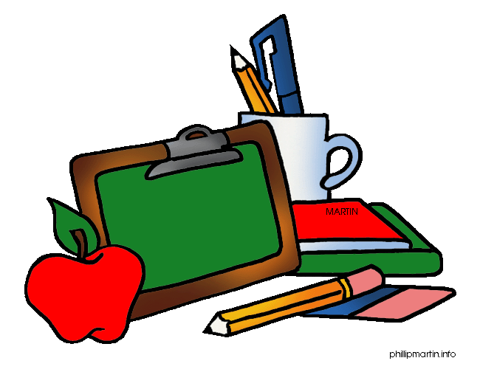
Reading Books are changed when the children have finished their reading book. Please help your child to practise their reading book every night (just a few pages or short story) and sign and date in the blue record book, showing the page reached or book finished. There is room to write a comment about your child’s reading if you wish. Remember, if the children have read four times a week and it is signed in their planner, they will be given a Remarkable Reader ticket.
The children will be given an opportunity to either change or renew their Library book every week. If your child hasn’t finished reading their book they will be able to renew it.
PE lessons are held on Tuesday and Thursday. Please make sure that your child wears full PE Kit to school on those days.
PE Kit consists of: House t-shirt, shorts, trainers, and tracksuit.
Homework will be given out every Wednesday. Please ensure that your child completes this and returns it to school the following Wednesday.
Please make sure that your child has the equipment they need for Homework – a pencil, ruler, glue stick and crayons and a quiet place to work, at a table if possible.
- CGP Maths and Reading Comprehension. We will work through the books in order.
- A Weekly Spelling List. This will be uploaded to the Spelling Frame website every Friday and will need to be completed by the following Friday.
Please practise all Multiplication Tables regularly. Our aim is for children to know their multiplication facts with instant recall ie give an answer within three seconds.
At St. Stephen’s, we want all children to be happy and to enjoy school life, making the most of learning opportunities and experiences.
If you have any concerns during the school year, please contact me via the School Office or Dojo and I will contact you as soon as possible to discuss this and/or arrange an appointment to meet with me.

Miss. Sarah Kinsey
Year 5 Class Teacher

