

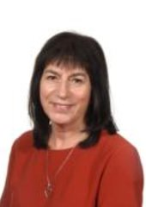

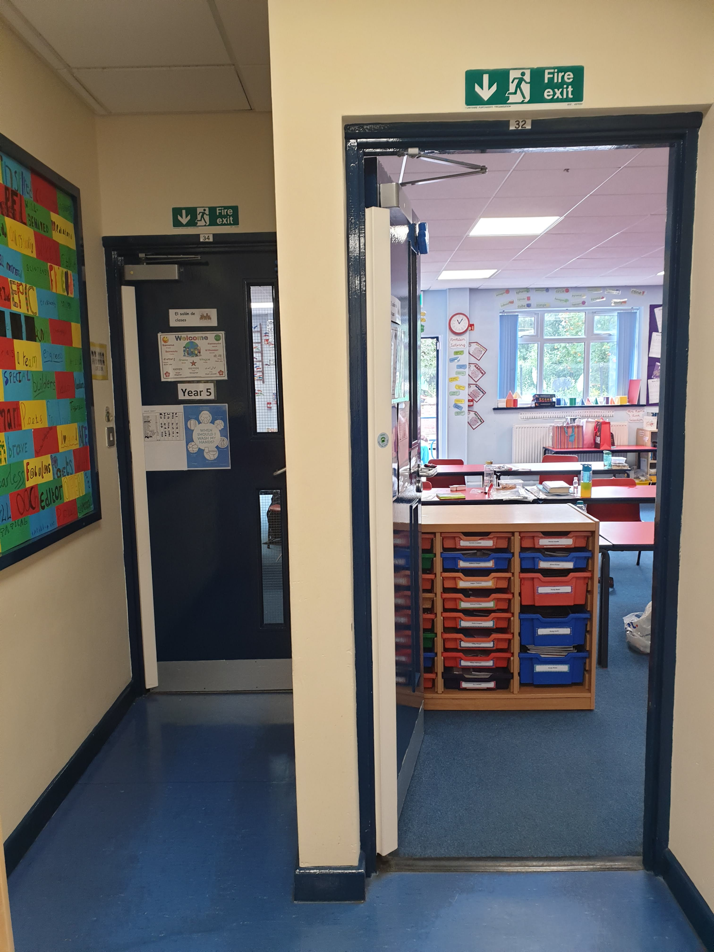

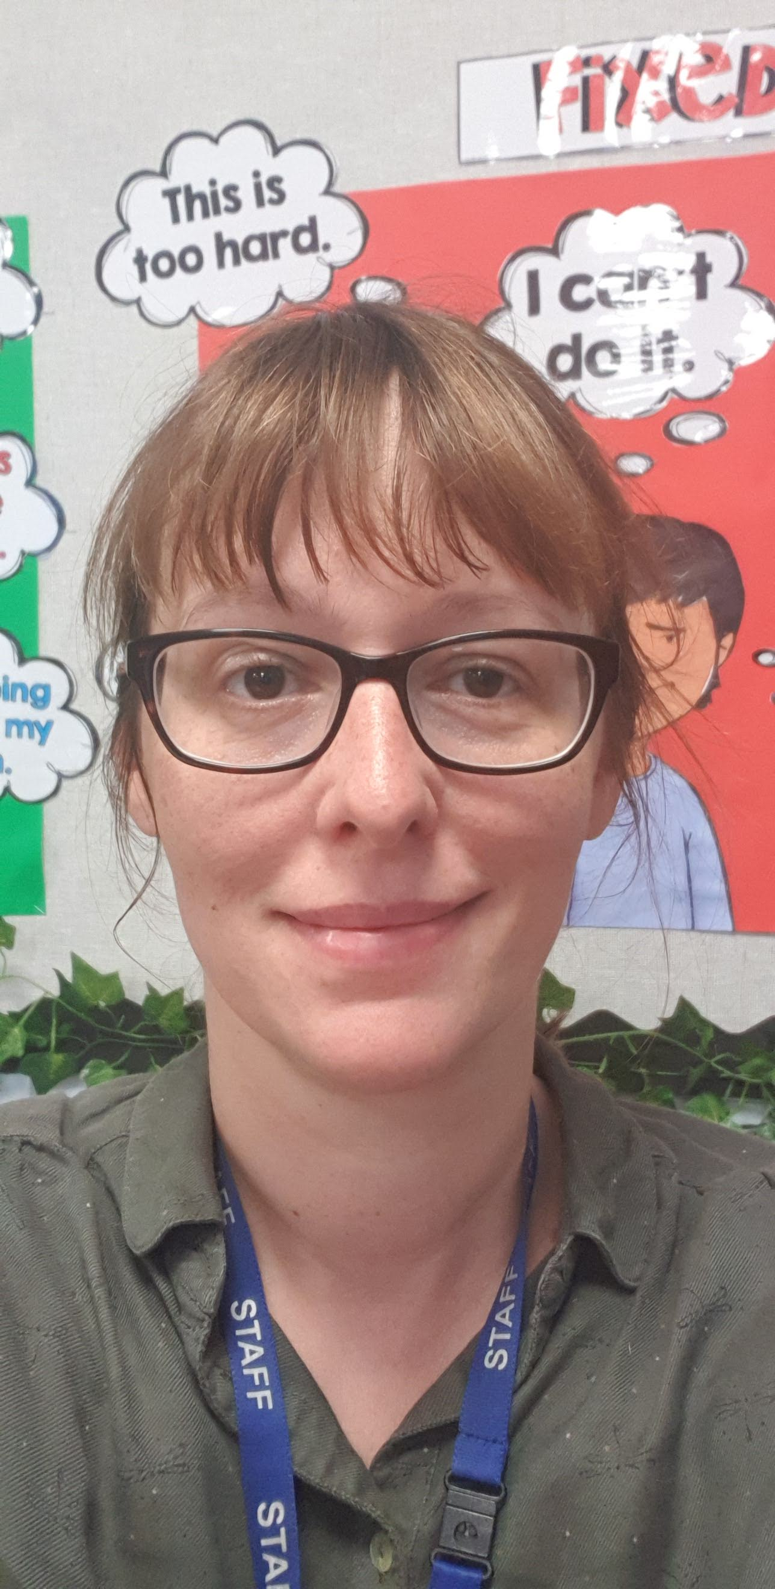

Hello,

My name is Miss Kinsey and I am going to be your new class teacher. I am really excited for you to be back in school and to be in my class as is Mrs Robinson who will complete the Y5 team.

I have spoken with Mr. Townsend who has told me how kind, caring and hardworking you all are. I know that you are a wonderful group of children that you are. I just know that we are going to have an amazing year together.

Your new classroom is at the far end of school next to the Year 6 classroom.

In our class, I love making learning fun, giving out rewards and keeping active by exercising and dancing. We have lots of fun topics to cover in Year 5 that I know you will love. We have lots of exciting learning ahead of us. We learn about the Anglo-Saxons, Vikings, rivers and mountains as well as having an overnight stay in Grasmere as part of a geographical fieldtrip.

I know that a lot of you will be really excited to be coming back to school, which is great! However, some of you may feel a little worried and that is okay too. Please don’t worry too much, as I promise I will help you settle back in.

I really can’t wait to meet you all and get to know you properly. I hope you have a lovely summer and I will see you in September.

Miss Kinsey