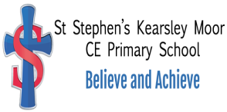

Collective Worship

St Stephen’s (Kearsley Moor)
Church of England Primary School

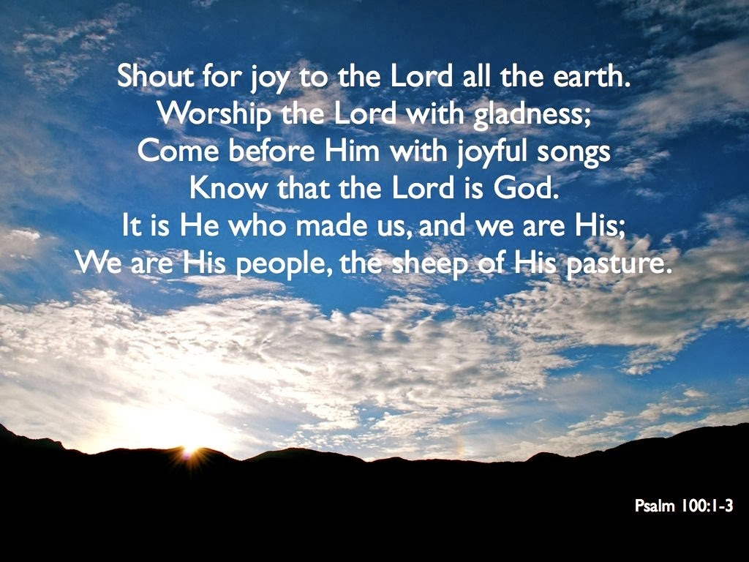

Collective worship Policy
At St Stephen’s Church of England Primary School, we are committed to offering high quality collective worship. Collective worship is central to fostering a sense of community and for expressing our school’s Christian vision. We intend to ensure that collective worship remains relevant, essential component of our children’s’ education that enables all of the St Stephen’s family to flourish and to ‘live life in all its fullness’ John 10:10. It is the unique heartbeat of our St Stephen’s family and it is offered as part of a wider opportunity for our school family to encounter faith by engaging in conversations about God, both as individuals and together. We want our children to leave school with a rich experience and understanding of Christianity, and we are committed to offering them an encounter with Jesus Christ, with the Christian faith and practice in a way that enhances their lives. We believe collective worship provides the vital opportunity for prayer, reading and reflection upon the Bible, liturgy, sacrament, and experience of the musical and other imaginative riches of Christianity in a truly welcoming and inclusive manner, exemplifying the principles of Christian hospitality. Our approach intends to meet the needs of all pupils irrespective of their place on their journey of faith and belief.
Collective worship at St Stephen’s gives children, staff and the wider school family the opportunity to:
- Engage in an act of community.
- Express praise and thanksgiving to God.
- Be still and reflect.
- Explore the big questions of life and respond to national events.
- Foster respect and deepen spiritual awareness.
- Reflect on the character of God and on the teachings of Christ.
- Affirm Christian values and attitudes.
- Share each other's joys and challenges.
- Celebrate special times in the Christian calendar.
- Develop the confidence to speak out against issues of injustice, on behalf of those whose voice is not heard and to truly become a courageous advocate.

Christian Values
Worship is delivered through our Christian values of Love, Hope, Faith, Trust, Respect, Resilience and Justice. This permeates everything we do at St Stephen’s and is underpinned by our motto “Our Faith can move mountains” Matthew 17.20. A schedule of key worship themes are planned across the school year based on our Christian values. Love is our overarching value.
 | Autumn Term | Spring Term | Summer Term
LOVE | HOPE | FAITH | TRUST
LOVE | Resilience | Justice | Respect

Worship is developed by all members of our St Stephen’s family from weekly acts of class worship, to invitational worship led in church/ school by specific classes and/or the ethos team (Mountain Movers). Throughout the church year classes have a responsibility to develop and deliver acts of collective worship e.g.
Monthly Wiggle worship for EYFS and KS1 facilitated by Mountain Movers
Year 5 – Harvest
Year 3 – Christingle
Mountain Movers and members of the school community - Jesse Tree
Reception – Nativity
Whole School – Christmas Worship including Year 1 tableau
Year 4 – Easter
Year 2 -Easter ( including EYFS and Year 1)
Year 6 – Leavers Service

Schedule of Daily acts of Worship

Worship is an integral part of school life and as such this takes place on a daily basis.
Monday – Thematic Value introduction/discussion delivered by Head Teacher
Tuesday – Exploration of Monday’s theme based around key text using age appropriate questioning techniques and reflection time, deepening our understanding so that we can learn about and from others. This is a classroom based act of Worship.
Wednesday – Church/School act of worship usually led by faith leader.
Thursday- Singing Worship (praise worship time exploring key bi-termly value theme through song and prayer time)
Friday – Celebration (exploring the mountains we’ve climbed and the journey to get there)

Legal Requirements
At St Stephen’s CE Primary, we understand worship to be a special act or occasion whose purpose is to show reverence to God. Collective Worship involves all members of the school coming together. In line with the 1988 Education Reform Act, which states that Collective Worship should be 'wholly or mainly of a broadly Christian character', we usually base our Collective Worship on the teachings of Christ and traditions of the Christian Church. This also reflects our status as a church school. However, we conduct our worship time in a manner that is sensitive to the individual faith and beliefs of all members of the school. While the majority of acts of worship in our school are Christian based, we also hold assemblies that reflect other world views by, for example, celebrating certain festivals. We recognise that many themes covered are common to a number of worldviews. Worship is collective in that it involves meeting, exploring, questioning, and responding to others and, for some, to God. Children at St Stephen’s, their families and other adults can expect to encounter worship that is inclusive of, and fully accessible to, all. Many children and staff in our school may come from homes of different faith backgrounds including those with no faith at all. Moreover, many children will naturally be at different stages of their spiritual journey during their time St Stephen’s. Children are given the opportunity to think and ask questions to formulate their own worldview.

Right to withdraw
We expect all children to attend Collective Worship however, parents have the right to withdraw their children. Parents wishing to exercise this right will be invited to discuss the matter with the Headteacher. Children who are withdrawn from Collective Worship will be supervised, however no other form of religious instruction or worship will be offered.
It should be noted that:
‘The Worship and Religious Education provided by the school is in accordance with the Church of England or Methodist Church Foundation. This foundation is also reflected ion the curriculum and whole school life of the school community. Since the conduct of the school reflects the Church of England or Methodist Church ethos, removal of pupils from Worship and/or Religious Education (as parents are legally entitled to do) cannot insulate them from the religious life of the school.’ (Church of England Board of Education)

HEAD TEACHER: Mr Paul Puckey
RE SUBJECT LEADER: Mrs Lyndsey Faulkner
Contact details: Tel: 01204 333642 email office@st-stephens-kearsley-moor.bolton.sch.uk

