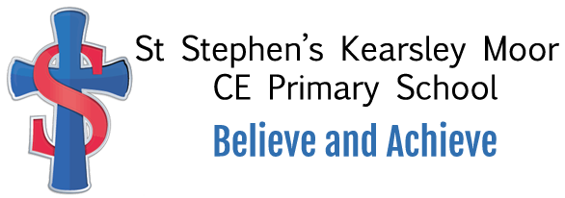
Hello to my lovely Year One children, my name is Mrs Faulkner and I am going to be your new class teacher when we return to school in September. I am really excited to have such an amazing group of children as we start our epic Year One mountain journey. I have met lots of you over the past year (aswell as in our transiton days) and I can’t wait to meet everyone again but this time in our big year one classroom. Miss Wild, Mrs Bostock and Mrs Leach have already told me lots about you and that you are a fantastic class. The lovely Mrs Bostock is also going to be our teaching assistant all week and she will be getting upto all sorts of fun learning challenges with us.
Your new classroom is just next door to your old Reception class and instead of going through the doors and turning left we’ll come in through the Year One gate and turn right. Mr Williams has been working extremely hard to get everything ready for our Year One. I love this classroom and when I first joined St Stephen’s over 24 years ago it was my first ever classroom where I taught 5 and 6 year olds just like you. Lots of you have spotted me around school already when I’ve been leading worship times, munching our lunch at dinner times alongside popping into your class to say “Hi” and sharing your good news. I just can’t wait!
I love making learning fun and helping children to be the best that they can be through lots of different activities, keeping our whole bodies and minds fit and healthy. We have got so many different things to learn about in Year One including exploring how awesome we really are, what a brilliant place Kearsley and St Stephen’s is aswell as discovering all things great and small in the world we live in. Now that you’ll be in big Year One we get to work with our specialist P.E coach, Coach Josh, every week , who will help develop our sporting skills alongside your co-ordination and balance through dance and gymnastics. During our year together we will be working with Mrs Lomax out in the forest schools area and applying all your forest school expertise from Reception class. This year we will also have a super computing expert, Mr Choudry, who will work with us to complete our computing projects. We’ll also be working really hard with our phonics aswell as using numbers upto 100. I love a good challenge and know we can do this together.
I know lots of you will be feeling really excited to be coming back to school and that is great! However, some of you may be feeling a little worried and that is okay too. Please don’t worry too much, all your friends will be in class waiting for you with myself and Mrs Bostock and I promise I will help you to settle back in.
I can’t wait to see you all and see how much you’ve all grown and to hear all about your adventures before we start our own adventure together as we get to know each other properly.
I hope you have all had a fantastic summer and I will see you very soon.
Mrs Faulkner and Mrs Bostock.
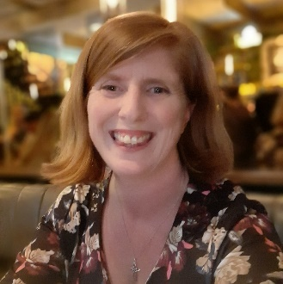
Mrs Faulkner Our Year One door to our classroom Mrs Bostock
Year 1 Class Teacher Year 1 HLTA

