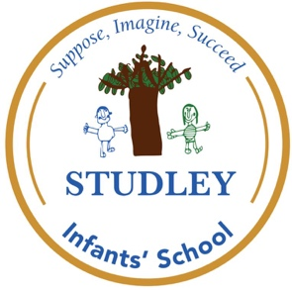

At Studley Infants’ School we…
Suppose, Imagine & Succeed!
Vision/curriculum: Perseverance curiosity.



Year: EYFS
Subject: Science

Activity/ experience: Growing

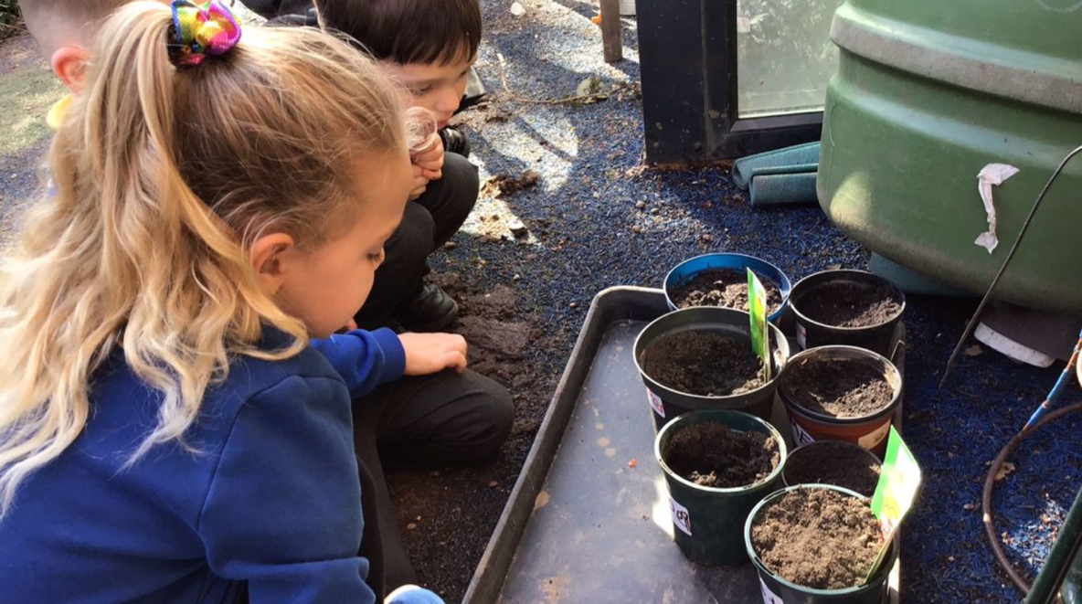
Intent/ implement: Understanding what plants need to grow

We became garden experts and talked about what we need to plant seeds and what they will need to help them to grow.

