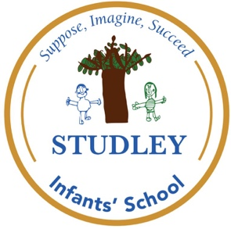

At Studley Infants’ School we…
Suppose, Imagine & Succeed!



Year: KS1
Subject: Science

Activity/ experience: Comparing evergreen and deciduous trees

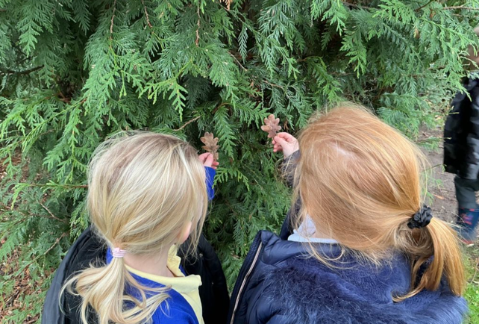
Intent/ implement: Looking at similarities and differences between trees.
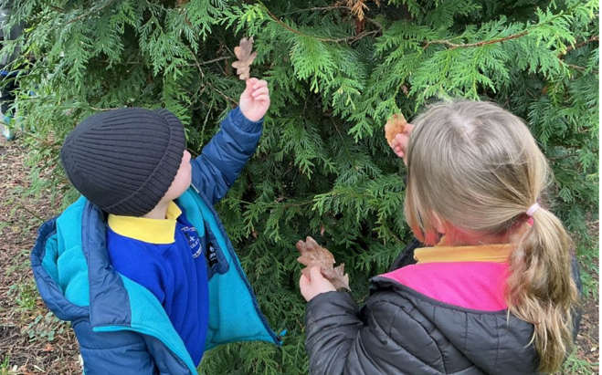
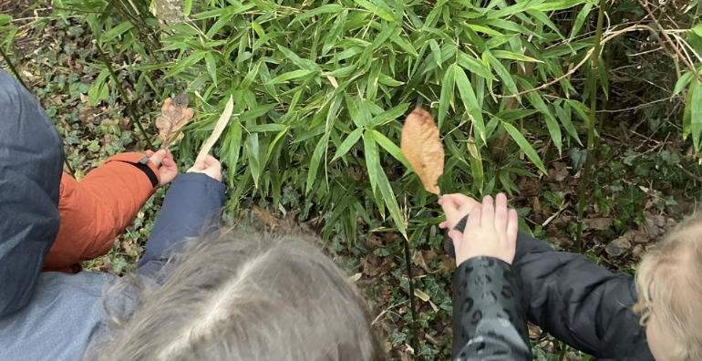

We discussed the similarities and differences between evergreen and deciduous trees in class ad then took our learning out into the outdoor environment. The children were able to spot deciduous and evergreen leaves.
Vision/curriculum: Perseverance curiosity.

