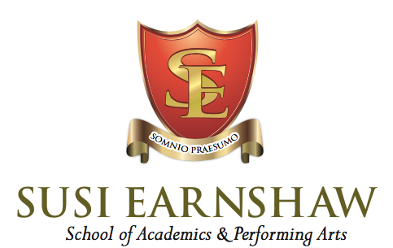

**ADMISSIONS POLICY**

|  |  |
| --- | --- |
| Date: July 2025 | Next review: July 2026 |
| Ratified by: Susi Earnshaw (Proprietor) | |

Susi Earnshaw is a full-time stage school providing vocational training in the performing arts, primary teaching from year five, and secondary teaching from year six to year 11 inclusive.

Acceptance of entry into the school is dependent upon vocational aptitude, and places are offered to students who show they are able and willing to take full advantage of the education and training that Susi Earnshaw is able to offer.

1. The first stage in the Admissions Procedure is when the parent or guardian of a prospective pupil, completes an application form for the school. It is advisable for applications to be made as soon as possible.
2. The prospective student will be invited to audition at the school. At this stage, parent/guardians will be asked to supply a copy of their child’s most recent school report.
3. Dependent upon the outcome of this audition, the prospective student and his/her parent/guardians will be invited to attend an interview with either the head mistress or the admissions officer, to discuss the child’s school history, talk about the school and show the child and parent/guardians around the premises.
4. The school may then inform the parent/guardians in writing of the school’s decision or ask them back for a further interview.
5. If the pupil is admitted to the school, a contract is drawn up and signed between the parent, student and the school.

**Admissions Criteria**

Susi Earnshaw is concerned that parent/guardians of any pupil or prospective pupil should understand and support the aims and ethos of the school, and to this end the interviews conducted with prospective pupil and parent/guardians will be open and friendly, and the parent/guardians and child will be free to ask any questions about the school.

No pupils will be discriminated against; please see our Equal Opportunities Policy. Parent/guardians will be asked to give full details of any special needs which their child may have. These will be considered in the light of the Special Needs Policy in place at Susi Earnshaw before a place is offered. Please note that Susi Earnshaw is a specialist stage school, and that parent/guardians may be asked to pay for private lessons should these be required to support the child’s learning. Susi Earnshaw looks for a positive attitude to learning (both academic and vocational) and will take into account the child’s enthusiasm as well as his or her academic record.

Vocational aptitude is a requirement of entry to the school.