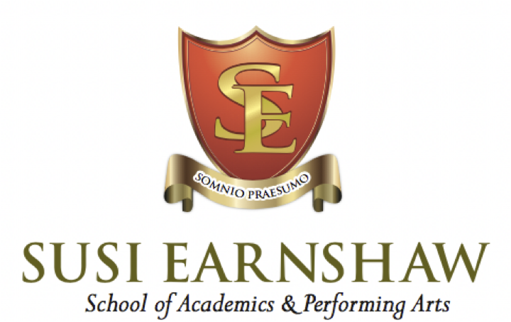

**Careers Policy**

**Approved by:** The Headteacher  **Frequency of Review:** Annually

**Date Reviewed:** August 2024 **Next Review Due:** August 2025

At Susi Earnshaw we aim to provide a **whole school approach** to the subjects in PSHE. In our timetable, this subject is referred to as **“Lifeskills and Careers”** and are taught mainly by Melissa Gillespie.

The School is an independent school with a strong specialised background in the performing arts. Upon joining the school, it could be said that many students may have already chosen their career path. The aim of our vocational school, is to ensure that specific skills and talents are nurtured with the view that students may pursue these areas in adult life. Although our vocational programme is effective in preparing students for further training in performing arts, we do not want to limit their scope and have created a varied curriculum in which all options remain open.

Our School places great value on education that will prepare pupils for the challenges of their future lives. It recognises that in a world of rapidly changing employment opportunities pupils need to be given equally wide information, experience, and understanding of the world of work. It also recognises that pupils need to be given assistance in recognising their own abilities and aptitudes so that they can develop high and appropriate aspirations for their own future.

**Introduction**

1. Careers Education, Information, Advice and Guidance (CEIAG) at the Susi Earnshaw Theatre school is delivered through curriculum learning, dedicated talks, workshops and events, as well as one-to-one or group meetings with staff.
2. As part of the School’s commitment to the broadest and fullest education for every one of its pupils, each pupil is entitled to an effective programme of Careers education, information, advice and Guidance (CEIaG) at appropriate phases of their progress through the School. The CEIaG programme aims to empower pupils to gather as much relevant information as possible, under the School’s guidance, in order for them to be able to make informed decisions about their futures.
3. Susi Earnshaw Theatre School is committed to providing all students in Years 7-11 with a programme of careers activities and supporting activity in line with the eight Gatsby benchmarks. These benchmarks are intended to ensure best practice and to meet the requirements of the Department for Education’s statutory guidance 2021.

**Summary of the Gatsby Benchmarks**

1. A Stable Careers Programme: The school should have an embedded programme of careers education and guidance that is known and understood by students, teachers, parents and employers.
2. Learning from Career and Labour Market Information: Every student, and their parents, should have access to good quality information about future study options and labour market opportunities. They will need the support of an informed adviser to make best use of available information.
3. Addressing the Needs of Each Student: Students have different career guidance needs at different stages. Opportunities for advice and support need to be tailored to the needs of each student. The school’s careers programme should embed equality and diversity considerations throughout.
4. Linking Curriculum Learning to Careers: All teachers should link curriculum learning with careers. For example, STEM subject teachers should highlight the relevance of STEM subjects for a wide range of career pathways.
5. Encounters with Employers and Employees: Every student should have multiple  
    opportunities to learn from employers about work, employment and the skills that are valued in the workplace. This can be through a range of enrichment opportunities including visiting speakers, mentoring and enterprise schemes.
6. Experiences of Workplaces: Every student should have first-hand experience of the workplace through work visits, work shadowing and/or work experience to help their exploration of career opportunities, and expand their networks.
7. Encounters with Further and Higher Education: All students should understand the full range of learning opportunities that are available to them. This includes both academic and vocational routes and learning in schools, colleges, universities and in the workplace.
8. Personal Guidance: Every student should have opportunities for guidance interviews with a career adviser, who could be internal (a member of school staff) or external, provided that they are trained to an appropriate level. These should be available whenever significant study or career choices are being made. They should be expected for all students but should be timed to meet their individual needs.

**Provider Access**

This section sets out the school’s arrangements for managing the access of providers to pupils at the school for the purpose of giving them information about the provider’s education or training offer. This complies with the school’s legal obligations under Section 42B of the Education Act 1997.

1.Pupils are entitled:

* To find out about technical education qualifications and apprenticeships opportunities, as part of a careers programme which provides information on the full range of education and training options available at each transition point.
* To hear from a range of local providers about the opportunities they offer, including technical education and apprenticeship, through options evenings, assemblies and group discussions and taster events.
* To understand how to make applications for the full range of academic and technical courses.

**Management of provider access requests**

A provider wishing to request access should contact the school’s Careers Leader

**Opportunities for access**

A number of events, integrated into the school careers programme, will offer providers an opportunity to come into school to speak to students and/or their parents/carers.

**Premises and facilities**

1.The school will make the main studio, theatre, classrooms or private meeting rooms available for discussions between the provider and students, as appropriate to the activities.

2.The school will also make available AV and other specialist equipment to support provider presentations. This will all be discussed and agreed in advance of the visit with the Careers Leader or appropriate member of school staff.

3.Providers are welcome to leave a copy of their prospectus or other relevant course literature at our school.

**Policy monitoring and review**

This policy will be reviewed and updated by the head teacher on an annual basis.