

COMPLAINTS PROCEDURE
Date: August 2025 | Next review: August 2026
Ratified by: Susi Earnshaw (proprietor)

School’s Statement Regarding Parents’ and Students’ Concerns and Complaints.
The Susi Earnshaw Theatre School cares deeply about the welfare of its students and staff alike and is committed to dealing with any possible concern or complaint as promptly as possible. An initial concern will in many cases be easily resolved without the need to resort to a formal complaint, and communication between parents, students and staff will be always encouraged, whilst maintaining confidentiality where appropriate. The Susi Earnshaw Theatre School also encourages openness, tolerance, and a willingness to apologise when appropriate, and believes that this is all part of ensuring a happy and healthy working environment for all.
Neither racism nor other kinds of bullying will be tolerated from anyone in the school, and any instances of either will be treated very seriously. The school also has a comprehensive procedure on bullying and how to deal with any such instances which may arise.
The Complaints Procedure is published in the School Handbook, which is updated and distributed to all parents/students at the start of each academic year.

Timescales:
We aim to resolve any complaints in a timely manner. Timescales for each stage of the Complaints Procedure are set out below in the relevant paragraphs. For the purpose of this procedure, a “working day” is defined as a weekday during term time, when the school is open. The definition of “working day” excludes weekends and Bank Holidays. For the avoidance of doubt, term dates are published on the Schools website and information about term dates is made available to parents and pupils periodically.
It will not always be possible to deal with a concern or complaint instantly, but every priority will be given to dealing with an initial concern as promptly as possible.

If a complaint is made during any of the school holidays, including half terms, it will be noted that this complaint was considered as ‘received’ on the first day of the new term/half term.
A pupil/pupils’ may be excluded from the school at the discretion of the Headteacher during the complaints procedure if it is deemed to be in the best interests of the student/students.
A written record will be kept of all complaints, whether they are resolved following a formal procedure or proceed to a panel hearing. Records are kept of action taken by the school as a result of these complaints, regardless of whether they are upheld. Correspondents, statements, and records relating to individual complaints are kept confidential, except where the Secretary of State or a body conducting an inspection under section 108 or 109 of the 2008 Act requests access to them.

Stage 1 - Informal Resolution
If a parent or pupil is concerned about a particular issue in the school, they should refer their concern to a member of staff or to the headteacher, who may be able to resolve the problem immediately, if not, we usually aim to deal with stage one complaints within 24hrs. However, if the complaint is made on a Friday, the issue will be dealt with the following school day (being Monday) The staff member will in any case take written records of the issue raised and will inform the Proprietor of the outcome. There is a form for recording complaints at this initial/non-formal stage, entitled “Form for Recording a Non-Formal Complaint and its Outcome.”
Following this, should the Complainant choose to register a formal complaint, staff may refer the Complainant to another member of staff to discuss their concern should the Complainant wish to do so, or if the member of staff initially approached might feel compromised by dealing with the concern him/herself.

Stage 2 - Formal Resolution
If the parent or student still has concerns following discussion with a staff member, the parent/guardian must fill in the General Complaints Form and submit it to the school, who will refer it straight to the Head.
A written record of all complaints that reach this stage will be kept and
- Such record cover whether they are resolved following this formal procedure, or proceed to a panel hearing: and
- Cover the action taken by the school as a result of these complaints (regardless of whether they are upheld)

Your complaint will be acknowledged by telephone (and followed up by in writing) normally within 24hrs of receipt during term time and as soon as possible during the holidays. The receipt will include the action that is being taken and the likely timescale for resolution. It may be that the Headteacher and or Proprietor may need to investigate further, if this is the case all meetings and interviews will be recorded and held in relation to the complaint.
Once the Head/Proprietor is satisfied that, so far as is possible, all of the relevant facts have been established, a decision will be made and parents will be informed of this decisions well as reasons for their decisions in writing normally within a further 7 working days, during term time. During the holidays, the complaint may take longer to resolve, but would be resolved within 28days.

Stage Three: Panel Hearing
Should the Complainant not be satisfied with the outcome of the investigation, the complaint will be referred to a Complaints Panel, which will invite the Complainant to a meeting within ten days in order to try to resolve the matter. The student and both of the student’s parents or legal guardians may attend the Panel, and they can be accompanied by one other adult should they so wish. Following the meeting, the panel will write to the Complainant informing them of their decision. The decision will be sent to the Complainant within a further ten working days. This brings the overall timescale to four weeks.
The Panel will consist of three people who are not directly involved in the matters detailed in the complaint. At least one member of the panel will be independent of the management and running of the school.
The Complaints Panel have a formal Complaints Panel Procedure and a Complaints Panel Form for dealing with complaints and appeals and may suggest updates of school policies following issues raised during the course of the above Complaints Procedure (a place is provided for this within the Complaints Panel Procedure, which forms the general agenda for the panel meeting, and also as a section of the Complaints Panel Form).
The meeting of the panel will be sensitive in tone and will take place in a setting designed to make the Complainant feel comfortable and fully at ease to air their grievance freely, to state their case and to ask questions. Where a student is present, special care will be taken to ensure that the student feels comfortable and able to speak freely and to ask any questions they may have. The meeting, although formal, will be welcoming in tone.
All findings and recommendations of the panel hearing will be recorded and made available to the complainant and, where relevant, the person complained, and for inspection on the school premises by the proprietor and head teacher. The decision of the panel is final.
A record of all complaints is kept for seven years, to permit independent scrutiny by ISI of our handling of complaints.

Below is a flowchart detailing the Complaints Procedure.
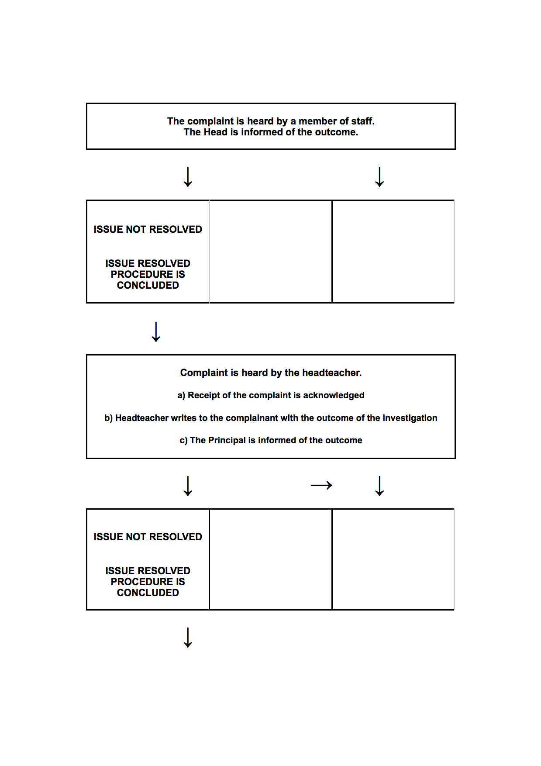
Meeting of the Complaints Panel is arranged.

- Complainant invited to meeting by letter.
- Letter issued confirming the decision made by the panel. THE PANELS DECISION IS FINAL.

Complaints
2021 – 2022 | 0
2022 – 2023 | 0
2023 – 2024 | 0



Formal Complaint Form

Name of Parent  Susi Earnshaw Theatre School Formal Complaint Form | Parent Contact Details  Number:  E-mail:
Full Name of Child | Child’s Address
Details of the Complaint:

Name of Parent/Carer_____________________________________________________________

Signature of Parent Carer__________________________________________________________

Date:____________________________________________________________________________

Please see our Complaints Policy and Procedure for full details on how Complaints are handled with regards to timescales panel hearings etc..

