

**SAFEGUARDING AND CHILD PROTECTION POLICY**

|  |  |
| --- | --- |
| Last updated: August 2023 | Next review: August 2025 |
| Ratified by: Proprietor – Susi Earnshaw | Date: August 2024 |

This policy applies to the full-time school, and also to the part-time, evening and weekend classes.

Safeguarding is the responsibility of all school staff, both teaching and administrative.

Designated Safeguarding Lead (DSL): Julia Hammond

Office hours telephone: 020 8441 5010

Emergency telephone: 07973 362 351

E-Mail: headteacher@susiearnshaw.co.uk

Deputy Designated Safeguarding Lead

(DDSL): Katherine Tyler

Office hours telephone: 020 8441 5010

Emergency telephone: 07973 362 351

E-Mail: katherine.tyler@susiearnshaw.co.uk

Proprietors Susi and David Earnshaw

Office hours telephone: 0208 441 5010

Emegency telephone: 07973 362 351

E-Mail: [susi@susiearnshaw.co.uk](mailto:susi@susiearnshaw.co.uk)

[david@susiearnshaw.co.uk](mailto:david@susiearnshaw.co.uk)

**This policy is read and referred to, both in inset days and in regular staff meetings. It is also annually updated and reviewed by and signed off by the Proprietor Susi Earnshaw, who’s responsibility is also to oversee safeguarding issues and hold an annual review. This is in line with guidance from, and in full compliance with, the Department for Education (DfE), and, whenever appropriate, with the latest versions of:**

* *Keeping Children Safe in Education (KCSIE)* and further information in Annex A (2024)
* *Working Together to Safeguard Children* (2023)
* *Relationships Education, Relationships and Sex Education (RSE) and Health Education (2019, updated September 2021)*
* *Revised Prevent Duty* Guidance: for England and Wales (2023)
* *The Prevent Duty: Departmental advice for schools and childminders (June 2015)*
* *The Use OF Social Media for Online Radicalisation* (2015).
* *What to Do If You Are Worried A Child Is Being Abused – Advice for Practitioners* (March 2015)
* *Schools Covid-19 operational guidance (August 2021)*
* *D.F.E Child Sexual Exploitation Definition and A Guide for Practitioners, Local Leaders and Decision Makers Working to Protect Children from Child Sexual Exploitation with Annexes* (Feb 2017)
* DBS Staff Referral Guidance (20th Nov 2017)

Copies of all the above documents are available for staff to view in the staff room.

This policy should be read with the Safeguarding Handbook, and consists of the following sections:

1. Safeguarding and Covid-19…………………………………………….3
2. Safeguarding and Child Protection……………………………………. 3
3. Early Help………………………………………………………………7
4. Acceptable Use of ICT and Online Safety …………………………… .24
5. Prevent

Appendix A: Contact Details & Information

Appendix B: The role of the DSL and DDSL

Appendix C: Forms

**SAFEGUARDING STATEMENT**

Regarding safeguarding, the best interests of children must always continue to come first!

Safeguarding and promoting the welfare of children is defined for the purposes of this policy as

* Providing help and support to meet the needs of children as soon as problems emerge
* Protecting children from harm/maltreatment, whether that is within or outside the home, including online.
* Preventing impairment of children’s mental and physical health or development.
* Ensuring that children grow up in circumstances consistent with the provision of safe and effective care and
* Taking action to enable all children to have the best outcomes.

Everyone working at Susi Earnshaw’s shares an objective to help keep children safe by:

* Providing a safe environment for children to learn; and
* Identifying children who are suffering or likely to suffer significant harm and taking appropriate action to make sure they are kept safe both at home and in school.

To achieve this objective, we have put systems in place that are designed to:

* Prevent unsuitable people working with children;
* Promote safe practice and challenge poor and unsafe practice;
* Identify instances in which there are grounds for concern about a child’s physical and mental welfare, and initiate or take appropriate action to keep them safe; and
* Contribute to effective partnership working between all those involved with providing services for children.

Safeguarding and Covid-19

The way we at Susi Earnshaw are currently operating in response to coronavirus (COVID-19) is fundamentally different to business as usual, however, a number of important safeguarding principles remain the same:

* With regard to safeguarding, the best interests of children must always continue to come first
* If any staff member, parent or pupil has a safeguarding concern about any child they should continue to act and act immediately.
* Julia Hammond is still operating as the DSL and is available at all times
* children should continue to be cautious when they are online, and practice E-Safety from home.

Keeping pupils and teachers safe during remote education is essential. While our teachers deliver classes remotely online, they should be aware that the same principles set out in the school’s Staff Code of Conduct Policy will apply. In addition, teachers are advised to use school email accounts and devices rather than personal, provide links to other resources and set out many other considerations and practical tips for safe remote learning, as advised by *Safeguarding and Remote Education.*

If a child, parent or member of staff has a concern regarding a child, they must contact the DSL (Julia Hammond) at [headteacher@susiearnshaw.co.uk](mailto:headteacher@susiearnshaw.co.uk) or call 07973 362 351. She will be able to contact relevant external agencies, all of whom are still in operation.

This was implemented under guidance from the department who issued safeguarding in schools, colleges and other providers (<https://www.gov.uk/government/publications/covid-19-safeguarding-in-schools-colleges-and-other-providers>) during the coronavirus outbreak. This guidance supports governing bodies, proprietors, senior leadership teams and designated safeguarding leads to continue to have appropriate regard to KCSIE and keep their children safe. It suggests where schools and colleges might consider safeguarding policy and process differently when compared to business as usual.

**SAFEGUARDING AND CHILD PROTECTION**

**Issues relating to the specific nature of the school**

As a specialist performing arts school with several pupils working in the business, we are mindful of our added responsibility to our pupils beyond the boundaries of our school, when they are working in film, television or theatre. To ensure that our pupils are safe going to auditions and when working, we adhere to the rules set out by the local education authorities.

The school will only provide a letter to allow a child to take time off school to work if the student is up to date with their work. The school provides academic work for pupils who are away working via their school Gmail account, and parents and pupils can contact individual teachers via this e-mail account. When a student returns to school, catch up classes are given if necessary. Pupils are also reminded to welcome their friends back, especially if they have been away on tour, as coming back to school after having time off can sometimes be daunting.

The education authorities check on the vetted and licensed chaperones who accompany children, the tutors who work with them on set and the hours that they are allowed to work. They also issue the licenses that allow them to work.

The school has appointed an agency to represent all our pupils and works closely with them to ensure that all safeguarding procedures are met.

**AIMS:**

* To create an environment in the school which encourages our pupils to develop a positive self-image, regardless of race, language, religion, culture or home background.
* To work with parents to build their understanding of, and commitment to, the welfare of all our children
* To help pupils to establish and sustain satisfying relationships with their families, with peers and with other adults.
* To encourage our pupils to develop a sense of autonomy and independence.
* To enable pupils to have self-confidence and the appropriate vocabulary to resist inappropriate approaches.
* To enable our pupils to develop an on-going stable relationship of trust with those helping them.
* To approach all pupil with positive expectations.
* To inform our pupils about, and involve them in, procedures, decisions, concerns and plans.
* To inform our pupils of the outcome of assessments and decisions and the reasons, when their views have not met with a positive response.
* To provide our pupils with support in their own right, and, when necessary, provide support and advice to their families.
* To provide our pupils with advocacy to assist them in putting forward their views.

**GENERAL:**

**At the Susi Earnshaw Theatre School, we operate a ZERO TOLERANCE OF ABUSEIVE BEHAVIOURS**

With regards to Safeguarding, the best interests of children must always continue to come first.

All staff, both teaching and administrative including voluntary and supply, are dedicated to safeguarding and promoting the welfare of children who are pupils at the school, including the part-time pupils and those in various holiday club activities. Anyone including all members of staff are encouraged and expected to make a referral to the relevant agency should an incident arise and are reminded of this frequently.

Susi Earnshaw’s Designated Safeguarding Lead (Julia Hammond) and the Deputy Designated Safeguarding Lead (Megan McNamara) have received appropriate training which includes inter-agency working and safeguarding partners’ approach to Prevent duties, so that they provide support to others. For details on the role of the DSL and DDSL, please see Annex B.

Our Proprietor (Susi Earnshaw) has the same level of training to cover in the event of Julia’s absence. In the event of the Designated Safeguarding Lead, also in this case headteacher, being the subject of an allegation, the report should be made to the Proprietor who will co-ordinate the response.

The school ensures that every member of staff (including temporary and supply staff and volunteers) know and understand:

* The name of the Designated Safeguarding Leads and their roles
* The responsibility of all staff to be alert to the signs of abuse and their responsibility for referring any concerns to the Designated Safeguarding Lead.
* The procedures identified within the school policy.

The school ensures that parents have an understanding of the responsibility placed on the school and staff in relation to safeguarding and child protection, by publishing appropriate policies on the school’s website.

All staff are aware of the early help process and understand their role in it. This includes identifying emerging problems, liaising with the designated safeguarding lead, sharing information with other professionals to support early identification and assessment and, in some cases, acting as the lead professional in undertaking an early help assessment. They are also, advised to maintain an attitude of **‘it could happen here’** where safeguarding is concerned.

If early help is appropriate, the designated safeguarding lead should support the staff member in liaising with other agencies and setting up an inter-agency assessment as appropriate.

Early help means providing support as soon as a problem emerges at any point in a child’s life. Where a child would benefit from co-ordinated early help, an early help inter-agency assessment should be arranged. Chapter one of Working Together to Safeguard Children provides detailed guidance on the early help process. We also follow procedures and guidance from the local (Barnet) Safeguarding Children Board’s statutory guidance for schools.

All safeguarding issues are treated very seriously. Should any specific concern arise, a report must be provided immediately for the attention of the Designated Safeguarding Lead – Julia Hammond, who will liaise with the appropriate external bodies. All staff are required to read and understand Keeping Children Safe in Education Part 1 and the further information found in Annex A (Annex B for leaders) of the *KCSIE,* and also to take the online KCSIE training (with certificate) provided iHASCO.

**NB Each time Part One of the KCSIE is updated by the DfE, existing staff must be updated accordingly.**

Susi Earnshaw’s recognises that, because of their day to day contact with children, school staff are well placed to notice the outward signs or manifestations of Abuse, Female Genital Mutilation (FGM), Radicalisation, Child Criminal Exploitation (CCE) and Child Sexual Exploitation (CSE) Consequently, every member of staff at Susi Earnshaw’s has up to date training in child protection, all of them to Level 2 and most of them to Level 3. This is renewed every two years with Sue Manning from Education Child Protection LTD (www.ecplimited.com)

This enables staff to have a clear understanding that is their duty to:

* Establish and maintain an environment where children feel secure, are encouraged to talk, and are listened to.
  + Ensure that children know there are adults in the school whom they can approach if they are worried.
  + Include opportunities in the PHSE curriculum for children to develop the skills they need to recognise and stay safe from abuse.

We will follow the procedures set out by the area Child Protection Committee and take account of guidance issued by the Department for Education and Skills to:

* + Ensure we have a designated teacher for child protection who has received appropriate training and support for this role.
  + Ensure that every member of staff and volunteer knows the name of the designated teacher responsible for child protection and their role
  + Ensure all staff and volunteers understand their responsibilities in being alert to the signs of abuse and the responsibility for referring any concerns to the designated teacher responsible for chid protection.
  + Ensure that parents have an understanding of the responsibility placed on the school and staff for child protection by setting out its obligations in the school prospectus.
  + Notify social services if there is an unexplained absence of more than one day of a pupil who is on the child protection register.
  + Develop effective links with relevant agencies and co-operate as required with their enquiries regarding child protection matters including attendance at case conferences.
  + Keep written records of concerns about children, even where there is no need to refer the matter immediately.
  + Ensure all records are kept securely; separate from the main pupil file, and in locked locations.
  + Develop and then follow procedures where an allegation is made against a member of staff or volunteer.
  + Ensure safe recruitment practices are always followed.

We recognise that children who are abused or witness violence may find it difficult to develop a sense of self worth. They may feel helplessness, humiliation and some sense of blame. The school may be the only stable, secure and predictable element in the lives of children at risk. When at school their behaviour may be challenging and defiant or they may be withdrawn.

The school will endeavour to support the pupil through:

* + The content of the curriculum.
  + The school ethos which promotes a positive, supportive and secure environment and gives pupils a sense of being valued.
  + The school behaviour policy which is aimed at supporting vulnerable pupils in the school. The school will ensure that the pupil knows that some behaviour is unacceptable but they are valued and not to be blamed for any abuse which

has occurred.

* + Liaison with other agencies that support the pupil such as social services, Child and Adult Mental Health Service, education welfare service and educational psychology service.
  + Ensuring that, where a pupil on the child protection register leaves, their  information is transferred to the new school immediately and that the child’s social worker is informed.

All staff must be vigilant and report any concerns immediately to the Head Teacher should they notice or suspect that a child may be troubled.

**SAFGUARDING REGISTER/FILE**

Confidential records are kept on file in the Safeguarding Register/File . Whilst cases are active, these are regularly updated and checked by the Head Teacher and DSL to ensure that a central record of concerns is maintained. If the event of an unexplained absences of more than one day of a pupil, who is on the safeguarding children register, the DSL will notify the appropriate external bodies. See Annex A for contact details and Annex be for forms.

Susi Earnshaw’s has a Missing Child Policy. We also have measures in place to make sure that all our pupils remain safe online whilst at school. For more information, please see section Acceptable Use of ICT (E-Safety), Prevent section and our PHSCE Department Policy.

**EARLY HELP**

Early identification of children who may not be at risk of significant harm but are in need of additional support from one or more agencies is also essential. Early help is support for children of all ages that improves a family’s resilience and outcomes or reduces the chance of a problem getting worse, and providing support as soon as a problem arises. These cases should lead to inter-agency assessments using the Local Authority (L.A) processes. If a staff member feels that a child is in need of additional support, as mentioned above, they should record and report their concerns to the DSL. If a decision is made to access Early Help, then the safeguarding team will monitor the case and refer should the situation not seem to improve.

Any child may benefit from early help, but all staff should be particularly alert to the potential need for early help for a child who:

* Has experienced multiple suspensions, is at risk of being permanently excluded from schools, colleges and in alternative provision or a pupil referral unit.
* Has a parent or carer in custody or is affected by parental offending.
* Is frequently missing/goes missing from education, home or care.
* Is disabled and has specific additional needs
* Has special educational needs (whether or not they have a statutory education, health and care plan)
* Is a young carer
* Is showing signs of being drawn in to anti-social or criminal behaviour, including gang involvement and association with organised crime groups
* Is frequently missing/goes missing from care or from home
* Is misusing drugs or alcohol themselves
* Is at risk of modern slavery, trafficking or exploitation
* Is in a family circumstance presenting challenges for the child, such as substance abuse, adult mental health problems or abuse
* Has returned home to their family from care
* Is showing early signs of abuse and/or neglect
* Is at risk of being radicalised or exploited
* Is a privately fostered child.

**LIASON WITH OTHER BODIES**

We have procedures for contacting the local authority on safeguarding and child protection issues to ensure that it is easy, in any emergency, for the School and local statutory children’s agencies, including social services, to work well together.

All staff who have contact with children are required to have read this policy, and this includes part-time teachers, supply teachers and volunteers.

We provide adequate and appropriate staffing resources to meet the needs of children. We take particular care to ensure that those involved in one-to-one teaching are aware of their safeguarding responsibilities.

We operate safe recruitment procedures (to include enhanced DBS checks for all posts within the school) and we abide by the DfE requirement – in respect of references and police checks for staff and volunteers – to ensure that no disqualified or unfit person works in the school or has access to the children. Induction of new staff includes their training in safeguarding matters, A requirement for this induction process is that they will be given, asked to read and understand an up to date copy of Part 1 and Annex A of the KCSIE, a copy of the schools following policies:

* + Safeguarding and Child Protection Policy, including details for dealing with peer-on-peer abuse
  + Staff Code of Conduct,
  + Whistleblowing Policy and Procedure
  + Acceptable use of ICT, staff and pupil relationships and low levels of concerns and details and Pupil Behaviour Policy which includers measures to prevent bullying, including cyberbullying prejudice-based and discriminatory bullying.

They will also be given details role and identity of our DSL’s, information on the safeguarding response to Children Missing in Education and On-line Safety.

(For further information, please download the up-to-date Staff Recruitment Policy, which is available on our website).

If a crime has been committed, the police must be informed from the outset as well as the LADO. We also advise the use of 101 (non emergency police number) for cases of serious harm and also concerns and advice on matter concerning radicalization and extremism. The DFE helpline and mailbox for non-emergency advice for staff and proprietors: 02073407264 and [counter-extreamism@education.gsi.gov.uk](mailto:counter-extreamism@education.gsi.gov.uk)

**TRAINING AND INDUCTION**

Both the Designated and Deputy Safeguarding Leads will receive appropriate Designated Lead training through accredited bodies carried out at least every two years. This training is provided to ensure the DSL’s fulfil their obligations. These obligations include:

1. understanding the assessment processes for providing early help and intervention.
2. having a working knowledge of the locally agreed procedures for child protection and inter-agency workings, (in particular, how the local authority conducts a child protection conference and a child protection review conference) and being able to attend and contribute to these effectively when required to do so.
3. ensuring that each member of staff has access to and understands the school’s Safeguarding and Child Protection Policy, the most up to date K.C.S.I.E Pt 1 with the Annex A (especially new and part-time staff), and Annex B for leaders. All staff have access to the Staff Handbook.
4. being alert to and supporting the specific needs of children in need, young carers and children with Special Educational Needs.

All staff receive annual training (as specified by the Barnet Safeguarding Children Partnership) from the DSL on safeguarding, and child protection which includes Prevent awareness and how to identify children and young people at risk, and online safety is delivered by the Designating Safeguarding Lead. Volunteers and temporary and voluntary staff are also made aware of Child Protection matters. We introduce key elements of Child Protection into our PHSCE courses, so that children can develop an understanding of why and how to keep safe on a regular basis.

We recognise that because of the day to day contact with children, school staff are well placed to observe the outward signs of Abuse, FGM, Radicalisation, Peer on Peer Abuse, Child Sexual Exploitation (CSE) and Child Criminal Exploitation (CCE). Because of this, every member of staff at the Susi Earnshaw Theatre School are required to complete relevant training e.g. Prevent, annually and have up to date level 2 training in Child Protection and understand that it is all staff members duty to:

* Establish and maintain an environment where children feel secure, are encouraged to talk, and are listened to.
* Ensure that children know there are adults in the school whom they can approach if they are worried.
* Include opportunities in the PHSE curriculum for children to develop the skills they need to recognise and stay safe from abuse.

Other induction for new staff includes the pupil behaviour (Pupil Behaviour Policy), safeguarding responses to children that go missing in education (Children Missing in Education Policy), mental health (Mental Health Policy) and online safety (Acceptable use of ICT Policy)

**All staff are trained on how to manage a report of child-on-child abuse, sexual violence and sexual harassment.**

**ALLEGATIONS OF ABUSE AGAINST A MEMBER OF STAFF, SUPPLY STAFF, VOLUNTEERS OR THE HEAD TEACHER.**

If an allegation is made against staff, supply staff or volunteers, working with children in a school, all unnecessary delays should be eradicated, and will be reported to the Head, Julia Hammond, or in her absence Susi Earnshaw, (proprietor) who will notify the Local (Barnet) Authority Designated Officer (LADO) immediately. Under no circumstances would be undertake our own investigations of allegations without prior consultation with the LADO, or in the most serious cases, the police, so as not to jeopardise statutory

Please note: Any referrals made to statutory agencies does NOT require parental consent.

Allegations that meet the following criteria must be reported to Barnet’s Local Authority Designated Officer (LADO) within one working day:

Where it is alleged that someone has:

* behaved in a way that has harmed or may have harmed a child.
* possibly committed a criminal offence against or related to a child.
* behaved towards a child in a way that indicates that he/she would pose a risk of harm if they worked regularly or closely with children.

The LADO can also be contacted for advice regarding concerns or suspicions about behaviour towards children by staff within Barnet’s Children's Workforce. This includes volunteers as well as paid staff and those in a position of trust.

Rob Wratten, Barnet’s Local Authority Designated Officer (LADO), should be contacted via Jamie Preston at the Barnet Multi Agency Safeguarding Hub, (MASH). The function of the LADO is to provide advice and preside over the investigation of any allegation of suspicions of abuse directed against anyone working at the school.

Any accusations against the Head Teacher should be reported to the Proprietors, without the Head being informed. The Proprietor must ensure that the LADO is informed immediately.

Any allegations against the Proprietors (Susi Earnshaw and David Earnshaw) will need to go the LADO straight away. If any criminal offence is suspected, the police should be informed immediately.

The above applies to any allegation of harm or abuse by any person working or looking after children in our school (whether that allegation relates to harm or abuse committed on our premises or elsewhere) and to any other abuse which is alleged to have taken place on the premises or elsewhere. If the Head Teacher is absent, the allegation should be passed to the Proprietor, (Susi Earnshaw).

If the school dispenses with a person’s services due to an unsuitability to working with children, or would have done so had the person not resigned, a report will be promptly sent to the Disclosing and Barring Service. In a case of a teacher being dismissed, or when a teacher would have been dismissed had they not resigned, we will make a referral to the Teaching Regulation Agency (TRA) if a prohibition order may be appropriate due to ‘unacceptable professional conduct’, ‘conduct that may bring the profession into disrepute’, or a ‘conviction at any time for a relevant offence.’

**HELPING STAFF AVOID ALLEGATIONS OF ABUSE**

Staff should avoid one-to-one tuition with a student in a room where there are no other staff or pupils present. If this is unavoidable, they should make sure that it is done in as public a room as possible. Also, in demonstrating certain vocational techniques, the teacher should refrain from any inappropriate physical contact. For further information and guidance, please see the Staff Code of Conduct.

Induction for new staff includes thoroughly going through the school’s Safeguarding and Child Protection Policy, the Staff Code of Conduct, the identity and function of the DSL’s and a copy of Part 1 and Annex A of the KCSIE. All staff are required to take a small test based on information provided in the KCSIE.

**SPECIFIC SAFEGUARDING ISSUES**

**All** staff should have an awareness of safeguarding issues, some of which are listed further down in this document. Staff should be aware that behaviours linked to the likes of drug taking, alcohol abuse, truanting and sexting put children in danger.

Expert and professional organisations are best placed to provide up-to-date guidance and practical support on specific safeguarding issues. For example, information for schools and colleges can be found on the TES, MindEd and the NSPCC websites. School and college staff can access government guidance as required on the issues listed below via GOV.UK and other government websites:

* Bullying including cyberbullying
* Children and the court system
* Children missing education
* Children with family members in prison
* Child on Child Sexual Violence and Harassment
* Child sexual exploitation (CSE) – KCSIE specifically Annex A
* Child Criminal Exploitation (CCE) – KCSIE specifically Annex A
* County Lines
* Domestic violence/ abuse
* Homelessness
* So-called honour-based abuse
* Female genital mutilation (FGM)
* Forced marriage
* Preventing Radicalisation
* The Prevent Duty
* Channel
* Child on Child Abuse
* Sexual violence and sexual harassment between children in schools and colleges
* Upskirting
* The response to a report of sexual violence or sexual harassment.

**Annex A found in the latest (2024) KCSIE contains important additional information about specific forms of abuse and safeguarding issues. School leaders and those staff who work directly with children are required to read and understand Pt 1 and the Annex A.**

**All** staff should be aware that safeguarding issues can manifest themselves via peer on peer abuse.

**ALLEGATIONS AGAINST PUPILS**

A pupil against whom an allegation of abuse has been made may be suspended from the school during the investigation, as determined by the Headteacher. In addition to the procedures in this policy, the school’s policy on behaviour, discipline and sanctions will apply. A bullying incident will be treated as a child protection concern when there is reasonable cause to suspect that a child is suffering, or likely to suffer significant harm. The school takes a firm line in relation to possible peer-on-peer abuse. This includes; sexting, verbal abuse, including when it is passed off as “banter” sexual abuse between young people gender-based issues.

The school ensures that no form of peer abuse is allowed to be dismissed as banter, either by staff or by pupils

**SUSPECTED HARM FROM OUTSIDE THE SCHOOL:**

A member of staff who suspects that a pupil is suffering harm from outside the school should seek information from the child with tact and sympathy using “open” and not leading questions. A sufficient record should be made of the conversation and given to the Designated Safeguarding Lead for child protection.

**PUPILS WITH SEND**

Children with disabilities are three time more likely to be abused by than their peers. They can face additional Safeguarding challenges and there may be additional barriers to recognising abuse and neglect in this group of children. This may include

* Assumptions that indicators of possible abuse such as behaviour, mood or injury relate to the child’s disability without further exploration
* Children with SEND being disproportionately impacted by issues such as bullying without showing any outward signs
* Children with SEND being unable to communicate instances of possible abuse. The school’s behaviour and anti-bullying policies make specific reference to dealing appropriately with SEND. Staff should be vigilant in relation to the bulleted points above, reporting any concerns to the DSL.

**SUSPICIONS OF ABUSE, NEGLECT, EXPOITATION OR CONCERNS ABOUT A PUPIL’S WELFARE.**

There may be occasions when a staff member may suspect that a child may be at serious risk but have no ‘real’ evidence. The child’s behaviour may have changed, their art or written work could contain elements giving cause for concern, or a member of staff may have noticed various other physical but inconclusive signs. In these circumstances, the staff member should try to give the child the opportunity to talk. The signs they have noticed may be due to a variety of factors, and it is perfectly acceptable to ask the child if they are all right or if they can help in any way.

The member of staff must record these early concerns and pass them to the DSL immediately.

If it suspected that a crime has been committed all members of staff should contact the police.

We recognise that there is a difference between children who are in need and children who are at risk from harm, and we will contact MASH in either case, who will direct us to the appropriate department.

In all instances, the school contributes to inter-agency working.

**WHAT TO DO IF YOU WISH TO REPORT A CONCERN ABOUT A CHILD’S WELFARE.**

Regular training is provided to update staff on pupil welfare and safeguarding issues. All staff learn how to report suspicions of abuse, neglect, exploitation or concerns about a pupil’s welfare to the DSL. Staff are made aware that behaviours linked to the likes of drug taking, alcohol abuse, truanting and sexting put children in danger.

When a member of staff wishes to report a suspicion or concern, they are asked to complete a written record (Safeguarding Concern), blank copies of which are always available in the staff room in the Blue in-trays. For the avoidance of doubt, we have a unique form for Safeguarding concerns, and is **always returned to the DSL** as well as for onward review by the Proprietor.

The Head reviews the forms regularly, takes action as appropriate (including notifying the Proprietor) and all records are kept confidential, and reviewed regularly so that concerning patterns of behaviour can be spotted.

**WHAT STAFF SHOULD DO IF A CHILD IS IN DANGER OR AT RISK FROM HARM.**

If staff (including volunteers) believe that a child is in immediate danger or at risk of harm, they should make an immediate referral to children’s social care and/or the Police. Anyone can make a referral. Any such referral must be made immediately and in any event within 24 hours (one working day) of staff being aware of the risk.  Parental consent is not needed for referrals to statutory agencies such as the police and children’s social care.  If anyone other than the DSL makes a referral, they should inform the DSL as soon as possible that a referral has been made.  Staff should challenge any inaction and follow this up with the DSL and children’s social care as appropriate. All concerns, discussions and decisions made and the reasons for those decisions should be recorded in writing.

**WHAT STAFF SHOULD DO IF A CHILD IS SEEN AS AT RISK OF RADICALISATION.**

Staff should follow the School’s normal referral processes when there are concerns about children who may be at risk of being drawn into terrorism, as set out above. This may include a referral to Channel or children’s social care depending on the level of risk. However, if staff have concerns that there is an immediate/significant risk of a child being drawn into terrorism they must call 999.  Advice and support can also be sought from children’s social care.

The School, in recognition that pupils may be at risk of being drawn into terrorism or other forms of extremism, carries out appropriate risk assessments following consultation with local partners, such as the Police and our own Safeguarding internal audit, of the potential risk in the local area. Such risk assessments are discussed with the Head, and Deputy Safeguarding Lead, to ensure the School’s safeguarding arrangements are sufficiently robust to help prevent and protect children from being drawn into terrorism and are regularly revised.

**WHAT STAFF SHOULD DO IF THEY DISCOVER AN ACT OF FEMALE GENITAL MUTILATION**

Staff must report to the Police cases where they discover that an act of FGM appears to have been carried out. Unless the member of staff has a good reason not to, they should still consider and discuss any such case with DSL and involve children’s social care as appropriate.

**WHAT STAFF SHOULD DO IF A CHILD GOES MISSING FROM EDUCATION.**

Children who go missing from education, particularly on repeat occasions, is a potential indicator of abuse, neglect or exploitation. The School’s procedures for unauthorised absence and for dealing with children who go missing from education Can be found in our ‘Children Missing from Education Policy.

The School will report to Barnet Council, a pupil who fails to attend school regularly or has been absent from school without the School’s permission for a continuous period of 10 school days or more.

**ABUSE, NEGLECT AND EXPLOITATION**

All staff should be aware of indicators of abuse, neglect and expoitation. Knowing what to look for is vital for the early identification of abuse and neglect and specific safeguarding issues such as child criminal exploitation and child sexual exploitation so that staff are able to identify cases of children who may be in need of help or protection.

If staff are unsure, they should always speak to the designated safeguarding lead, or deputy.

All school and college staff should be aware that abuse, neglect and safeguarding issues are rarely standalone events and cannot be covered by one definition or one label alone. In most cases, multiple issues will overlap with one another, therefore staff should always be vigilant and always raise any concerns with their designated safeguarding lead (or deputy).

**DEFINITIONS**

**Abuse**: a form of maltreatment of a child. Somebody may abuse or neglect a

child by inflicting harm or by failing to act to prevent harm. Harm can include ill

treatment that is not physical as well as the impact of witnessing ill treatment of

others. This can be particularly relevant, for example, in relation to the impact on

children of all forms of domestic abuse, including where they see, hear or

experience its effects. Children may be abused in a family or in an institutional or

community setting by those known to them or, more rarely, by others. Abuse can take place wholly online, or technology may be used to facilitate offline abuse.

Children may be abused by an adult or adults or by another child or children.

**Physical abuse:**  a form of abuse which may involve hitting, shaking, throwing, poisoning, burning or scalding, drowning, suffocating or otherwise causing physical harm to a child. Physical harm may also be caused when a parent or carer fabricates the symptoms of, or deliberately induces, illness in a child (Munchausen’s Syndrome By Proxy).

**Emotional abuse:**  the persistent emotional maltreatment of a child such as to cause severe and adverse effects on the child’s emotional development. It may involve conveying to a child that they are worthless or unloved, inadequate, or valued only insofar as they meet the needs of another person. It may include not giving the child opportunities to express their views, or deliberately silencing them or ‘making fun’ of what they say or how they communicate. It may feature age or developmentally inappropriate expectations being imposed on children. These may include interactions that are beyond a child’s developmental capability, as well as overprotection and limitation of exploration and learning, or preventing the child from participating in normal social interactions. It may involve seeing or hearing the ill-treatment of another. It may involve serious bullying (including cyberbullying), causing children to feel frightened or in danger, or the exploitation or corruption of children. Some level of emotional abuse is involved in all types of maltreatment of a child, although it may also occur alone.

**Sexual abuse:** involves forcing or enticing a child or young person to take part in sexual activities, not necessarily involving violence, whether or not the child is aware of what is happening. The activities may involve physical contact, including assault by penetration (for example rape or oral sex) or non-penetrative acts such as masturbation, kissing, rubbing, and touching outside of clothing. They may also include non-contact activities, such as involving children in looking at, or in the production of, sexual images, watching sexual activities, encouraging children to behave in sexually inappropriate ways, or grooming a child in preparation for abuse. Sexual abuse can take place online, and technology can be used to facilitate offline abuse. Sexual abuse is not solely perpetrated by adult males. Women can also commit acts of sexual abuse, as can other children. The sexual abuse of children by other children is a specific safeguarding issue (also known as peer on peer abuse) in education and all staff should be aware of it and of their school or colleges policy and procedures for dealing with it

**Neglect:**  the persistent failure to meet a child’s basic physical and/or psychological needs, likely to result in the serious impairment of the child’s health or development. Neglect may occur during pregnancy as a result of maternal substance abuse. Once a child is born, neglect may involve a parent or carer failing to: provide adequate food, clothing and/or shelter (including exclusion from home or abandonment); protect a child from physical and emotional harm or danger; ensure adequate supervision (including the use of inadequate care-givers); or ensure access to appropriate medical care or treatment. It may also include neglect of, or unresponsiveness to, a child’s basic emotional needs.

All staff should have an awareness of safeguarding issues that can put children at risk of harm. Behaviours linked to issues such as drug taking and or alcohol misuse, deliberately missing education and consensual and non-consensual sharing of nudes and semi-nudes images and/or videos can be signs that children are at risk. Other safeguarding issues all staff should be aware of include:

**Child Sexual Exploitation (CSE) and Child Criminal Exploitation (CCE)**

Both CSE and CCE are forms of abuse that occur where an individual or group takes advantage of an imbalance in power to coerce, manipulate or deceive a child into taking part in sexual or criminal activity. This may involve an exchange for something the victim needs or wants, and/or for the financial advantage or increased status of the perpetrator or facilitator and/or through violence or the threat of violence. CSE and CCE can affect children, both male and female and can include children who have been moved (commonly referred to as trafficking) for the purpose of exploitation.

**Child Criminal Exploitation (CCE)**

Some specific forms of CCE can include children being forced or manipulated into transporting drugs or money through county lines, working in cannabis factories, shoplifting or pickpocketing. They can also be forced or manipulated into committing vehicle crime or threatening/committing serious violence to others.

Children can become trapped by this type of exploitation as perpetrators can threaten victims (and their families) with violence, or entrap and coerce them into debt. They may be coerced into carrying weapons such as knives or begin to carry a knife for a sense of protection from harm from others. As children involved in criminal exploitation often commit crimes themselves, their vulnerability as victims is not always recognised by adults and professionals, (particularly older children), and they are not treated as victims despite the harm they have experienced. They may still have been criminally exploited even if the activity appears to be something they have agreed or consented to.

It is important to note that the experience of girls who are criminally exploited can be very different to that of boys. The indicators may not be the same, however professionals should be aware that girls are at risk of criminal exploitation too. It is also important to note that both boys and girls being criminally exploited may be at higher risk of sexual exploitation.

**Child Sexual Exploitation (CSE)**

CSE is a form of child sexual abuse. Sexual abuse may involve physical contact, including assault by penetration (for example, rape or oral sex) or nonpenetrative acts such as masturbation, kissing, rubbing, and touching outside clothing. It may include non- contact activities, such as involving children in the production of sexual images, forcing children to look at sexual images or watch sexual activities, encouraging children to behave in sexually inappropriate ways or grooming a child in preparation for abuse including via the internet.

CSE can occur over time or be a one-off occurrence, and may happen without the child’s immediate knowledge e.g. through others sharing videos or images of them on social media.

CSE can affect any child, who has been coerced into engaging in sexual activities. This includes 16 and 17 year olds who can legally consent to have sex. Some children may not realise they are being exploited e.g. they believe they are in a genuine romantic relationship.

**So-called ‘honour’-based abuse (including Female Genital Mutilation and Forced Marriage)**

So-called ‘honour’-based abuse (HBA) encompasses incidents or crimes which have been committed to protect or defend the honour of the family and/or the community, including female genital mutilation (FGM), forced marriage, and practices such as breast ironing. Abuse committed in the context of preserving ‘honour’ often involves a wider network of family or community pressure and can include multiple perpetrators. It is important to be aware of this dynamic and additional risk factors when deciding what form of safeguarding action to take. All forms of HBA are abuse (regardless of the motivation) and should be handled and escalated as such. Professionals in all agencies, and individuals and groups in relevant communities, need to be alert to the possibility of a child being at risk of HBA, or already having suffered HBA.

**Female Genital Mutilation (FGM)**

Whilst all staff should speak to the designated safeguarding lead (or deputy) with regard to any concerns about female genital mutilation (FGM), there is a specific legal duty on teachers.10 If a teacher, in the course of their work in the profession, discovers that an act of FGM appears to have been carried out on a girl under the age of 18, the teacher must report this to the police.

**Serious violence and County Lines**

County Lines is the term used “when drug gangs from big cities expand their operations to smaller towns, often using violence to drive out local dealers and exploiting children and vulnerable people to sell drugs. These dealers will use dedicated mobile phone lines, known as 'deal lines', to take orders from drug users. Heroin, cocaine and crack cocaine are the most common drugs being supplied and ordered. In most instances, the users or customers will live in a different area to where the dealers and networks are based, so drug runners are needed to transport the drugs and collect payment.” (National Crime Agency 2019)

All staff are aware of the associated risks and understand the measures in place to manage these issues. Further advice for schools and colleges is provided in the Home Office’s Preventing youth violence and gang involvement and its *‘Criminal exploitation of children and vulnerable adults: county lines guidance’*

**MENTAL HEALTH**

All staff at the Susi Earnshaw Theatre School should also be aware that mental health problems can, in some cases, be an indicator that a child has suffered or is at risk of suffering abuse, neglect or exploitation.

Only appropriately trained professionals should attempt to make a diagnosis of a mental health problem. Staff, however, are well placed to observe children day-to-day and identify those whose behaviour suggests that they may be experiencing a mental health problem or be at risk of developing one.

Where children have suffered abuse and neglect, or other potentially traumatic adverse childhood experiences, this can have a lasting impact throughout childhood, adolescence and into adulthood. It is key that staff are aware of how these children’s experiences, can impact on their mental health, behaviour and education.

If staff have a mental health concern about a child that is also a safeguarding concern, they must report it to Julia Hammond (DSL) or Megan McNamara (Deputy) immediately.

The school has adapted it’ Life Skills Scheme to include positive health, well being and resilience using guidance from Public Health England including: *Mental Health and Behaviour in Schools* *and Promoting children and young people’s emotional health and wellbeing*, which resources include social media, forming positive relationships, smoking and alcohol.

**CHILD ON CHILD ABUSE**

All staff at Susi Earnshaw Theatre School are aware that children can abuse other children (often referred to as child-on-child abuse). And that it can happen both inside and outside of school and online. It is important that all staff recognise the indicators and signs of peer-on-peer abuse and know how to identify it and respond to reports.

All staff understand, that even if there are no reports in school it does not mean it is not happening, it may be the case that it is just not being reported. When staff member have concerns regarding child-on-child abuse they should speak to Julia Hammond (Designated Safeguarding Lead)

Child on Child abuse is most likely to include, but may not be limited to:

* bullying (including cyberbullying, prejudice-based and discriminatory bullying);
* abuse in intimate personal relationships between peers;
* physical abuse such as hitting, kicking, shaking, biting, hair pulling, or otherwise causing physical harm (this may include an online element which facilitates, threatens and/or encourages physical abuse);
* sexual violence, such as rape, assault by penetration and sexual assault; (this may include an online element which facilitates, threatens and/or encourages sexual violence);
* sexual harassment, such as sexual comments, remarks, jokes and online sexual harassment, which may be standalone or part of a broader pattern of abuse;
* causing someone to engage in sexual activity without consent, such as forcing someone to strip, touch themselves sexually, or to engage in sexual activity with a third party;
* consensual and non-consensual sharing of nudes and semi nudes images and or videos (also known as sexting or youth produced sexual imagery);
* upskirting, which typically involves taking a picture under a person’s clothing without their permission, with the intention of viewing their genitals or buttocks to obtain sexual gratification, or cause the victim humiliation, distress or alarm; and
* initiation/hazing type violence and rituals (this could include activities involving harassment, abuse or humiliation used as a way of initiating a person into a group and may also include an online element).

**DEALING WITH CHILD-ON-CHILD ALLEGATIONS (including sexting, sharing of nudes and semi nudes)**

Child-on-child abuse occurs when a young person is exploited, bullied and / or harmed by their peers who are the same or similar age; everyone directly involved in peer-on-peer abuse is under the age of 18. ‘Child-on-child’ abuse can relate to various forms of abuse (not just sexual abuse and exploitation), and crucially it does not capture the fact that the behaviour in question is harmful to the child perpetrator as well as the victim.

Situations where young people are forced or coerced into sexual activity by peers or associates can be related with gang / serious youth violence activity but that is not always the case. Peer influence or peer pressure is a major factor in the decisions made by young people to join groups. Many young people see it as a “way out” from their day to day life and feel a strong bond with their peers, one which they may be lacking at home.

Abusive behaviour by pupils must be taken seriously and all staff understand the importance of challenging inappropriate behaviours between peers that are abusive in nature. These should not be dismissed as being normal between young people, as ‘banter’ or simply as ‘part of growing up’, ‘just being boys’ or ‘just having a laugh’ All of these behaviours can lead to an unsafe environment for children and at worst, create a culture that normalises abuse, which will result in less people coming forward to report it. **At the Susi Earnshaw Theatre School, we have zero tolerance to the use of ‘banter’ in school.** Behaviour such as initiation, violence or any form of sexual harassment is NOT acceptable. If this cannot be handled with measures stated in the Anti-Bullying Policy and the matter becomes a Child Protection issue, we will refer the case to Barnet Safeguarding Children Partnership (BSCP)

Research suggests that girls and young women are more at risk of abusive behaviours perpetrated by their peers; however it can also affect boys and young men, those with learning difficulties or disabilities, LGBTQ Children and young people (CYP) and those who are from different communities.

The School recognises that children with special educational needs and disabilities can be more prone to child-on-child group isolation than other children and will consider extra pastoral support for those children. The School recognises that children can be particularly vulnerable in residential settings and are alert to the potential for child-on-child abuse. The School takes the following steps to minimise the risk of peer-on-peer abuse.

Where an issue of pupil behaviour or bullying gives ‘reasonable cause to suspect that a child is suffering, or is likely to suffer, significant harm’, then this becomes a safeguarding issue and staff should follow the procedures below rather than the School’s Anti-Bullying and Behaviour policies

A pupil against whom an allegation of abuse has been made may be suspended from the School during the investigation. The School will take advice from the multi-agency safeguarding arrangements put in place by the Local Authority on the investigation of such allegations and will take all appropriate action to ensure the safety and welfare of all pupils involved including the alleged victim and perpetrator. If it is necessary for a pupil to be interviewed by the Police in relation to allegations of abuse, the School will ensure that, subject to the advice of the Local authority, parents are informed as soon as possible and that the pupils involved are supported during the interview by an appropriate adult and until the investigation is completed. Confidentiality will be an important consideration for the School and advice will be sought as necessary from the MASH team and/ or the Police as appropriate.

Police may be informed of any harmful sexual behaviours which are potentially criminal in nature, such as grabbing bottoms, breasts and genitalia. Rape, assault by penetration and sexual assaults will be passed to the police. Advice is sort from the Sexual harassment and sexual violence document linked in KCSIE. If the DSL decides to make a referral to children’s social care and/or a report to the police against a victim’s wishes, the reasons should be explained to the pupil and appropriate specialist support offered. It is clear to all staff that anyone can make a referral and does not require parental consent in the child is deemed at significant risk of harm.

The School’s approach to sexting follows our guidance to all sexual harassment allegations. The definition of sexting: ‘Sexting is when someone shares sexual, naked or semi-naked images or videos of themselves or others or sends sexually explicit messages. They can be sent using mobiles, tablets, smartphones, laptops - any device that allows you to share media and messages’ (NSPCC website).

It is against the law for a child to: take an explicit picture of another child, to share or store or eve download that image, regardless of whether there is consent from the person being photographed. Therefore, all aspects of sexting will be reported to the police, and the police will decide if it becomes a criminal offence or not. The school supports all parties in this matter and appropriate sanctions are put in place in accordance with the Behaviour and Discipline policy.

In the event of disclosures about child-on-child abuse, all children involved (both victim and perpetrator) will be treated as being at risk and safeguarding procedures in accordance with this policy will be followed. Victims will be supported by the school in line with our pastoral care plans, and support from external agencies will be sought, as appropriate.

When there has been a report of sexual violence, the DSL will make an immediate risk and needs assessment. Where there has been a report of sexual harassment, the need for a risk assessment should be considered on a case-by-case basis. The risk and needs assessment should consider:

* the victim;
* the alleged perpetrator; and
* the other children (and, if appropriate, staff) at the School.

Risk assessments will be recorded and kept under review. In relation to a report of sexual violence or sexual harassment, the DSL will reassure any victim that they are being taken seriously and that they will be supported and kept safe. The victim will never be given the impression that they are creating a problem by reporting sexual violence or sexual harassment; nor would a victim ever be made to feel ashamed for making a report.  The DSL will consider the risks posed to pupils and put adequate measures in place to protect them and keep them safe. This may include consideration of the proximity of the victim and alleged perpetrator and considerations regarding shared classes, sharing school premises and school transport.

The sending of inappropriate text or multimedia messages between any pupils or staff is not allowed. We will not tolerate any illegal material and will always report illegal activity to the Police and/or the Local Child Safeguarding Board (LCSB). If we discover that a child or young person is at risk as a consequence of online activity, we may seek additional assistance from the Child Exploitation and Online Protection Unit (CEOP). We will impose a range of sanctions on any adult, child or young person who misuses technology in this way.

Should any bullying occur at Susi Earnshaw’s, it will be dealt with in line with our Anti-Bullying Policy. In order to keep our student’s safe in school and out of school, the effects of bullying (including cyber bullying) and ways to deal with this are taught within PHSCE.

**CYBER-BULLYING INCLUDES**

* Texting threatening, frightening or rude messages by mobile phone.
* Sending unpleasant photographs by mobile phone.
* Using online message boards, chat rooms or social networking sites to post cruel messages.
* Deleting the victim's name from or ignoring their messages on social networking sites.
* Someone taking an indecent image of themselves, and sending it to their friends or boyfriend/girlfriend via a mobile phone or some other form of technology. This is sometimes referred to as sexting. Once these images have been taken and sent to others, control is lost of them and they can end up anywhere. They could be seen by friends or family, a future employer, or even, in some cases, end up in the possession of an offender.

Pupils may only use cameras or any mobile electronic device with the capability for recording and/or storing still or moving images with the express permission of the member of staff in charge and with the permission of those appearing in the image. All pupils must allow staff access to images stored on mobile phones and/or cameras and must delete images if requested to do so.

The posting of images which, in the reasonable opinion of the Head Teacher, are considered to be offensive, on any form of social media or websites (such as YouTube) is a serious breach of discipline and will be subject to disciplinary procedures, whatever the source of the material, and irrespective of whether the image was posted using School or personal facilities.

Pupils are never allowed to leave the building unless they are given express permission by a member of staff. Parents of pupils in years 10 and 11 must give written authorisation to allow their children to leave the school at lunchtime. All pupils must be picked up from School by a person known to them or go straight home via public transport. They must not talk to strangers, and any problems must be reported to staff, parents and (where appropriate) the police, immediately.

**RECOGNISING ABUSE**

We acknowledge that abuse of children can take different forms: physical abuse, emotional abuse, sexual abuse and neglect. When children are suffering from physical, sexual or emotional abuse or neglect, this may be demonstrated through changes in their behaviour, or in their play. Where such changes in behaviour occur, or where a child’s play gives cause for concern and there is a possibility of a child suffering significant harm, Chris Miller at the Barnet Safeguarding Children Partnership or Child Services will be consulted immediately. Subsequent to a referral to Children’s Social Care, the relevant Duty Social Worker (DSW) will advise the next steps.

All suspicions and investigations are shared only with those who need to know. The discussion or report of an incident will be dealt with sensitivity and leading questions must NOT be asked. Any information is shared under the guidance of the LADO (adults) and Children’s Social Care (children/young persons). Confidentiality cannot be promised.

**All school staff are aware that abuse, neglect, exploitation and safeguarding issues are rarely standalone events that can be covered by one definition or label. In most cases, multiple issues will overlap with one another.**

**BREAK AND LUNCHTIME DUTIES**

All staff are expected to be vigilant around the building at all times, to assist in ensuring that pupils are safe and happy and behaving in a responsible way. The majority of bullying in any school usually takes place during unstructured times such as breaks and lunchtimes, and all staff have a joint responsibility to ensure that this does not happen at Susi Earnshaw’s. For more information, please read our Break and Lunchtime Policy.

Pupils who are working on set or on a location outside of the school must be effectively chaperoned by a licensed chaperone. This includes children who are out on auditions.

**VISITORS**

We take security steps to ensure that we have control over who comes into the School, so that no unauthorised person has unsupervised access to the children. All visitors are checked as suitable (whether invited by staff or pupils) and supervised. We have procedures for recording the details of visitors to the school. All visitors are required to fill in the visitor’s book at the Front Desk before being granted entry into the school, and are given a name card for easy identification. For more information, please see our Access to School Premises Policy, which can be downloaded from our website.

**Currently due to Covid-19 restrictions, visitors will be signed in by a member of staff rather than sign in themselves. This is to avoid cross contamination.**

**MANAGING A DISCLOSURE - What to do if a child discloses to you.**

**What to say to a child and how to respond.**

1. **Listen carefully to what they're saying**Be patient and focus on what you’re being told. Try not to express your own views and feelings. If you appear shocked or as if you don’t believe them it could make them stop talking and take back what they’ve said.
2. **Give them the tools to talk**If they're struggling to talk to you, show them [Childline's letter builder tool](https://www.childline.org.uk/info-advice/bullying-abuse-safety/getting-help/asking-adult-help/#Writesomeonealetter), found here https://www.childline.org.uk/info-advice/bullying-abuse-safety/getting-help/asking-adult-help/#Writesomeonealetter It uses simple prompts to help them share what's happening and how they're feeling.
3. **Let them know they've done the right thing by telling you**Reassurance can make a big impact. If they’ve kept the abuse a secret it can have a big impact knowing they’ve shared what’s happened.
4. **Tell them it's not their fault**Abuse is never a child’s fault. It’s important they hear, and know, this.
5. **Say you'll take them seriously**They may have kept the abuse secret because they were scared, they wouldn’t be believed. Make sure they know they can trust you and you’ll listen and support them.
6. **Don't confront the alleged abuser**Confronting the alleged abuser could make the situation worse for the child.
7. **Explain what you'll do next**For younger children, explain you’re going to speak to someone who will able to help. For older children, explain you’ll need to report the abuse to someone who can help.
8. **Report what the child has told you as soon as possible**Report as soon after you’ve been told about the abuse so the details are fresh in your mind and action can be taken quickly. It can be helpful to take notes as soon after you’ve spoken to the child. Try to keep these as accurate as possible.

**ACCEPTABLE USE OF ICT**

This policy is addressed to all pupils and parents who are encouraged to read it with their child. A copy of the policy is available to parents on request and the School actively promotes the participation of parents to help the School safeguard the welfare of pupils and promote the safe use of Information and Communications Technologies ("ICT").

This policy relates to all communications devices, smart devices network hardware and software and services and applications associated with them in use at the School including:

* The internet
* Email
* Mobile phones and smartphones
* Desktops, laptops, netbooks, tablets/phablets
* Personal music players
* Devices with the capability for recording and / or storing still or moving images
* Social networking, micro blogging and other interactive web sites
* Instant messaging (including image and video messaging via apps such as SnapChat and WhatsApp), chat rooms, blogs and message boards
* Webcams, video hosting sites (such as YouTube)
* Gaming sites
* Other photographic or electronic equipment.

It applies to the use of any of the above on School premises and also any use, whether on or off school premises, which affects the welfare of other pupils or any member of the School community or where the culture or reputation of the School are put at risk. Staff are subject to a separate policy which forms part of their contract of employment.

**AIMS**

The aims of this policy are:

* + To encourage pupils to make positive use of the educational opportunities presented by access to ICT.
  + To safeguard and promote the welfare of pupils, in particular by anticipating and preventing the risks arising from:

a) exposure to inappropriate material (such as pornographic, racist, extremist or offensive materials);

b) the sharing of personal data, including images;

c) inappropriate online contact; and

d) cyberbullying and other forms of abuse;

* To minimise the risk of harm to the assets and reputation of the School;
* To help pupils take responsibility for their own ICT safety (i.e. limiting the risks that children and young people are exposed to when using ICT);
* To ensure that pupils use ICT safely and securely and are aware of both external and peer to peer risks when using ICT;
* To prevent the unnecessary criminalisation of pupils.

**SAFE USE OF ICT**

The safety of pupils online is of paramount importance. Details of the School's ICT safety procedures include:

* Roles and responsibilities for the safe and acceptable use of ICT in the School;
* How the School builds resilience through education and training;
* Cyberbullying - advice for pupils; and
* Advice for parents on online safety.

**INTERNET AND EMAIL**

The School provides internet access and an email system to pupils to support its academic activities and to maximise the educational opportunities presented by such access.

Pupils may only access the School's network when given specific permission to do so. All pupils will receive guidance on the use of the School's internet and email systems and the School's curriculum includes information about online safety to build resilience in pupil’s to protect themselves and their peers. If a pupil is unsure about whether he / she doing the right thing, he / she must seek assistance from a member of staff. For the protection of all pupils, their use of email and of the internet will be monitored by the School. Pupils should remember that even when an email or something that has been downloaded has been deleted, it can still be traced on the system. Pupils should not assume that files stored on servers or storage media are always private. Logs of online usage will be regularly reviewed and will form part of the School's ongoing monitoring and review of safeguarding.

**CONTENT FILTERING**

Content filtering system put in place to process data and act on any content that meets certain criteria. Our system, provided by google has been put in place to filter content, key words, topics inappropriate and dangerous to children including, but not limited to adult and illegal filesharing drugs, alcohol, tobacco, terrorism etc..

**Monitoring and Filtering:**

1. Susi Earnshaw Theatre School uses Securus Software, a leading UK-based company specializing in online safety solutions.

2. Securus Software offers advanced monitoring and filtering capabilities to ensure that pupils are protected from harmful online content.

3. The software allows us to monitor internet usage, block inappropriate websites, and track online activities to maintain a safe online environment for our pupils.

**About Securus Software:**

Securus Software is a trusted provider of online safety solutions for schools, offering comprehensive tools to protect pupils from online threats. Their features include:

* Real-time monitoring of online activities
* Customizable filtering of websites and content
* Reporting and alerting capabilities for suspicious online behavior
* Compliance with UK data protection regulations and safeguarding standards

By partnering with Securus Software, Susi Earnshaw Theatre School aims to create a secure online environment where pupils can learn and interact safely. We are dedicated to fostering a culture of responsible online behavior and ensuring the digital well-being of all our pupils.

**PUPILS RESPONSIBILITIES**

Pupils are responsible for their actions, conduct and behaviour online and when using personal mobile electronic devices at all times. Use of ICT should be safe, responsible, respectful to others and legal. If a pupil is aware of misuse by other pupils, he / she should talk to a teacher about it as soon as possible. Any misuse of ICT by pupils will be dealt with under the School's Behaviour and Discipline Policy.

Pupils must not use their own or the School's technology to bully others. Bullying incidents involving the use of ICT will be dealt with under the School's Anti-Bullying Policy. If a pupil thinks that he / she might have been bullied or that another person is being bullied, he / she should talk to a teacher about it as soon as possible. See also of this policy for further information about cyberbullying and e-safety, including useful resources.

If there is a suggestion that a child is at risk of abuse or significant harm, the matter will be dealt with under the School's Child Protection procedures. If a pupil is worried about something that he / she has seen on the internet, or on any electronic device, including on another person's electronic device, he / she must tell a teacher about it as soon as possible.

In a case where the pupil is considered to be vulnerable to radicalisation they will be referred to the Channel programme. Channel is a programme which focuses on support at an early stage to people who are identified as being vulnerable to being drawn into terrorism.

**SANCTIONS**

Where a pupil breaches any of the School rules, practices or procedures set out in this policy or the appendices, the Proprietors and or Head Teacher will apply any sanction which is appropriate. These sanctions might include: increased monitoring procedures, withdrawal of the right to access the School's internet and e-mail facilities, detention. Any action taken will depend on the seriousness of the offence.

Unacceptable use of electronic devices or the discovery of inappropriate data or files could lead to confiscation of the device or deletion of the material.

The School reserves the right to charge a pupil or his / her parents for any costs incurred to the School as a result of a breach of this policy.

**THE LIABILITY OF THE SCHOOL**

Unless negligent under the terms of this policy, the School accepts no responsibility to the pupil or parents caused by or arising out of a pupil's use of ICT whilst at School. The School does not undertake to provide continuous internet access. E-mail and website addresses at the School may change from time to time.

**MONITORING AND REVIEW**

All serious ICT safety incidents will be reported to the Designated Safeguarding lead and the Head of ICT. The Designated Safeguarding Lead will ensure all incidents are logged in the ICT Safety Book. The Designated Safeguarding Lead has responsibility for the implementation and review of this policy and with the Head of ICT, will consider the record of ICT safety incidents and the logs of internet activity (including sites visited) as part of the ongoing monitoring of safeguarding procedures, to consider whether existing security and ICT safety practices within the School are adequate.

**ICT SAFETY**

The School is committed to safeguarding the welfare of all pupils and an effective ICT safety strategy is paramount to this.

**ROLES AND RESPONSIBILITIES**

**The Proprietors**

1. The Proprietors have overall responsibility for the safeguarding procedures within the School, the day to day responsibilities for which are delegated to the Head Teacher.
2. The Nominated Safeguarding Lead takes leadership of the School's safeguarding arrangements, including the School's online safety procedures, on behalf of the Governing Body.
3. The Proprietors will undertake an annual review of the School's safeguarding procedures and their implementation, which will include consideration of how pupils may be taught about safeguarding, including online safety, through the School's curricular provision, ensuring relevance, breadth and progression.

**Head and Senior Management Team**

1. The Head has overall responsibility for the safety and welfare of members of the School community. The Head delegates day to day responsibility for the online safety of pupils to the Designated Safeguarding Lead as the person with responsibility for safeguarding in the School.
2. The Designated Safeguarding Lead is responsible for managing online safety incidents in the same way as other safeguarding matters in accordance with the School's Safeguarding Policy including the keeping and monitoring of the ICT Safety Book.
3. The Designated Safeguarding Lead will work with the Head of ICT (see below) in monitoring the School's ICT safety practices and the implementation of the procedures to assess whether any improvements can be made to ensure the online safety and wellbeing of pupils.
4. The Senior Management Team will be updated regularly by the Designated Safeguarding Lead on the operation of the School's safeguarding arrangements, including online safety practices.

**Head of ICT**

1. The Head of ICT is responsible for supporting the education of all pupils so that they may learn to be safe when using ICT.
2. He is responsible for ensuring:

* That the School’s technical infrastructure is secure and is not open to misuse or malicious attack;
* That users may only access the School’s networks and devices if properly authenticated and authorised;
* That the filtering policy is applied and updated on a regular basis;
* That the use of the School’s networks and devices is regularly monitored to ensure compliance with this Policy and that any misuse or attempted misuse can be identified and reported to the appropriate person for investigation; and
* That monitoring software and systems are kept up to date.

**All Staff**

1. All School staff have a responsibility to act as good role models in their use of technologies, the internet and mobile electronic devices.
2. Staff are expected to follow the guidelines in the Staff Handbook, and in this acceptable use policy.
3. Staff have a responsibility to report any concerns about a pupil's welfare and safety in accordance with this policy and the School's Safeguarding Procedures.

**EDUCATION AND TRAINING**

Internet safety is integral to the School's entire curriculum. The safe use of ICT is also a focus in all areas of the curriculum and key ICT safety messages are reinforced as part of assemblies and tutorial / pastoral activities, teaching pupils about the risks associated with using the internet and how to protect themselves and their peers from potential risks;

* To be critically aware of content they access online and guided to validate accuracy of information; How to recognise suspicious, bullying or extremist behaviour;
* The definition of cyberbullying, its effects on the victim and how to treat each other's online identities with respect;
* The consequences of negative online behaviour; and
* How to report cyberbullying and / or incidents that make pupils feel uncomfortable or under threat and how the School will deal with those who behave badly;

The School provides ICT safety training to staff to protect pupils and themselves from online risks and to deal appropriately with ICT safety incidents when they occur. Ongoing staff development training includes training on online safety together with specific safeguarding issues including cyberbullying and radicalisation. The frequency, level and focus of such training will depend on individual roles and requirements.

**CYBERBULLYING**

Cyberbullying is the use of ICT, particularly mobile electronic devices and the internet, deliberately to upset someone else.

Pupils should remember the following:

1. Always respect others - be careful what you say online and what images you send.
2. Think before you send - whatever you send can be made public very quickly and could stay online forever.
3. If you or someone you know are being cyberbullied, TELL SOMEONE. You have the right not to be harassed or bullied online. Tell an adult you trust - your parents, any member of staff, the School's listening ear or a helpline such as Childline on 0800 1111. See the School's Anti-Bullying Policy for further guidance.
4. Don't retaliate or reply online.
5. Save the evidence - learn how to keep records of offending messages, pictures or online conversations. Ask someone if you are unsure how to do this. This will help to show what is happening and can be used by the School to investigate the matter.
6. Block the bully. Most social media websites and online or mobile services allow you block someone who is behaving badly.

If you see cyberbullying going on, support the victim and report the bullying.

Where any non-positive use of ICT system is identified, the head teacher may suspend apupil’s access to the School’s ICT resources until any issues have been investigated and resolved.

**PARENTS**

The role of parents in ensuring that pupils understand how to stay safe online is crucial. The School expects parents to promote safe online practice and to:

1. Support the school in the implementation of this policy and report any concerns in line with the School's policies and procedures;
2. Talk to their child to understand the ways in which they are using the internet, social media and their mobile devices and promote responsible behaviour;
3. Monitor their child’s use of ICT at home, and ensure that security settings are at an age appropriate levels and that their child does not have access to online content deemed unsuitable for their age, and
4. Encourage their child to speak to someone if they are being bullied or need support.

The School informs, updates, communicates with and educates parents in online safety through letters and the regular school newsletter where appropriate. The school also arranges for industry experts to visit the school and speak to Staff, Parents and Children about how to stay safe online.

If parents have any concerns or require any information about online safety, they should contact the Designated Safeguarding Lead (Susi Earnshaw).

**PREVENT (Prevention of Extremism and Radicalisation)**

**INTRODUCTION**

The Susi Earnshaw Theatre School provides a secure environment for pupils, where young people feel safe and are kept safe. All staff both teaching and administrative agree that safeguarding is everyone’s responsibility irrespective of the role they undertake or whether their role has direct contact or responsibility for young people or not.

This Preventing Extremism and Radicalisation Policy is one element within our overall school arrangements to safeguard and promote the welfare of all young people in line with our statutory duties.

**SCHOOL ETHOS AND PRACTICE**

When operating this policy, we use the following accepted Governmental definition of extremism which is:

‘Vocal or active opposition to fundamental British values, including democracy, the rule of law, individual liberty and mutual respect and tolerance of different faiths and beliefs; and/or calls for the death of members of our armed forces, whether in this country or overseas’.

Radicalisation is the process of a person legitimising support for, or use of, terrorist violence’

There is no place for extremist views of any kind in our school, whether from internal sources –pupils, staff, proprietors, or external sources - school community, external agencies or individuals. Our pupils see our school as a safe place where they can explore controversial issues safely and where our teachers encourage and facilitate this – we have a duty to ensure this happens.

As a school, we recognise that extremism and exposure to extremist materials and influences can lead to poor outcomes for young people and so should be addressed as a safeguarding concern as set out in this policy. We also recognise that if we fail to challenge extremist views we are failing to protect our pupils.

Extremists of all persuasions aim to develop destructive relationships between different communities by promoting division, fear and mistrust of others based on ignorance or

prejudice and thereby limiting the life chances of young people. Education is a powerful weapon against this; equipping young people with the knowledge, skills and critical thinking, to challenge and debate in an informed way.

Therefore, at Susi Earnshaw’s we will provide a broad and balanced curriculum, so that our pupils are enriched, understand and become tolerant of difference and diversity and also to ensure that they thrive, feel valued and not marginalised.

Furthermore, we are aware that young people can be exposed to extremist influences or prejudiced views from an early age which emanate from a variety of sources and media, including via the internet, and at times pupils may themselves reflect or display views that may be discriminatory, prejudiced or extremist, including using derogatory language.

Any prejudice, discrimination or extremist views, including derogatory language, displayed by pupils or staff will always be challenged and where appropriate dealt with.

As part of wider safeguarding responsibilities school staff will be alert to:

* Disclosures by pupils of their exposure to the extremist actions, views or materials of others outside of school, such as in their homes or community groups, especially where pupils have not actively sought these out
* Graffiti symbols, writing or art work promoting extremist messages or images
* Pupils accessing extremist material online, including through social networking sites
* Parental reports of changes in behaviour, friendship or actions and requests for assistance
* Partner schools, local authority services, police reports of issues affecting pupils in other schools or settings
* Pupils voicing opinions drawn from extremist ideologies and narratives
* Use of extremist or ‘hate’ terms to exclude others or incite violence
* Intolerance of difference, whether secular or religious or, in line with our equalities policy, views based on, but not exclusive to, gender, disability, homophobia, race, colour or culture
* Attempts to impose extremist views or practices on others
* Anti-Western or Anti-British views.

Our school will closely follow any locally agreed procedure as set out by the Local Authority Safeguarding Children Board’s agreed processes and criteria for safeguarding individuals vulnerable to extremism and radicalisation.

**TEACHING APPRAOCHES**

We will all strive to eradicate the myths and assumptions that can lead to some young people becoming alienated and disempowered, especially where the narrow approaches young people may experience elsewhere may make it harder for them to challenge or question these radical influences. In our school, this will be achieved by good teaching, but also by adopting the methods outlined in the Government’s guidance ‘Teaching approaches that help build resilience to extremism among young people’ DfE 2011.

We will ensure that all of our teaching approaches help our pupils build resilience to extremism and give pupil a positive sense of identity through the development of critical thinking skills. We will ensure that all of our staff are equipped to recognise extremism and are skilled and confident enough to challenge it.

We will be flexible enough to adapt our teaching approaches, as appropriate, so as to address specific issues so as to become even more relevant to the current issues of extremism and radicalisation. In doing so we will apply the ‘key ingredients’ for success as set out in the Table in Appendix 1 taken from the DfE document above and we will apply the methodologies set out in that document following the three broad categories of:

* Making a connection with young people through good teaching and a pupil-centred approach
* Facilitating a ‘safe space’ for dialogue, and
* Equipping our pupils with the appropriate skills, knowledge and awareness for resilience.

Therefore, this approach will be embedded within the ethos of our school so that pupils know and understand what safe and acceptable behaviour is in the context of extremism and radicalisation.

This will work in conjunction with our school’s approach to the Spiritual, Moral, Social and Cultural development of pupils.

Our goal is to build mutual respect and understanding and to promote the use of dialogue not violence as a form of conflict resolution. We will achieve this by using a curriculum that includes:

* Citizenship classes
* Open Discussion and Debate
* Work on anti-violence and a restorative approach
* Focused educational programmes

We will also work within the community to ensure our school understands and embraces our local context and values in challenging extremist views and to assist in the broadening of our pupils’ experiences and horizons. We will help support pupils who may be vulnerable to such influences as part of our wider safeguarding responsibilities and where we believe a pupil is being directly affected by extremist materials or influences we will ensure that the pupil is offered mentoring. Additionally, in such instances our school will seek external support from the Local Authority.

At the Susi Earnshaw Theatre School we will promote the values of democracy, the rule of law, individual liberty, mutual respect and tolerance for those with different faiths and beliefs. We will teach and encourage pupils to respect one another and to respect and tolerate difference, especially those of a different faith or no faith. It is indeed our most fundamental responsibility to keep our pupils safe and prepare them for life in modern multi-cultural Britain and Globally.

**WHISTLEBLOWING**

Where there are concerns about the extremism or radicalisation of pupils, staff will be encouraged to make use of our internal systems to Whistle Blow or raise any issue in confidence.

They must inform the Head teacher straight away (or if it relates to the Headteacher inform the Proprietor).

**SAFEGUARDING**

Please refer to our Safeguarding Policy for the full procedural framework on our Safeguarding and Child Protection duties.

All staff will be alert to the fact that whilst Extremism and Radicalisation is broadly a safeguarding issue there may be some instances where a child or young people may be at direct risk of harm or neglect. For example; this could be due to a child displaying risky behaviours in terms of the activities they are involved in or the groups they are associated with or staff may be aware of information about a child’s family that may equally place a child at risk of harm. (These examples are for illustration and are not definitive or exhaustive).

Therefore, all adults working at Susi Earnshaw’s (including visiting staff, volunteers’ and contractors) are required to report instances where they believe a child may be at risk of harm or neglect to the Designated Safeguarding Lead or Head Teacher.

**ANNEX A**

**Contact Details and Information**

**If a person is in immediate danger, ring 999 and ask for the Police.**

**Police Child Abuse Investigation Team** (8am-6pm) **Tel**: **020 8733 5070**

At all other times-contact this number where the controller will take initial details and contact the appropriate out of hour’s officer. **Tel**: **020 8200 1212**

**ADVICE: If you need outside advice on a safeguarding matter regarding a child, the following organisations give confidential advice:**

**Childline 0800 1111**

**Kidscape 0845 1295**

**NSPCC 0808 800 5000**

**Barnet Safeguarding Children Partnership (BSCP) 020 8359 4540**

**barnetscb@barnet.gov.uk**

**Independent Chair:**

**Chris Miller: 020 8359 4519**

**____________________________________________________________________________________**

**Rob Wratten**

**Local Authority Designated Officer (LADO) Tel: 020 8359 4528 -**

**Rob.wratten@barnet.gov.uk**

**Multi-agency Safeguarding Hub (MASH)** **Tel**: **020 8359 4066**

**Secure** **Fax**: 0871 594 8766

**Email:** [mash@barnet.gov.uk](mailto:mash@barnet.gov.uk)

**Operating Hours:**

**9am – 5.15pm Monday to Thursday**

**9am – 5pm Friday**

**____________________________________________________________________________________**

**Out of Office Hours Emergency Social Work Service Tel: 020 8359 2000**

(Including out of hours Child Protection Referrals)

The Barnet Council Emergency Service Controller will take initial details and contact the appropriate out of hours officer.

**CAF Team Tel**: **020 8359 4405**

CAF Coordinator **Email**: [e-caf@Barnet.gov.uk](mailto:e-caf@Barnet.gov.uk)

**Web**: www.barnet.gov.uk/caf-practioner-info

**Consultation Line** (9.30am - 11.30am Tuesday and Wednesday) **Tel**: **020 8359 4336**

This number is available for consultation, advice or when you just want to talk over a situation and case names are not required.

**This number is not for referrals.**

**Disclosure and Barring Service (DBS)**

**The DBS can be contacted by post, telephone or e-mail: P O Box 181, Darlington DL1 9FA**

**01325 953 795**

[**dbsdispatch@dbs.gsi.gov.uk**](mailto:dbsdispatch@dbs.gsi.gov.uk)

**PREVENT:**

**Non-emergency advice line: 020 7340 7264**

[**counter-extremism@education.gsi.gov.uk**](mailto:counter-extremism@education.gsi.gov.uk)

**Confidential anti-terrorist hotline: 0800 789 321**

**SCHOOL:**

**Designated Safeguarding Lead (DSL) Julia Vanellis-Hammond 07973 362 351**

**Deputy Designated Safeguarding Lead (Deputy DSL) Megan McNamara 07973 362 351**

**ANNEX B**

**ROLE OF THE DESIGNATED SAFEGUARDING LEAD**

Governing bodies and proprietors should ensure an appropriate senior member of staff, from the school or college leadership team, is appointed to the role of designated safeguarding lead. The designated safeguarding lead should take lead responsibility for safeguarding and child protection (including online safety). This should be explicit in the role holder’s job description.

This person should have the appropriate status and authority within the school or college to carry out the duties of the post. The role of the designated safeguarding lead carries a significant level of responsibility, and they should be given the additional time, funding, training, resources and support they need to carry out the role effectively. Their additional responsibilities include providing advice and support to other staff on child welfare, safeguarding and child protection matters, taking part in strategy discussions and inter- agency meetings, and/or supporting other staff to do so, and to contributing to the assessment of children.

**DEPUTY DESIGNATED SAFEGUARDING LEADS**

It is a matter for individual schools and colleges as to whether they choose to have one or more deputy designated safeguarding leads. Any deputies should be trained to the same standard as the designated safeguarding lead and the role should be explicit in their job description. Whilst the activities of the designated safeguarding lead can be delegated to appropriately trained deputies, the ultimate lead responsibility for child protection, as set out above, remains with the designated safeguarding lead, this lead responsibility should not be delegated.

**AVAILABILITY**

During term time the designated safeguarding lead (or a deputy) should always be available (during school or college hours) for staff in the school or college to discuss any safeguarding concerns. Whilst generally speaking the designated safeguarding lead (or deputy) would be expected to be available in person, it is a matter for individual schools

**MANAGE REFERALS**

The designated safeguarding lead is expected to refer cases:

* of suspected abuse and neglect to the local authority children’s social care as required and support staff who make referrals to local authority children’s social care;
* to the Channel programme where there is a radicalisation concern as required and support staff who make referrals to the Channel programme;
* where a person is dismissed or left due to risk/harm to a child to the Disclosure and Barring Service as required; and
* where a crime may have been committed to the Police as required. NPCC - When to call the police should help understand when to consider calling the police and what to expect when working with the police.

**WORKING WITH OTHERS**

The designated safeguarding lead is expected to:

* + act as a source of support, advice and expertise for all staff;
  + act as a point of contact with the safeguarding partners;
  + liaise with the headteacher or principal to inform him or her of issues- especially ongoing enquiries under section 47 of the Children Act 1989 and police investigations;
  + as required, liaise with the “case manager” (as per Part four) and the local authority designated officer(s) (LADO) for child protection concerns in cases which concern a staff member;
  + liaise with staff (especially teachers, pastoral support staff, school nurses, IT Technicians, senior mental health leads and special educational needs co- ordinators (SENCOs), or the named person with oversight for SEN in a college and Senior Mental Health Leads) on matters of safety and safeguarding and welfare (including online and digital safety) and when deciding whether to make a referral by liaising with relevant agencies so that children’s needs are considered holistically;
  + liaise with the senior mental health lead and, where available, the Mental Health Support Team, where safeguarding concerns are linked to mental health;
  + promote supportive engagement with parents and/or carers in safeguarding and promoting the welfare of children, including where families may be facing challenging circumstances;
  + work with the headteacher and relevant strategic leads, taking lead responsibility for promoting educational outcomes by knowing the welfare, safeguarding and child protection issues that children in need are experiencing, or have experienced, and identifying the impact that these issues might be having on children’s attendance, engagement and achievement at school or college.

**INFORMATION SHARING AND MANAGING THE CHILD PROTECTION FILE**

The designated safeguarding lead is responsible for ensuring that child protection files are kept up to date.

Information should be kept confidential and stored securely. It is good practice to keep concerns and referrals in a separate child protection file for each child.

Records should include:

* a clear and comprehensive summary of the concern;
* details of how the concern was followed up and resolved;
* a note of any action taken, decisions reached and the outcome.

They should ensure the file is only accessed by those who need to see it and where the file or content within it is shared, this happens in line with information sharing advice as set out in Part one and Part two of this guidance.

Where children leave the school or college (including in year transfers) the designated safeguarding lead should ensure their child protection file is transferred to the new school or college as soon as possible, and within 5 days for an in-year transfer or within the first 5 days of the start of a new term. This should be transferred separately from the main pupil file, ensuring secure transit, and confirmation of receipt should be obtained. Receiving schools and colleges should ensure key staff such as designated safeguarding leads and SENCOs or the named person with oversight for SEN in colleges, are aware as required.

Lack of information about their circumstances can impact on the child’s safety, welfare and educational outcomes. In addition to the child protection file, the designated safeguarding lead should also consider if it would be appropriate to share any additional information with the new school or college in advance of a child leaving to help them put in place the right support to safeguard this child and to help the child thrive in the school or college. For example, information that would allow the new school or college to continue supporting children who have had a social worker and been victims of abuse and have that support in place for when the child arrives.

**RAISING AWARENESS**

The designated safeguarding lead should:

* ensure each member of staff has access to, and understands, the school’s or college’s child protection policy and procedures, especially new and part-time staff;
* ensure the school’s or college’s child protection policy is reviewed annually (as a minimum) and the procedures and implementation are updated and reviewed regularly, and work with governing bodies or proprietors regarding this;
* ensure the child protection policy is available publicly and parents are aware of the fact that referrals about suspected abuse or neglect may be made and the role of the school
* link with the safeguarding partner arrangements to make sure staff are aware of any training opportunities and the latest local policies on local safeguarding arrangements; and, help promote educational outcomes by sharing the information about the welfare, safeguarding and child protection issues that children who have or have had a social worker are experiencing with teachers and school and college leadership staff.

**TRAINING, KNOWLEDGE AND SKILLS**

The designated safeguarding lead and her deputy should undergo training to provide them with the knowledge and skills required to carry out the role. This training should be updated at least every two years. The designated safeguarding lead should undertake Prevent awareness training. Training should provide designated safeguarding leads with a good understanding of their own role, how to identify, understand and respond to specific needs that can increase the vulnerability of children, as well as specific harms that can put children at risk, and the processes, procedures and responsibilities of other agencies, particularly children’s social care, so they:

* understand the assessment process for providing early help and statutory intervention, including local criteria for action and local authority children’s social care referral arrangements;
* have a working knowledge of how local authorities conduct a child protection case conference and a child protection review conference and be able to attend and contribute to these effectively when required to do so;
* understand the importance of the role the designated safeguarding lead has in providing information and support to children social care in order to safeguard and promote the welfare of children;
* understand the lasting impact that adversity and trauma can have, including on children’s behaviour, mental health and wellbeing, and what is needed in responding to this in promoting educational outcomes;
* are alert to the specific needs of children in need, those with special educational needs and disabilities (SEND), those with relevant health conditions and young carers;
* understand the importance of information sharing, both within the school and college, and with the safeguarding partners, other agencies, organisations and practitioners;
* understand and support the school or college with regards to the requirements of the Prevent duty and are able to provide advice and support to staff on protecting children from the risk of radicalisation;
* are able to understand the unique risks associated with online safety and be confident that they have the relevant knowledge and up to date capability required to keep children safe whilst they are online at school or college.
* can recognise the additional risks that children with special educational needs and disabilities (SEND) face online, for example, from online bullying, grooming and radicalisation and are confident they have the capability to support children with SEND to stay safe online;
* obtain access to resources and attend any relevant or refresher training courses; and,
* encourage a culture of listening to children and taking account of their wishes and feelings, among all staff, in any measures the school or college may put in place to protect them.

In addition to the formal training set out above, their knowledge and skills should be refreshed (this might be via e-bulletins, meeting other designated safeguarding leads, or simply taking time to read and digest safeguarding developments) at regular intervals, as required, and at least annually, to allow them to understand and keep up with any developments relevant to their role.

**PROVIDING SUPPORT TO STAFF**

Training should support the designated safeguarding lead in developing expertise, so they can support and advise staff and help them feel confident on welfare, safeguarding and child protection matters. This includes specifically to:

* + ensure that staff are supported during the referrals processes; and
  + support staff to consider how safeguarding, welfare and educational outcomes are

linked, including to inform the provision of academic and pastoral support.

**UNDERSTANIND THE VIEWS OF CHILDREN**

It is important that children feel heard and understood. Therefore, designated safeguarding leads should be supported in developing knowledge and skills to:

• encourage a culture of listening to children and taking account of their wishes and feelings, among all staff, and in any measures the school or college may put in place to protect them; and,

• understand the difficulties that children may have in approaching staff about their circumstances and consider how to build trusted relationships which facilitate communication.

**HOLDING AND SHARING OF INFORMATION**

The critical importance of recording, holding, using and sharing information effectively is set out in Parts one, two and five of this document, and therefore the designated safeguarding lead should be equipped to:

* understand the importance of information sharing, both within the school and college, and with other schools and colleges on transfer including in-year and between primary and secondary education, and with the safeguarding partners, other agencies, organisations and practitioners;
* understand relevant data protection legislation and regulations, especially the Data Protection Act 2018 and the UK General Data Protection Regulation (UK GDPR); and,
* be able to keep detailed, accurate, secure written records of concerns and referrals and understand the purpose of this record-keeping.

**APPENDIX C**

**FORMS:**

1. **Safeguarding Concerns Form**
2. **Disclosure Form**
3. **Actions where there are concerns about a child**
4. **Allegations against Staff Processes within London Borough of Barnet**
5. **Child Missing from Education Forms**
6. **ICT and E-Safety Agreement**
7. **Use of Internet and E-Mail**

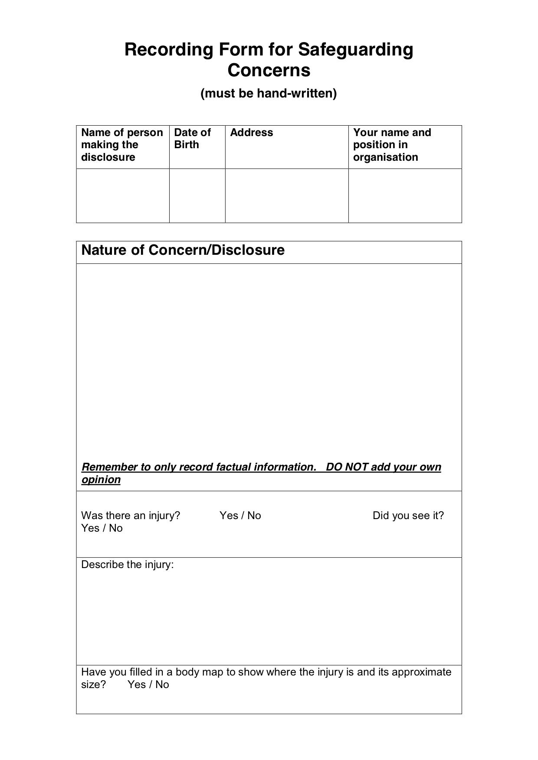

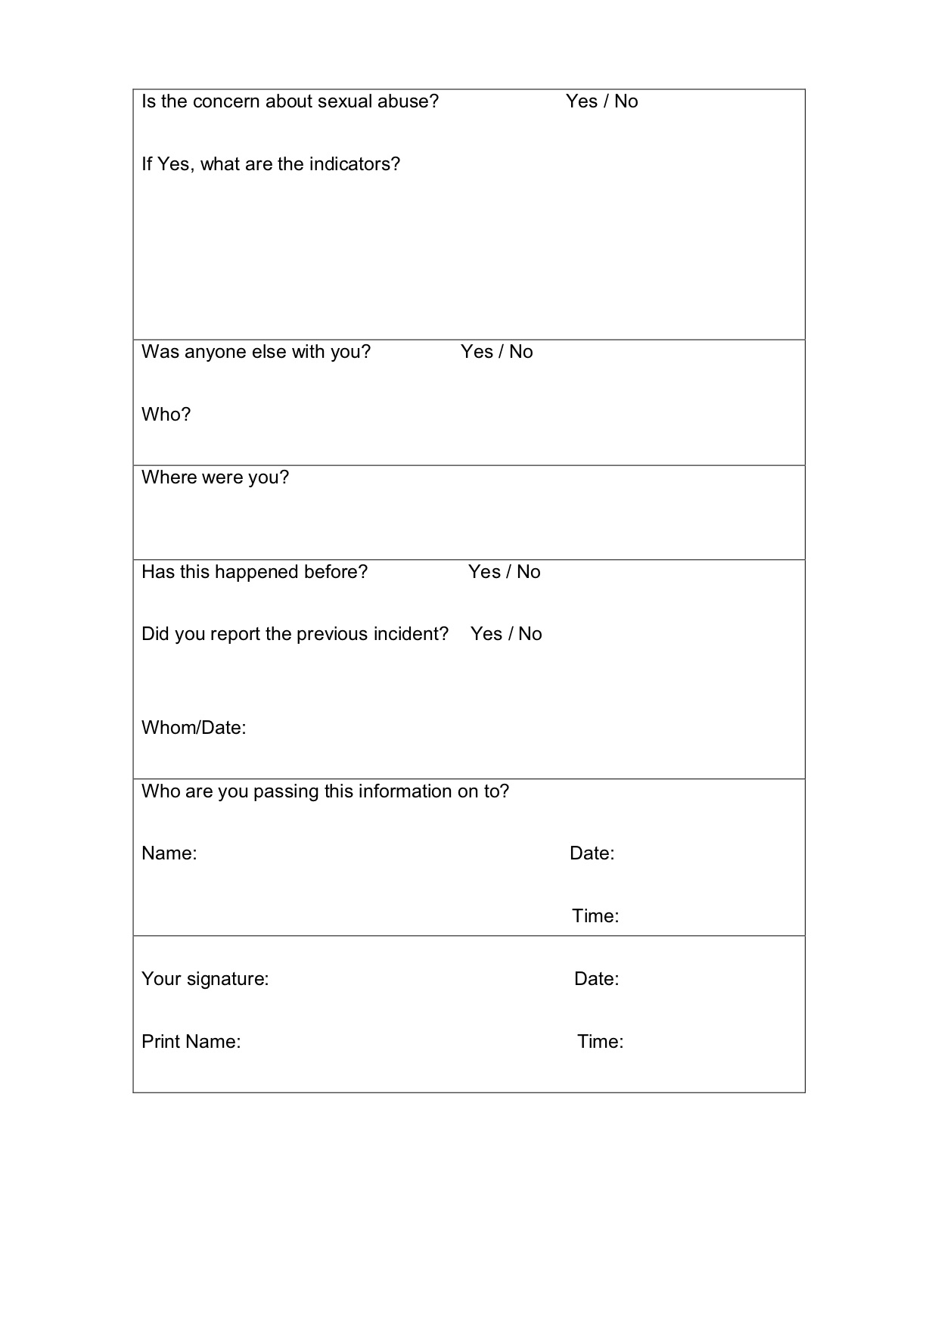

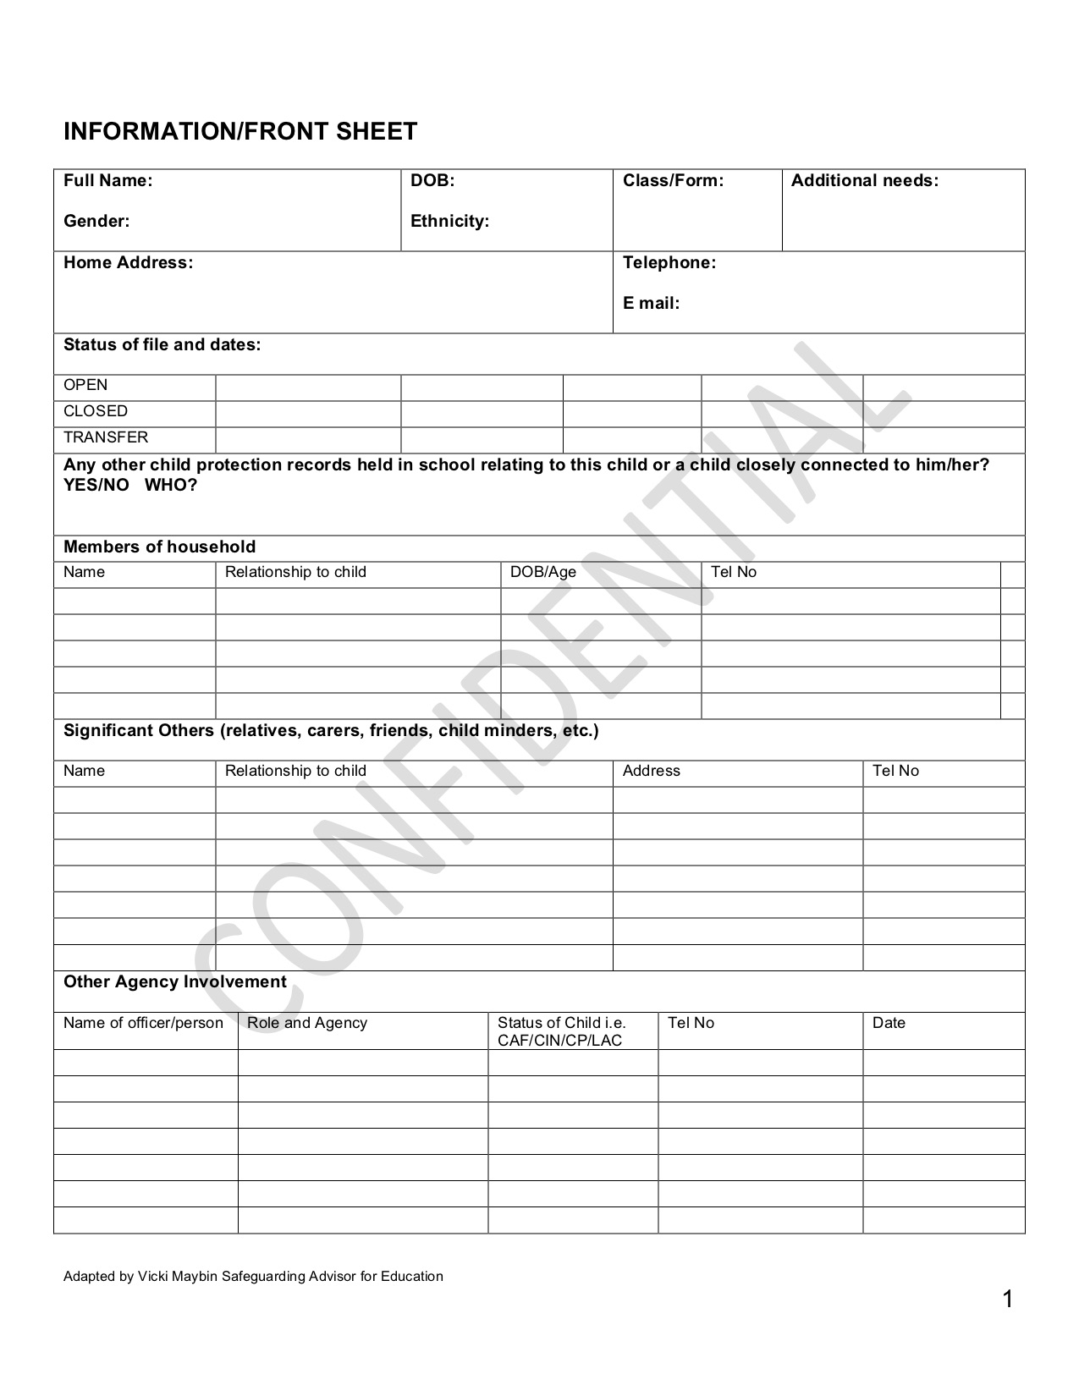

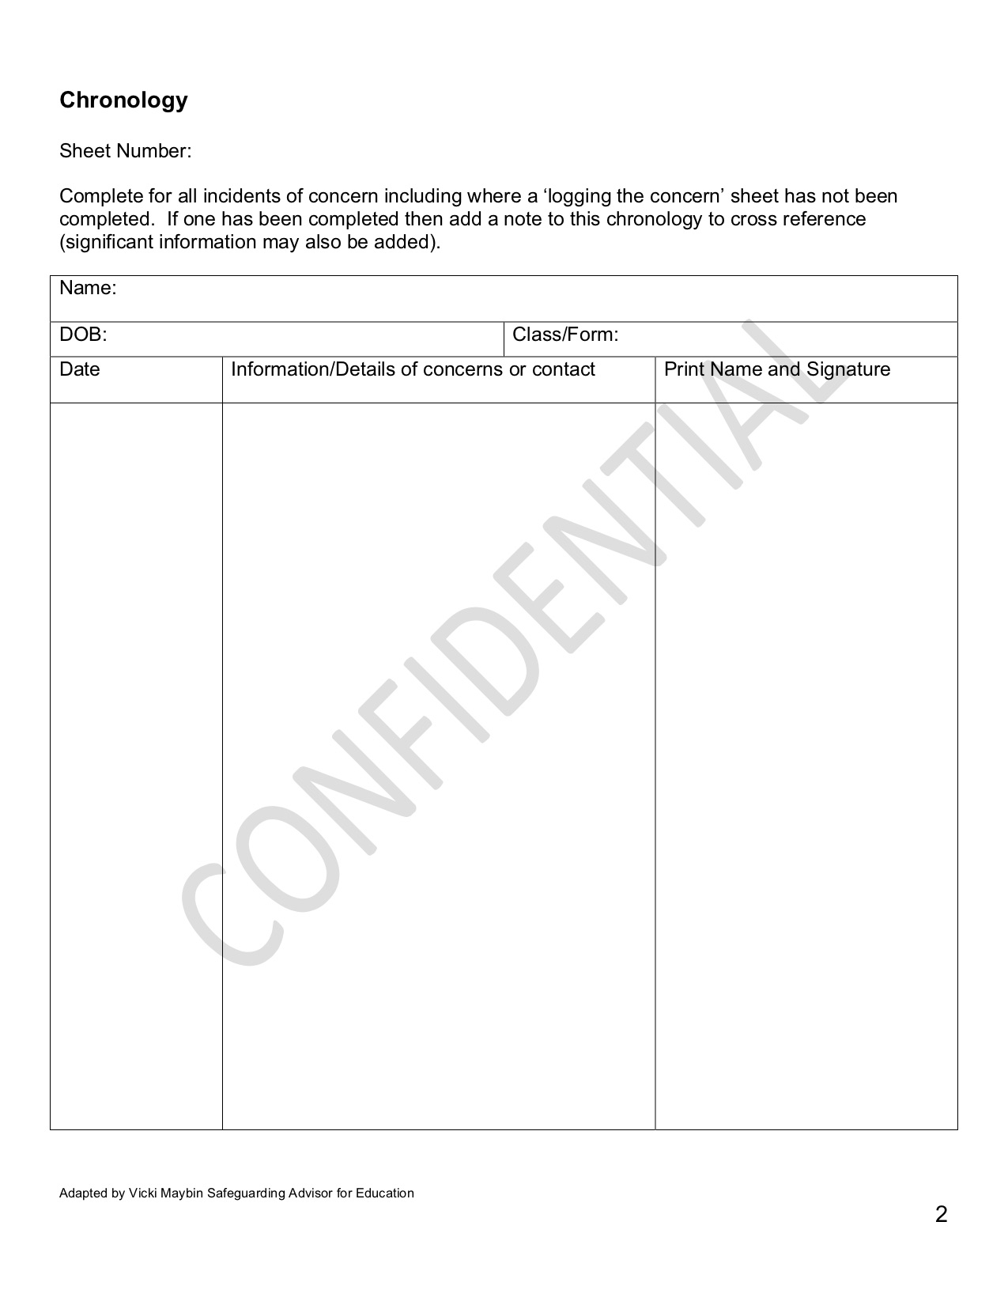

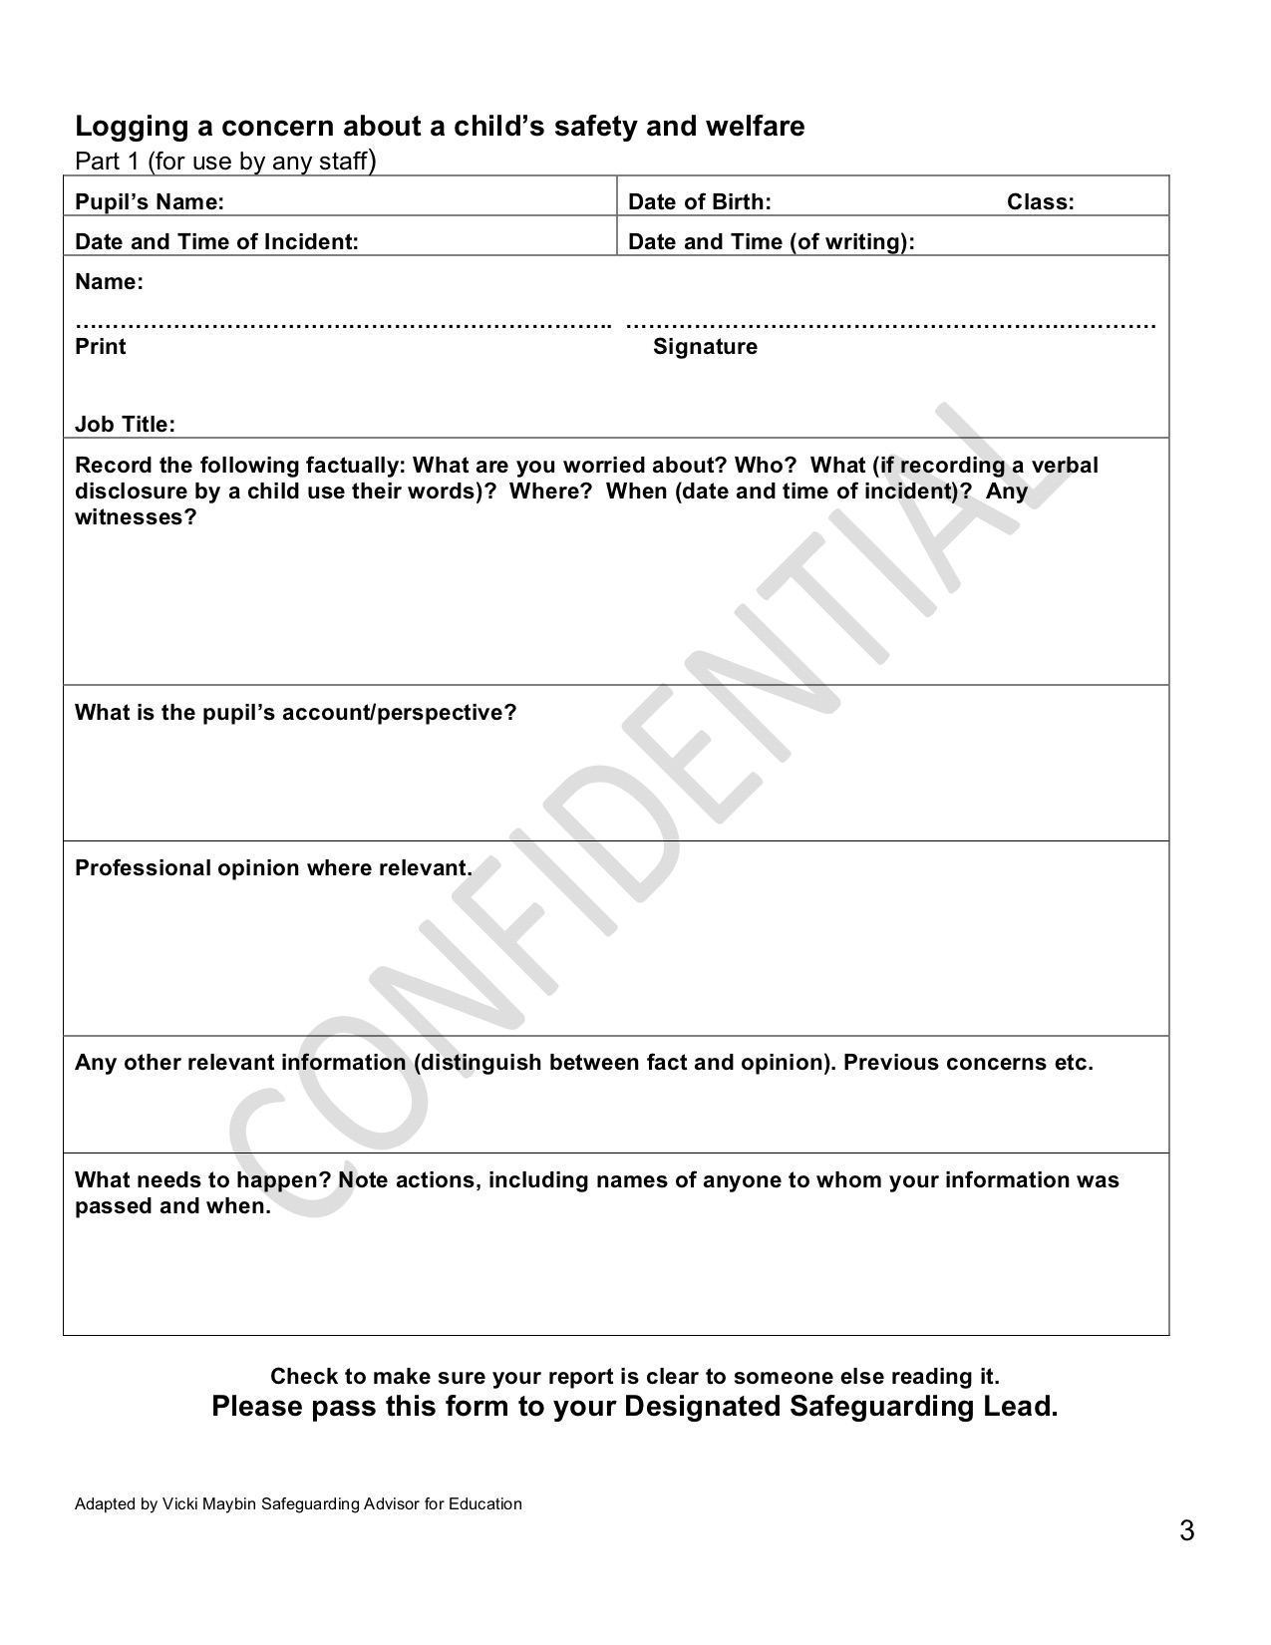

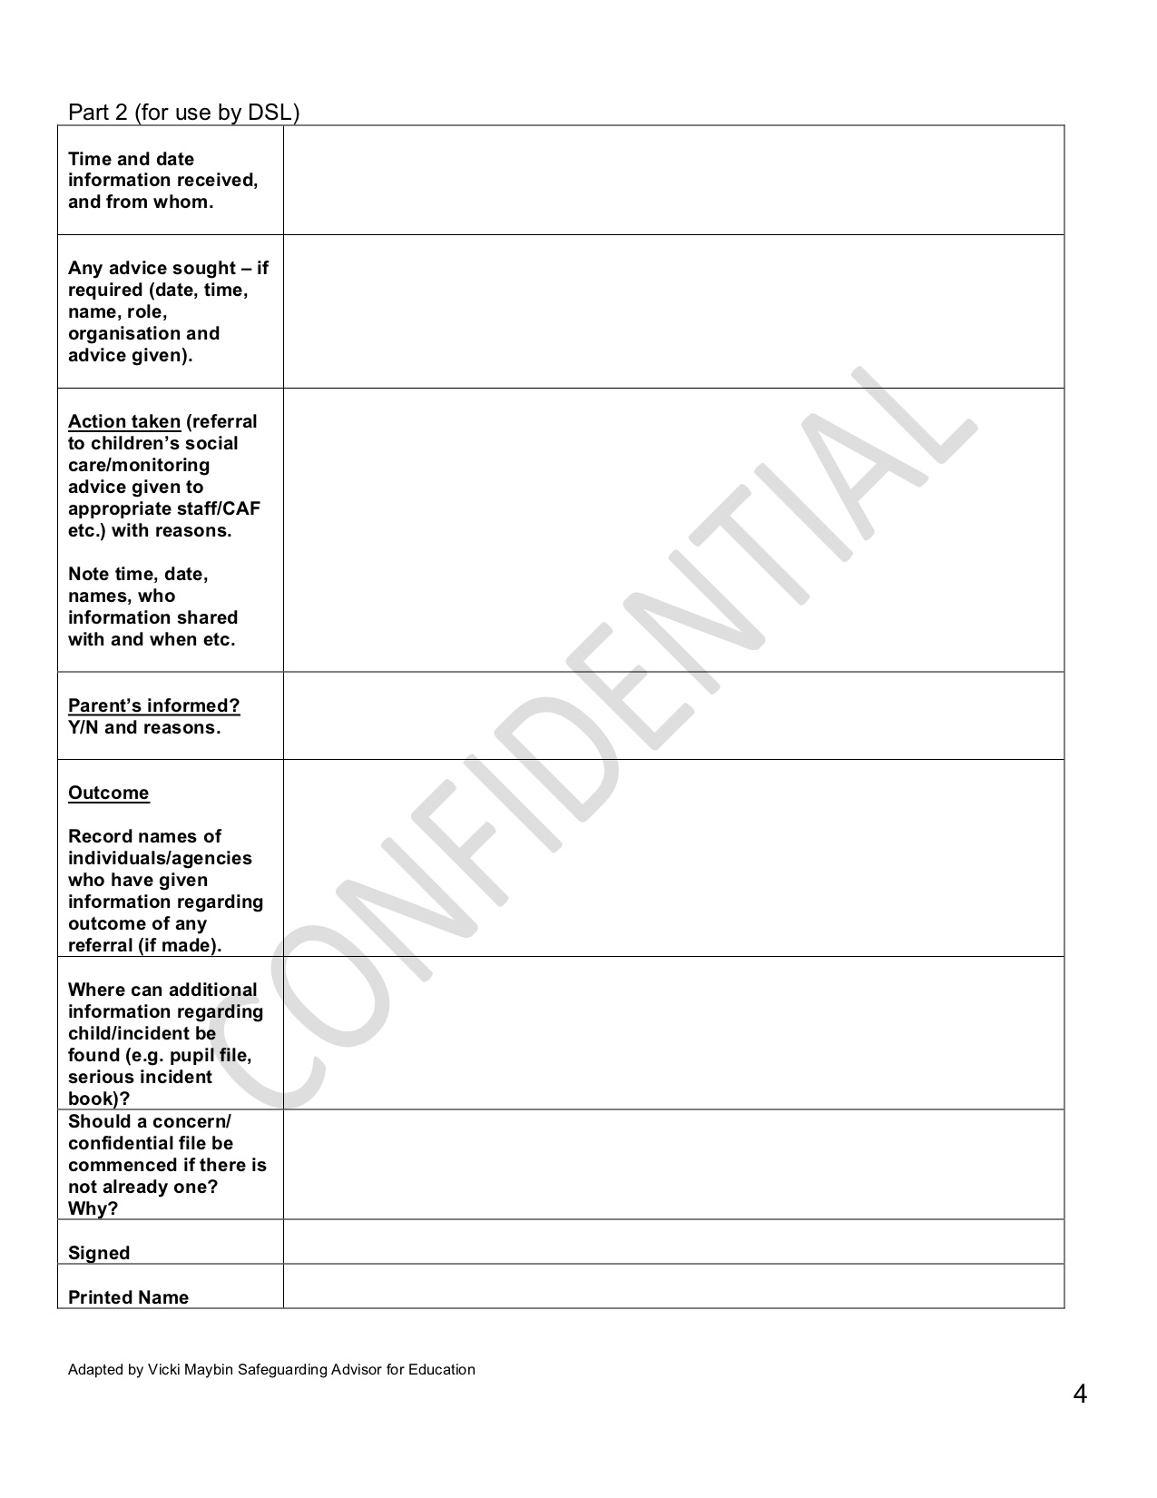

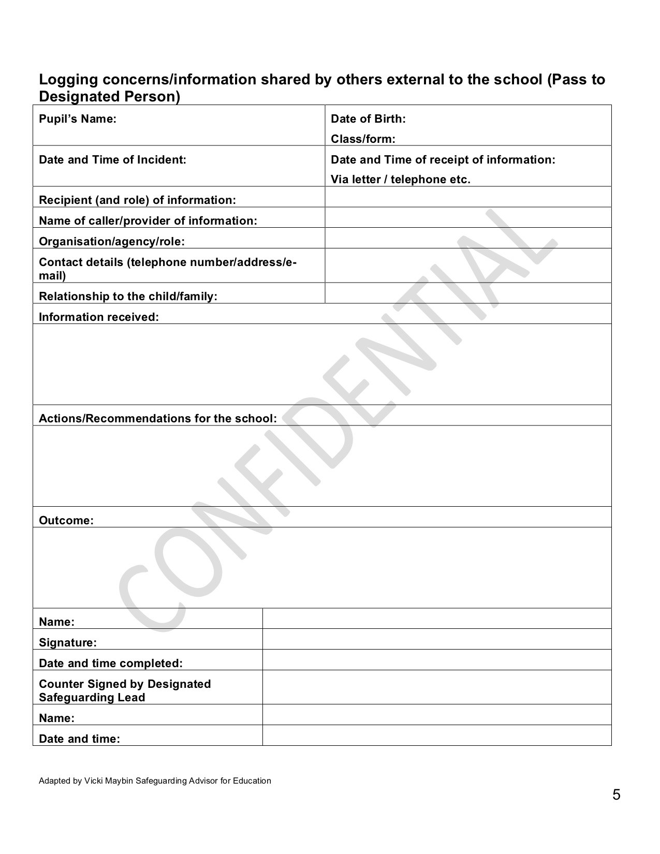

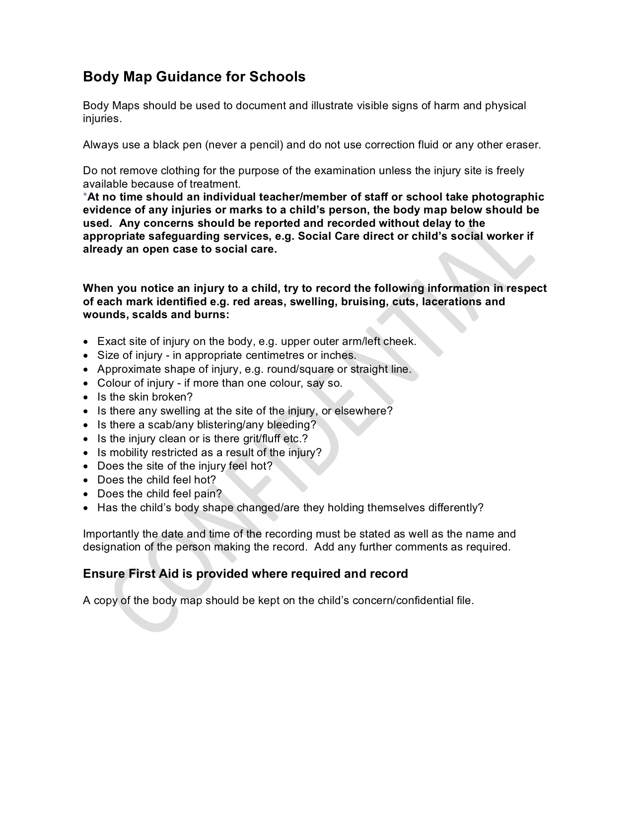

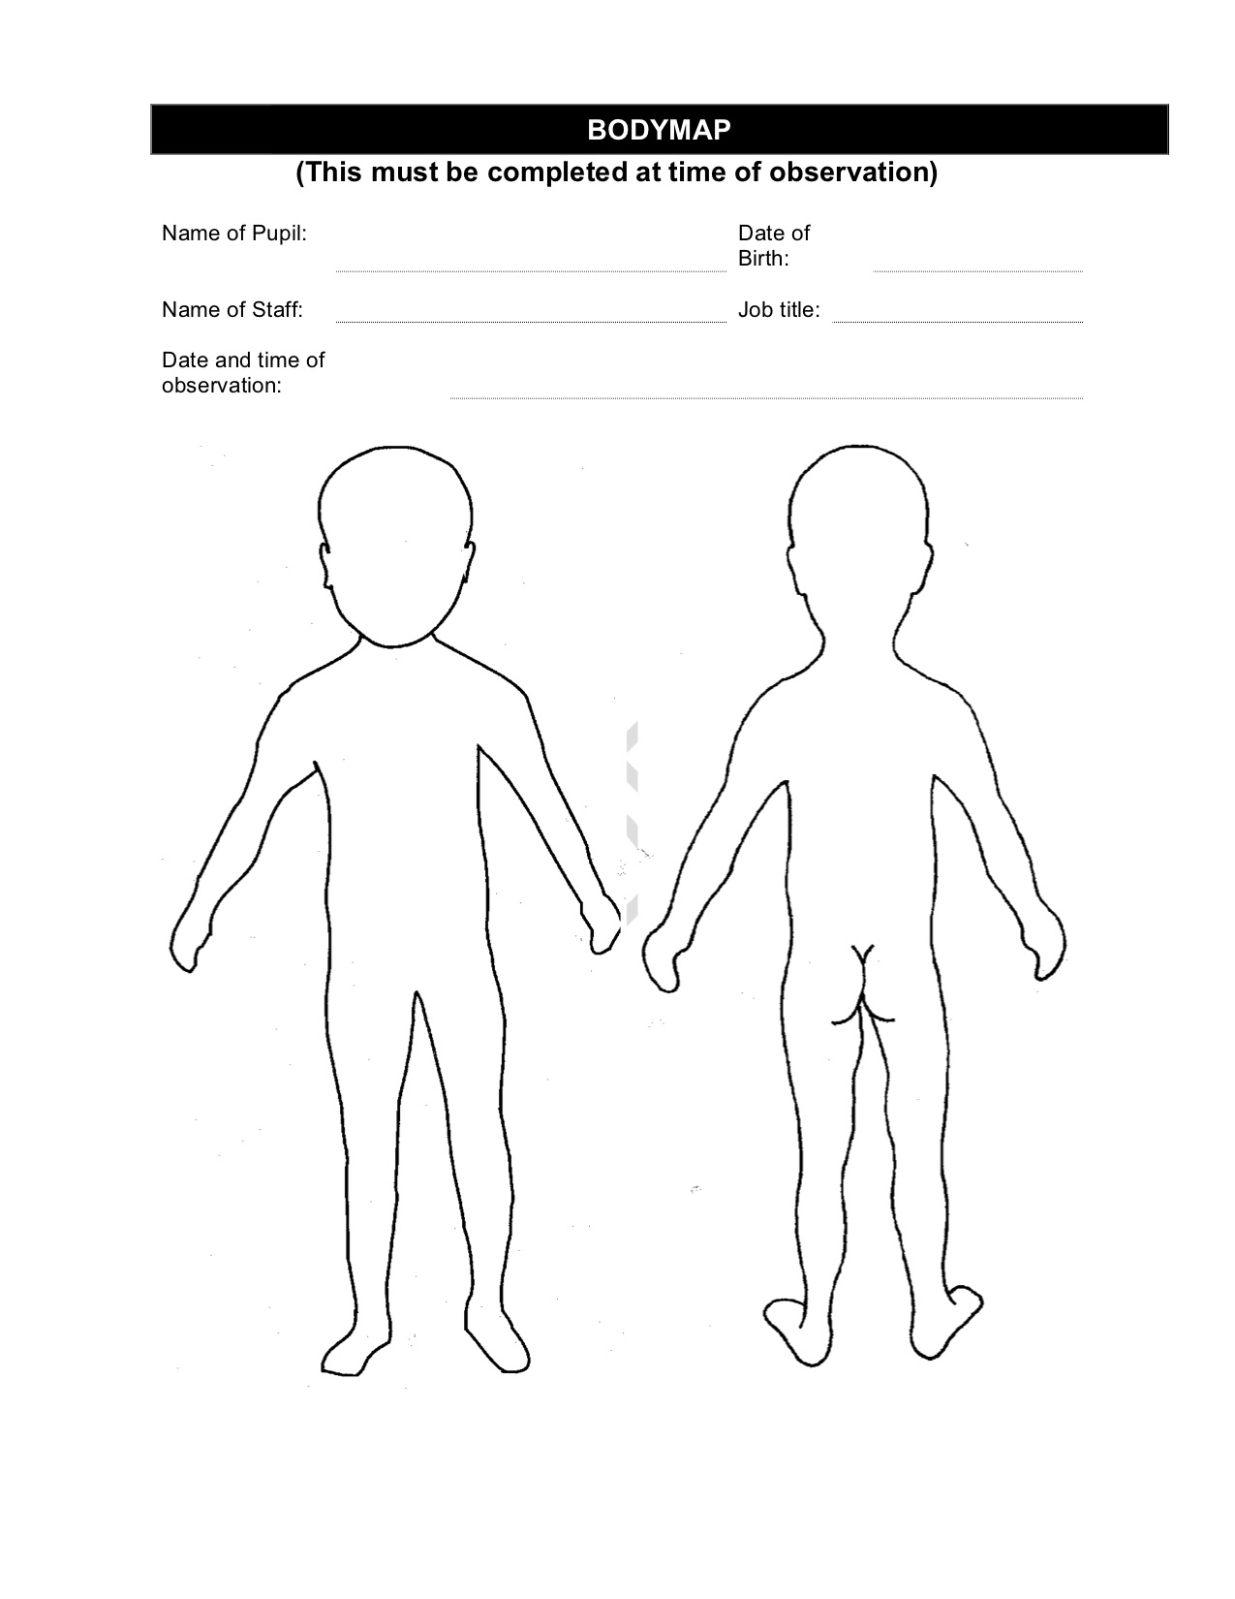

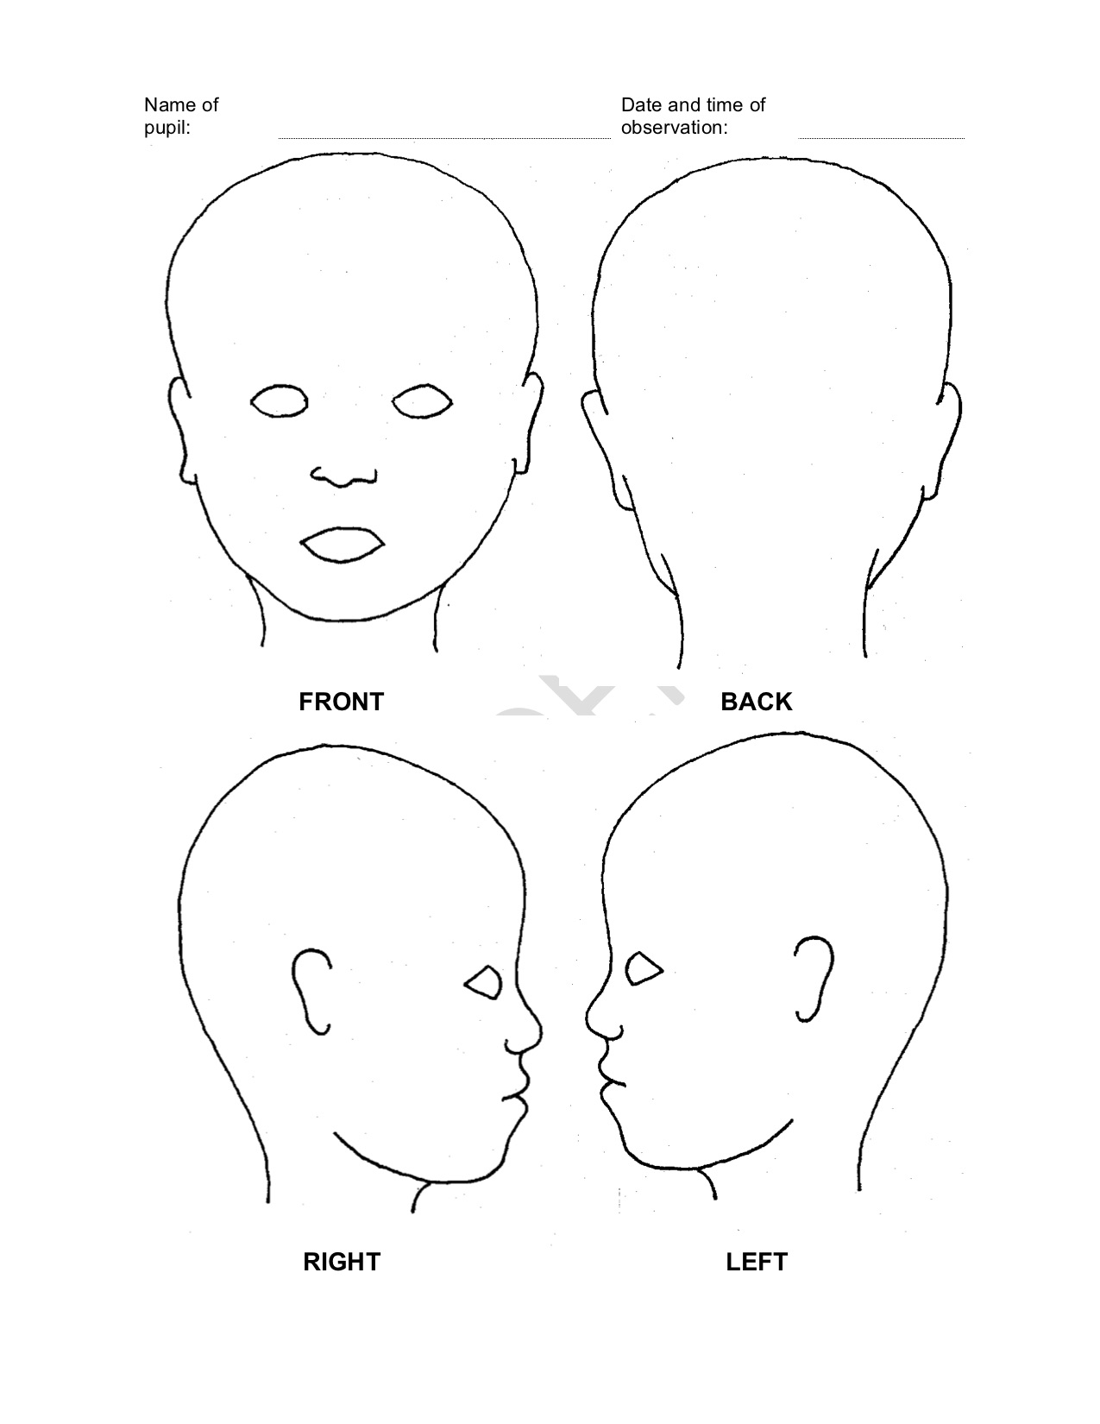

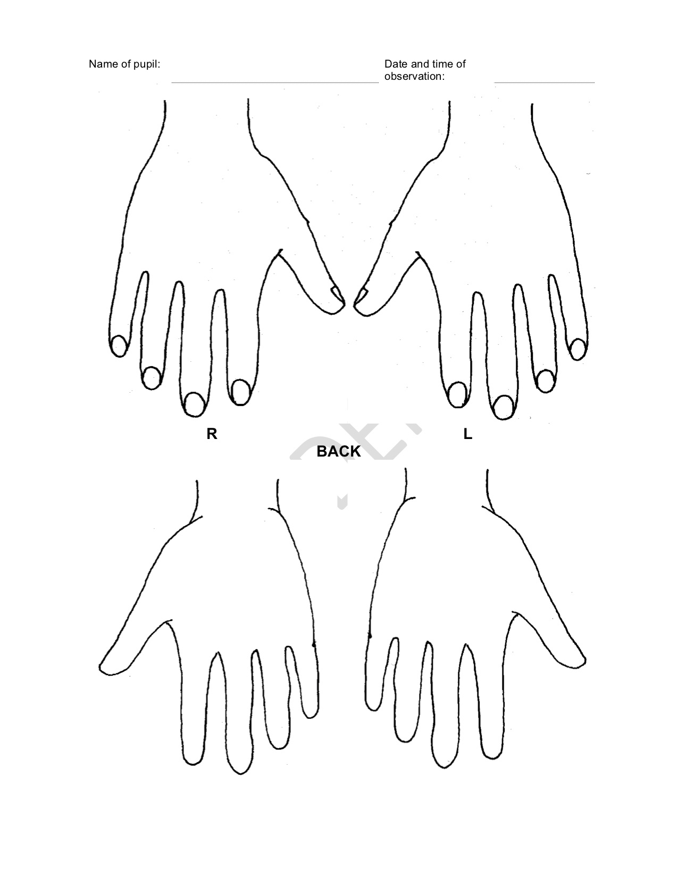

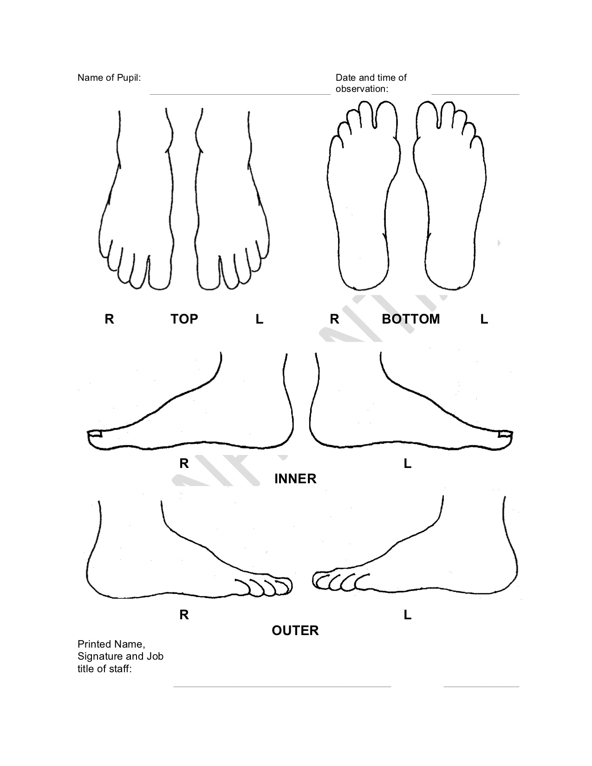

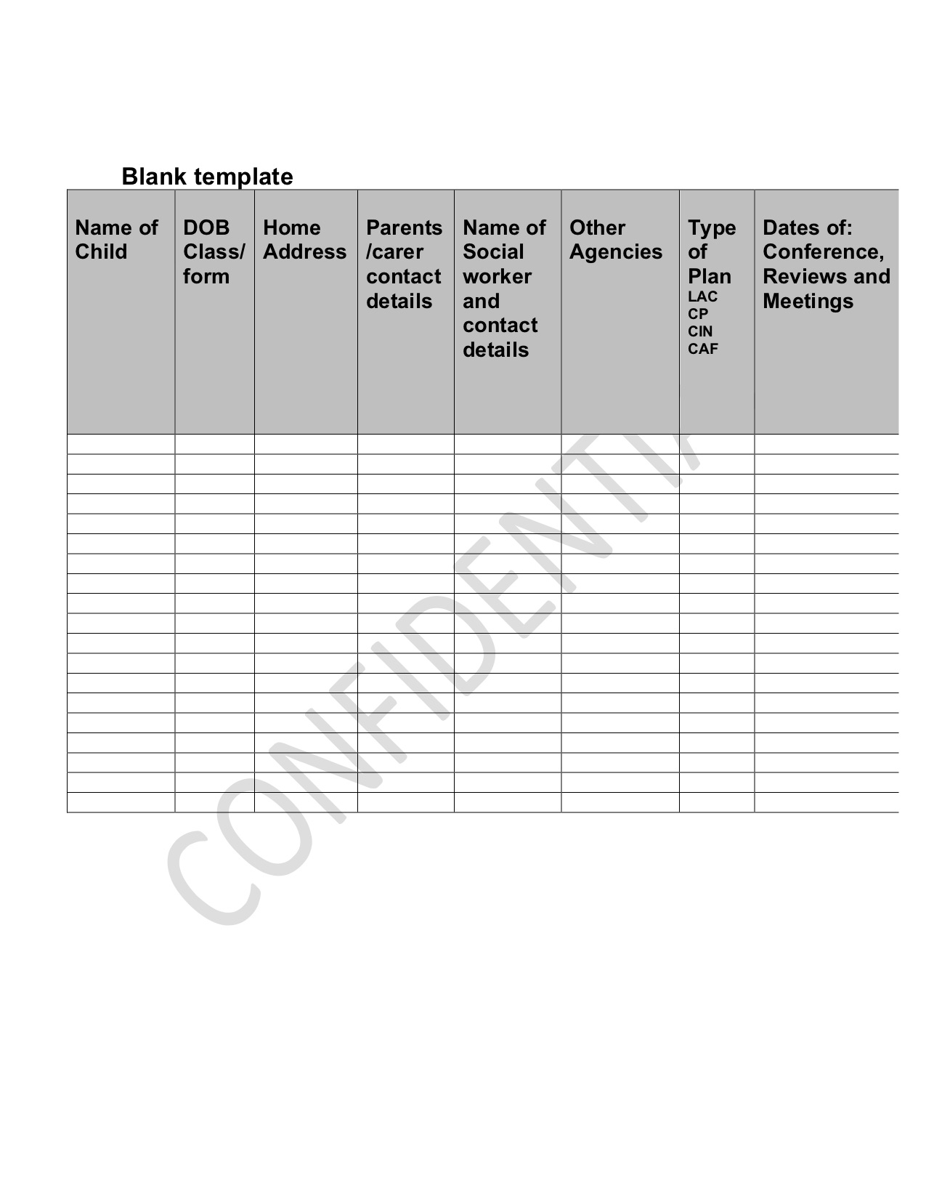

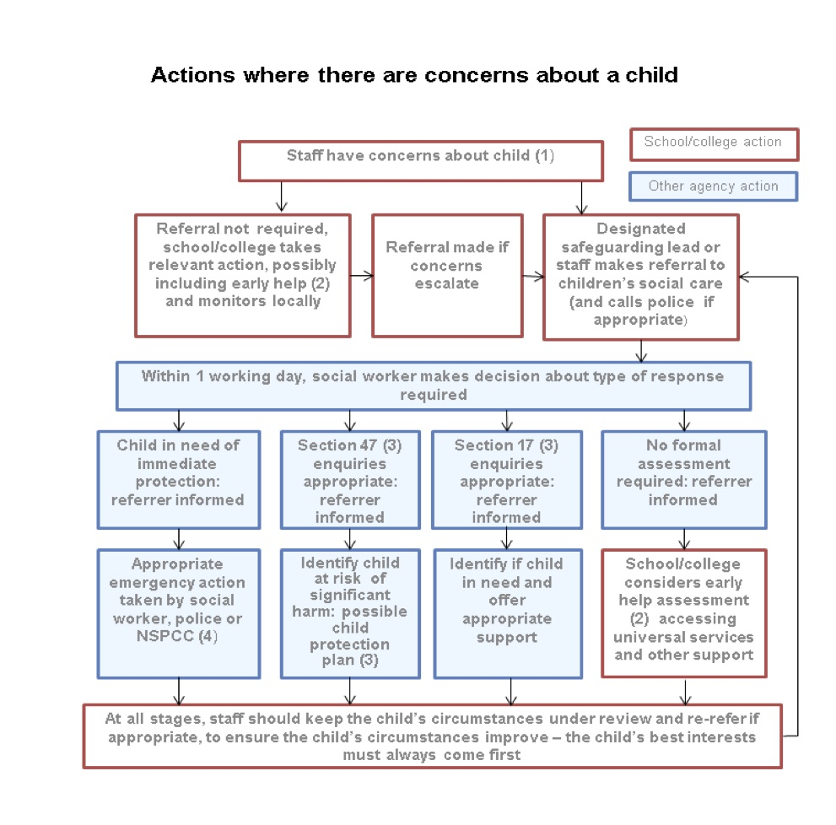

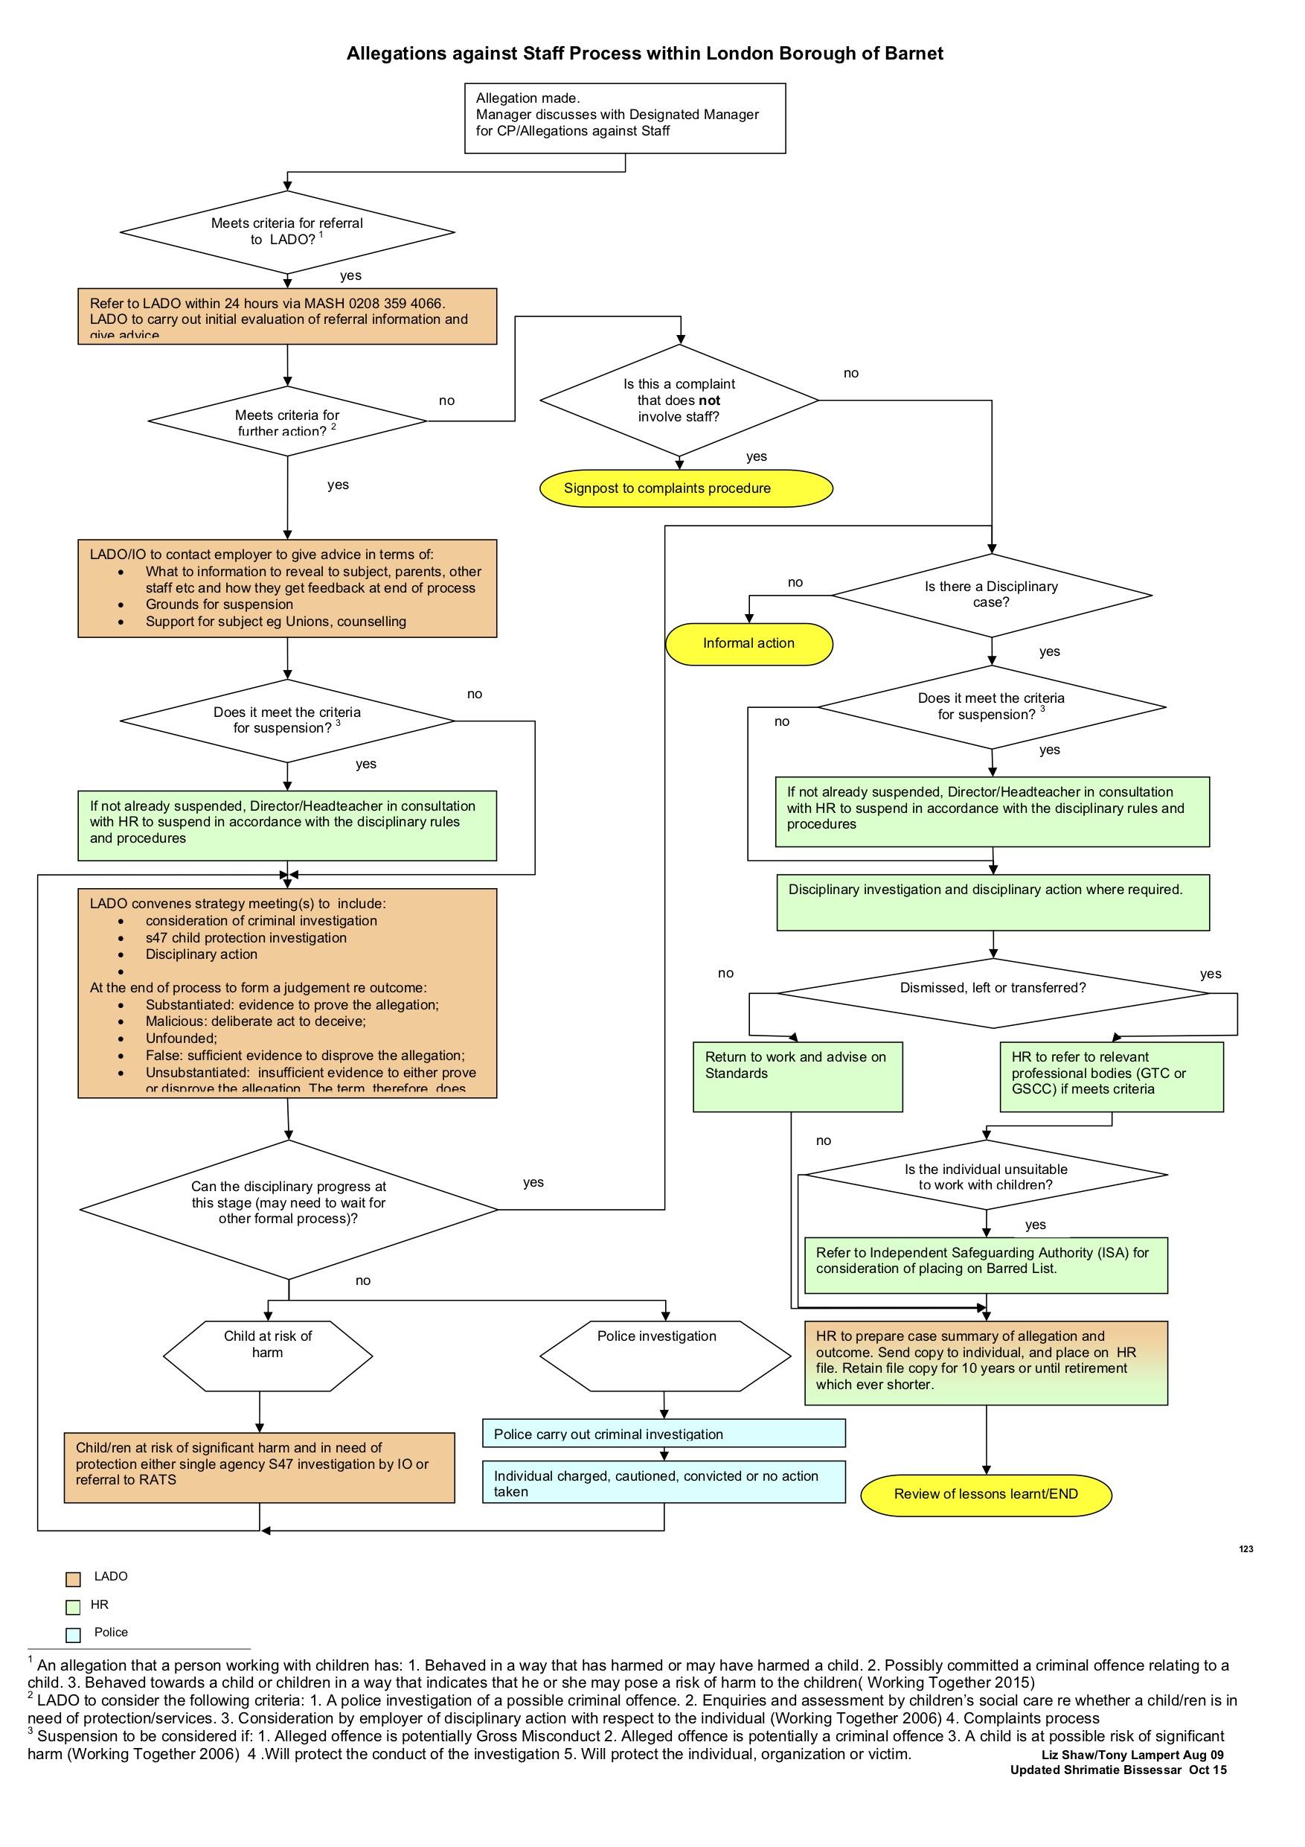

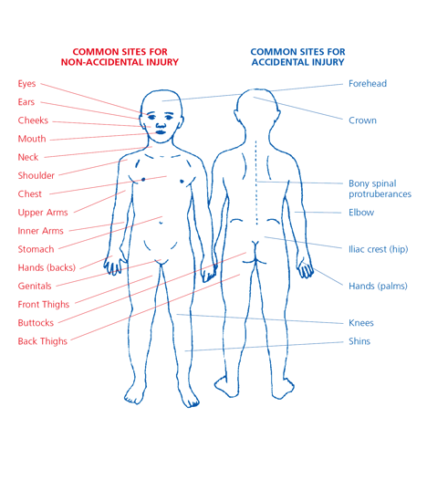

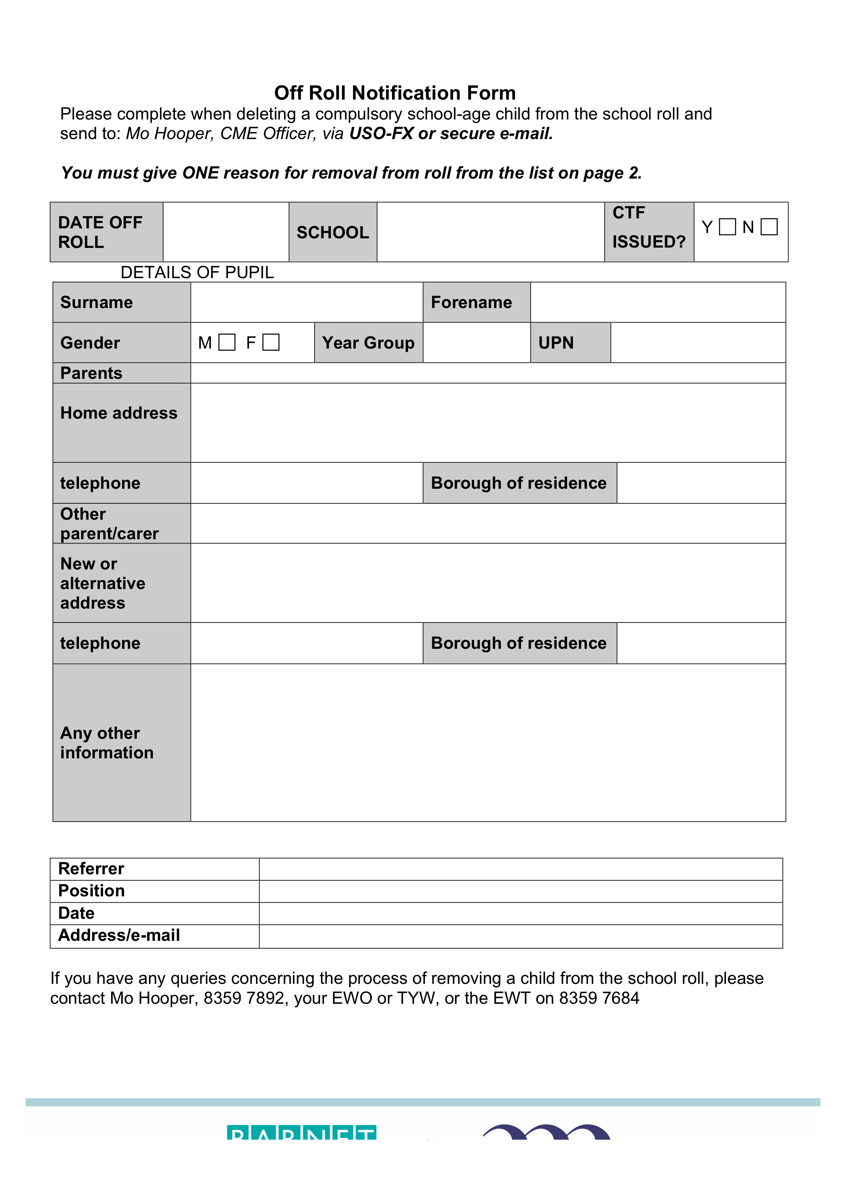

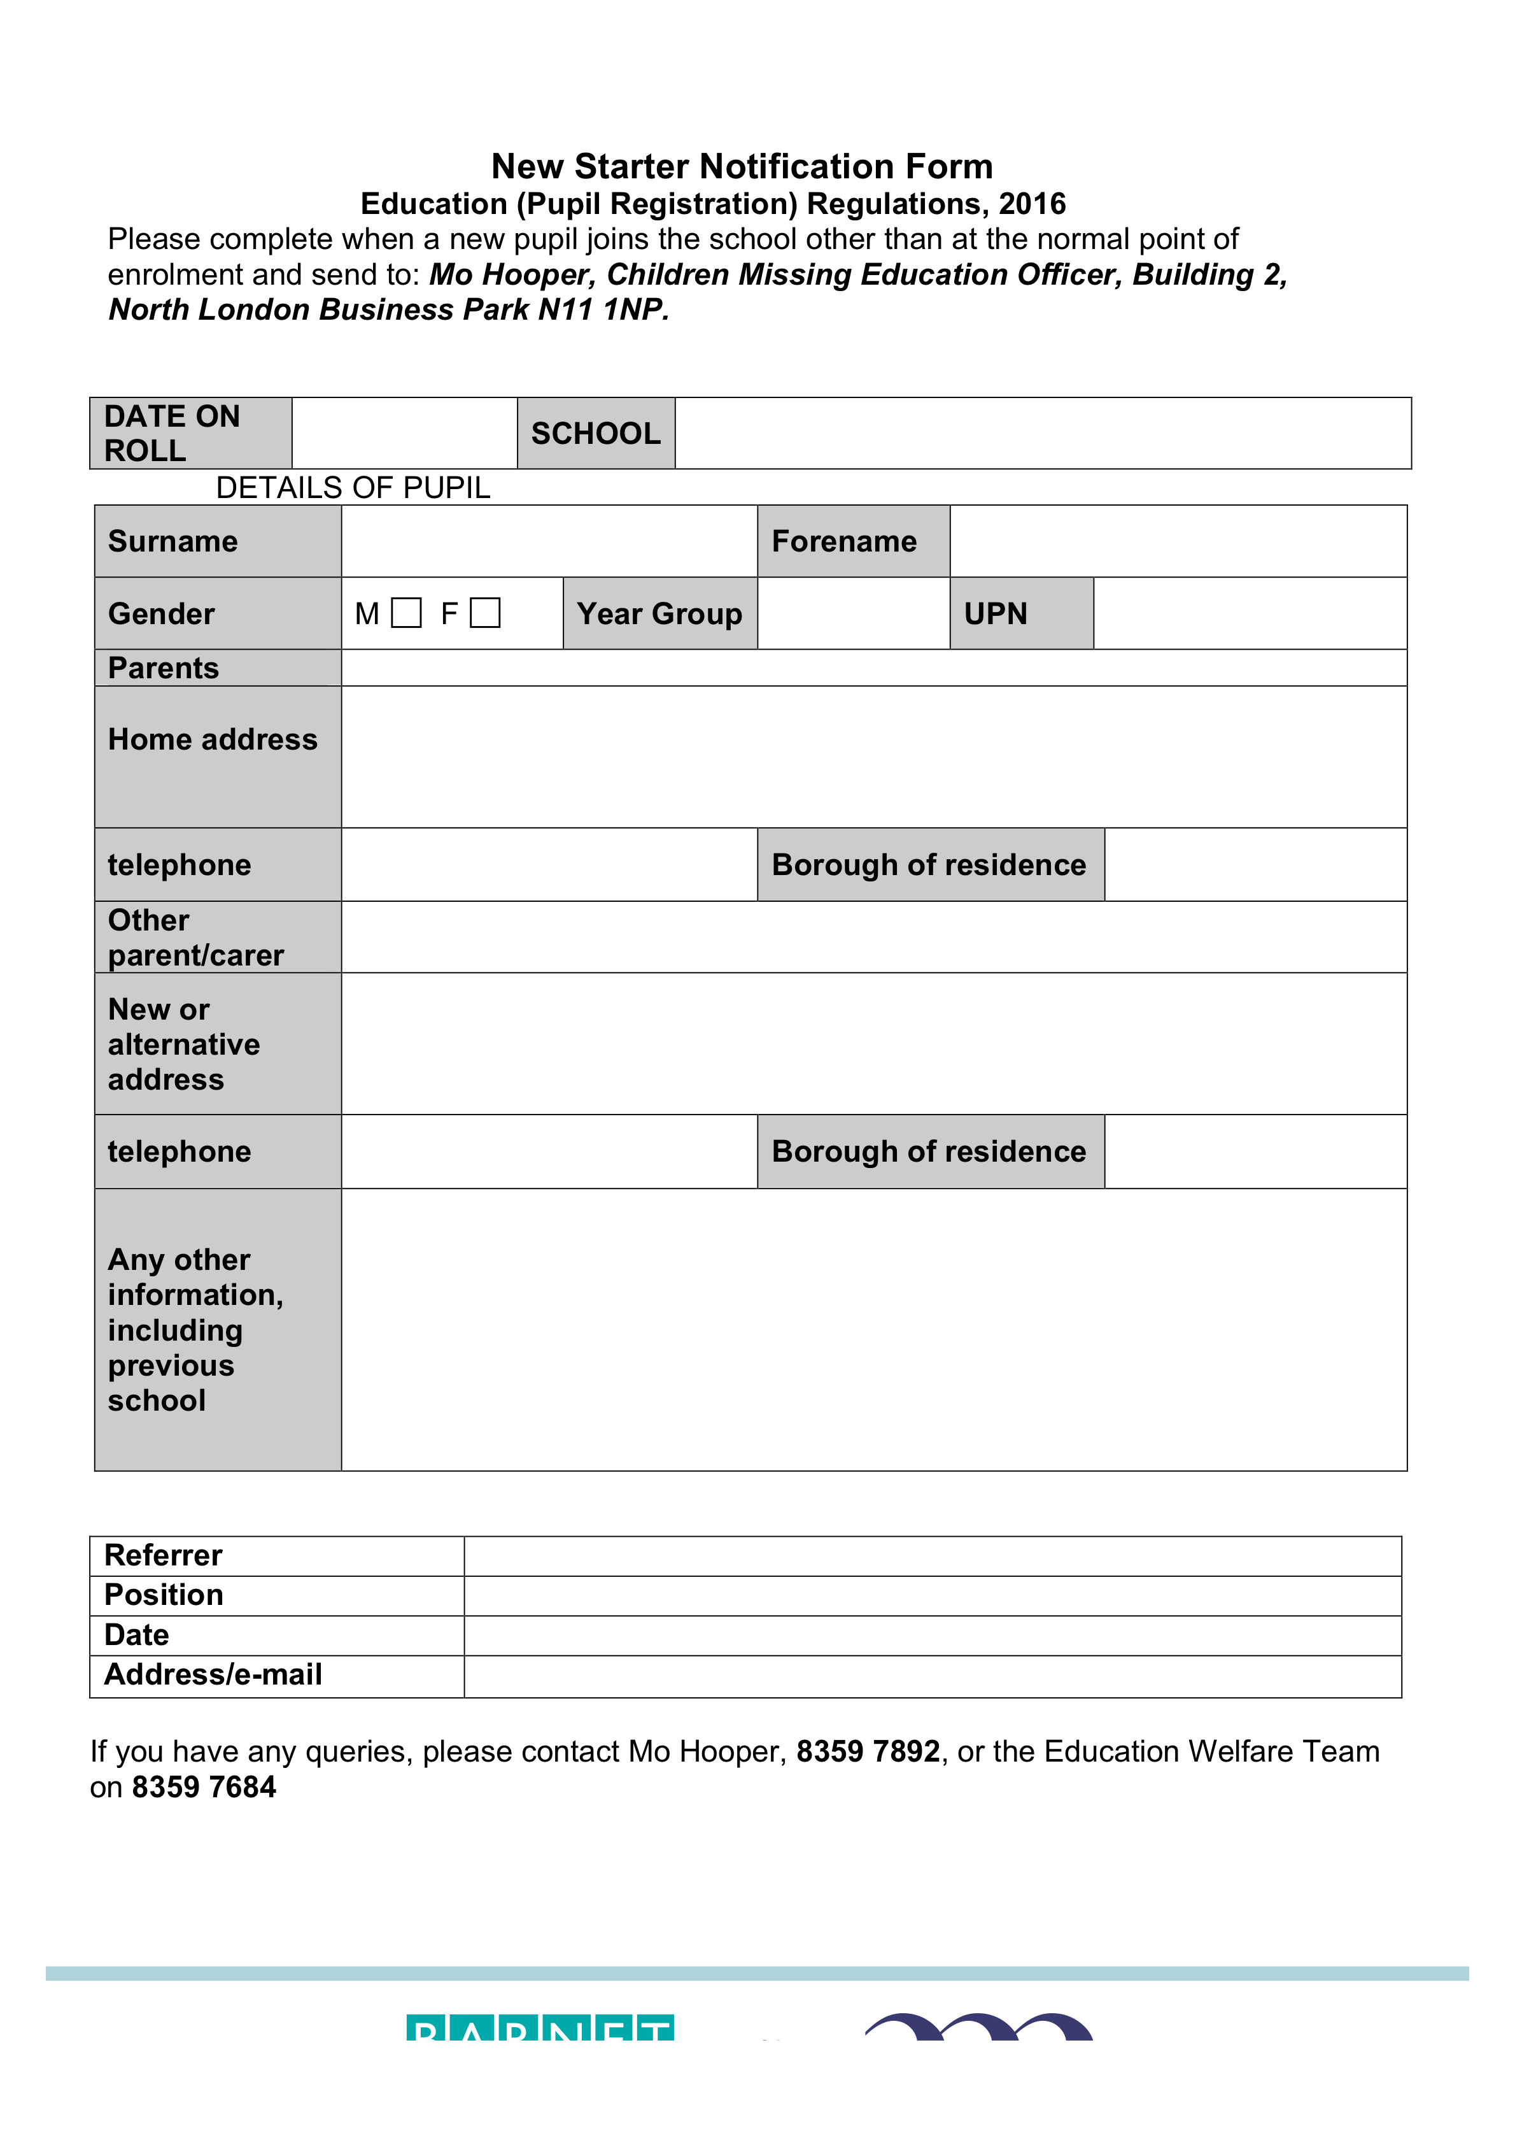

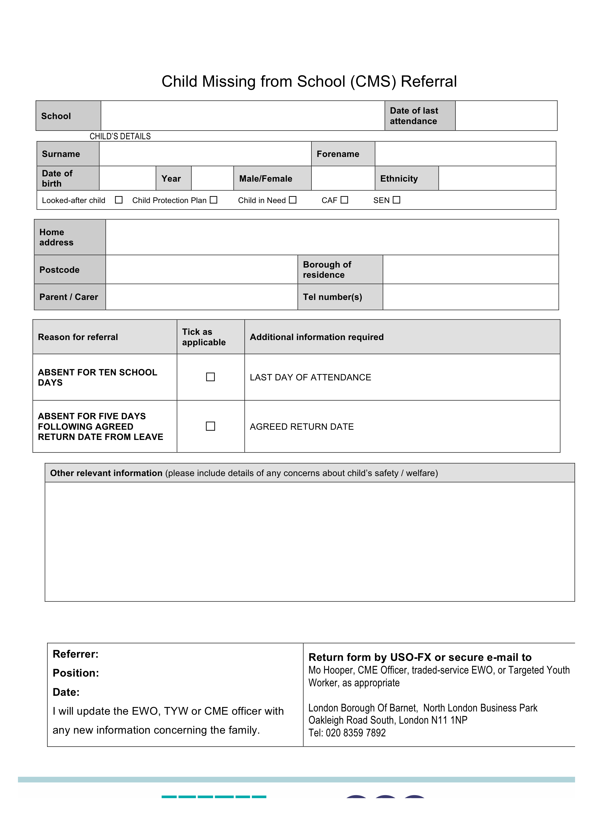

**SUSI EARNSHAW THEATRE SCHOOL: ICT AND E-SAFETY AGREEMENT**

**Name: _______________________________ Year: ________**

**To make sure that I stay safe when using ICT at school I will:**

* Use all ICT positively
* Only post positive comments about others, including my peers
* Not engage in cyber bullying
* Ask permission or wait to be told to use the internet.
* Only email people I know or who have been approved by a teacher, parent or a guardian
* Ask permission before opening an email from people I do not know
* Not use internet chat rooms
* Not use my real name when using games on the internet (I could create a nickname)
* Never give out a home address, phone or mobile number
* Never share where I go to school with someone over the interne
* Never arrange to meet someone who I have made contact with on the internet
* Only use webcams with people I know
* Tell someone immediately if I am ‘lost’ on the internet
* Tell someone immediately if I see something on the internet with which I am unhappy or uncomfortable or they feel is inappropriate
* Not access or attempt to access inappropriate material including films or computer games for people above my age
* Not make any online purchases, including in-app purchases
* Not attempt to bypass any restrictions on my use of ICT, including internet sites. not make any online purchases, including in-app purchases
* Not upload any data, including from USB devices, CDs or DVDs, without the permission of a member of staff
* Not attempt to befriend staff over face book or social media

**Signed: _______________________________ Date: ______________________________**

**SUSI EARNSHAW THEATRE SCHOOL: RULES ON USE OF INTERNET AND E-MAIL**

* We want each pupil to enjoy using the internet, and to become proficient in drawing upon it both during your time at School, and as a foundation for their further education and career. However, there are some potential drawbacks with e-mail and the internet, both for pupils and for the School.
* The purpose of these rules are to set out the principles which pupils must bear in mind at all times and also the rules which you must follow in order for all pupils to use the internet safely and securely.
* The principles and rules set out below apply to all use of the internet, including social media, and to the use of e-mail in as much as they are relevant. Failure to follow these rules will constitute a breach of discipline and will be dealt with in accordance with the School's behaviour Policies and in particular the Disciplinary Principles and Practices policy and is applicable, the Exclusions Policy. Access and security
* Access to the internet from the School's computers and network must be for educational purposes only. Pupils must not use the School's facilities or network for personal, social or non-educational use without the express, prior consent of a member of staff.
* Pupils must not knowingly obtain (or attempt to obtain) unauthorised access to any part of the School's or any other computer system, or any information contained on such a system.
* No laptop or other mobile electronic device may be connected to the School network without the explicit consent of a member of staff.
* Passwords protect the School's network and computer system. To facilitate learning, our younger pupils are given a common password, as at this stage they are just familiarising themselves with the system under supervision and it will not be used to store any private information. Pupils in Years 5 and above should not let anyone else know their password. If a pupil believes that someone knows his / her password he / she must change it immediately. Pupils should not attempt to gain unauthorised access to anyone else's computer or to confidential information to which he / she is not authorised to access. If there is a problem with your passwords, pupils should speak to his / her class teacher or contact the Head of ICT.
* Pupils must not attempt to access or share information about others without the express permission of a member of staff. To do may breach data protection legislation and laws relating to confidentiality.
* The School has a firewall in place to ensure the safety and security of the School's networks. Pupils must not attempt to disable, defeat or circumvent any of the School's security facilities. Any problems with the firewall must be reported to the form or subject teacher or the Head of ICT.
* The School has filtering systems in place to block access to unsuitable material, wherever possible, to protect the welfare and safety of pupils.
* Viruses can cause serious harm to the security of the School's network and that of others. Viruses are often spread through internet downloads or circulated as attachments to e-mails. If a pupil thinks or suspects that an attachment, or other material to download, might contain a virus, he / she must speak to his / her teacher before opening the attachment or downloading the material. Pupils must not disable or uninstall any anti-virus software on the School's computers.

**USE OF THE INTERNET**

* Pupils must use the School's computer system for educational purposes only and are not permitted to access interactive or networking web sites without the express, prior consent of a member of staff.
* Pupils must take care to protect personal and confidential information about themselves and others when using the internet, even if information is obtained inadvertently. Pupilsshould not put personal information about themselves, for example their full name, address, date of birth or mobile number, online.
* Pupils must not load material from any external storage device brought in from outside the School onto the School's systems, unless this has been authorised by the Head of ICT.
* Pupils should assume that all material on the internet is protected by copyright and such material must be treated appropriately and in accordance with the owner's rights - pupils must not copy (plagiarise) another's work.
* Pupils must not view, retrieve, download or share any offensive material. Offensive material includes, but is not limited to, content that is abusive, racist, considered to be of an extreme or terrorist related nature, sexist, homophobic, any form of bullying, pornographic, defamatory or criminal activity. Use of ICT in this way is a serious breach of discipline. Pupils must tell a member of staff immediately if they have accidentally read, downloaded or have been sent any offensive material or material that is inappropriate, including personal information about someone else.
* Pupils must not communicate with staff using social networking sites or other internet or web-based communication channels unless this is expressly permitted for educational reasons.
* Pupils must not enter into any contractual commitment using the internet when in the care of the School, or otherwise associated with the School, whether for themselves or on behalf of another (including the School).
* Pupils must not bring the School into disrepute through their use of the internet.

**USE OF E-MAIL:**

* Pupils must not use any personal web-based e-mail accounts such as Yahoo or Hotmail through the School's network. Any email being received by a pupil account from a non-school address (e.g. @susiearnshaw.co.uk) is received first by the IT department to be screened and sanctioned and pupils are unable to send emails to non-school accounts.
* Pupils must use their School e-mail accounts for any e-mail communication with staff. Communication either from a student's personal email account or to a member of staff's personal email account is not permitted.
* E-mail should be treated in the same way as any other form of written communication. Pupils should not include or ask to receive anything in an e-mail which is not appropriate to be published generally or which the student believes his / her parents or the Head teacher would consider to be inappropriate.
* Pupils must not send or search for any e-mail message which contains offensive material. Offensive material includes, but is not limited to, content that is abusive, racist, considered to be of an extreme or terrorist related nature, sexist, homophobic, any form of bullying, pornographic, defamatory or criminal activity. If pupils are unsure about the content of a message, they must speak to a member of staff. If a student comes across such material, he / she must inform a member of staff as soon as possible. Use of the e-mail system in this way is a serious breach of discipline. The School will take no responsibility for any offence caused by a student as a result of downloading, viewing or forwarding inappropriate e-mails.
* Trivial messages and jokes should not be sent or forwarded through the School's e-mail system. Not only could these cause distress to recipients (if considered to be inappropriate) but could also cause the School's ICT system to suffer delays and / or damage.
* All correspondence from your School e-mail account must contain the School's disclaimer.
* Pupils must not read anyone else's e-mails without their consent.

**I confirm that I have read and understood the Susi Earnshaw Theatre School Rules on Use of Internet and E-Mail.**

**Signed: _______________________________ Date: ______________________________**