Name: _____________________________________________________

This is your maths pack for the week commencing 11.05.20. I have tried to put as much help on it as possible. If you have any problems please either phone the school or email: mgater@suttonhouse.org.uk me and I will call you and try to guide you through.

Rearranging formulas
Making a letter the subject of a formula means rearranging the formula so that the letter you want is on its own on the left.
It’s a bit like solving an equation – you always have to do the same thing to both sides.

Example 1: Make e the subject of the formula f = eg

1 | Write down the original formula | f = eg
2 | Divide both sides by g  Then e is on its own since eg ÷ g = e | f ÷ g = eg ÷ g  f ÷ g = e
3 | In your final answer, always write the letter that’s on its own on the left hand side of the formula. All the other letters should be on the right hand side | e = f ÷ g

Your turn

Make s the subject of the following formulas. All your answers should begin with s =
r = s + 4 | h = 12 + s
p = s - 8 | j = 28 + s

Function machines

Example 1:
The input is your start number
You then do the first calculation
Then use the answer for the second calculation
The output is your final answer

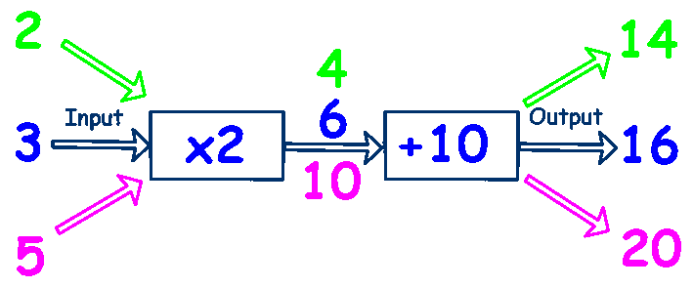

Your turn
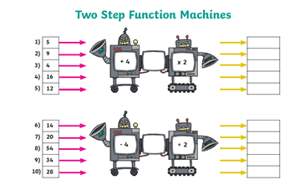
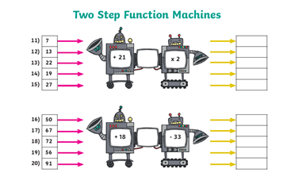

Sequences
A sequence is a list of numbers or shapes which follows a particular rule.
Each number or shape in a sequence is called a term.
The rule for extending a sequence tells you how to find the next term
Example 1: The first term in a sequence is 3. The rule for finding the next term is add 4 to the previous term. Write down the first 5 terms of the sequence.

- The first term is 6, so write this down  - Add 4 each time to find the terms |  | 6 | ͜  +4 | 10 | ͜  +4 | 14 | ͜  +4 | 18 | ͜  +4 | 22

Example 2: Consider the sequence 2, 6, 18, 54…

- Explain the rules for finding the next term in the sequence |  |  | Multiply the previous term by 3
- Write down the next four terms in the sequence |  | 2 | ͜  X3 | 6 | ͜  X3 | 18 | ͜  X3 | 54 | ͜  X3 | 162

Your turn

Write the first 5 terms of each of these sequence
The first term is 5. The rule for finding the sequence is add 4 to the previous term.
The first term of a sequence is 2. The rule for finding the next term is multiply the previous term by 2.
The first term of a sequence is 100. The rule for finding the next term is subtract 6 from the previous term.

Sequences Term to Term rules
You can also work out a term by using its position (n) in the sequence.
For example the first term has position n = 1, the second term has n = 2, the 10th term has n = 10 and so on.

Example 1: The nth term of a sequence is 2n – 1. Find the first 4 terms of the sequence
1 | To find the 1st, 2nd, 3rd and 4th terms of the sequence substitute the values n = 1, n = 2, n = 3 and n = 4 into the formula |  | (2 x 1) – 1 = 1  (2 x 2) – 1 = 3  (2 x 3) – 1 = 5  (2 x 4) – 1 = 7
2 | Write the terms in order to form the sequence |  | So the first four terms of the sequence are  1, 3, 5, 7

Your turn

Find the first four terms in each sequence
The nth term of a sequence is 2n + 3
The nth term of a sequence is 20 – 2n
The nth term of a sequence is 2n + 20
The nth term of a sequence is 100 – 3n
This pack should be completed and returned for marking by 25th May 2020

