Name: _____________________________________________________

This is your maths pack for the week commencing 11.05.20. I have tried to put as much help on it as possible. If you have any problems please either phone the school or email: mgater@suttonhouse.org.uk me and I will call you and try to guide you through.

Sequences
A sequence is an ordered list of terms.
The rule for extending a sequence tells you how to find the next term
Example 1: Find the rule for extending the sequence:
6, 10, 14, 18, 22
- Write the difference between the neighbouring terms in the gaps |  | 6 | ͜  +4 | 10 | ͜  +4 | 14 | ͜  +4 | 18 | ͜  +4 | 22
- Identify the rule |  | Add 4 each time

Example 2: Find the rule for extending the sequence:
2, 6, 18, 54, 162
- Write the difference between the neighbouring terms in the gaps |  | 2 | ͜  +4 | 6 | ͜  +12 | 18 | ͜  +36 | 54 | ͜  +108 | 162
- If this doesn’t give an obvious addition rule, see if each number can be multiplied by some number |  | 2 | ͜  X3 | 6 | ͜  X3 | 18 | ͜  X3 | 54 | ͜  X3 | 162
- This works so the rule is |  | Multiply by 3 each time

Your turn

Find the rule for each sequence
1, 5, 9, 13, 17 | 8, 15, 22, 29, 36, 43
20, 17, 14, 11, 8 | 284, 276, 268, 260, 252
24, 18, 12, 6, 0 | 412, 388, 364, 340, 316
1, 4, 16, 64, 256 | 3, 21, 147, 1029, 7203

Finding terms

To write down a sequence you need to know 2 things:
- The first term of the sequence
- The rule for extending the sequence

Example 1: The first term of the sequence is 4 and the rule is add 6 each time. Write the first five terms.

1 | Add 6 to the first term to find the second term | 4 + 6 = 10
2 | Now add 6 to the second term to find the third term | 10 + 6 = 16
3 | Continue to find the fourth and fifth terms | 16 + 6 = 22  22 + 6 = 28
4 | Write the first 5 terms of the sequence | 4, 10, 16, 22, 28

Your turn

Write the first 5 terms of each of these sequence
The first term is 7 and the rule is add 2 each time
The first term is 18 and the rule is subtract 4 each time
The first term is 4375 and the rule is divide by 5 each time

Function machines

Example 1:
The input is your start number
You then do the first calculation
Then use the answer for the second calculation
The output is your final answer

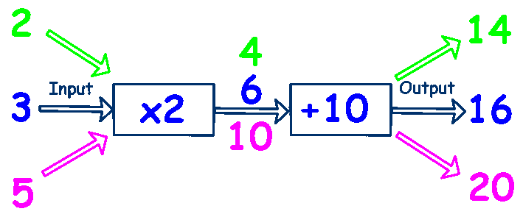

Your turn
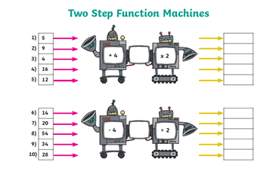

Position to Term Rules
Example 1: How many dots would be in the 100th shape in this sequence?
 |  | ●●● | ●●●  ●●● | ●●●  ●●●  ●●● | ●●●  ●●●  ●●●  ●●●
1 | Draw a table with the position in the top row and the number of dots in the bottom row |  | Position 1 2 3 4  Number of dots 3 6 9 12
2 | Find the connection between the top row and the bottom row |  | 1 2 3 4  ↓ X3 ↓ X3 ↓ X3 ↓ X3  3 6 9 12
3 | Write the rule to get from the top to the bottom |  | Multiply the position by 3
4 | Use this to find the 100th term |  | 100th term = 100 x 3 = 300  So there are 300 dots in the 100th shape
Your turn

For each of these sequences,
- Write down the number of squares in each term of the first three terms
- Find the rule to get from the position to the term
- Work out the number of squares needed to get to the 10th shape in the sequence
□□  □□ | □□□□  □□□□ | □□□□□□  □□□□□□

□□□□□ | □□□□□  □□□□□ | □□□□□  □□□□□  □□□□□

This pack should be completed and returned for marking by 25th May 2020

