Name: _____________________________________________________

This is your maths pack for the week commencing 18.05.20. I have tried to put as much help on it as possible. If you have any problems please either phone the school or email: mgater@suttonhouse.org.uk me and I will call you and try to guide you through.
Coordinates
Coordinates describe the position of a point. They are written in pairs inside brackets, with the x coordinate (horizontal – across) first followed by the y coordinate (vertical – up or down). Try to remember the phrase along the corridor and up/ down the stairs so you know which order to go in.
Examples of coordinates plotted on an axis.
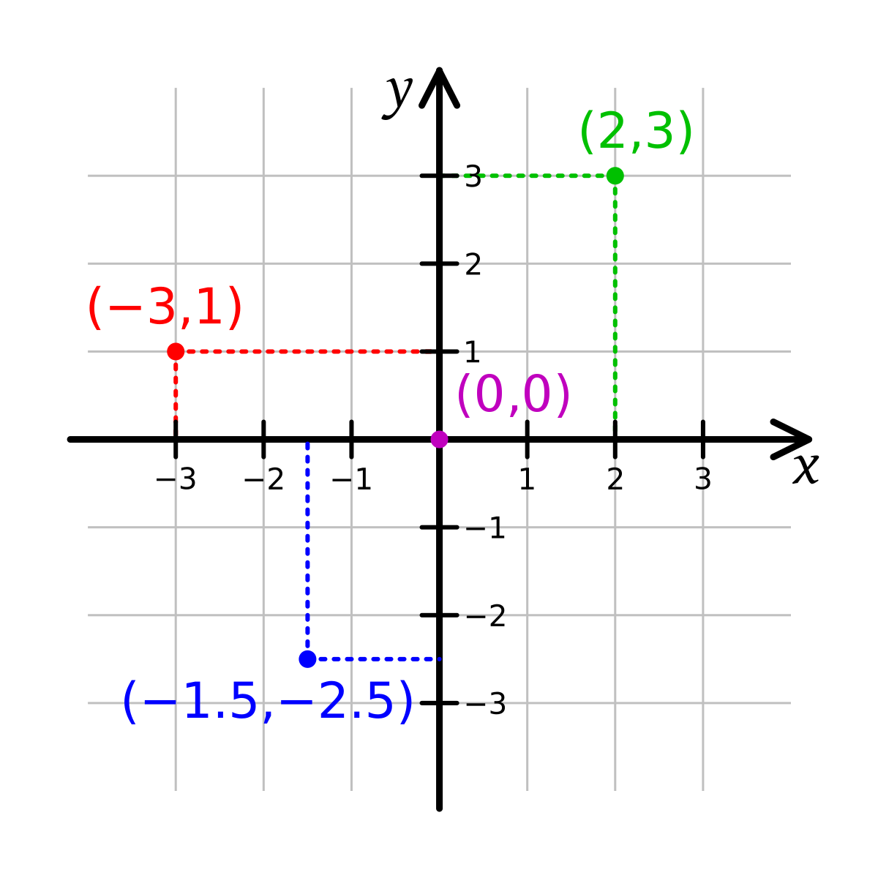
Your turn

Write the coordinates for each point
A | ___________ | 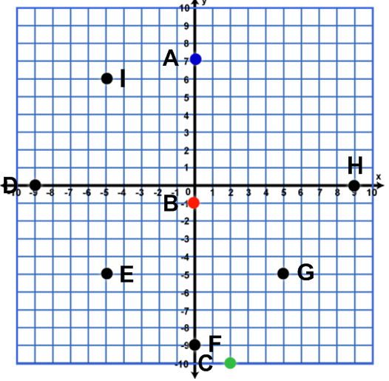
B | ___________
C | ___________
D | ___________
E | ___________
F | ___________
G | ___________
H | ___________

Horizontal and Vertical Graphs

All horizontal lines on a graph have the equation y = a (where a is a number), since every point on the horizontal line has the same y-coordinate (a).
All vertical lines on a graph have the equation x = b (where b is a number), since every point on the vertical line has the same x-coordinate (b).

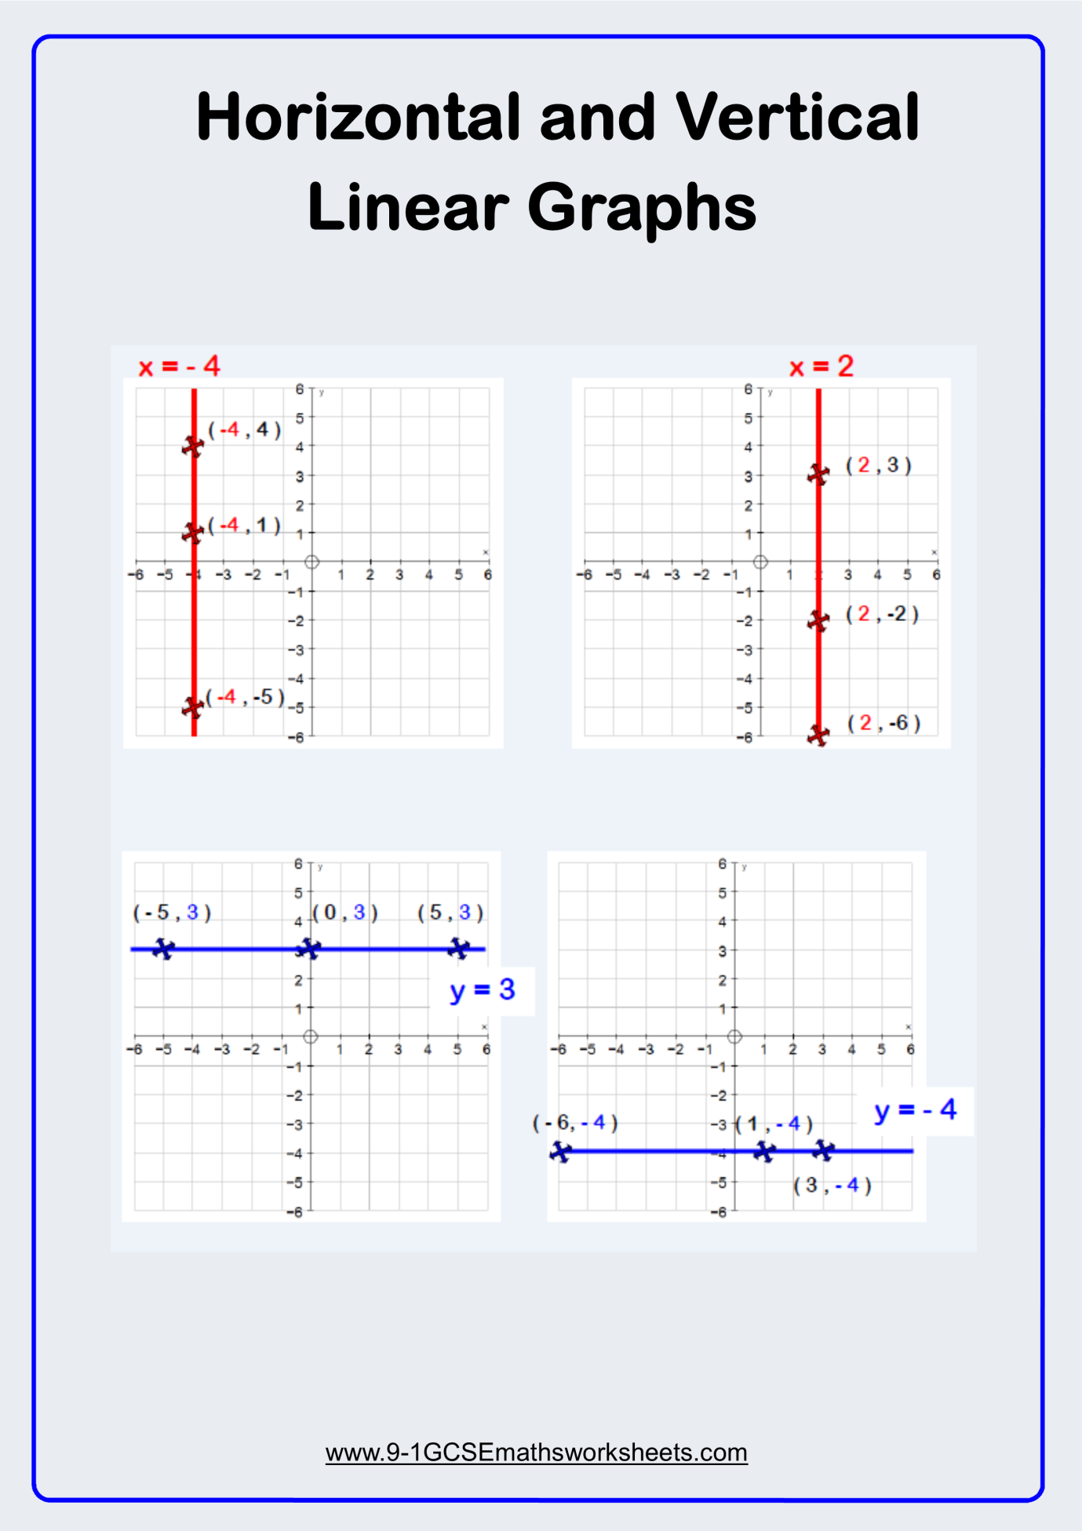
Your turn
Match the equation to the graph
Y = -2
Y = 0
Y = 2
Y = 3
X = 3

Probability – Listing outcomes
When two things are happening at once (for example tossing a coin and rolling a dice) it’s much easier to work out probabilities if you list all the possible outcomes in a logical way
Example 1: If you toss a coin and then throw a dice list the possible outcomes, work out the probability of getting a head and an even number
1 | First list all the possible combinations | Coin Dice  Head 1  Head 2  Head 3  Head 4  Head 5  Head 6  Tail 1  Tail 2  Tail 3  Tail 4  Tail 5  Tail 6
2 | Count the total number of possible outcomes | Possible outcomes Coin Dice  1 Head 1  2 Head 2  3 Head 3  4 Head 4  5 Head 5  6 Head 6  7 Tail 1  8 Tail 2  9 Tail 3  10 Tail 4  11 Tail 5  12 Tail 6
3 | Cross off all the outcomes that are not a head and an even number and count what you have left | Possible outcomes Coin Dice  Head 1  1 Head 2  Head 3  2 Head 4  Head 5  3 Head 6  Tail 1  Tail 2  Tail 3  Tail 4  Tail 5  Tail 6
4 | Work out the probability of tossing a head with and even number  - Number of positive outcomes  - Total number of outcomes | 3  12

Example 2: Anne has three tickets for a theme park. She chooses two friends at random to go with her. She chooses on girl from Belinda, Claire and Dee and one boy from Fred and Greg. What is the probability that she will choose Claire to go with her?
1 | First list all the possible combinations | Girls Boys  Belinda Fred  Belinda Greg  Claire Fred  Claire Greg  Dee Fred  Dee Greg
2 | Count the total number of possible outcomes | Possible outcomes Girls Boys  1 Belinda Fred  2 Belinda Greg  3 Claire Fred  4 Claire Greg  5 Dee Fred  6 Dee Greg
3 | Cross off all the outcomes that do not contain Claire and count what you have left | Possible outcomes Girls Boys  Belinda Fred  Belinda Greg  1 Claire Fred  2 Claire Greg  Dee Fred  Dee Greg
4 | Work out the probability of Claire going to the theme park  - Number of positive outcomes  - Total number of outcomes | 2 1  6 or 3

Your turn

Use a table to list all the possible outcomes when two coins are tossed. What is the probability of tossing two heads?
A burger bar offers the meal deal shown here.  List all the different combinations available.  Jane picks one of the combinations at random.  - What is the probability of choosing a veggie burger and a cola?  - What is the probability of choosing a cheeseburger? | Choose 1 burger and 1 drink  Burgers Drinks  Hamburger Cola  Cheeseburger Lemonade  Veggie burger Coffee

Probability from experiments
You can estimate probability using the results of an experiment or what you know has already happened. Your estimate is called a relative frequency (or an experimental probability) Work out relative frequency using this formula.

Relative frequency = | Number of times the result has happened
 | Number of times the experiment has been carried out
The more times you do the experiment, the more accurate the estimate should be.
Example 1:
A biased dice is rolled 100 times. Here are the results. |  | Score 1 2 3 4 5 6  Frequency 11 14 27 15 17 16
1 | Estimate the probability of rolling a 1  - Find the number of times a 1 was rolled  - Divide by the total number of rolls | 1 was rolled 11 times  So probability = 11  100
2 | Estimate the probability of rolling a 3  - Find the number of times a 3 was rolled  - Divide by the total number of rolls | 3 was rolled 27 times  So probability = 27  100

Your turn
A spinner with four sections is spun 100 times the results are shown in the table

Colour | red | Green | Yellow | Blue
Frequency | 49 | 34 | 8 | 9

Find the relative frequency of each colour

Jamal records the colour of cars passing his school

Colour | Silver | Black | Red | Blue | Other
Frequency | 452 | 124 | 237 | 98 | 89

Find the relative frequency of
- red cars

- Silver cars

Estimate the probability that the next car passing Jamal’s school will not be silver, black, red or blue

This pack should be completed and returned for marking by 1st June 2020

