Unit Assessment & Feedback
Learner Name
Qualification
Unit Title | Drugs and substance misuse
Unit Number |  | Level
Tutor/Assessor |  | Date

Feedback from Assessor to Learner

Comments from Learner

Have all assessment criteria for the unit been met? | Yes |  | No
If no, please detail action required and target dates for completion. Please initial and date once these have been completed.
Any further actions? | By when? |  | Completed?

Learner Signature |  | Date
Tutor/Assessor Signature |  | Date
IQA Signature (if sampled) |  | Date

Learner Evidence Record

Learner Name
Qualification
Unit Title | Drugs and substance misuse
Unit Number |  | Level |  | Credit Value
Tutor/Assessor

AC | Assessment Criteria | Page No.

I confirm that the work I have submitted is all my own work
Learner Signature |  | Date
Tutor/Assessor Signature |  | Date
IQA Signature (if sampled) |  | Date
EQA Signature (if sampled) |  | Date

DRUGS & SUBSTANCE
MISUSE
Unit Level: One
Unit Credit Value: 1
GLH: 9
Unique Reference Number: T/503/0969
This Unit has 3 Learning outcomes.
LEARNING OUTCOMES | ASSESSMENT CRITERIA | Date started | Date completed
The Learner will: | The Learner can:
- Understand the use and misuse of legal and illegal drugs and other substances. | - Give examples of legal and illegal drugs and other substances.  - Identify two reasons why people may use substances legitimately.  - State two reasons why people may misuse substances.
- Understand the risk of using and misusing drugs and other substances. | - Outline the risks associated with drug and substance misuse.  - Give an example of where long term use of a specific drug or substance can have a positive impact on daily life.  - Give an example of where long term drug or substance use can have a negative impact on daily life.
- Know how to access sources of help/support relating to substance misuse. | - State how to access help/support relating to substance misuse.

  - Give examples of legal and illegal drugs and other substances. (try and think of 10 for each)

Legal | Illegal

Drugs and Substance Misuse
NOCN
Level 1
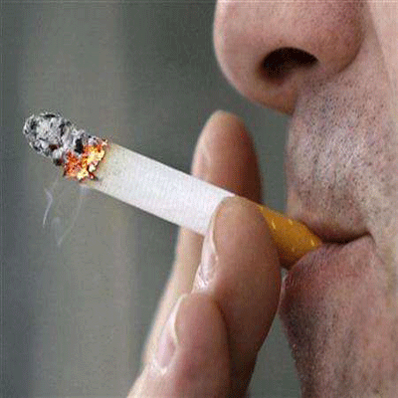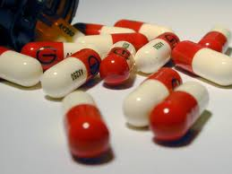
1. The Learner will understand the use and misuse of legal and illegal drugs and other substances

1.2 Identify two reasons why people may use substances legitimately.

_________________________________________________________________________________________________________________________________________________________________________________________________________________________________________________________________________________________________________________________________________________________________________________________________
_________________________________________________________________________________________________________________________________________________________________________________________________________________________________________________________________________________________________________________________________________________________________________________________________
______________________________________________________________________________________________________________

NOCN
Level 1
1. The Learner will understand the use and misuse of legal and illegal drugs and other substances

1.3 State two reasons why people may misuse substances.

_________________________________________________________________________________________________________________________________________________________________________________________________________________________________________________________________________________________________________________________________________________________________________________________________
_________________________________________________________________________________________________________________________________________________________________________________________________________________________________________________________________________________________________________________________________________________________________________________________________
______________________________________________________________________________________________________________

2.1 Short and long term effect of drugs and substances

Drug | Short term effects | Long term effects

Drugs and Substance Misuse
NOCN
Level 1

2. The Learner will understand the risks of using and misusing drugs and other substances

2.2 Give an example of where long term use of a specific drug or substance can have a positive impact on daily life.

___________________________________________________________________________________________________________________________________________________________________________________________________________________________________________________________________________________________________________________________________________________________________________________________________________________________________________________________________________________________________________________________________________________________________________________________________________________________________________________________________________________________________________________________________________
Drugs and Substance Misuse
NOCN
Level 1
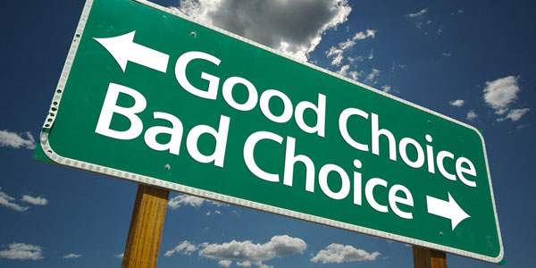

2. The Learner will understand the risks of using and misusing drugs and other substances

2.3 Give an example of where long term drug or substance use can have a negative impact on daily life.

_________________________________________________________________________________________________________________________________________________________________________________________________________________________________________________________________________________________________________________________________________________________________________________________________________________________________________________________________________________________________________________________________________________________________________________________________________________________________________________________________________________________________________________________________________________________________________________________________________________________________________________________

NOCN
Level 1
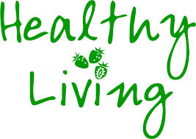

3. The Learner will know how to access sources of help/support relating to substance misuse.

3.1 State how to access help/support relating to substance misuse.

_________________________________________________________________________________________________________________________________________________________________________________________________________________________________________________________________________________________________________________________________________________________________________________________________________________________________________________________________________________________________________________________________________________________________________________________________________________________________________________________________________________________________________________________________________________________________________________________________________________________________________________________
_______________________________________________________

