Unit Assessment & Feedback
Learner Name
Qualification
Unit Title | Recognising and dealing with bullying
Unit Number |  | Level
Tutor/Assessor |  | Date

Feedback from Assessor to Learner

Comments from Learner

Have all assessment criteria for the unit been met? | Yes |  | No
If no, please detail action required and target dates for completion. Please initial and date once these have been completed.
Any further actions? | By when? |  | Completed?

Learner Signature |  | Date
Tutor/Assessor Signature |  | Date
IQA Signature (if sampled) |  | Date

Learner Evidence Record

Learner Name
Qualification
Unit Title | Recognising and dealing with Bullying
Unit Number |  | Level |  | Credit Value
Tutor/Assessor

AC | Assessment Criteria | Page No.

I confirm that the work I have submitted is all my own work
Learner Signature |  | Date
Tutor/Assessor Signature |  | Date
IQA Signature (if sampled) |  | Date
EQA Signature (if sampled) |  | Date

RECOGNISING &
DEALING WITH BULLYING

Unit Level: One
Unit Credit Value: 2
GLH: 18
Unique Reference Number: J/503/0989

This Unit has 4 Learning outcomes.
LEARNING OUTCOMES | ASSESSMENT CRITERIA | Date started | Date completed
The Learner will: | The Learner can:
- Understand what is meant by “bullying” | - Identify three different forms of bullying.  - State what is meant by being a victim.
- Be able to recognise the effects of bullying. | - Give three examples of the effects of bullying on the victim.  - Identify the emotions that may be experienced by a bully when bullying.
- Be able to recognise strategies for dealing with bullying. | - Outline one intervention that may help the victim.  - State two ways in which the self-esteem of the victim can be raised.  - Outline one intervention that may help the bully.
- Know where to access help and support. | - Identify three sources of help and support available.
Recognising and Dealing with Bullying
NOCN
Level 1
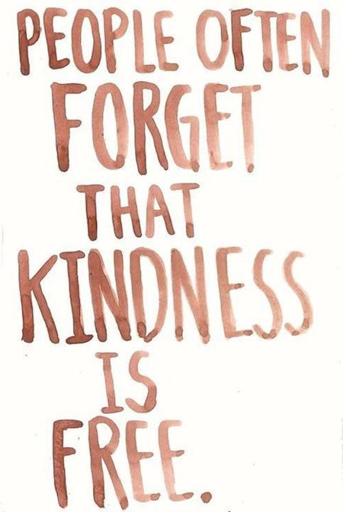

1. The Learner will understand what is meant by ‘bullying’.

1.1 Identify three different forms of bullying.

____________________________________________________________________________________________________________________________________________________________________________________________________________________________________________________________________________________________________________________________________________________________________________________________________________________________________________________________________________________________________________________________________________________________________________________________________________________________________________________________________________________

____________________________________________________________________________________________________________________________________________________________________________________________________________________________________________________________________________________________________________________________________________________________________________________________________________________________________________________________________________________________________________________________________________________________________________________________________________________________________________________________________________________

NOCN
Level 1
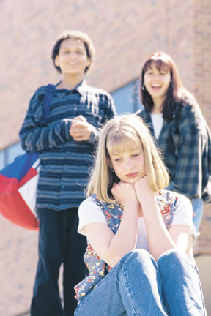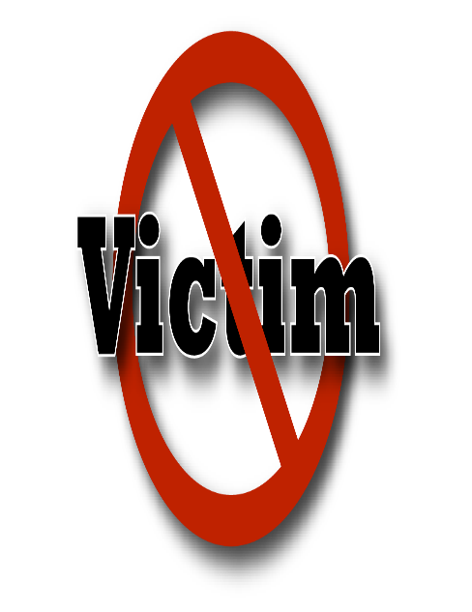

1. The Learner will understand what is meant by ‘bullying’.

1.2 State what is meant by being a victim.

____________________________________________________________________________________________________________________________________________________________________________________________________________________________________________________________________________________________________________________________________________________________________________________________________________________________________________________________________________________________________________________________________________________________________________________________________________________________________________________________________________________

______________________________________________________________________________________________________________________________________________________________________________________________________________________________________________________________________________________________________________________________________________________________________________________________________________________________________________________________________________

2.1 give three examples of the effects of bullying on the victim
Effect on the victim | How it makes the victim feel

What emotions do you think a bully might experience when bullying? Please write the answers on the next page.
Happy | Funny | love
Excited | Exhilarated | confusion
Scared | Worried | envy
Angry | Ashamed | Hate
Sorry | No emotion | Fear
Powerful | fearful | Love
Guilty | Jealousy | Pity
Sad | pride | Pain

Recognising and Dealing with Bullying
NOCN
Level 1

2. The Learner will be able to recognise the effects of bullying.

2.2 Identify the emotions that may be experienced by a bully when bullying.

____________________________________________________________________________________________________________________________________________________________________________________________________________________________________________________________________________________________________________________________________________________________________________________________________________________________________________________________________________________________________________________________________________________________________________________________________________________________________________________________________________________
__________________________________________________________________
______________________________________________________________________________________________________________________________________________________________________________________________________________________________________________________________________________________________________________________________________________________________________________________________________________________________________________________________________________
____________________________________________________________________________________________________________________________________
Interventions for the victim and bully (3.1 and 3.3)
3.1- A younger pupil at your school is being bullied, you have been asked to write a proposal to the head teacher on what can be done to help this person who is being bullied.
What could be done?

How could it be put in place?

How do you think it would prevent this pupil being bullied?

3.3 You find out the person bullying this younger pupil is a friend, outline one thing that could be done to prevent this pupil from bullying.
What could be done?

How could it be put in place?

How do you think it would prevent this pupil from being a bully?

Recognising and Dealing with Bullying
NOCN
Level 1
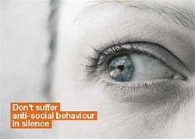

3. The Learner will be able to recognise strategies for dealing with bullying.

3.2 State two ways in which the self-esteem of the victim can be raised.

____________________________________________________________________________________________________________________________________________________________________________________________________________________________________________________________________________________________________________________________________________________________________________________________________________________________________________________________________________________________________________________________________________________________________________________________________________________________________________________________________________________
__________________________________________________________________
______________________________________________________________________________________________________________________________________________________________________________________________________________________________________________________________________________________________________________________________________________________________________________________________________________________________________________________________________________
____________________________________________________________________________________________________________________________________

4.1 Know how to get help and support
Create a poster aimed at teenagers in a school, to let them know how they could get help and support if they are being bullied, your poster must include:
  - 3 different types of help and support available and how they can help
  - A title
  - Should encourage teenagers to get help

