
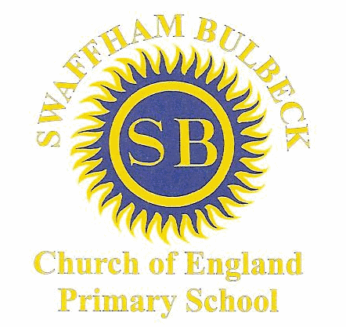
Swaffham Prior & Swaffham Bulbeck Primary Schools’
End of Day Collection Permissions Update

Name of child / children: _________________________________________________________________________
The following people have permission to collect my child/children from school at the end of the day.
________________________________________________________________________________________________________________________________________________________________________________________________________________________________________

Yes / No I understand that if the school have any concerns, they may refuse to release the child/children until they have confirmed with a parent or legal guardian.
Yes / No I have read and understood the End of Day Protocols for the school and agree to adhere to these protocols.

Signed: __________________________________________________

