

Swaffham Bulbeck & Prior Newsletter
January 2025
I hope you all had a good rest over the festive break. This year in particular there seem to be a lot of bugs around. Hopefully, the cold spell has eradicated some and now the nights are starting to get shorter and the days longer we will have a spring in our step!
Spring Term Events Calendar
The Spring Term Events Calendar is also included and a paper copy will be sent out (please be aware that dates can be subject to change).
Job Vacancy
Here is the live link to the Maternity-Cover Teacher advert for Dove’s Class. Please share it far and wide and tell everyone what a lovely community of learners we are!
https://mynewterm.com/jobs/146469/EDV-2025-SBCEPS-03957
Uniform
We would like to highlight the uniform policy. There may be aspects in it that are new to parents and children. There is a one-page guide on the last page. If there are any queries, please feel free to discuss them with a member of staff. We know that just after Christmas is not the time to be rushing out to update uniform. Therefore, we propose that this term up to Easter will be a transition phase and as children grow out of their current clothing, the guidance is followed. There is a wide array of pre-loved uniform availble for parents to peruse in school or if there are financial challenges, please let us know and we will do our best to help.
We wanted to share the thinking behind some of the decisions we have made and are always happy to answer questions regarding the policy. For example, although leggings are very comfortable, they can also become quite transparent very quickly or not sit securely around the waist. Therefore they can be worn under skirts as an alternative to tights if preferred but not on their own. Boots are ideal for the cold weather but children find them very difficult to sit on the carpet or in the hall and can make children feel too hot in the classrooms (they are quite warm with so many people in one space)! I suggest that children who wear boots have a simple pair of indoor shoes that they can wear around school.
Finally, please ensure your child has their winter PE kit (an extra layer is welcome and robust trainers) in school everyday. Occasionally the PE lesson may have to change days but they are also handy if they need an emergency change!
Attendance this term
Hedgehogs: 91% | Bees: 97%
Swifts: 96% | Butterflies: 95%

So far this term
The children have thrown themselves back into their learning.
In Year 5 and 6, the children have launched into their new history topic of World War 2 and have linked their English learning to this writing adventure stories about an abandoned spitfire.
In Year 3 and 4, there was a buzz in the air after the children spent an afternoon participating in a sportshall athletics festival. They have also completed some very notable still-life pictures using pastels.

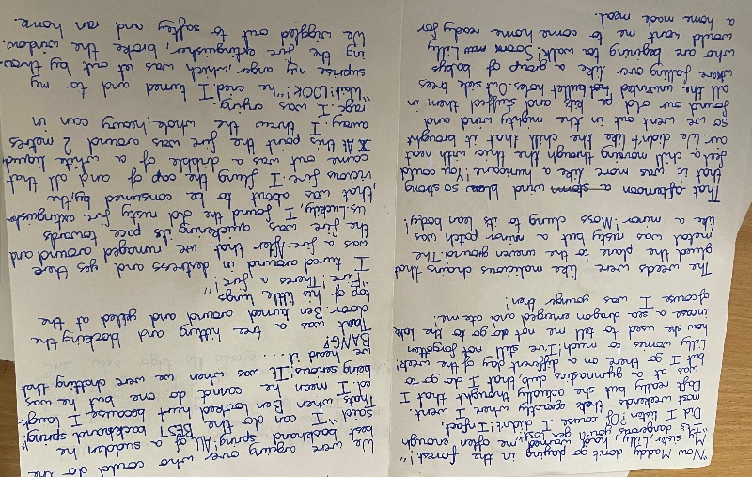

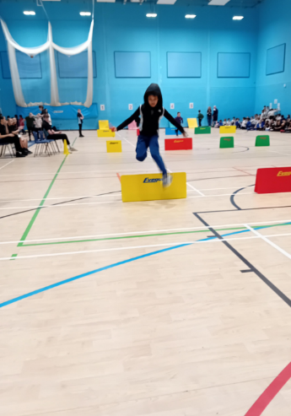
In Year 1 and 2, children have been learning about feelings in PSHE. In Geography they have been learning about map work and naming the continents and oceans. They have also had an introduction to the climate and the equator. The children have been very inspired by the book, How the Elephant got his Trunk. Alex wants to know how the Cheetah got his spots!

In Early Years, the topic are People Who Help Us. They were detectives investigating a ‘crime scene’ in the classroom which was very exciting. They also have various visitors who are sharing their experiences with the children.
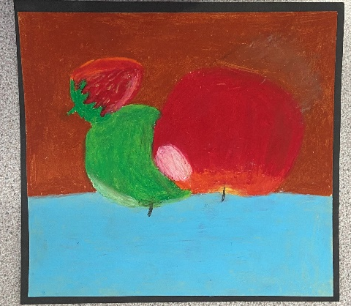

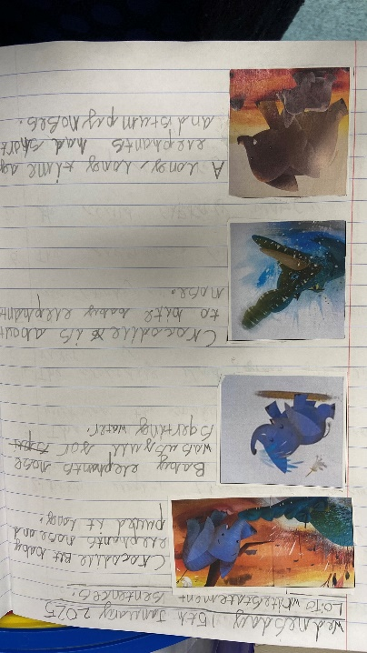
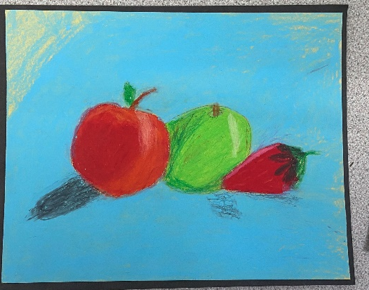
‘I really enjoyed the fact that everyone took part in the competition and that everybody did their best in the challenges they were given.’ MWJ

Sports hall Athletics

SCHOOL UNIFORM
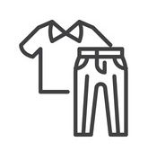 | School uniform | - Red polo shirt  - Red jumper or cardigan  - Dark grey trousers, shorts, skirt or pinafore (not jogging bottoms; grey leggings can be worn under skirts as an alternative to tights if preferred)  - Plain socks / tights
 | Shoes | - Plain black shoes or plain black trainers, no sandals.  - Child-friendly fastenings to enable independence.  - Boots or wellies may be worn outside, but are not ideal for indoors as they are too restrictive for children sitting on the carpet etc.
 | PE kit | - Red t-shirt  - Black shorts  - Black jogging bottoms or leggings  - Red sweatshirt  - Trainers  - Additional layers for outdoor PE in winter
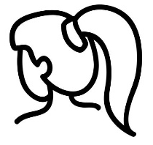 | Hair | - Hair that is long enough should be tied back.  - Hair accessories in school colours, with no large decorations.  - No coloured or dyed hair, patterns cut into hair, or excessive use of styling products
 | Jewellery, Make up and nail varnish | - No jewellery, except plain stud earrings.  - Earrings must be removed for PE.  - Make up and nail varnish are not permitted.
 | Watches | - Only standard analogue or digital watches may be worn.  - No smart watches; staff cannot monitor them to ensure that they are being used appropriately.


EVENTS COMING UP!
Date | Class | Event | Notes
7.1.25 | ALL | First Day Back at School
23.1.25 | ALL |   Trip to Starlight Express | Coach leaves school at 4.30pm. More details to follow
23.1.25 | Year 3 and 4 | Sports Hall Athletics Festival
24,1,25 | Reception Class | Vision Screening
30.1.25 | Owls & Butterflies | Football Tournament | Teversham School
7.2.25 | ALL | PINS Project Coffee Morning | All families are welcome. Venue is Swaffham Bulbeck.
7.2.25 | Swaffham Prior | Book Fair
7.2.25 | Swaffham Prior | PTA - Valentine’s Disco
7.2.25 | Swaffham Bulbeck | PTA – Valentine’s Event
11.2.25 | Owls & Butterflies |   Swimming Gala | At Bottisham Village College
11.2.25 | ALL | Safer Internet Day
HALF TERM 17th to 21st February, 2025
26.2.25 | Swaffham Bulbeck and Prior | Bags to School Collections
Wednesday 26.2.25 and Wednesday 5.3.25 | All classes |   Parent Consultations | Details to follow.
5.3.25 | Bees |   Class Cafe | At drop off, drop in (until 10am). Have a cuppa and join your child’s learning.
5.3.25 | Robins & Wrens | Class Cafe | At drop off, drop in (until 10am). Have a cuppa and join your child’s learning.
6.3.25 | All classes |   World Book Day
6.3.25 | Kingfishers | Class Cafe | At drop off, drop in (until 10am). Have a cuppa and join your child’s learning.
6.3.25 | Hedgehogs & Hoglets | Class Cafe | At drop off, drop in (until 10am). Have a cuppa and join your child’s learning.
11.3.25 | Swifts | Class Cafe | At drop off, drop in (until 10am). Have a cuppa and join your child’s learning.
11.3.25 | Owls | Class Cafe | At drop off, drop in (until 10am). Have a cuppa and join your child’s learning.
12.3.25 | Doves | Class Cafe | At drop off, drop in (until 10am). Have a cuppa and join your child’s learning.
12.3.25 | Butterflies | Class Cafe | At drop off, drop in (until 10am). Have a cuppa and join your child’s learning.
12.3.25 | Swifts | Gymnastics Festival
20.3.25 | KS2 |   Basketball Skills Festival
21.3.25 | All Classes | Red Nose Day
24.3.25 | Year 5 & 6 | Science Festival
24.3.25 | Bees / Kingfishers | Multiplication Tables Check Meeting | A chance to discuss arrangements for the 2023 Multiplication Tables Check for Y4 children.
26.3.25 | All classes |   Open Classrooms | Come in, have a look at what your child is learning.
26.3.25 and 28.3.25 | Swaffham Prior | Mother’s Day Gift Shop
27.3.25 | Y1 | Multi-skills Festival
27.3.25 – 2.4.25 | Swaffham Bulbeck | Book Fair
2.4.25 at 9.15am | Swaffham Bulbeck |   Easter Service | Parents are very welcome.
2.4.25 at 2.15pm | Swaffham Prior | Easter Service | Parents are very welcome.
2.4.25 | Swaffham Prior | Easter Egg Hunt
2.4.25 | Swaffham Bulbeck | Easter Bingo
3.4.25 |  | Last Day of term!

