Behaviour Principles Statement
Person Responsible: | Suzanne Hamilton, Director of Education
Last Updated: | 20.06.2026
Review Date: | July 2028
Previous Review Date: | August 2024
Adopted by Trustees on: | 09.07.2026

Contents

1. Behaviour Principles Statement 3
2. Regulation, Relationships and Readiness to Learn 4
3. Behaviour Principles 4
3.1 Inclusivity 4
3.2 Respect and Empowering Individuality 5
3.3 Working Collaboratively 6
3.4 Honesty 7
3.5 Innovation 7
4. School Behaviour Procedures 8
4.1 High standards of behaviour 8
4.2 Teaching Behaviour Explicitly 8
4.3 Rewards 8
4.4 Unacceptable behaviour 8
5. Suspensions and exclusions 9
5.1 Reintegration following suspension 10
6. Power to Use Reasonable Force and Physical Intervention 11
7. Prohibited items 12
8. Safeguarding 12
9. Consistency and Staff Development 12
10. Notes 13

- Behaviour Principles Statement
(to be read in conjunction with the school’s own Behaviour Policy)
Synergy Education Trust is committed to creating calm, safe and purposeful learning environments where every pupil feels secure, valued and ready to learn. We recognise that behaviour is a form of communication and that children and young people require support, guidance and explicit teaching to develop self-regulation, positive relationships and successful learning behaviours. Behaviour support across the Trust is underpinned by the principles of inclusion, high expectations, consistency and the understanding that pupils learn best when they feel safe, regulated and able to engage in learning.
This statement reflects the Department for Education's guidance on Behaviour in Schools, Suspension and Permanent Exclusion, Use of Reasonable Force in Schools, Keeping Children Safe in Education and the Equality Act 2010. It establishes the principles that all schools within Synergy Education Trust must consider when developing and implementing their own behaviour policies.
The Trust is committed to a relational, trauma-informed and inclusive approach to behaviour. Schools are expected to prioritise positive relationships, proactive support, reasonable adjustments, de-escalation and co-regulation strategies to help pupils succeed. We recognise that some pupils may require additional support due to special educational needs and disabilities (SEND), social, emotional and mental health needs, safeguarding concerns or adverse childhood experiences, and that behaviour support should be adapted to meet individual needs wherever possible.
The Board of Trustees has a statutory responsibility to promote high standards of behaviour while safeguarding the welfare, dignity and rights of all pupils. Restrictive practices, including the use of reasonable force, physical intervention or seclusion, should only be used as a last resort where necessary to prevent harm, maintain safety or preserve good order. Any intervention must be lawful, reasonable, proportionate and in the best interests of the pupil and must never be used as a punishment.
The Trust further recognises that suspensions and permanent exclusions are serious sanctions that should only be used where necessary, lawful, reasonable and proportionate. Schools are expected to demonstrate a commitment to early intervention, pastoral support, reasonable adjustments, restorative practice and multi-agency working before exclusion is considered. Permanent exclusion should always remain a last resort, following careful consideration of individual circumstances, safeguarding responsibilities and the welfare of the wider school community.

This statement provides the Trust-wide framework through which individual schools develop their behaviour policies, ensuring a consistent approach that promotes inclusion, safety, positive relationships, effective behaviour support and successful outcomes for all pupils

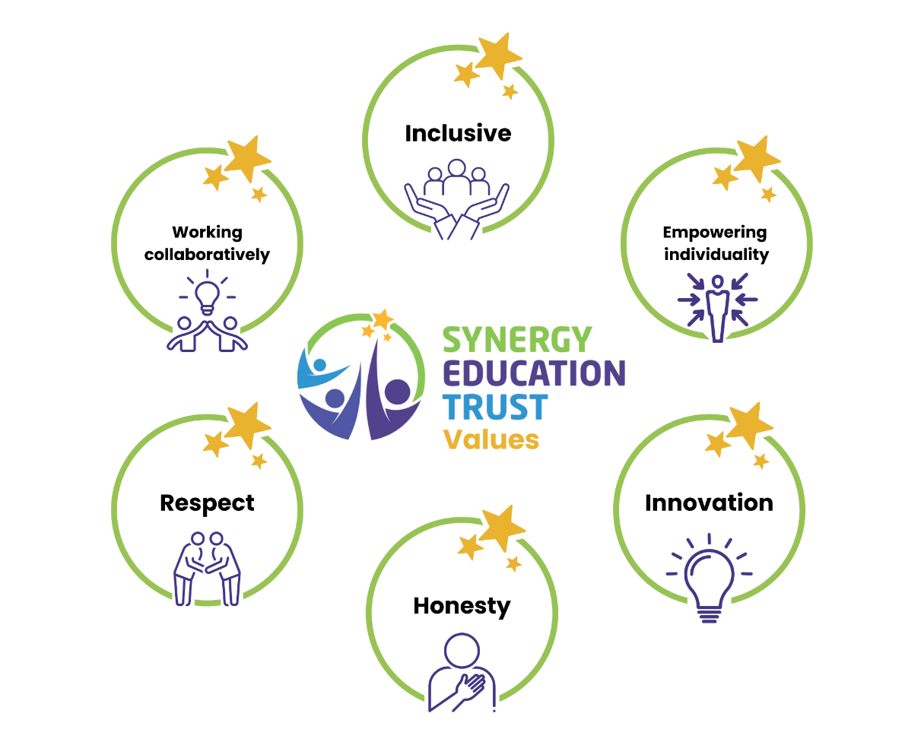

- Regulation, Relationships and Readiness to Learn
At Synergy Education Trust, behaviour is understood through the interconnected principles of Regulation, Relationships and Readiness to Learn. These principles provide the foundation for creating safe, supportive and successful learning environments where all pupils can thrive.
- Regulation – supporting pupils to understand and manage their emotions through co-regulation, explicit teaching and structured, predictable environments.
- Relationships – developing positive, trusting and respectful relationships between pupils, staff, families and the wider school community.
- Readiness to Learn – ensuring pupils are supported to reach a state in which they can engage, participate and achieve success in learning.
The Trust expects schools to prioritise relational, inclusive and proactive approaches to behaviour, recognising that positive relationships and effective support are key to reducing dysregulation, promoting wellbeing and enabling pupils to achieve their potential

- Behaviour Principles
  - Inclusivity
Synergy Education Trust is committed to creating an inclusive culture in which every member of the school community is valued, respected and able to thrive. All pupils, staff and visitors have the right to learn and work in an environment free from discrimination, harassment, bullying and prejudice. In line with the Equality Act 2010, schools will promote equality, celebrate diversity and foster a strong sense of belonging for all.

To support this commitment, every school within the Trust will maintain clear and comprehensive Behaviour and Anti-Bullying Policies that are understood by pupils, staff, parents and carers, consistently implemented and regularly reviewed for effectiveness. These policies will set out robust measures to prevent and address bullying, discrimination and prejudice-related incidents, ensuring that all members of the school community feel safe and supported.

The Trust recognises that behaviour is often a form of communication and that pupils may require different levels of support to achieve success. Schools will adopt a relational, inclusive and trauma-informed approach that seeks to understand the underlying causes of behaviour and responds with appropriate support, guidance and intervention.

Particular consideration will be given to pupils with SEND, SEMH needs, EHCPs, looked after and previously looked after children, pupils with social workers and other vulnerable groups. Schools will make reasonable adjustments, reduce identified barriers and provide targeted support to enable all pupils to participate successfully in school life and achieve readiness for learning.

The Trust recognises that behaviour may be influenced by a range of factors, including special educational needs, trauma, adverse childhood experiences, anxiety, sensory differences, emotional dysregulation and safeguarding concerns. Schools will seek to identify and reduce known triggers, work collaboratively with families and external agencies where appropriate, and ensure behaviour support reflects individual needs and circumstances.

Schools will monitor behaviour, sanctions, suspensions and exclusions to ensure that policies are applied fairly and equitably. Particular attention will be given to identifying and addressing any disproportionate impact on protected or vulnerable groups, ensuring that behaviour systems remain inclusive and responsive to pupils' needs.

  - Respect and Empowering Individuality
Positive behaviour is built upon respectful, trusting and consistent relationships. Staff will model calm, predictable and professional behaviours, creating environments in which pupils feel safe, valued, listened to and supported. Through these relationships, pupils are more likely to develop confidence, resilience and a sense of belonging within their school community.

The Trust believes that every pupil should be treated with dignity and respect and supported to develop as an individual. Behaviour support should encourage pupils to understand the impact of their actions, reflect on their choices and develop the skills needed for self-regulation, positive relationships and successful participation in school life.

All pupils, staff and visitors have the right to feel safe and free from the effects of unacceptable behaviour. Mutual respect should underpin all interactions within the school community, and each school's Behaviour Policy should promote a culture of kindness, responsibility, inclusion and accountability.

The Trust recognises that behaviour may be influenced by a range of individual experiences and circumstances. Staff will adopt relational and trauma-informed approaches that seek to understand the underlying reasons for behaviour, respond with empathy and consistency, and support pupils to develop greater self-awareness and self-regulation over time. Behaviour responses should preserve the rights, welfare and dignity of pupils while maintaining high expectations and clear boundaries.

By fostering positive relationships and recognising individual strengths, needs and experiences, schools will empower pupils to become responsible, resilient and respectful members of their communities, ready to learn and succeed.

  - Working Collaboratively
Synergy Education Trust recognises that positive behaviour and successful outcomes are best achieved when schools, families and pupils work together in partnership. Parents and carers play a vital role in supporting their child's learning, wellbeing and behaviour, and schools will actively encourage open, positive and constructive relationships with families. Pupils will also be supported to understand their responsibilities as members of the school community and the role they play in creating a safe, respectful and productive learning environment.

Schools will ensure that parents, carers and pupils are made aware of the school's behaviour expectations, values and routines from the point of admission and throughout the pupil's time in school. Clear communication and regular engagement will help promote a shared understanding of expectations and enable schools and families to work together to support positive behaviour.

The Trust expects all schools to maintain a welcoming and inclusive culture in which parents and carers feel respected, valued and able to contribute to discussions about their child's development and support needs. Strong partnerships with families are central to promoting pupil wellbeing, engagement and success.

Where concerns about behaviour arise, schools will work proactively with parents, carers and relevant professionals to identify barriers to learning, participation and positive behaviour. Early intervention, effective communication and collaborative problem-solving should be used to address concerns at the earliest opportunity.
The Trust recognises that behaviour difficulties may be linked to wider educational, social, emotional, safeguarding or special educational needs. Schools should therefore seek appropriate multi-agency involvement where necessary, ensuring that support plans are informed by the expertise of families, external agencies and other professionals, with the aim of improving outcomes and reducing the need for more restrictive interventions, suspensions or exclusions
  - Honesty
Honesty, openness and transparency are fundamental to effective behaviour support. Schools should communicate clearly and respectfully with pupils, parents, carers, staff and the Central Trust Team about behaviour concerns, successes and next steps. By maintaining open dialogue, schools can build trust, strengthen relationships and ensure that everyone involved has a shared understanding of the support being provided.
Pupils should be encouraged to reflect honestly on their experiences, behaviours and choices, while being supported to understand the impact of their actions on themselves and others. Equally, schools should ensure that pupil voice is heard and considered when making decisions about behaviour support, intervention and, where necessary, sanctions.
When behaviour concerns arise, schools should work collaboratively with families and relevant professionals to share information, identify underlying causes and agree appropriate strategies and support. Honest and timely communication enables informed decision-making and helps ensure that interventions are proportionate, supportive and focused on achieving positive outcomes for the pupil.
The Trust expects behaviour records, incident reporting and decision-making processes to be accurate, fair and transparent. This includes providing clear explanations for significant behaviour decisions, the use of reasonable force, suspensions or exclusions, and ensuring that parents, carers and relevant professionals are kept appropriately informed.

  - Innovation
Synergy Education Trust is committed to continually improving its approach to behaviour through engagement with current research, evidence-informed practice and professional learning. The Trust recognises that understanding behaviour is an evolving field and encourages schools to remain reflective, adaptive and responsive to emerging knowledge and best practice.
Schools will draw upon a range of research, professional expertise and proven approaches to develop effective behaviour systems that promote inclusion, wellbeing and positive outcomes for pupils. This includes exploring strategies related to behaviour as communication, relational practice, trauma-informed approaches, emotional regulation, SEND and mental health.
The Trust encourages innovation that supports early intervention, strengthens relationships and reduces the need for restrictive practices, suspensions and exclusions. Schools should evaluate the impact of their approaches, share effective practice across the Trust and use evidence to inform continuous improvement in behaviour support.
Through ongoing professional development, collaboration and reflective practice, Synergy Education Trust aims to ensure that behaviour policies and procedures remain effective, inclusive and aligned with current research, statutory guidance and the needs of the pupils and communities we serve

- School Behaviour Procedures
The School Behaviour Procedures should be clearly stated in the individual school’s Behaviour Policy. These should set out expected standards of behaviour and shared with, and explained to, all students and parents/carers.
Synergy Education Trust Board expects the schools agreed behaviour system to be consistently always applied by all staff. With regular training given to staff.
  - High standards of behaviour
High standards of behaviour are achieved through clear expectations, strong relationships and consistent adult responses.
The Trust promotes a proactive approach, where adults:
- anticipate and reduce triggers
- support co-regulation
- provide predictable routines
- reinforce positive behaviours
The primary focus is to ensure pupils are in a regulated state that enables learning, rather than simply reacting to behaviour after it occurs.
  - Teaching Behaviour Explicitly
Schools will explicitly teach expected behaviours in the same way as any other part of the curriculum.
Pupils will be supported to:
- understand expectations
- practise and rehearse positive behaviours
- develop emotional literacy and regulation strategies
This ensures all pupils, regardless of need, can succeed.
  - Rewards
Synergy Education Trust Board would like to see a wide range of rewards consistently and fairly applied in such a way as to encourage and reward good behaviour in the classroom and elsewhere.
School reward systems should be made clear in the individual school’s Behaviour policy.
  - Unacceptable behaviour
Where behaviour falls below expected standards, responses should be fair, proportionate, consistent and focused on supporting learning, repairing relationships and achieving positive long-term outcomes. The Trust recognises that while clear boundaries and consequences are important, behaviour responses should also seek to understand and address the underlying causes of behaviour wherever possible.
Consequences should be designed to:
- support reflection and accountability
- repair and restore relationships
- teach and reinforce positive alternative behaviours
- promote personal responsibility and self-regulation
- enable pupils to successfully re-engage with learning and school life.
Where appropriate, schools should use restorative, relational and solution-focused approaches to help pupils understand the impact of their behaviour, make amends and rebuild positive relationships within the school community.

The Trust expects schools to adopt a graduated approach to behaviour support. Before more serious sanctions are considered, schools should demonstrate that appropriate support, intervention, reasonable adjustments and targeted strategies have been implemented and reviewed, taking account of any SEND, SEMH, safeguarding or other underlying needs.

Behaviour records should provide evidence of interventions, support offered, pupil and parent engagement, and the impact of strategies used. Schools should regularly review behaviour plans and support arrangements to ensure they remain effective and responsive to the needs of the pupil.

Whilst the Trust promotes inclusive and supportive approaches, it also recognises the need to maintain a safe and orderly learning environment for all. In cases of serious or persistent breaches of the school's Behaviour Policy, sanctions may be necessary. Any sanctions, including suspension, must be lawful, reasonable, proportionate and applied consistently, with due regard to safeguarding responsibilities, equality duties and the individual circumstances of the pupil.

School sanctions should be made clear in the individual school’s Behaviour policy.

- Suspensions and exclusions
Synergy Education Trust is committed to creating inclusive learning environments where all pupils are supported to succeed. Through strong relationships, effective behaviour support, early intervention and targeted pastoral provision, schools should seek to reduce the need for suspensions and permanent exclusions wherever possible. Behaviour difficulties should be addressed through a graduated and supportive approach that promotes engagement, wellbeing and positive outcomes for pupils.

Before considering suspension or permanent exclusion, schools should demonstrate that appropriate strategies, interventions and support have been considered and implemented where appropriate. This should include reasonable adjustments for pupils with SEND, targeted pastoral support, multi-agency involvement and individualised behaviour planning where required.

When making decisions regarding suspension or exclusion, Headteachers must ensure that decisions are:
- lawful, reasonable and proportionate
- based on the balance of probabilities
- informed by the views of the pupil, where appropriate
- mindful of safeguarding responsibilities
- compliant with the Equality Act 2010 and SEND duties
- informed by consideration of appropriate alternatives and available support.
Suspension or exclusion should never be used:
- because of a pupil's academic attainment
- solely because a pupil has SEND
- for non-disciplinary reasons
- where behaviour is primarily the result of unmet needs that have not been appropriately identified, assessed or supported.

The Trust recognises that, on occasion, Headteachers may need to make difficult decisions to safeguard pupils and staff and maintain a safe and orderly learning environment. In reaching these decisions, Headteachers must balance the needs of the individual pupil with those of the wider school community. The safety, welfare and education of all pupils and staff remain paramount, and behaviour that places others at significant risk may result in suspension or, in exceptional circumstances, permanent exclusion.

Permanent exclusion should always be regarded as a last resort. Before such a decision is made, schools should be able to demonstrate that all reasonable steps, interventions and alternatives have been carefully considered, unless an immediate and serious breach of the Behaviour Policy necessitates exclusion. Where permanent exclusion is being considered, schools must complete the Trust's at Risk of Permanent Exclusion process and inform the Deputy CEO and/or CEO in accordance with Trust procedures.

Where a suspension has taken place, reintegration should be viewed as an important part of the behaviour support process. Schools should ensure that pupils experience a structured and supportive return to school that promotes belonging, restores relationships and enables successful re-engagement with learning. All schools must use the agreed Synergy Education Trust Paperwork for Reflecting on Incidents (PIRM) and the Trust's reintegration documentation to support reflection, planning and successful reintegration.

The Trust expects schools to monitor suspension and exclusion data carefully, particularly for pupils with SEND, looked after and previously looked after children, pupils with social workers and other vulnerable groups, to ensure that behaviour systems are fair, equitable and inclusive and that any disproportionate outcomes are identified and addressed

  - Reintegration following suspension
Reintegration should be viewed as an important part of the behaviour support process. Schools should ensure that pupils returning from suspension experience a structured and supportive re-entry which promotes belonging, restores relationships and enables successful participation in learning. Reintegration planning should involve pupils, parents/carers and relevant professionals where appropriate.

For more detailed information please read the Trust Exclusions Policy.

- Power to Use Reasonable Force and Physical Intervention

Synergy Education Trust is committed to promoting positive behaviour through prevention, de-escalation, co-regulation and supportive relationships. However, the Trust recognises that there may be rare occasions when staff need to use reasonable force or physical intervention to prevent a pupil from harming themselves or others, to prevent serious damage to property, to prevent the commission of an offence, to reduce the risk of absconding where a pupil may come to significant harm, or to maintain good order and discipline.

The use of reasonable force is a serious matter and must only be used as a last resort when all appropriate preventative and de-escalation strategies have been considered or attempted and have been unsuccessful, or where immediate action is required to ensure safety. Any use of force must be lawful, necessary, reasonable and proportionate to the circumstances and must always be in the best interests of the pupil and those around them. It must never be used as a punishment or to cause pain, humiliation or distress.

When considering the use of physical intervention, staff must take account of the individual needs, vulnerabilities and circumstances of the pupil, including any SEND, SEMH needs, medical conditions, trauma history, safeguarding concerns or other factors that may influence behaviour or increase vulnerability. The dignity, welfare and rights of the pupil must be preserved throughout any intervention.

Any use of reasonable force or physical intervention should:
- be a last resort
- be necessary and proportionate to the level of risk presented
- use the minimum force for the shortest time required
- only be used for a lawful purpose
- take account of the pupil's individual needs and vulnerabilities
- never be used as a punishment
- be followed by appropriate recording, parental communication, reflection and review.
Schools must ensure that their Behaviour Policy and Physical Intervention Policy clearly set out:
- preventative, relational and de-escalation strategies
- the circumstances in which reasonable force may be used
- procedures for reporting, recording and reviewing incidents
- arrangements for informing parents and carers
- safeguarding and leadership oversight of incidents
- support, debrief and welfare arrangements for pupils and staff following an incident
- processes for reviewing behaviour plans, risk assessments and support strategies following significant incidents.
The Trust is committed to learning from behaviour incidents and reducing the need for restrictive practices wherever possible. Following any significant physical intervention, schools should ensure that appropriate reflection, support and review take place so that pupils, staff and families can contribute to identifying strategies that help prevent future incidents and promote positive outcomes.

For more detailed information please read the Trust Physical Intervention Policy.

- Prohibited items
Schools must clearly set out in their Behaviour Policy the authority to search for and confiscate prohibited items in accordance with current legislation and DfE guidance.

The Trust expects schools to take appropriate action where prohibited, illegal or dangerous items are brought onto school premises. Where items such as weapons, controlled drugs or other unlawful substances are identified, the Headteacher should ensure that relevant authorities, including the Local Governing Board and external agencies where necessary, are informed without delay.

All actions should be proportionate, lawful and focused on safeguarding, while ensuring appropriate support is provided to pupils where required.

- Safeguarding
The Trust views behaviour support as an integral part of safeguarding. Significant behaviour incidents, including the use of reasonable force, restrictive interventions or seclusion, must be appropriately recorded, reviewed and shared with parents/carers. Schools should use post-incident reflection and debrief processes to understand triggers, capture pupil voice, support staff wellbeing and reduce the likelihood of future incidents.
The Trust recognises that there may be occasions when a pupil is educated away from site for safeguarding reasons. Such arrangements are distinct from suspension or exclusion and should be managed in accordance with safeguarding procedures, with appropriate review, parental communication and multi-agency involvement
- Consistency and Staff Development
The Trust recognises that consistency of adult response is key to successful behaviour support.
All staff will receive regular training in:
- behaviour as communication
- de-escalation and co-regulation
- relational practice
- trauma-informed approaches
- lawful use of reasonable force and physical intervention
- recording and reporting requirements
- safeguarding responsibilities following restrictive interventions
- Equality Act duties and reasonable adjustments
- post-incident reflection and learning processes.
This ensures a shared, consistent approach across all settings.

- Notes

- The purpose of the Statement is to provide guidance to the Heads of Schools’ in drawing up their individual Behaviour Policy so that it reflects the shared aspirations and beliefs of all stakeholders in Synergy Education Trust; Trustees, Local Governing Boards, staff, parents and students, as well as taking full account of law and guidance on behaviour matters. It is intended that by providing this statement Synergy Education Trust is empowering leaders by providing a framework in which to draw up and be accountable for the implementation and success of their behaviour policy in their school. It is intended to help all staff to be aware of and understand the extent of their powers in respect of recognition and reward for good behaviour, discipline, and sanctions for unacceptable behaviour and how to use them. Staff should be confident that they will always have Synergy Education Trustees’ support when following this guidance.

- This is a statement of principles, not practice: it is the responsibility of the Heads to draw up the school’s Behaviour Policy, taking account of these principles when formulating this policy. The Head of School should also take account any guidance from the DfE

- Schools must ensure that their Behaviour Policy is read alongside the Trust's Use of Physical Intervention Policy, Safeguarding and Child Protection Policy, SEND Policy and relevant DfE guidance on Behaviour in Schools and the Use of Reasonable Force

- With consideration of our duty of care to our pupils, this written statement and the policies that are influenced by it apply to all pupils when in school, when travelling to and from school, when engaged in extra-curricular activities such as educational trips and visits (residential and non-residential) and when being educated as a member of the Synergy Education Trust Community offsite

- The Behaviour Policy must be published on the school’s website and be accessible to all members of staff.

