EYFS Teaching Assistant Level 2 Application Pack


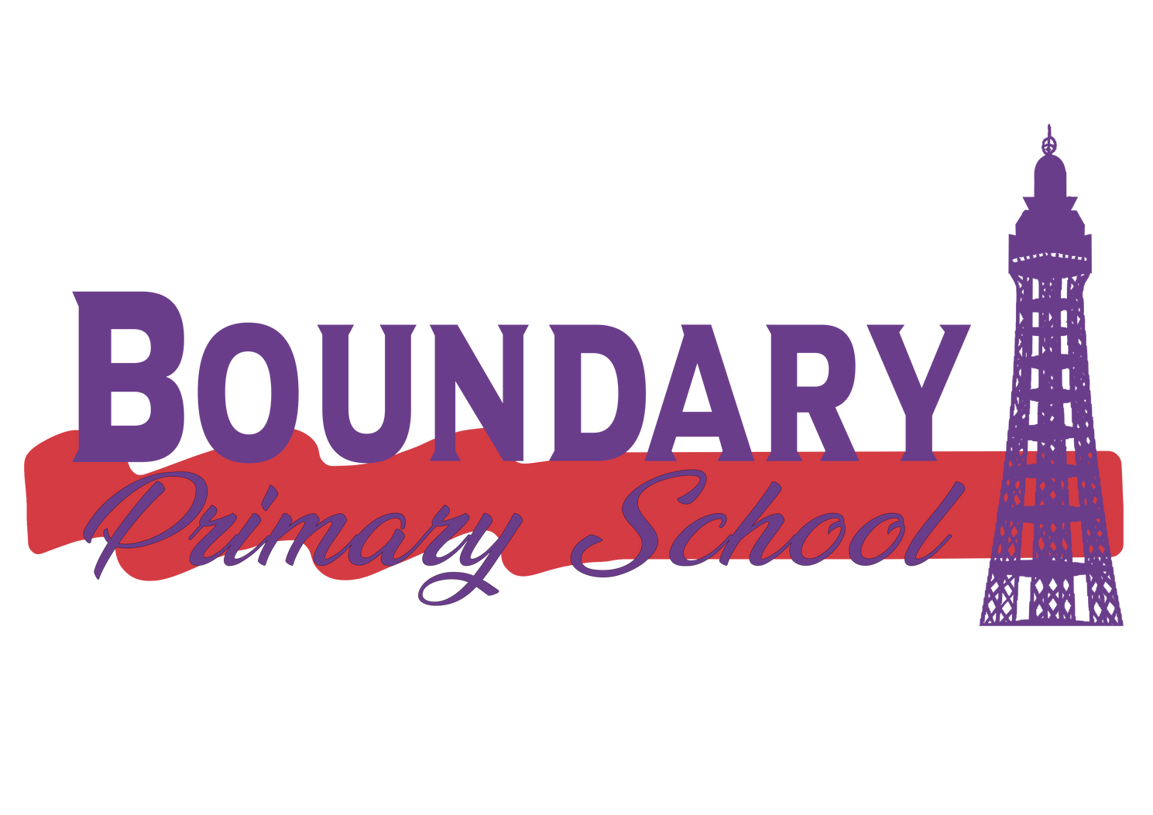
Boundary Primary School

Boundary Primary School, Blackpool, FY3 7RW 01253 287250
www.boundaryschool.co.uk www.seteducation.org.uk

Welcome

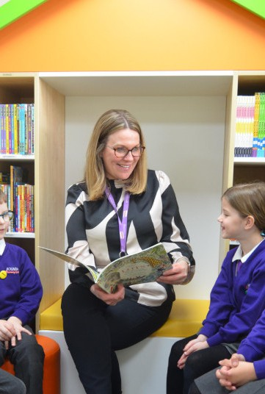



www.seteducation.org.uk
Greetings and warm regards,

I am delighted that you have expressed an interest in the post of EYFS Teaching Assistant at Boundary Primary School. I hope that after considering all the information you will make an application.

At Boundary Primary School we work hard to provide the best education we can for our pupils and we are continuously driving for improvement – living up to our motto ‘we work as one to be the best that we can be!’
At Boundary, we take the ‘whole child’ into account. We want our pupils to leave school with excellent subject knowledge and skills, but also to leave as caring, respectful, tolerant and enthusiastic learners, who are well-equipped to become good citizens.
We look forward to you visiting our school so that you can see it all in practice.
In April 2024 Boundary became an academy joining the newly formed multi academy trust- Synergy Education Trust with other Blackpool schools.
We are determined and passionate to ensure that all of our staff are supported and trained to make a first class provision for all of our young people.
Synergy has six key values that underpin our work and ethos:
- Inclusive Provision
- Empowering Individuality
- Innovation
- Honesty
- Respect
- Collaborative Working
We are looking to recruit an exceptional Teaching Assistant. They will be passionate about helping every pupil to achieve their potential and ambition, whilst leaving no child behind and will hold safeguarding central to all the systems, processes and strategies at school.
If you require further information or have any questions about the role please contact the School on 01253 287250.
Wishing you every success on the submission of your application
Warm regards,
Helen Moyes
Head of School, Boundary Primary School



About Boundary Primary School

Boundary Primary School is a large, two form entry primary school in Blackpool. We are a very good school where staff and pupils continuously drive for improvement – living up to our motto ‘we work as one to be the best that we can be’.

We take the ‘whole child’ into account. We want our pupils to leave school with excellent subject knowledge and skills, but also to leave as caring, respectful, tolerant and enthusiastic learners, who are well-equipped to become good citizens of the future.

We are looking to appoint a hard-working, competent, skilled, enthusiastic TA2 (Key Stage 2) to join our staff team.

Applicants must be able to demonstrate, on their application form, all essential criteria detailed in the job description and person specification.

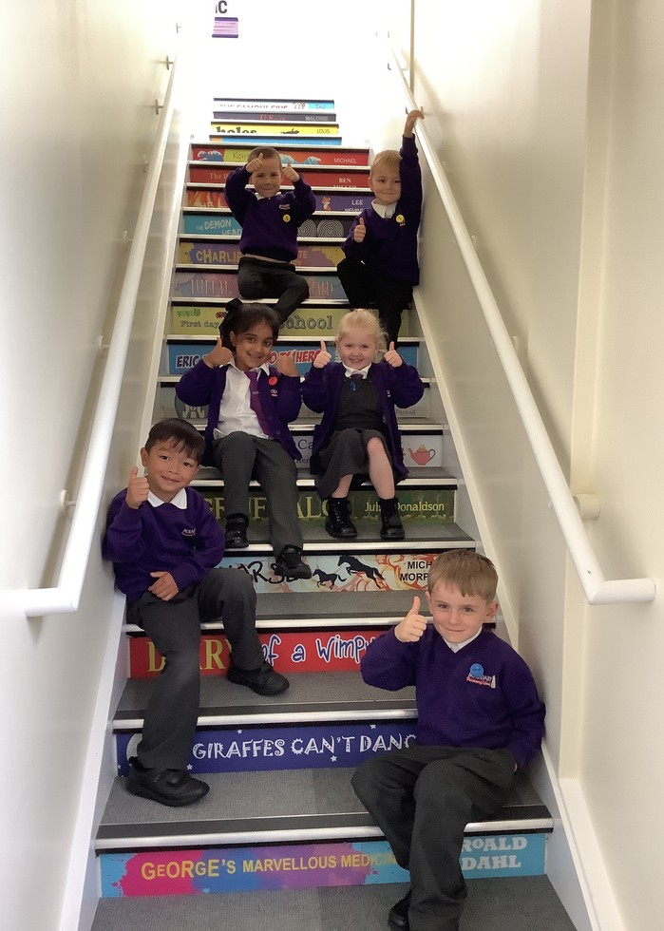
At Boundary School, our mission is to ensure all children are provided with the opportunities to succeed to the best of their ability – to become happy, confident, caring, trustworthy and community-minded people with their own positive vision for the future.

Vision and Values
We care about your child/children beyond their academic abilities within the classroom and value each child as an individual whilst appreciating the ups and downs of life they each face. The emotional health and well-being of your child is of utmost importance to us, as we want all children that come to our school to be happy and content and to achieve their full potential in life.
We believe in the importance of lifelong learning and the contribution made by each individual to our community of learners. This includes all children, parents, staff, Governors and the wider community.
We have a highly experienced and trained pastoral team who are able to offer a variety of different interventions and support for both you and your children.

.


Benefits of working in the Trust

Vision
At Synergy Education Trust we pride ourselves on being an employer that continually invests in our employees as we know that it is our staff who will ensure that we meet our vision. As a new Trust, we are currently designing and building our offer for staff which is a priority for Trustees and the Central Team.

Current Benefits

Employee Assistance Programme
01
Our programme is run by Health Assured and provides a support line for staff to access a range of practical and emotional help 24/7. This includes counselling, financial, legal and practical support from qualified professionals. There is also access to an online health and wellbeing resource, as well as face to face counselling as required
Pensions
02
You will have the option to join the Local Government Pension Scheme, which is a defined benefit scheme that provides a guaranteed income pension for support staff in England and Wales
Pay Progression
03
As well as any nationally agreed pay award (a salary increase linked to inflation), our employees also have access to pay progression in accordance with the pay scale for the role.
Continuous Professional Development
04
a strong commitment to continuing professional development, with regular training opportunities

Job Description

EYFS Teaching Assistant Level 2 Grade C
Core purpose:

Teaching Assistants are appointed to work within the school as part of a year group team, under the general direction of the Headteacher, specific line management from the Deputy Headteacher and specific direction, guidance and supervision of the classroom teacher. The role focuses on the direct development of children and young people to build their personal capacity. To work with teachers to support teaching and learning by working with individuals or groups of pupils under the direction of teaching staff and may be responsible for some learning activities within the overall teaching plan.

Key characteristics:

- Ensure the availability of the necessary materials and equipment required to deliver teaching and learning
- Carry out routine record keeping and assessments as directed by the class teacher
- To support the good conduct and safe order of the classroom
- To ensure all policies and procedures relating to health and safety and safeguarding, the promotion of the welfare of children and online-safety are all read, understood, signed for and adhered to at all times.

Key duties:

The Teaching Assistant will be a member of a year group team, under the immediate leadership of the class teacher. In co-operation with the teacher, the post holder will, to a level reflected by the grade of the post:

Support the pupil by:

·Undertaking activities with individuals or groups of children to ensure their safety and facilitate their physical emotional and educational development, in the classroom under the direct supervision of teaching staff
- Implementing planned learning activities/teaching programmes, whilst promoting personalised learning under the direction and guidance of the class teacher; adjusting activities according to pupils’ responses and resolving related problems as appropriate
- Working to establish a supportive relationship with the children and parents concerned
- Understand and support independent learning and inclusion of all pupils as required
- Promoting and reinforcing the child’s social, health and emotional well-being, reporting problems to the teacher as appropriate;
- Contributing to the monitoring and progress of a pupil’s/group’s individual targets
- Having a duty of care and responsibility for the children that they support.

Job Description

EYFS Teaching Assistant Level 2 Grade C

Support the teacher by:

  - Monitoring the learner’s progress and informing class teacher of observations and provide feedback;
  - Co-ordinate and manage learning resources under the direction of the class teacher to ensure continuity in learning
  - Keeping such records of the children’s development and basic pupil data as are required by the School
  - Assisting teaching staff in the delivery of learning programmes for individuals and groups of children
  - Where appropriate, carry out testing and assessment arrangements for pupils, including invigilating exams and tests;
  - Assisting the teaching staff in the smooth transition between educational phases
  - Carrying out non-teaching tasks as agreed with the class teacher and line manager, e.g. classroom displays, collecting money, recording assessment data, prepare and clear up learning environment and resources, including photocopying, filing and contribute to maintaining a safe environment;
  - Support the teacher in behaviour management and keeping pupils on task including understanding instructions, supporting independent learning and inclusion of all pupils;
  - Ensuring safe, effective learning environment; use of equipment such as play equipment and ICT under the class teacher’s direction

Support the school by:

  - Being aware of and adhering to all school policies, routines and recognised procedures including health and safety policies and procedures.
  - Being aware of confidential issues linked to home/pupil/teacher/school work in order to maintain confidentiality and adhere to safeguarding procedures;
  - Working as part of a team
  - Support the induction of non-routine admissions
  - Taking responsibility for personal CPD to ensure that they are effective in their role, working within the needs of the School.
  - Attending Parents Evenings, Presentation Evenings (induction, curriculum, etc.)
  - Carrying out play and lunch time tasks and duties as required by the School
  - Assisting with escorting pupils on educational visits;
  - Assist pupils with eating, dressing and hygiene, as required, whilst encouraging independence;
  - Demonstrate own duties to new or less experienced staff.
  - Leading or supporting the delivery of an after school club/clubs

Person Specification
EYFS Teaching Assistant Level 2 Grade C
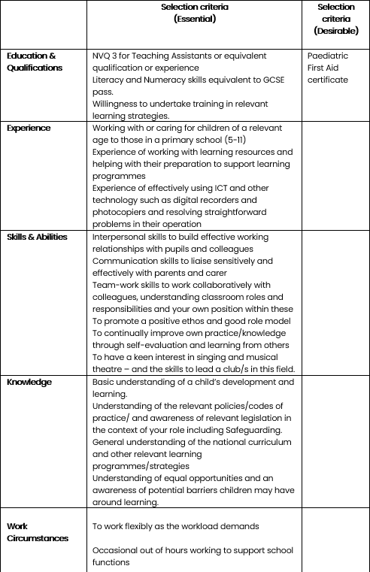

Next steps;

Closing date for all applications is Tuesday 31st May 2026 at 9am All application forms to be sent to jarek.radon@boundary.seteducation.org.uk

Application information
01
02

School visit day: Please contact the school office on 01253 287250 for more information.

03 Interviews will take place week commencing 13th April 2026

04 S tart Date : As soon as possible

Safeguarding Information
We do reserve the right to close this advertisement early if we receive a high volume of suitable applications. As a part of our recruitment process, we will carry out an online search on shortlisted candidates to identify any comment, image or other content that could cause reputational damage to the school and/or give rise to a safeguarding concern. If we discover anything during our searches this will be passed onto the recruitment manager and discussed during interview. We are deeply committed to safeguarding and promoting the welfare of children and expect all staff and volunteers to share this commitment.
All necessary safeguarding checks will be undertaken which must have satisfactory outcomes, otherwise the conditional job offer may be withdrawn. Details of the checks that will be undertake can be found at: Keeping Children Safe in Education, 2023 – KCSIE 2023.
This role has been assessed as working in regulated activity and is subject to an Enhanced DBS plus Children’s Barred List Check. It is an offence to apply for this role if you are barred from engaging in regulated activity relevant to children. This post is exempt from the Rehabilitation of Offenders Act 1974 (Exceptions) Order 1975 (2013 and 2020). This means that certain convictions and cautions are considered ‘protected’ and do not need to be disclosed to employers, and if they are disclosed, employers cannot take them into account.
No applicant will be disadvantaged or discriminated against because of the protected characteristics under the Equality Act 2010.

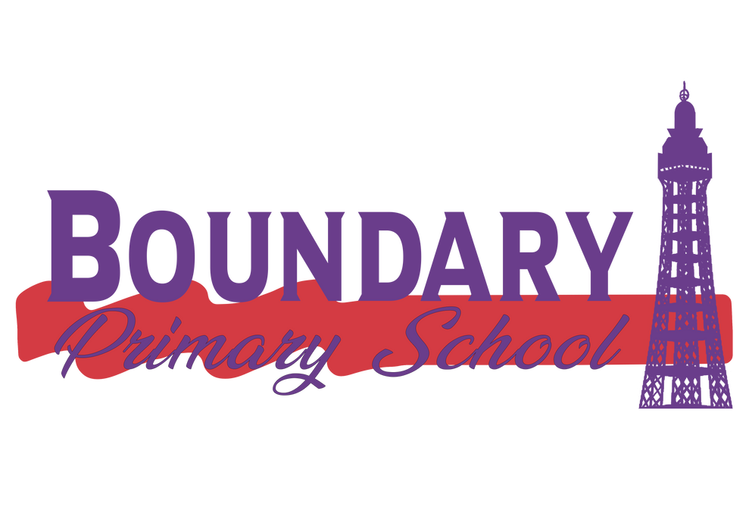

For further information please visit our website at: www.boundaryschool.co.uk



Boundary Primary School, Blackpool, FY3 7RW 01253 287250
www.boundaryschool.co.uk www.seteducation.org.uk

