
Welcome back to school after the Summer holidays. The first week of Year 2 has been really busy with getting to know the class routines, getting back into school life after the summer break and diving into our learning!
We have lots of exciting themes and lessons planned for the year and are sure that your children will enjoy their time in Year 2. We’ve already started our first topic, ‘The Big Smoke’. This topic focuses on comparing the village of Tanworth with the big city of London. In the second half term we will go back in time to look at the Great Fire of London.
We have also got our ‘Remembrance Week’ this term and, of course, all of the build up to Christmas, including our Christmas production.


Year 2 Autumn Newsletter

Important days of the week for Year 2
This half term, there will be no Forest School for Year 2. Instead, we will be having a PE slot twice a week, on a Wednesday and a Thursday. Children should come to school in their PE kit and can remain in it for the day. They may wish to wear their plain black or green tracksuits over their kit, especially on colder days!

Staffing in Year 2
Teacher: Mrs Woodward
TA: Mrs Coffey (Mon – Fri mornings)
We have an ‘open door policy’. Please come and speak to us at the start of the day or when you pick your children up if you have any worries or concerns. Thank you!

Weekly Homework
Spellings
Spellings will be issued weekly on a Monday and the spellings test will then be taken the following Monday. Children will be given spellings that they will then learn the patterns and rules for the following week in school. In Year 2 much of the children’s spellings work is about rules, rule breakers and patterns. If your child finds the spellings easy, check that they understand the pattern, can find other words with the same pattern and look for any rule breakers.

Reading
Children should be reading at home daily. Can you please make sure that reading diaries are kept up to date and that reading books and diaries are brought into school each day. Thank you!

Hello

Rewards and Expectations
We have a positive reward system in place that recognises good behaviour and effort during the school day as we follow our school rules of being Ready, Respectful and Safe.
House points: These are awarded for great work and effort in lessons and count towards the house cup.
Recognition Board: Children are placed onto the recognition board in the classroom when they show excellent learning behaviours, which will often be a specific focus for the class for that day or week.
Table Points: The table with the most points at the end of the school day can earn themselves a sticker.

Home Learning
Home learning works the same way as in Year 1 and the suggested tasks are still optional for the children and last the Autumn term. The children will be asked to bring their tasks into school by the 21st of November and a gallery will be on display in the hall for the children to showcase their learning on the 24th and 25th of November. Tasks can be in their book or models, posters, craft projects etc. We are currently reviewing our Home Learning policy and will of course update you all once the new policy has been agreed.

+
 Reading
In Year 2, we always see a real love of reading develop as the children move away from phonics-based books into longer stories and finally chapter books. Some children will be sent home with both a phonic based book and a second, colour-banded book, which will be more of a challenge, perhaps needing your support. Some children will also be sent home with flash cards and key words to learn.
Children who wish to change their book must place their reading diary and book in the book box at the start of the day to ensure they get a new one that day.

Dates for your Diary
19.9.19 – Meet the teacher evening
04.10.19 - Harvest Festival
23.10.19 & 24.10.19 - Parent Evenings
25.10.19 Teacher Training SCHOOL CLOSED
These dates are accurate at time of press; I will notify you of any change 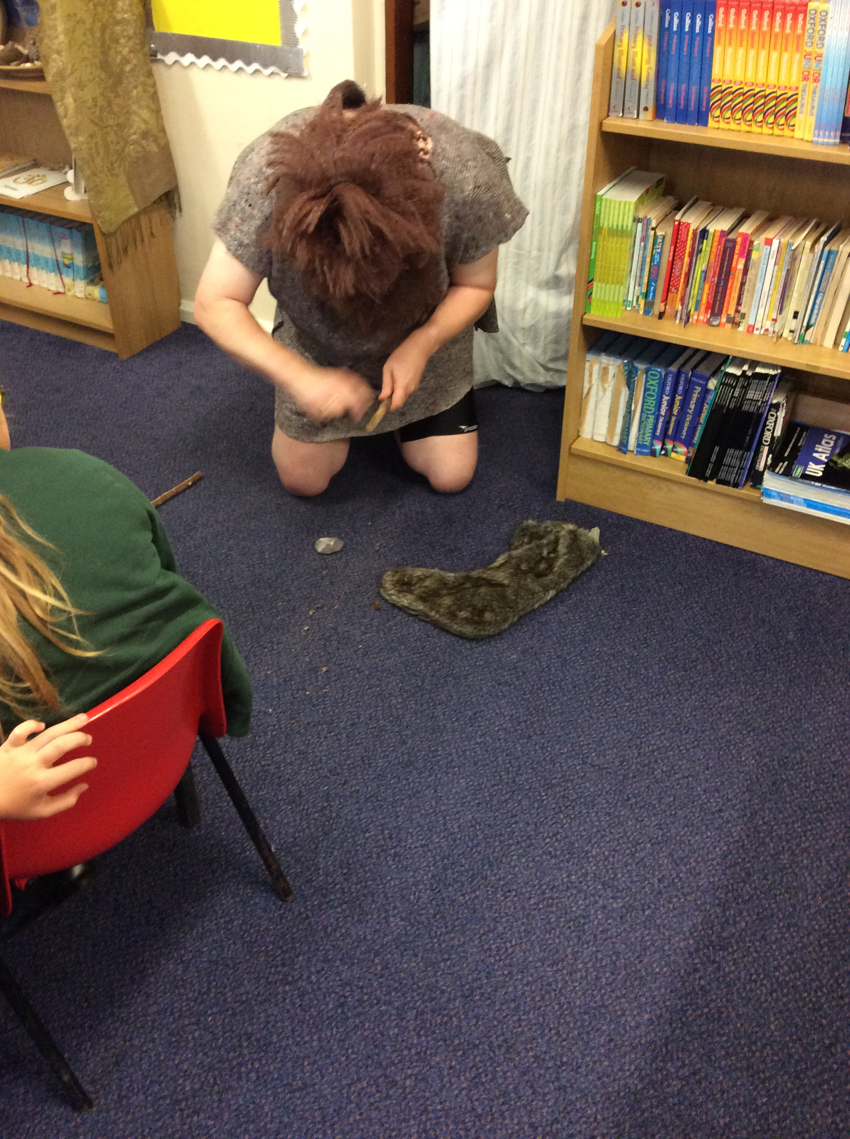s in advance.
Website
Please check out the class website for copies of important termly documents and curriculum support which your child can access at home.

Dates for your diary
Tuesday 21st October- Parents Evening
Thursday 23rd October- Parents Evening
Friday 24th October- Teacher Training Day (School closed)
Monday 27th- Friday 31st October- Half Term
Monday 3rd November- School reopens for Autumn 2
Friday 21st November- Home Learning Due
Monday 24th November- Home Learning Gallery (after school)
Tuesday 25th November- Home Learning Gallery (before school)
Friday 19th December- Break up for Christmas

CHRISTMAS PRODUCTION DATES TBC

Reminders
Snack- Children can bring a piece of fruit for their snack, although the school does provide free seasonal fruit and vegetables for each child. No yoghurts please. If bringing grapes, they must be cut lengthways.
Names – Please ensure that your children’s belongings are clearly labelled with their names so that they can be returned to them when they get lost!
Coats/ Water bottles – Please remember to send your child with a water bottle and coat every day.
Shoelaces – If your child has shoes or trainers with laces, can you please practice with them at home so they feel confident and are able to tie them. Thank you!
Please remember, due to allergies, we are a nut-free school.

