ueries about h
Music
Learn a song from the Caribbean, such as a calypso. Perhaps you might learn a sea shanty that explorers might have sung to keep their spirits up and help with their tasks. Record yourself or perform it to your family or even to the class!
Artist
Research famous artists from Europe, pick a favourite and try to recreate one of their pieces of art.
Model
Modelling
Can you make a model of Ernest Shackleton’s ship, the Endurance or perhaps of Ranulph Fienes
Cave Art
Make up your own story, it can be about anything you like but tell it through cave art pictures!

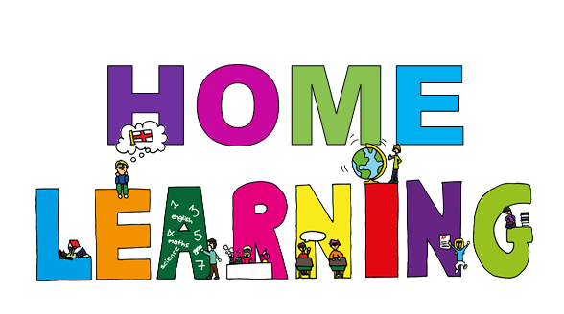
ueries about homework please
Spirituality
Choose something which makes you happy or connected with the world. It might be a pet or a flower for example. Look at it carefully and notice the detail in it. Respond in words, draw a picture or take a photograph and enjoy being in that moment.

It is up to you how much or how little home learning you want to complete over the term.
You can choose from the tasks suggested or even make up one of your own!

However, please bring any work you have completed in on Friday 20th March. We are hoping to showcase all learning after school on the 23rd of March and before school on the 24th of March.
Write a story
Create your own story all about an explorer who heads off to explore a new island in the Caribbean.

Science-Animals Including Humans
Create a menu for a healthy, balanced diet. What will you eat each day to make sure you have a healthy balance?

Diary
Imagine you are an explorer. Write a diary about what has happened to you on your adventure.
Mapwork
Can you make a map of one of the Caribbean islands? Put on the main cities and features. Can you create a key and add the points of the compass.
Postcard
Write a postcard from the Caribbean. What have you been doing? What has the weather been like? What food have you been tasting and what do you miss from home?
A Fact file
Can you create a fact file about a country in the Caribbean or about an explorer you have researched?
This half term’s home learning themes are:
Explorers
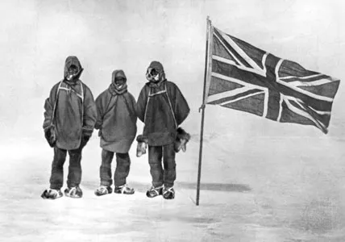
& The Caribbean


