
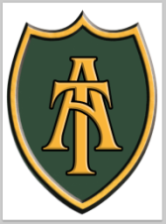
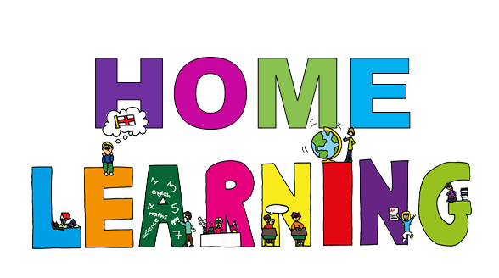
It is up to you how much or how little home learning you want to complete over the term.
You can choose from the tasks suggested or even make up one of your own!

However, please bring any work you have completed in on Friday 19th June. We are hoping to showcase all learning after school on the 22nd of June and before school on the 23rd of June. Please note this will take place in our Year 2 classroom.
Science-Plants
Can you grow a plant at home from a seed or a bulb? Keep a photo record of it or even record what changes you notice.

Wordsearch
Can you make a wordsearch using the key vocabulary from our topic? What words would you use and can you hide them well?
Diary
Pretend that you are one of the 3 nurses. Write a diary about your experiences and don’t forget to include your honest feelings!
Art
Look at the artwork of Andy Goldsworthy. Which of his sculptures and artwork do you like the best? Can you recreate one of the sculptures or even design one of your own?
New Lamp
Make a new and improved lantern for Florence Nightingale to help her see in the wards. You could update your lantern with battery power lights!

Story time
Write a story that is set in a hospital. Who will the main characters be? What will be the problem they have to overcome? How will it end? You decide!

Modelling
Make a model hospital ward from the time of Florence and Mary or make your own first aid kit.
Write a Letter

Write a letter to Florence Nightingale, Edith Cavell or Mary Seacole to thank them for what they did for nursing.

Music
Can you make up a song all about one of our famous nurses? Choose a tune you already know and then write the lyrics to explain what you’ve learnt!

Cave Art
Make up your own story, it can be about anything you like but tell it through cave art pictures!
Spirituality
A random act of kindness

Think of a really thoughtful or nice thing you can do for someone else. Plan it out and surprise them with this random act of kindness. Not only will it help them to feel good, but you will be amazed how good it makes you feel too!
This half term’s home learning theme is:
Nurturing Nurses

