4. We Three Kings
Westward leading, still proceeding
Guide us to thy perfect light

Year 6
Myrrh is mine
Its bitter perfume - breathes
A life of gathering gloom
Sorrow, sighing, bleeding, dying
Sealed in the stone cold tomb

All
O star of wonder, star of night
Star with royal beauty bright
Westward leading, still proceeding
Guide us to thy perfect light

All
Glorious now behold Him arise
King and God and Sacrifice!
Al-le-lu-ia, al-le-lu-ia
Heaven to earth replies

All
O star of wonder, star of night
Star with royal beauty bright
Westward leading, still proceeding
Guide us to thy perfect light

Year 3
We three kings of orient are
Bearing gifts we travel afar
Field and fountain
Moor and mountain
Following yonder star
All
O star of wonder, star of night
Star with royal beauty bright
Westward leading, still proceeding
Guide us to thy perfect light

Year 4
Born a King on Bethlehem's plain
Gold I bring to crown Him again
King for ever, ceasing never
Over us all to reign

All
O star of wonder, star of night
Star with royal beauty bright
Westward leading, still proceeding
Guide us to thy perfect light

Year 5
Frankincense to offer have I
Incense tells of Deity nigh
Prayer and praising, voices raising
Worship Him, God most high

All
O star of wonder, star of night
Star with royal beauty bright
5. Starry Night
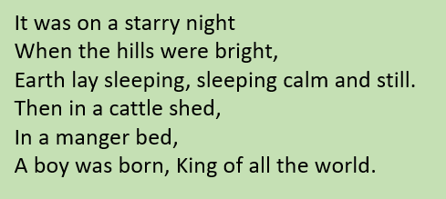
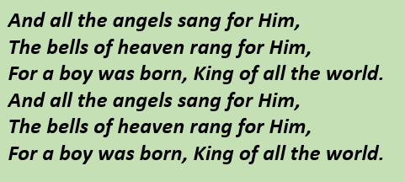
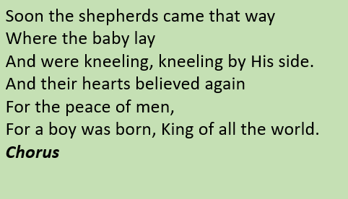

3. Calypso Carol

See him lying on a bed of straw
A draughty stable with an open door
Mary cradling the babe she bore
The prince of glory is his name.

Oh, now carry me to Bethlehem
To see the Lord appear to men
Just as poor as was the stable then
The prince of glory when he came.

Star of silver sweeps across the skies
Show where Jesus in the manger lies
Shepherds swiftly from your stupor rise
To see the Saviour of the world.

Oh, now carry me to Bethlehem
To see the Lord appear to men
Just as poor as was the stable then
The prince of glory when he came.

Angels, sing again the song you sang
Bring God's glory to the heart of man
Sing out, "Bethlehem's little baby can
Be salvation to the soul."

Oh, now carry me to Bethlehem
To see the Lord appear to men
Just as poor as was the stable then
The prince of glory when he came.

Cha cha cha

Silent Night
Y3 & Y4
Silent night, holy night!
All is calm, all is bright.
Round yon Virgin, Mother and Child.
Holy infant so tender and mild,
Sleep in heavenly peace,
Sleep in heavenly peace.
Y5 and Y6
Silent night, holy night!
Shepherds quake at the sight.
Glories stream from heaven afar
Heavenly hosts sing Alleluia,
Christ the Saviour is born!
Christ the Saviour is born!
All
Silent night, holy night!
Son of God love's pure light.
Radiant beams from Thy holy face
With dawn of redeeming grace,
Jesus Lord, at Thy birth.
Jesus Lord, at Thy birth.

6. O Come All Ye Faithful
O Come All Ye Faithful
Joyful and triumphant,
O come ye, O come ye to Bethlehem.
Come and behold Him,
Born the King of Angels;
O come, let us adore Him,
O come, let us adore Him,
O come, let us adore Him,
Christ the Lord.
O Sing, choirs of angels,
Sing in exultation,
Sing all that hear in heaven God's holy word.
Give to our Father glory in the Highest;
O come, let us adore Him,
O come, let us adore Him,
O come, let us adore Him,
Christ the Lord.
All Hail! Lord, we greet Thee,
Born this happy morning,
O Jesus for evermore be Thy name adored.
Word of the Father, now in flesh appearing;
O come, let us adore Him,
O come, let us adore Him,
O come, let us adore Him,
Christ the Lord.

9. Last Christmas
Last Christmas, I gave you my heart
But the very next day you gave it away
This year, to save me from tears
I'll give it to someone special
A crowded room, friends with tired eyes
I'm hiding from you, and your soul of ice
My god, I thought you were someone to rely on
Me? I guess I was a shoulder to cry on.
A face on a lover with a fire in his heart
A man under cover but you tore me apart
Oooo oooooo
Now, I've found a real love you'll never fool me again

Last Christmas, I gave you my heart
But the very next day you gave it away
This year, to save me from tears
I'll give it to someone special

Last Christmas, I gave you my heart
But the very next day you gave it away
This year, to save me from tears
I'll give it to someone special

A face on a lover with a fire in his heart
A man under cover but you tore him apart

I'll give it to someone
I'll give it to someone special
Last Christmas, I gave you my heart
But the very next day you gave it away
This year, to save me from tears
I'll give it to someone special

Once bitten and twice shy
I keep my distance
But you still catch my eye
Tell me, baby
Do you recognize me?
Well, it's been a year
It doesn't surprise me
(Happy Christmas!)
I wrapped it up and sent it
With a note saying, "I love you, " I meant it
Now, I know what a fool I've been
But if you kissed me now
I know you'd fool me again

Last Christmas, I gave you my heart
But the very next day you gave it away
This year, to save me from tears
I'll give it to someone special
Last Christmas, I gave you my heart
But the very next day you gave it away
This year, to save me from tears
I'll give it to someone special

That’s Christmas to me

[Verse 1]
The fireplace is burning bright, shining all on me
I see the presents underneath the good old Christmas tree
And I wait all night 'til Santa comes to wake me from my dreams
Oh, why? Cause that's Christmas to me
[Verse 2]
I see the children play outside, like angels in the snow
While mom and daddy share a kiss under the mistletoe
And we'll cherish all these simple things wherever we may be
Oh, why? Cause that's Christmas to me
[Chorus]
I've got this Christmas song in my heart (Song in my heart)
I've got the candles glowing in the dark
I'm hanging all the stockings by the Christmas tree
Oh, why? Cause that's Christmas to me
Oh, why? Cause that's Christmas to me
[Verse 3]
I listen for the thud of reindeer walking on the roof
As I fall asleep to lullabies, the morning's coming soon
The only gift I'll ever need is the joy of family
Oh, why? Cause that's Christmas to me
[Chorus]
I've got this Christmas song in my heart (song in my heart)
I've got the candles glowing in the dark
I'm hanging all the stockings by the Christmas tree
Oh, why? Cause that's Christmas to me
Oh, why? Cause that's Christmas to me

Sleigh bells

[Verse 1]
Just hear those sleigh bells jingling, ring tingle tingling too
(Ring-a-ling-a ding-dong-ding!)
Come on, it's lovely weather for a sleigh ride together with you
(Ring-a-ling-a ding-dong-ding!)
Outside the snow is falling and friends are calling "Yoo hoo!"
(Ring-a-ling-a ding-dong-ding!)
Come on, it's lovely weather for a sleigh ride together with you
(Ring-a-ling-a ding-dong-ding!)
(Ring-a-ling-a ding-dong-ding!)
(Ring-a-ling-a ding-dong-ding!)
(Ring-a-ling-a ding-dong-ding!)
[Verse 2]
Our cheeks are nice and rosy and comfy and cozy are we
(Ring-a-ling-a ding-dong-ding!)
Were snuggled up together like two birds of a feather would be
(Ring-a-ling-a ding-dong-ding!)
Let's take the road before us and sing a chorus or two
(Ring-a-ling-a ding-dong-ding!)
Come on, it's lovely weather for a sleigh ride together with you
(Ring-a-ling-a ding-dong-ding!)
(Ring-a-ling-a ding-dong-ding!)
(Ring-a-ling-a ding-dong-ding!)
(Ring-a-ling-a ding-dong-ding!)

"Celestial"
(from "Pokemon Scarlet & Violet" soundtrack)
You see tonight, it could go either way
Hearts balanced on a razor blade
We are designed to love and break
And to rinse and repeat it all again
I get stuck when the world's too loud
And things don't look up when you're going down
And I know your arms are reaching out
From somewhere beyond the clouds
You make me feel
Like my troubled heart is a million miles away
You make me feel
Like I'm drunk on stars and we're dancing out in the space
Celestial
Celestial
You see the light shinin' through the rain
A thousand colors in the brighter shade
Needed to rise from the lowest place
There's a silver lining that surrounds the gray
When I get lost will you come back around?
Things don't look up when you're going down
Know your arms are reaching out
From somewhere beyond the clouds
You make me feel
Like my troubled heart is a million miles away
You make me feel
Like I'm drunk on stars and we're dancing out in the space
Celestial
Celestial, ohh
We were made to be
Nothing more than this
Finding magic in all the smallest things
When we notice that's what really matters is
Make tonight go on and on and on
You make me feel
(We were made to be
Nothing more than this
Finding magic in all the smallest things)
You make me feel
(When we notice that's what really matters is)
You make me feel
Like my troubled heart is a million miles away
You make me feel
Like I'm drunk on stars and we're dancing out in the space
Celestial, ohh
Celestial, ohh
Celestial, ohh
We were made to be
Nothing more than this
Finding magic in all the smallest things
When we notice that's what really matters is
Make tonight go on and on and on
Celestial

Santa Claus is Coming to Town
You better watch out,
You better not cry,
Better not pout,
I'm telling you why:
Santa Claus is comin' to town.
He's making a list
And checking it twice,
Gonna find out
Who's naughty and nice.
Santa Claus is comin' to town.
He sees you when you're sleepin',
He knows when you're awake,
he knows if you've been bad or good,
So be good for goodness sake.
You better watch out,
You better not cry,
Better not pout,
I'm telling you why:
Santa Claus is comin' to town.

[Intro]
I don't want a lot for Christmas
There is just one thing I need
I don't care about the presents
Underneath the Christmas tree
I just want you for my own
More than you could ever know
Make my wish come true
All I want for Christmas is you, yeah
[Verse 1]
I don't want a lot for Christmas
There is just one thing I need (And I)
Don't care about the presents
Underneath the Christmas tree
I don't need to hang my stocking
There upon the fireplace (Ah)
Santa Claus won't make me happy
With a toy on Christmas Day
[Chorus]
I just want you for my own (Ooh)
More than you could ever know (Ooh)
Make my wish come true
All I want for Christmas is you
You, baby

