

SEND Information Report
2025-2026


Contents

Introduction 3
Definition and Types of SEND 4
Accessibility 4
Admissions 4
SEND staff contact information 5
Assessment and Identification 6
Education, Health and Care Plans (EHCP) 8
Provision 9
Activities Available 12
Evaluating the effectiveness of SEND provision 13
Emotional and social development of children with SEND 13
Anti-bullying 14
Raising a concern 14
External support services 15
Child and parental involvement 16
Transition 17
Useful contacts 18

Introduction

Welcome to Tanworth in Arden CofE’s SEND information report. This document gives information about the provision we offer for children with SEND and forms part of Warwickshire’s local offer. Details of Warwickshire’s Local Offer can be found here. Information for other authorities is available on the school website here.
Our school is a Church of England, Voluntary Aided School with 199 children on roll.
At Tanworth in Arden School, we are committed to ensuring that every child flourishes and achieves their full potential. Guided by our school vision of ‘In God’s family, learning, loving and growing to be our very best’ and inspired by the words of Jesus in John 10:10: “I have come that they may have life, and have it to the full,” we strive to create an inclusive environment where all pupils, including those with Special Educational Needs and Disabilities (SEND), experience life in all its fullness.
Our vision underpins everything we do: nurturing a community where every child feels valued, supported, and empowered to succeed academically, socially, and emotionally. This report outlines how we identify, support, and celebrate the unique strengths of our SEND learners, ensuring they have access to high-quality teaching, tailored interventions, and opportunities that enable them to thrive.

Our school’s SEND policy document is available on the school website.
 | Adam Walsh  CEO Arden Forest MAT | 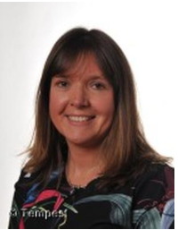 | Shelley Bamford  Headteacher
 | Samantha Joseph  Chair of Governors |  | Catherine Vanderson  SEND Governor

Definition and Types of SEND

A child has special educational needs if they have a significantly greater difficulty in learning than the majority of children of the same age, or if they have a disability, which has a long term and substantial adverse effect on their ability to carry out normal day-to-day activities.
Additional and/or different provision is currently being made in our school for children with a range of needs, including:
  Communication and Interaction –  autistic spectrum disorder, speech,  language and communication needs |   Sensory, Medical and Physical –  children with; hearing impairment, sensory processing difficulties, epilepsy.
  Cognition and Learning –  children with moderate learning difficulties  or specific learning difficulties |   Social, Emotional and Mental Health – children demonstrating attachment difficulties,  attention deficit hyperactivity disorder.


Accessibility

As a school we are happy to discuss individual access requirements.
- For more information, please see our Accessibility plan available on the policies section
of the website.


Admissions

Parents wanting their child to join our school must apply directly through Warwickshire Admissions via this link.
Moving schools within school year
Parents with children higher up the school – Years 1-6 must also apply directly to Warwickshire Admissions by completing the online form online. Alternatively, you can contact admissions on 01926 414143.

SEND staff contact information

All the staff are dedicated to providing our children with the very best education and life experience possible. There are a range of expertise and talents throughout the staff which greatly benefit the children as they move through the school. Together, we work hard to achieve success and we are committed to the development of every child in partnership with parents, carers and the community.
If your child has Special Educational Needs and/or disability and you would like to know more about our provision, please contact the school office on 01564 742284 alternatively via email: tanworthschool@welearn365.com

 | Paul Fidler  SENCo  fidler.p@welearn365.com  My name is Paul Fidler and I have been the SENCo at Tanworth in Arden C of E since September 2024. I am currently studying for the NPQ SEN and have been a qualified teacher for 16 years, the last 9 years within Warwickshire. I also teach across the school in addition to the SENCo role. I am passionate about the opportunities we provide for our children and want to ensure they have the best possible outcomes.  My role at Tanworth includes:  Coordinating all the support for children with special educational needs and or disabilities (SEND) and developing the school’s SEND Policy to ensure all children get a consistent, high-quality response to meeting their needs in school.  Ensuring that you are involved in supporting your child’s learning, kept informed about the support that your child is receiving and involved in reviewing how they are progressing. Providing specialist support and organising training for teachers and support staff in the school to enable them to best support your child and help them reach their potential. Maintaining the school’s SEND support list and making sure that there are detailed records of your child’s needs and progress. Liaising with all the other people who may be coming into school to help support your child’s learning.

Assessment and Identification

Early identification of children with SEND is our priority. Our school promotes a graduated approach to assessing, identifying and providing for children’s special educational needs. This approach follows a model of action and intervention to help children make progress and successfully access the curriculum.
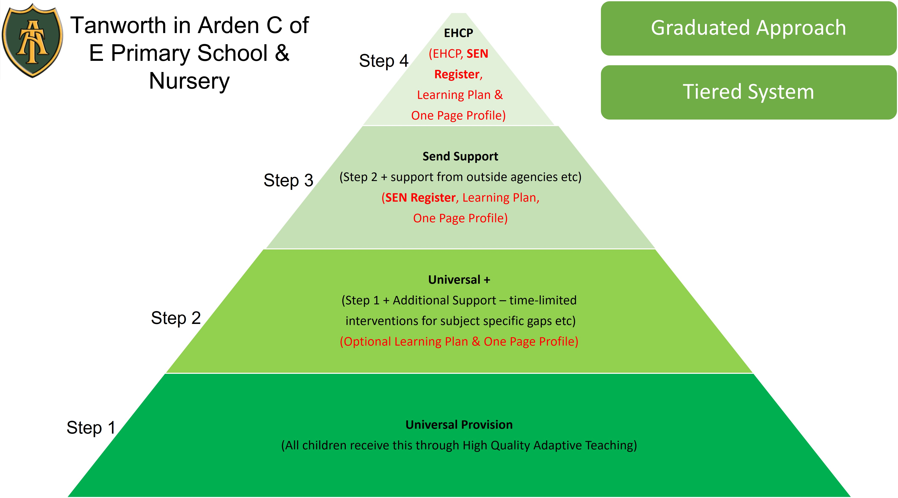

Our Graduated Approach
All children receive our Universal provision, which is access to a high-quality adaptive teaching (HQAT). HQAT involves responsively adjusting lessons based on real-time assessment to meet all students' needs, ensuring everyone has access to the same ambitious learning goals. It requires teachers to maintain high expectations, use flexible grouping, and implement strategies like immediate feedback, targeted questioning, and providing scaffolding or extension activities as needed, rather than assigning different tasks to different groups.
All teachers carefully monitor the children’s progress on a daily basis as part of the ongoing learning and teaching that happens in the classroom. Formal progress meetings and discussions take place each term enabling us to track and identify children who require extra support.
If a child needs support, they will be placed on our monitoring register and we will put support in place through time-limited interventions to address specific or short-term gaps in learning or specific needs.

Some of the early identification processes we use are:
- Liaison with previous nursery/schools
- Concerns raised by parents and carers

- Concerns raised by class teachers and teaching assistants
- Teacher assessment and baseline assessments
- Screening tools e.g. Phonics
- Regular teacher assessment
- Liaison with external professionals
- Communication from medical professionals and parents and carers
- Thrive screening

If a child needs to be placed on the SEND Register, this means that they need support which is ‘additional to or different from’, often being more long term and sometimes involving external support. All children accessing SEND support who are identified as having SEND have an individual Learning Plan, which is reviewed termly. Their Learning Plan contains information about their strengths, needs, appropriate resources and SMART targets that they are working towards. When providing support that is “additional to” or “different from” we engage in a four-stage process:

ASSESS  Identify pupil strengths and needs to inform effective planning and appropriate provision. | 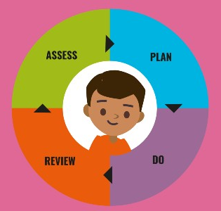 | PLAN  Use assessment information and views to plan teaching approaches.
REVIEW  Teachers carefully review pupil progress and how effective the support  has been. |  | DO  Implement the support  and gain a greater understanding of how  the pupil learns.


One Page Profile
All children on the SEND Support Register have a pupil profile called ‘One Page Profile. This document is important to ensuring all members of staff working with the child have a good understanding of their needs.


Learning Plan
Also, children accessing specific support for their SEND needs will have a ‘Learning Plan’ that is reviewed termly. Their Learning Plan contains information about the SMART targets that they are working towards.
Children, who have an EHCP, will have a ‘Learning Plan’ that will review the outcomes and small steps set out in their plan.
For further information please see the SEND policy available on
our website.


Education, Health and Care Plans (EHCP)

When a child is demonstrating a significant cause for concern or their learning need is more complex and persistent than can be met by the interventions already put in place, statutory assessment will be considered. The Education, Health and Care Plan outlines any special educational needs a child has, and the provision a local authority must put in place to help them.
An application for an EHC Needs Assessment is made via the school SENCo in ongoing collaboration with the learner, parents and external professionals involved. The request is made to Warwickshire Local Authority. The process is defined by a specific timescale and statutory procedures.
In some cases, parents can begin the EHCP process themselves through direct communication with the local authority; however, at Tanworth we strive to work closely together with parents in order to ensure that any request made is well-timed and appropriately evidenced. Once an EHCP request has been made, SENDAR have 20 weeks to make a decision.
Please see the Warwickshire website for further information about EHCP and the process.


Provision

Each class teacher plans lessons to consider the specific needs and preferences of all children in their class, in order to ensure that their needs are met through quality first adaptive teaching. We are an inclusive school and children are taught alongside their peers. Class adaptations can be seen in a variety of ways:
- Children may be taught in a variety of settings, including small group work, peer collaboration and one-to-one working with teachers or support staff. Where necessary, children with SEND are supported in class by our teaching assistants as well as accessing interventions out of class.
- Content of the lesson including a range of activities suited to different abilities with a range of expected outcomes from individual children.
- Teaching style (taking into account that children may be visual, auditory or kinaesthetic learners).
- Pace and format of the lesson.
- Provision of alternative recording methods; scribing, use of technology, mind mapping, photographic evidence.
- Materials and resources used and level of support provided.
Teachers adapt their high-quality teaching to cater for their pupils’ needs and plan individual timetables where necessary. When appropriate, staff are deployed to give children additional interventions in small groups outside the classroom, or to provide 1:1 support. Individual adaptations are always considered for children with SEND, which are outlined in the children’s ‘One Page Profile’ or ‘Learning Plan’.

What expertise and training do our staff have to support children with SEND?
All of our teachers are fully qualified and have undertaken additional specialist professional development.
Within school we have staff trained in a range of different areas, such as:
- The Thrive Approach
- Neurodiversity (AET)
- Speech and Language
- MOVES
- Team Teach
A number of teaching assistants support specific children on a one-to-one basis. We ensure that these TAs are highly supported by external support services who offer advice on support programs, strategies and latest developments.

Examples of interventions available to SEND children include;
OT Fine Motor Programmes  | Time to Talk (SALT)   | OT MOVES  
Personalised Speech and Language Support (SALT) | NELI  (Early Language Intervention) | Nessy- Spelling
  Personalised Aided Language Resources (AAC) |   EPATT  Reading, Spelling and Maths |   Toe by Toe Reading
 |  | 
 | As well as others…

What resources do we use to support children?
Our close working relationship with external support services leads to excellent advice and strategies to support children with SEND. We act upon advice received and will implement adaptations, resources and strategies as required.
This may include resources that are part of our Universal Provision and available to all children:
  Ear Defenders |   Therabands |   Wobble Cusions
  Fidgit and Focus |   Task Management Boards |   Coloured Overlays / Books
  Visual Timetables /  Now and Next Boards |   Alternative  Communication | 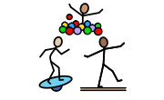  Sensory Circuits
Movement Breaks |   Writing Slopes |   Word Banks / Check-Lists

We endeavour to ensure that all classrooms are communication friendly therefore supporting children with a range of SEND needs.

Activities Available

Extra-Curricular
We have a range of extra-curricular activities available to all children at our school. These clubs change depending on the term and can be Key Stage specific. These include:
- Choir
- School orchestra
- Football
- Netball
- Lego club
- Eco-Warriors
- History Detectives


Residentials
All children in Years 6 have the opportunity to take part in an exciting residential trip. Staff escorting children on these experiences are highly knowledgeable and experienced in supporting children away from home.
We see these trips as opportunities for all pupils to build confidence, independence and create lasting memories alongside their peers.

Sporting events

We enjoy sports at Tanworth and we enable children to take part in a range of sporting activities whatever their need or disability.


Evaluating the effectiveness of SEND provision

The effectiveness of SEND provision at Tanworth analysed and reflected upon as part of the school monitoring and evaluation cycle which includes analysis of pupil data, regular learning walks, lesson observations, pupil interviews and monitoring by the Governing Body.
Termly meetings take place with class teachers and the Senior Leadership Team to discuss progress of all children. Additionally, all interventions are monitored and evaluated to assess impact and positive outcomes for children.
We use a variety of indicators to measure the progress that all children make including teacher assessments, evidence in books, standardised assessments and, for SEND children, progress towards their individual targets as detailed on Learning Plans.
Progress is regularly shared with parents through; termly parents’ evenings, termly SEND reviews, progress meetings, informal meetings and end of year school reports. Parents are actively encouraged to speak to class teachers and ask how their child is progressing.

Emotional and social development of children with SEND

As a school we recognise the importance of supporting all children with their emotional wellbeing and social development. Social and emotional wellbeing creates the foundations for healthy behaviours and educational attainment.

Emotional development for children at Tanworth-in-Arden, including those with SEND, is primarily supported through the ‘Thrive Approach’ and ‘Jigsaw PSHE’.
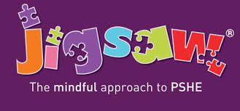
Thrive focuses on identifying and addressing gaps in emotional development through personalised strategies that build resilience, self-regulation, and confidence, ensuring children feel safe and valued. Jigsaw complements this by delivering a whole-school PSHE curriculum that teaches emotional literacy, empathy, and mindfulness, while promoting positive relationships and inclusive discussions. Together, these approaches help children manage emotions effectively, develop social skills, and foster a sense of belonging within the school community.
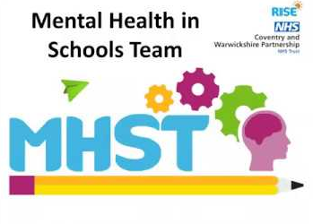
At Tanworth-in-Arden, teachers and the SENCo work closely to support children with social and emotional needs through tailored strategies and inclusive practices. In addition to classroom support, we have a qualified school counsellor who visits one day per week to provide targeted emotional support for pupils who need it. We also work in partnership with the Mental Health in Schools Team to ensure early intervention and specialist guidance. Mrs Bamford, our designated Mental Health Lead, oversees this provision and coordinates whole-school approaches to promote well-being and resilience among all children.


Anti-bullying

At Tanworth-in-Arden, we have a clear and robust anti-bullying policy that promotes a safe, respectful, and inclusive environment for all pupils. The school takes a zero-tolerance approach to bullying and ensures that any concerns are addressed promptly and effectively. Staff are trained to recognise and respond to bullying, including the additional vulnerabilities that children with SEND may face. Our aim is to create a community where every child feels valued and supported, free from fear or discrimination.

Click here to see our Anti-Bullying policy.


Raising a concern

If you have any concerns regarding your child, please seek support from your child’s class teacher. Alternatively, you can speak to Shelley Bamford (Head Teacher) or Paul Fidler (SENCo). For more information about our complaints procedure please follow this link.

External support services

Should a child require support from an external support service we are able to access advice, information and support from a number of agencies, including:
 | SALT  Speech and Language Therapy  https://www.swft.nhs.uk/our-services/speech-and-language-therapy-children
 | CAMHS/RISE (Child & Adolescent Mental Health Service)  https://cwrise.com/
 | EPS (Educational Psychologist Service)  https://schools.warwickshire.gov.uk/early-help-targeted-support/educational-psychology-service/1
 | SENDAR (SEND Assessment and Review Service)  https://www.warwickshire.gov.uk/contactussendar
 | IDS (Integrated Disability Service)  https://www.warwickshire.gov.uk/ids
Occupational Therapy
https://www.swft.nhs.uk/our-services/occupational-therapy-children

Child and parental involvement

At our school, parents are actively encouraged to be partners in their child’s education; we see this as vital if the children are to get the support and encouragement, they need to make good progress. We recognise that it is important to involve all children, regardless of SEND, in their learning and in the decisions that are made about our school and the educational experience we provide.
As long as a child remains on the SEND Register, parents are encouraged to be actively involved in reviewing their child’s progress by contributing to the decision making for their child. Termly review meetings are arranged for this purpose. The meetings are an excellent way to review each child’s progress, celebrate their effort and plan next steps in their education. Parents, teaching staff, support staff and external support services are invited to reviews. Teaching staff in collaboration with the child will discuss progress towards SMART targets, plan next steps and create a personalised ‘Learning Plan’. These often take place alongside the Parents’ evening.
Parents’ evenings are held each term where all teaching staff are available to discuss a child’s progress with their parent’s/carers. Our parents appreciate the schools ‘open door’ policy whereby appointments can be made to speak in more detail to the class teacher or the SENCo. These can be arranged by popping into the school office or via telephone or email.

SEND Coffee Mornings


We are currently developing SEND coffee mornings in collaboration with Warwickshire Parent Carer Voice. This is a chance for families to get together in a relaxed, familiar environment; meet new people and find out information about SEND.

PINS Project
This year we are taking part in the PINS Project (Partnerships for Inclusion of Neurodiversity in Schools). A new, national project which will develop multi-agency collaboration and strengthening of parent carer and school partnerships in mainstream education settings, focusing on supporting neurodiverse pupils.
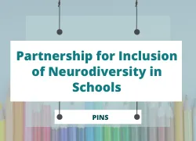
The PINS project will bring health and education specialists and expert parent carers into mainstream primary settings to:
- Help shape whole school SEND provision.
- Provide early interventions at a whole school level.
- Upskill school staff.
- Support strengthening of partnerships between schools and parent carers.

Parent Workshops
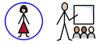
Over the year we plan a number of ‘parent workshops’ which are available to all parents. These have previously covered a range of topics including Maths, Reading, Phonics and Writing.
More information about forthcoming sessions is available on the school’s calendar, newsletter or by contacting the school office.

Transition

We recognise that ‘moving on’ can be difficult for a child with SEN/and or disabilities and take steps to ensure that any transition is as smooth as possible. Links with our feeder childcare providers and transfer schools are good due to our close liaison with them.
Transition to our school
As a school, we actively consult with parents and the child’s previous settings so that we are fully aware of their SEND needs before they join us and can prepare for their transition. We have an ongoing consultation with teaching staff, support staff and other lead professionals so as to be able to provide the best possible academic, medical and social support for each child. Transition meetings are arranged as necessary with previous setting, parents/carers and external support services.
If your child has an EHCP
If your child already has an Educational Health and Care Plan (EHCP) or is currently awaiting the outcome of a request for an Education Health and Care Plan Needs Assessment (EHCNA), then we welcome and encourage families to come and have a tour of our setting. This opportunity will also allow us to talk about your child’s individual needs in more detail and look at the targeted and specialist provision they require.
Secondary transition
When the time comes for children with SEND to move on to the next phase of education, we consult with parents/carers and the children themselves to facilitate a successful transition. We liaise with their new school during the Summer Term and
The program is designed to; tackle relevant issues that cause anxiety with regards to transition, build confidence, encourage independence and create a positive transition experience. The program includes an additional informal visit to their secondary school where they take photos and can ask questions (where possible), research into their new school to develop a presentation, creation of interview questions for Secondary staff, drama, role play and ‘what if?’ scenarios, all about me passports, thoughts and feelings discussions, art and visits from secondary representatives. All children take part in a ‘Moving up’ day where they attend their secondary placement for the day and where necessary additional visits are planned both with and without staff support.

Transition between Year groups and phases within school
During the summer term there are transition meetings within school across year groups and phases. Handover meetings take place in which all relevant, key information is shared with the child’s new class teacher. This includes sharing of relevant documents and information. SEND children’s ‘One Page Profile’ document and ‘Learning Plans’ are passed on to new class teachers and each child’s needs are discussed in depth.
During the Summer Term children who require additional support with transition are encouraged and supported to make additional visits to their new class to familiarise themselves with staff and the environment. Where necessary additional transition resources are created alongside the child for example, transition books that are taken home over the summer holidays.

Useful contacts

SEND Local Offer  Warwickshire’s local offer can be obtained from the Warwickshire website, this details information relating to education of children with SEND as well as local resources and services.  https://www.warwickshire.gov.uk/send | 
Family information service  The Family Information Service offers free support, advice  and signposting for all families with children and young people aged 0-25 years.  https://www.warwickshire.gov.uk/children-families | 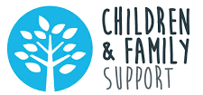
SENDIAS  Warwickshire SEND Information, Advice & Support Service supports parents & carers of all Warwickshire children SEND, whether they are of pre-school age, or in a mainstream or  special school.  https://www.warwickshiresendiass.co.uk/ | 

