sporty ed’s NEWS
how Teddy edward celebrated ve day!
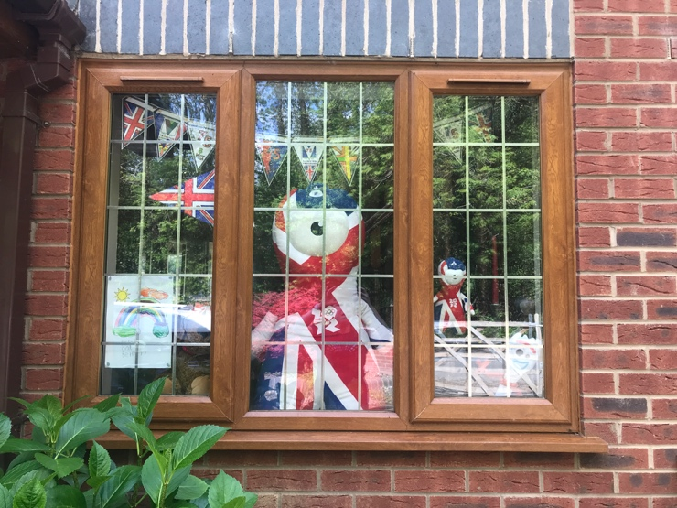  Bunting Flying High  Edward Hulse  Despite the country being in lockdown VE Day celebrations continue with decorated windows and picnics on your front lawn.   | 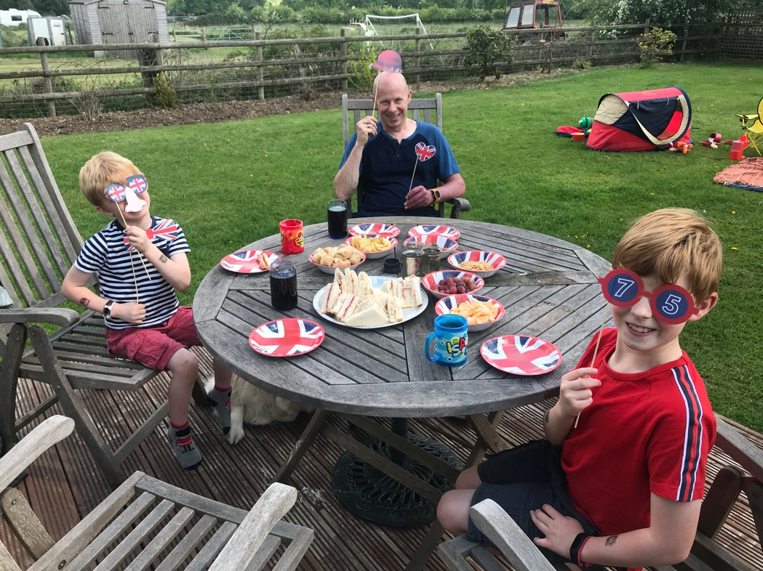  Red White & Blue Rules!
 | Edward Hulse  The VE day wardrobe was carefully selected to ensure that Red,White and Blue was incorporated into all clothing! Notice the attention to detail with Beefeater socks!  Warmed croisants with strawberry jam were served for breakfast and 2 minutes silence adhered to at 11am marked by the firing of a cannon in London.  A small History lesson followed as both Isaac and Edward had many questions about, soldiers, bombs and bunkers! | 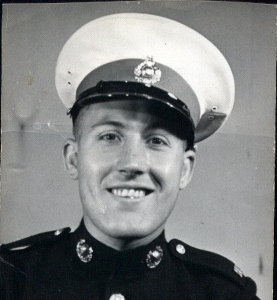  Sergeant William J Halifax Royal Marine
sporty ed’s ve day news
fire pits | cycling | Celebrations

VE Day Movie spectacular! |  | An Interview with Sporty Ed  Mummy  “What did you enjoy most about VE Day?”  “I really liked the movie and the fire which went really high and really low!”  What did you learn about VE Day?  “To wear Red, White and Blue to celebrate the Army”  “People lived in Bunkers”  “The Army killed baddies!”  Do you think the Soldiers were brave?  “Yes, because they went in the Army”  “The Army had no choice about fighting”  If you met a WWII Soldier what would you ask him?  “What kind of food did you eat?”  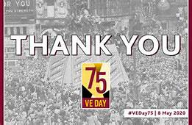  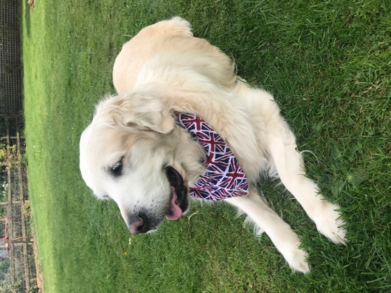  Patriotic River  
Edward Hulse  The Celebrations continued all day. We listened to Prime Minister Churchill address the nation at 3pm and then went outside to enjoy a BBQ and movie spectacular. Edward helped Daddy build a fire pit and we took the TV outside. We watched 2 movies! Despicable Me 2 and Scooby Doo Two! We were chilling on the logs in the play area whilst the sun set and the stars came out!  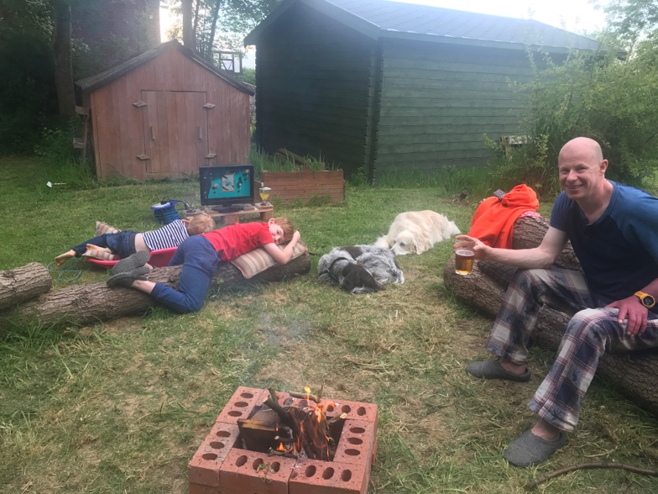  Time for a movie or two!  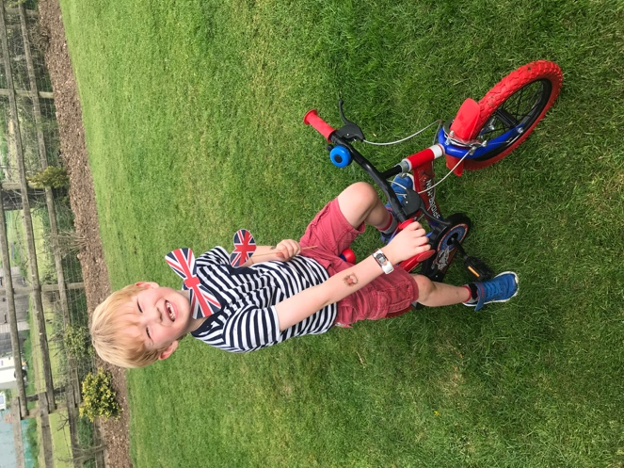  Cycling for Victory  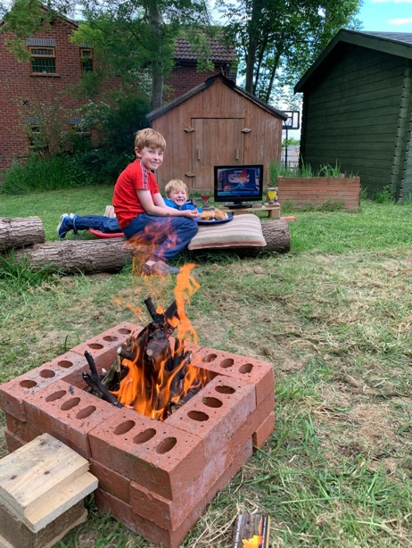 | 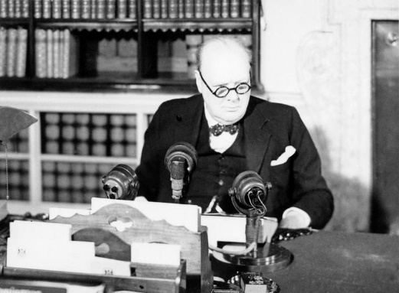  Winston Churchill VE Day Speach    Collecting sticks for the fire  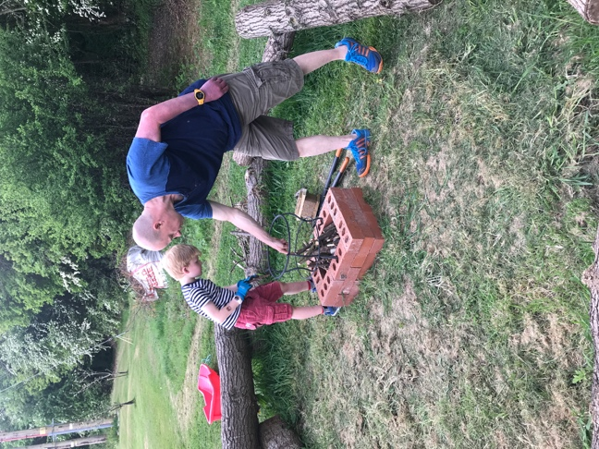 Building the Fire  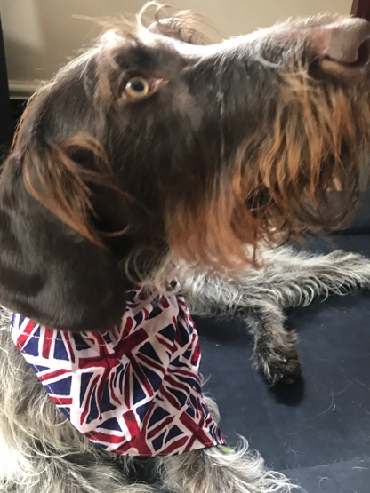  Patriotic Walter

