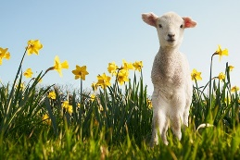
First of all, I would like to wish you all a Happy New Year! I hope you all had a good break at Christmas and enjoyed the festivities of the season. I would like to say a huge thank you for the generous gifts you gave me for Christmas. It was really kind of you all and much appreciated. Thank you so much for all of your well wishes too with my baby news! Since coming back after Christmas, the children have enjoyed discovering their new topic on ‘Explorers’ through our ‘Sparkly Start’, which we held last week. Thank you for your continued support. It is appreciated! Mrs Woodward 😊


Year 2 Spring Newsletter
13.01.25

Dates for your Diary
Tuesday 10th February- Parents Evening
Thursday 12th February- Parents Evening
Friday 13th February- break up for half-term
Monday 16th-Friday 20th February- half-term
Monday 23rd February- Spring 2 begins
Friday 20th March- Home learning due
Monday 23rd March- Home learning gallery after school
Tuesday 24th March- Home learning gallery before school
Friday 27th March- Easter service & break up
Monday 30th March-Friday 10th April Easter Holidays
These dates are accurate at time of press; We will notify you of any changes in advance.

Spring Term Theme
Our new theme for the Spring term is ‘Explorers and the Caribbean’ which is a mixture of both History and Geography based learning. The first half term, we will be discovering the intrepid explorers Shackleton and Ranulph Fienes with a History focus, with the second half term focussing mainly on the Geography of the Caribbean, it’s location in the world and features. This will include mapwork and also some comparing and contrasting.

Home Learning
It was fantastic to see the amazing home learning that the children produced last term. They thoroughly enjoyed showing the class all their hard work. Well done! This term’s home learning has been sent home with the newsletter and is due in on Friday 20th March and will be shown in the hall after school on the 23rd of March and before school on the 24th of March.

Hello



Topic Web & Vocabulary
You will find on a separate sheet, an overview of what we will be covering this term. This also includes a list of key questions we will be answering as part of the topic work and some important vocabulary that your children will be covering. We are not expecting you to answer all these and research them, but they are there to give you an idea of what we are doing!

Lost property
Please remember to label all of your child’s belongings, including jumpers, school clothing, jackets, hats, lunchboxes and water bottles. With lots of children having similar items, labels help us quickly return lost property to its owner and keep everything organised in the classroom. Thank you for your support!
Forest School & PE
For the foreseeable future we will continue with Forest School on a Wednesday afternoon and PE on a Thursday, so please stay with the existing arrangements unless you hear otherwise.

Thank you & PLEASE!
A huge thank you to all the parents who have supported Forest School during the Autumn Term by being the parent-helper on Wednesday afternoons. We are now looking to setup the rota for Spring Term, so please let me know if there are any Wednesday afternoons you can help with. Many thanks.

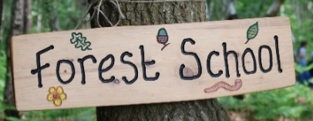
We
Reading & Reading Diaries
Please remember to put your reading book and reading diary in your bag each day. You never know which day you are going to be called to read! Please also don’t forget to put your book in the box first thing in the morning if you need to change your book.

Staff in Year 2
Teacher: Mrs Woodward Teaching Assistant: Mrs Coffey (Mon-Fri mornings)
We have an open door policy, so please feel free to come and speak to us at the start of the day or when you pick your children up if you have any worries or concerns.

