
Welcome back to the Summer Term! I hope you all enjoyed a restful Easter break. We have completed the last of our Spring topic on ‘Explorers and the Caribbean’ and are moving into ‘Nurturing Nurses’, which I know the children are going to find really interesting. We have a busy term ahead of us with lots of learning and many activities, as you will see by the list of key dates. Thank you for your continued support, as always. Mrs Woodward


Year 2 Summer Newsletter
17.04.26
Summer Term Theme
Our new theme for the Summer is ‘Nurturing Nurses’. We will be exploring and comparing the lives of Florence Nightingale, Edith Cavell and Mary Seacole and how their actions changed nursing.
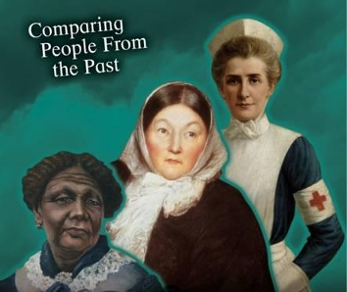

Key Dates
Monday 4th May School and Nursery closed for Bank Holiday

Monday 11th May-Friday 15th May KS2 SATS week

Friday 22nd May break up half-term

Friday 22nd May Class photographs

Monday 1st June Teacher Training Day

Tuesday 2nd June School and Nursery open

Friday 5th June Non-school uniform donations for Father’s Day shop

W/C Monday 8th June Phonics screening

Friday 12th June Sports Day (weather permitting)

Friday 19th June Father’s Day Shop £2.50

Friday 19th June Home learning due

Monday 22nd June Home learning gallery after school (in classroom)

Tuesday 23rd June Home learning gallery before school (in classroom)

Friday 26th June Year 6 Big Sell

Monday 29th June Friday 3rd July Year 6 Residential

Friday 3rd July Shine Day Reception to Year 5 (details to follow)

Wednesday 8th July Move up day/Secondary induction

Thursday 9th July School discos and Year 6 Leavers Disco

Friday 17th July Children break up for Summer Holidays

Monday 20th July Teacher Training Day
These dates are accurate at time of press.

Forest School & PE changes!

Forest School is changing to a Thursday this half term. Many thanks to those who have volunteered to help with Forest School in our Spring term. It’s not too late to volunteer for this term if you want to volunteer and have fun with the children!
Please note that this now means that PE is now on a Wednesday.

Hello


Hot weather
As the weather continues to get hotter, please remember to send your child to school with a hat to protect them from the sun. Please apply sun cream before they come to school.

Topic Web & Vocabulary
You will find on a separate sheet, an overview of what we will be covering this term. This also includes a list of key questions we will be answering as part of the topic work and some important vocabulary that your children will be covering. We are not expecting you to answer all these and research them, but they are there to give you an idea of what we are doing

Reading & Reading Diaries
Each child should be reading for 10 minutes each night as part of their homework. Please remember to put your reading book and reading diary in your bag each day as you never know which day you are going to be called to read. Please don’t forget to tell us first thing in the morning if you need to change your book or take a quiz.

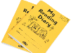


Spellings
A change in the spelling quiz day
Please note that spelling quizzes will now be taking place on a Friday. The children will receive their new spellings for the following week as normal on this day.

Staff in Year 2
Teacher: Mrs Woodward Teaching Assistants: Mrs Coffey (mornings)
Please remember that we have an open-door policy, so please feel free to come and speak to us at the start of the day or when you pick your children up if you have any worries or concerns. Thank you so much for your continued support.

