Sergeant Major Fredrick Charles Wiggett
My Grandma’s dad served in Burma and Rangoon in WWII on the front line in the artillery, he was still at war when my Grandma was born and did not see her until she was a toddler.
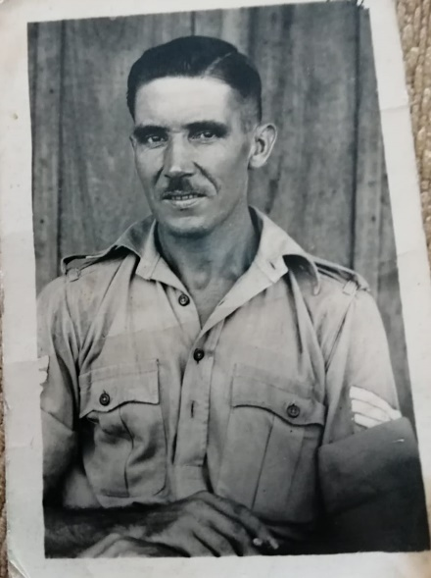

Navigator and Rear Gunner Frank William Tear
My Grandad’s dad served in the Fleet Air Arm and flew in a Fairy Swordfish, he wanted to be a pilot, but he had bad hearing, so he became a navigator and rear gunner. Unfortunately, whilst on a training exercise in Arbroath there was a mid-air collision killing all, on both planes. My great Grandad was 25 when he died leaving behind my great Grandma and my Grandad as a baby.
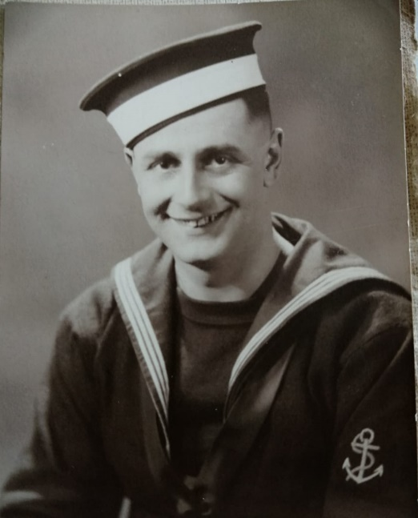

Lance Corporal Jack Jones
My Nanny‘s dad served in the Royal Engineers and was an Engineer and driver in Germany and France, he was a Bat Man (a soldier assigned to an officer as their assistant) to Field Marshal Montgomery. My Great Grandad also drove a half track truck, which unfortunately killed 5 of his men when they drove over a mine, which injured him, but he survived and after months in hospital returned home.
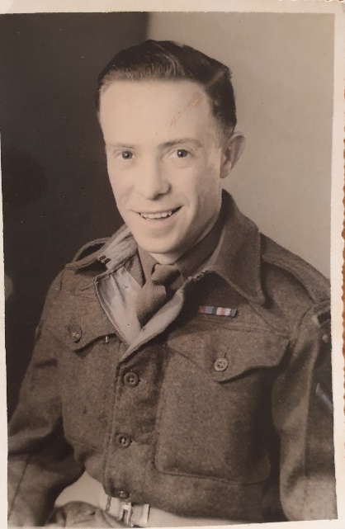

Leading Aircraft Man Harry Bright
My Grandad’s Dad was in the RAF from 1939 – 1946, he as an Aircraft Mechanic and worked on Radar. He served at RAF Scampton and RAF Coningsby. Here is a photo when he got married.
