Virtual Christmas Music Concert
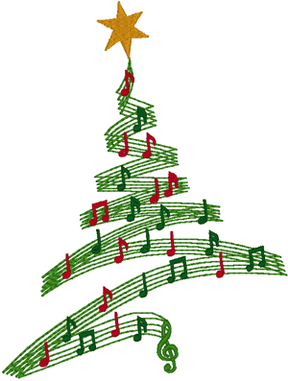
We would usually hold a concert towards the end of the Autumn term to showcase the wonderful musical talents that our children have and get us into the Christmas mood. As we are not able to have peripatetic music lessons at the moment, we can’t gather in the same hall and the blowing of wind instruments is not possible, we are going to hold a virtual music concert.

If you play an instrument, whether it is a piano, keyboard, recorder, flute, clarinet, guitar, drums or the tuba, why not get practising a Christmas piece of music, then ask your parents to record you playing it. Don’t forget, your voice is an instrument too!
Please record it in landscape mode, so the phone or tablet is long and wide and then send it to tanworthschool@welearn365.com letting us know the name and composer of the piece.
We will collate all your pieces of music into a concert that we can share in school and with the parents.
Please note that the music concert will be shared on Facebook and on the school website, so please do not send in a recording if you do not wish your child to be seen on these.
All videos will need to be submitted by 3pm on Wednesday 9th December and please only submit if you are happy for your child’s music to be shared electronically with the school community.

Many thanks,
Mr Fidler

