GREEN LANE NEWS
how wwii affected the HALIFAX-HULSE’s
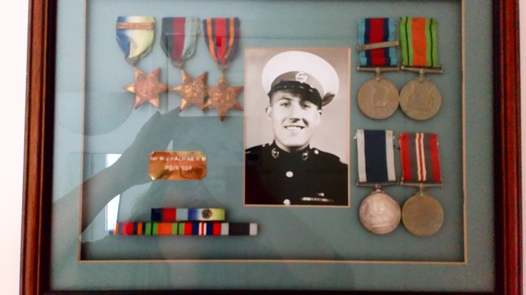  Our own War Heros  Isaac & Edward Hulse  Great Uncle Bill Halifax – Royal Marines  Great Grandpa Hulse – 1st Airborn Division  Great Nanny Hulse – Police  Great Grandad Halifax –Home Guard  Great Grandad Lillycrop – Lieutenant Colonel  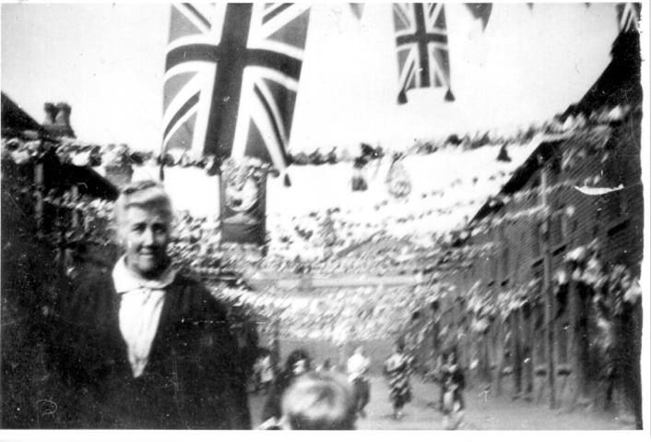  Great Great Granny hits the streets to celebrate | 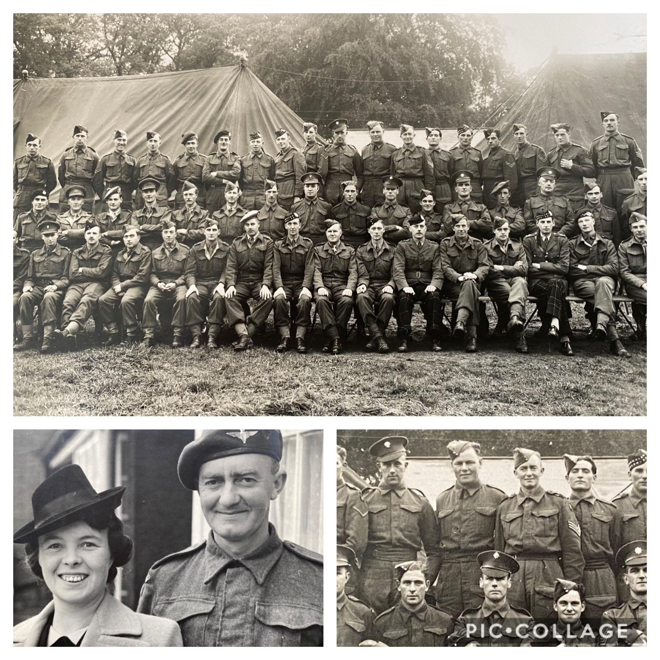  Service on HMS Belfast
 | Isaac & Edward Hulse  Great Uncle Bill before joining the Royal Marines was in a Reserved Occupation but was so determined to serve his country that he changed career and bacame a Sergent in the Royal Marines. He served on HMS Belfast between 3rd November 1942 and 13th September 1944. He was involved in Operation Neptune which was the Naval part of Operation Overlord- D Day! 6th June 1944 HMS Belfast’s bombardment covered Gold Beach and 3 miles westward of Courselles. | 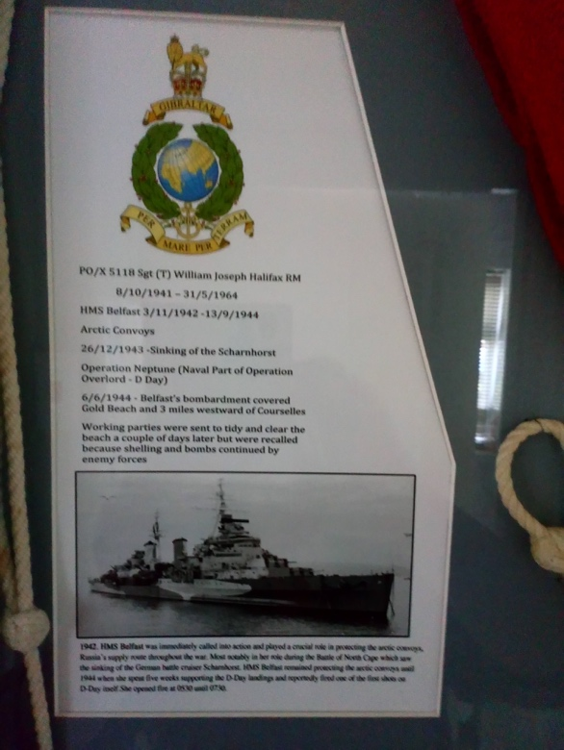
Halifax-Hulse WWII History
a snippet of our family history | wwII | heroes & Heroines

Great Nanny made Bren Guns! |  | An Interview with Aunty Fran  ISAAC & EDWARD HULSE  5th May 2020  Grandad was born in April 1939, so he was only a baby when the war broke out in September 1939. He grew up with the war being his normal life until the age of five. He lived in Smethwick, Birmingham which was an industrial area and near lots of factories that the German's wanted to bomb. Therefore, he remembered spending nearly every night until the age of five in air raid shelters, not knowing if his house was going to still be there when he came out in the morning. Which must have been very scary. He said that lots of houses on his road were bombed and that they were lucky that it did not happen to them. I think because he was so young, only Edward's age this was his most vivid memory, although I also think it was a bit of an adventure.  Nanny was born in 1944, so towards the end of the war. But she remembers rations. She did not like Bananas for a very long time, because you could not get them during the war and they were a bit of an exotic fruit back then.  Great Grandad had a job at Garringtons Factory in Bromsgrove. This factory made Ammunition, so his job was called a reserved occupation, which is why he did not go to the frontline of war. People who had jobs that were essential to back up the war effort and to keep the country running e.g. farmers, bakers, teachers, grocers, bank staff and railway workers continued with their jobs as normal (like Mummy and Daddy are doing now).  However, Great Grandad was signed up for a second job which was a member of the Home Guard. He wore a uniform and received military style training. The Home Guard defended key targets like factories, explosive stores, beaches and sea fronts. He protected where he worked. They patrolled overnight to look out for potential invasions from the Germans and then warned the army, who would come and help.
Isaac & Edward Hulse  Great Nanny used to work in a button factory before the war broke out. But as we are experiencing a bit now with the Pandemic, people took on different jobs to help with the war effort. So, Great Nanny started working at Longbridge, which was a car factory. They made cars for the military, as well as aeroplanes and lots of other things like ammunition and guns. Great Nanny was picked out as one of the girls who was very good at making ammunition and chosen as one of a selected group to train to make Bren Guns. This was a very responsible and respected job. The Bren Gun was a light machine gun, used throughout the war.  Great Nanny used to cycle to work from Bromsgrove to Longbridge (on the outskirts of Birmingham) every day. That is nearly 8 miles and would take about 50mins. She was very brave as she cycled in the dark, as all the streetlights were turned off for the black out and she said that the only light was from bombs exploding in Birmingham. The girls used to get to work and hope that the factory had not been bombed during the night.  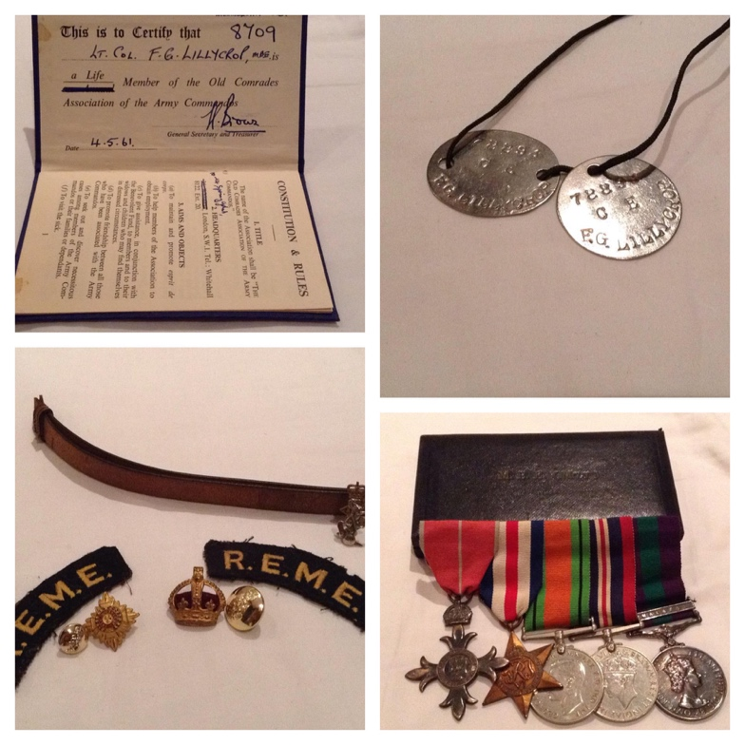 | 