For Parents/ Carers
We want to make your child’s time moving into a new class and time at school as easy, fun and interesting as we can. You can help by…

*Encouraging increasing independence by letting them become more responsible for their book bag, lunch box and coat and coming into school on their own.

*Listening to them read every day and talking about the story/ book.


*Please use Numbots as part of your child’s homework, we expect children to use Numbots for at least 25 minutes a week.

*The children will come home with phonics homework every week, please practise and go over sounds that we have learnt.



Things you will need in Year 1…
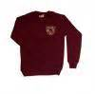Correct school uniform
*Ensure that ALL their possessions are labelled clearly with their name and check them regularly.
PE kits for indoor and outdoor PE.
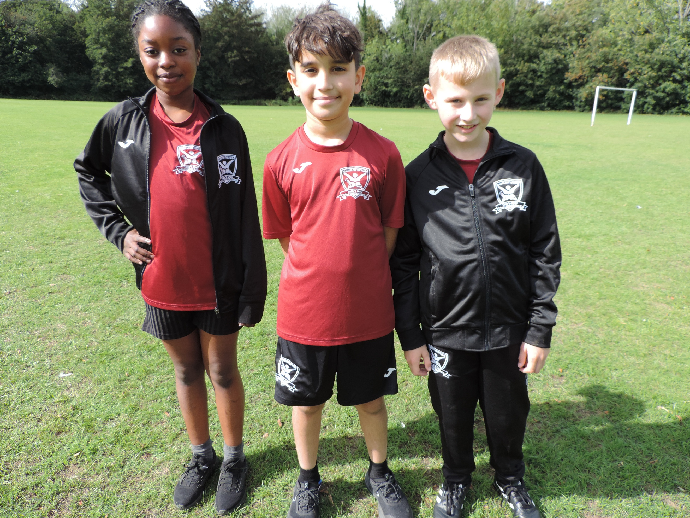
- Black shorts (Tany’s Dell logo or plain)
- Tany’s Dell burgundy round neck t-shirt
- Black trainers for PE/Games/Daily Mile
- Tany’s Dell tracksuit for cold weather
- Long hair to be tied back

PE Days are: Mondays & Wednesdays
Please remember all earrings should be removed and hair tied back on PE days.
Named book bag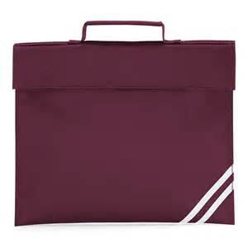
Children should bring in their book bag, with their zippy wallet in every day. Letters will be placed in their zippy wallet and reading books should be sent in every day.

Tany’s Dell Primary School

Welcome to KS1

Year One

In Coral Class the staff are Mrs Demirci, Miss Comiskey and Miss Batley.
Children will be given a daily piece of fruit or vegetables for their snack. Please provide a bottle of water for your child to have in class.

Year 1 are entitled to a free school dinner, please take up the offer. You can choose your child’s dinner on School Grid.
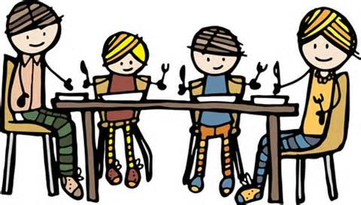
Parent pay
This can then be used later throughout the year for paid educational visits.

What we learn in Year 1 and how you can help…
*Phonic skills- when reading any words help your child sound them out and blend them together.
Use websites such as
www.phonicsplay.co.uk
www.letters-and-sounds.com
http://www.bbc.co.uk/schools/wordsandpictures/
These have information on phonics and lots of games you can play for free.

*Use the Phonics section on the school website to help your child with their sounds, tricky words and blending.

*General counting to 20 first and then onto 100. Practising number bonds (different ways to make the same number e.g. 1+4, 2+3, 3+2, 4+1, 5+0) Learning all the bonds to 10.

*Practising letter and number formation using the whiteboard in your child’s homework pack.

*The website www.ictgames.com has many literacy and numeracy games.

*Your child has access to Numbots for their homework. Their logins will be in the front of their reading diary. 
Children will be given a piece of fruit or vegetables for their snack and drinks of water during the day.
All KS1 children are entitled to a free school dinner now, please take up the offer.
There is a three weekly menu and the children are able to pick their dinner each day.
Please check the school website for updates and to find out what your child’s class has been doing.
www.tanysdell.essex.sch.uk

In Amber class the staff are Miss Pullin, Mrs Dunn, Miss Ismail and Mrs Cooper.
We are all here to help.

In KS1 we all Reach for the Stars by…
Ready to learn everyday
Expand and Challenge your mind
Aim high
Creative thinking
Have pride

Stay safe and happy
Trust and be honest
Accept and respect
Remember your responsibilities
See yourself as a star!


