For Parents/ Carers
We want to make your child’s time moving into a new class and time at school as easy, fun and interesting as we can. You can help by…

*Encouraging increasing independence by letting them become more responsible for their book bag, lunch box and coat and coming into school on their own.

*Listening to them read every day and talking about the story/ book. The children will change their reading books on a Monday and Friday (coloured sticker books) and their library books on a Wednesday.



*Completing the home learning games and activities sent home in a fun and informal way. Practising phonic and number skills regularly using your child’s home learning pack.



Things you will need in Year 1…
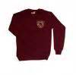Correct school uniform
*Ensure that ALL their possessions are labelled clearly with their name and check them regularly.
PE kits for indoor and outdoor PE.
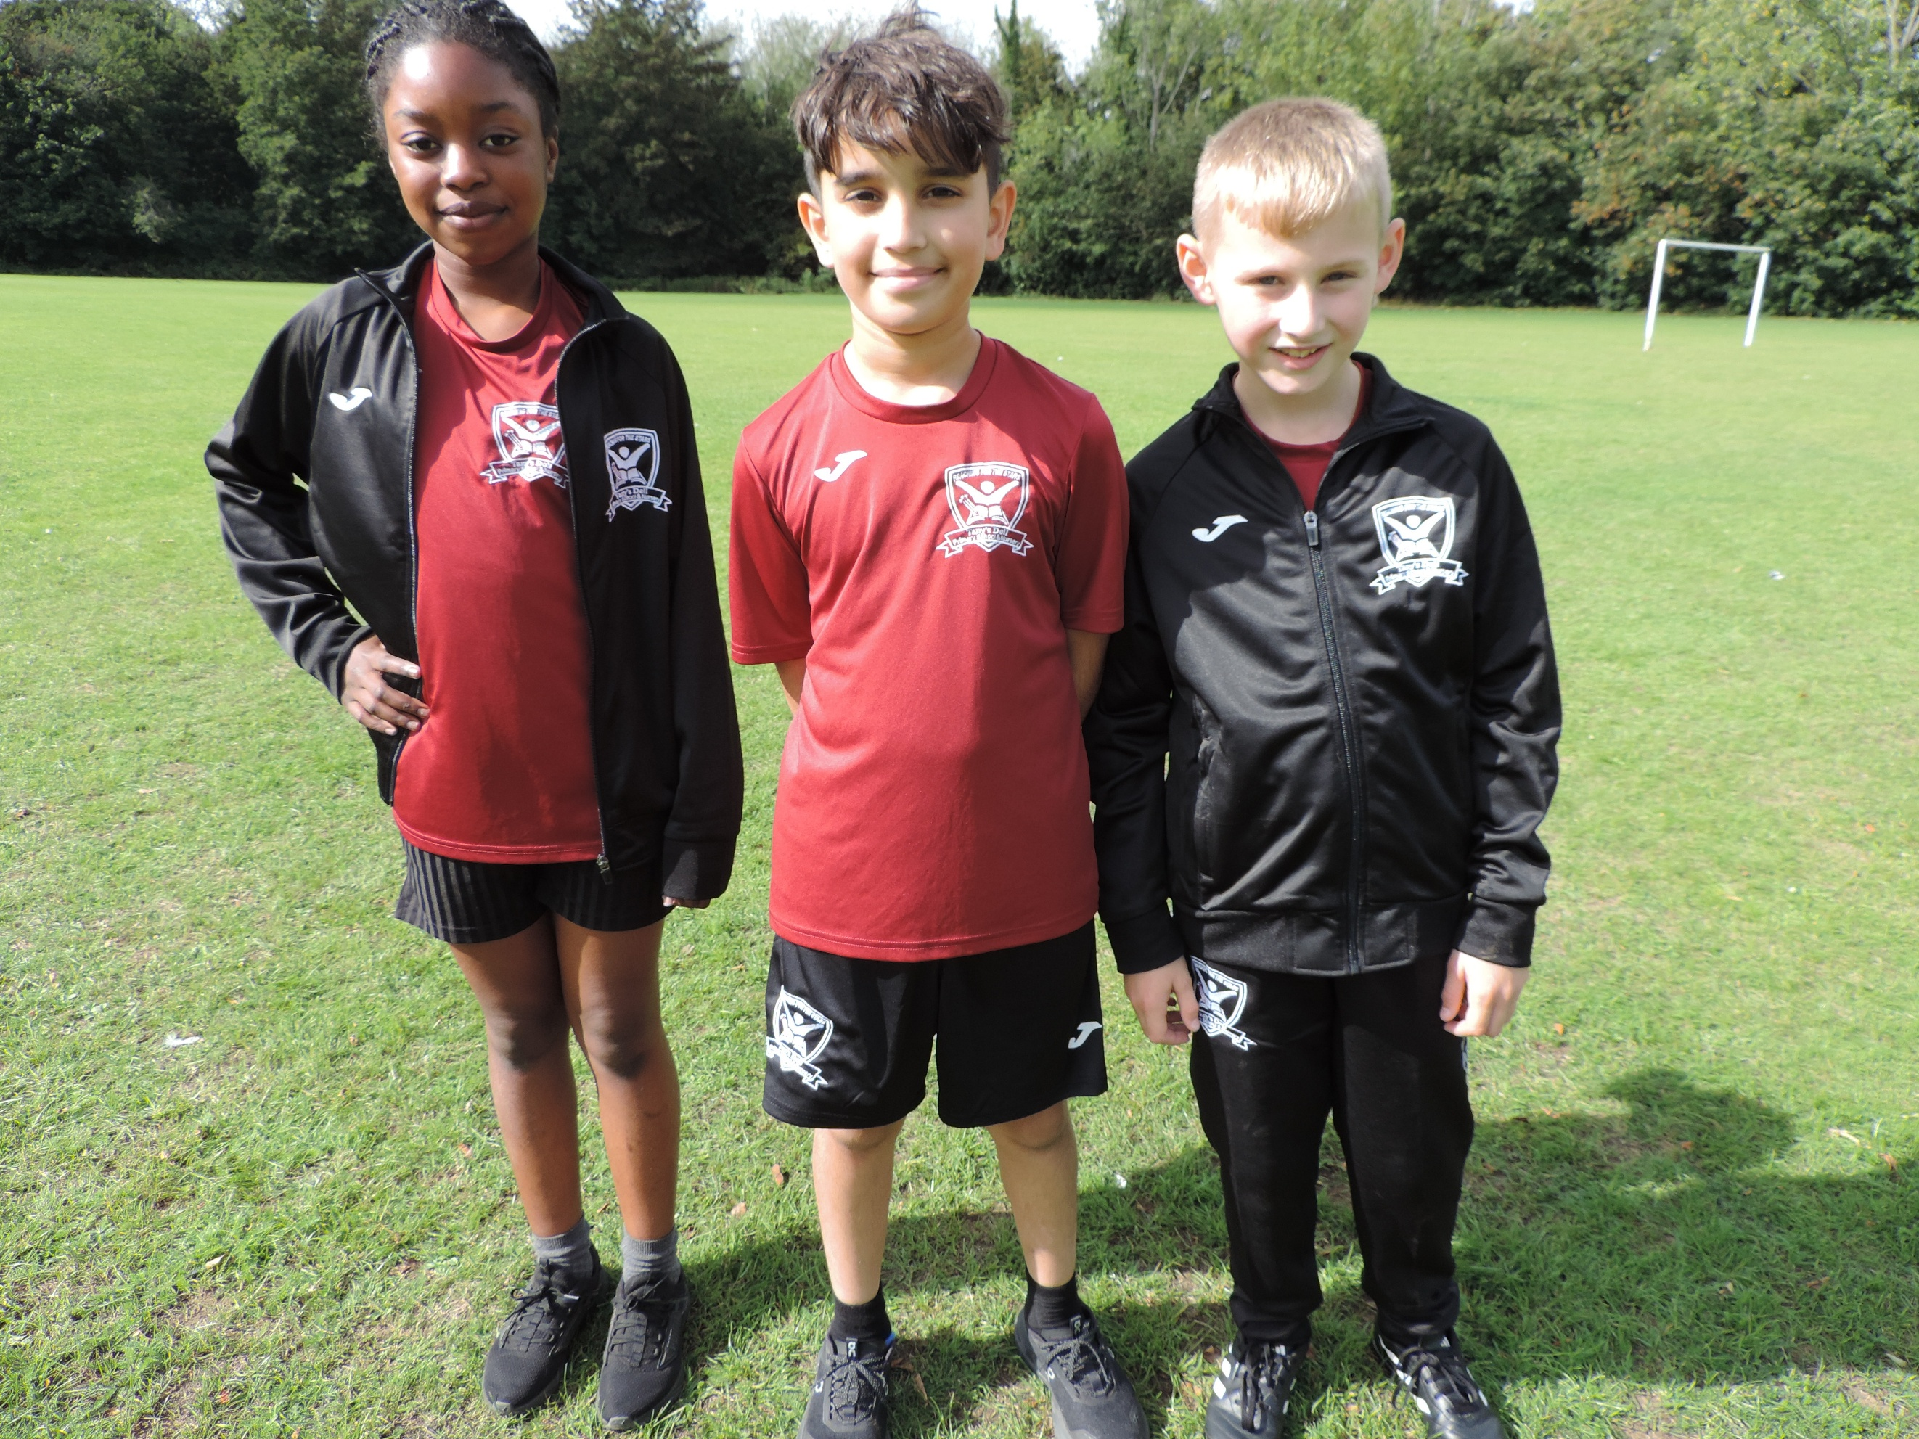
- Black shorts (Tany’s Dell logo or plain)
- Tany’s Dell burgundy round neck t-shirt
- Black trainers for PE/Games/Daily Mile
- Tany’s Dell tracksuit for cold weather
- Long hair to be tied back

PE Days are: Wednesdays & Fridays
Please remember all earrings should be removed and hair tied back on PE days.
Named book bag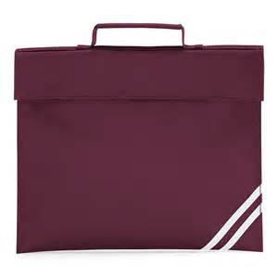
Children should bring in their book bag, with their zippy wallet in every day. Letters will be placed in their zippy wallet and reading books should be sent in every day.

Tany’s Dell Primary School

Welcome to KS1

Year Two

Children will be given a daily piece of fruit or vegetables for their snack every day. The children MUST have a named water bottle with them at school. This must be filled with water.

All KS1 children are entitled to a free school dinner now, please take up the offer.
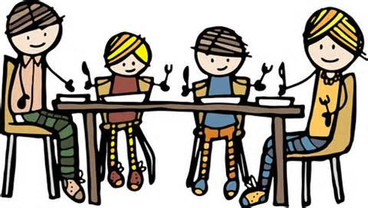
There is a three weekly menu and the children are able to pick their dinner each day.
Parent Workshops:
Key Stage 1 will be holding parent workshops throughout the year. Due to the current situation, we are unable to have these in school. We will send home the PowerPoints and worksheets so that you can complete these at home with your child.
Please check the school website to see what your child’s class have been doing.
www.tanysdell.essex.sch.uk
Home Learning

Home Learning should be fun and reinforce
what your child has learnt in school.
Please use the half termly grid for
appropriate activities.

Each week your child is expected to:

-Daily reading for 10 minutes.

-Spelling practice using the weekly
spelling pattern. New word lists and games are on Spellzone each week.

-Numbots to be accessed weekly.

Seesaw
Any home learning your child completes,
we would love to see it. Your child has a new Seesaw login, which is in their reading diary. Please upload images and videos.
These are checked once a week.


Children will be given a piece of fruit or vegetables for their snack and drinks of water during the day.
All KS1 children are entitled to a free school dinner now, please take up the offer.
There is a three weekly menu and the children are able to pick their dinner each day.
Please check the school website for updates and to find out what your child’s class has been doing.
www.tanysdell.essex.sch.uk

In KS1 we all Reach for the Stars by…
Ready to learn everyday
Expand and Challenge your mind
Aim high
Creative thinking
Have pride

Stay safe and happy
Trust and be honest
Accept and respect
Remember your responsibilities
See yourself as a star!

It is really important that both teachers and parents are keeping the children safe online. Online safety is something that we all need to be aware of at all times. To help keep the children safe online we follow these tips for SMART thinking online:
S: stay safe, don’t give out personal information
M: don’t meet up, never meet someone you don’t know from the internet
A: accepting files, do not accept files as this could cause problems
R: reliable, is the person or website telling the truth?
T: tell someone, tell an adult if you are worried or upset

