For Parents/ Carers
We want to make your child’s time moving into a new class and time at school as easy, fun and interesting as we can. You can help by…

*Encouraging increasing independence by letting them become more responsible for their book bag, lunch box and coat and coming into school on their own.

*Listening to them read every day and talking about the story/ book. They really do love it! Please remember to sign your child’s Reading Record. We advise you spend a minimum of 20 minute per day reading with your child.


* Practising English and Maths skills whilst utilising our online resources such as TTRockstars and Spellzone
We would like all children to practice for at least 20 minutes a week on TT Rockstars. This will support their learning and knowledge towards the Multiplication Test Check in the Summer.



Things you will need in Year 4…
Correct school uniform
*Ensure that ALL their possessions are labelled clearly with their name and check them regularly.
PE kits for indoor and outdoor PE.
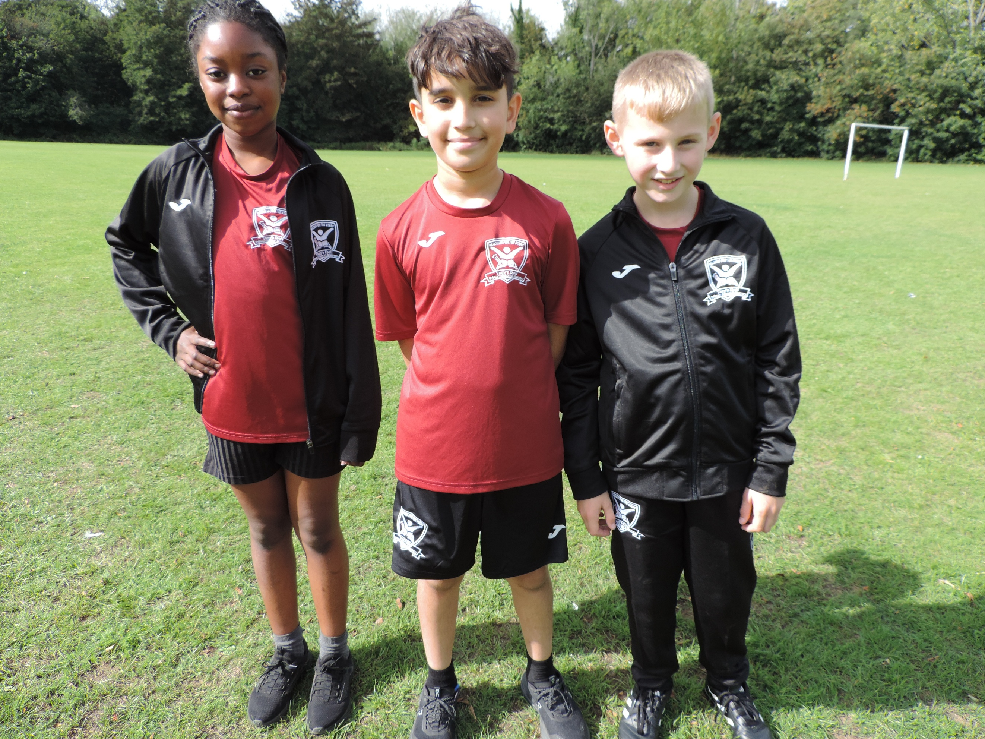
- Black shorts (Tany’s Dell logo or plain)
- Tany’s Dell burgundy round neck t-shirt
- Black trainers for PE/Games/Daily Mile
- Tany’s Dell tracksuit for cold weather
- Long hair to be tied back

PE Days are:
Marine – Mondays & Thursdays
Topaz – Thursdays & Fridays
Please remember all earrings should be removed and hair tied back on PE days.
Named book bag
Children should bring in their book bag, in every day.

Tany’s Dell Primary School

Welcome to LKS2

Year Four

Year 4 team are Mrs Wakelin, Mrs Collinson, Mrs Hales and Mrs Etienne
What we learn in Year 4 and how you can help…

*English Throughout KS2 your child will be encouraged to develop their key basic writing skills, whilst engaging in a wide variety of high quality texts. We set our expectations high in KS2. When completing any written work at home, please ensure your child is working to as higher standard as they would be in school.
As children become more independent learners in Year 4, your child’s reading skills are increasingly important. Your child will be read with regularly at school during 1:1 reading and whole class guided reading sessions. We ask that you read at home with your child every day.
We learn to read so that we can read to learn.

Maths- In Year 4, your child will continue to practise their times tables and related division facts, with a weekly challenge to support their learning. Please support your child in learning these at home.

*Wider Curriculum- Throughout the year, your child will be learning a range of fun, interesting topics including Vikings, Ancient Greece, Chocolate and The Rainforest and a topic about home families differ.

Useful websites to support learning:
www.ttrockstars.com
www.topmarks.co.uk
https://www.spellzone.com/

Your child also has access to the Purple Mash website, which has a wide range of activities for your child to do.
www.purplemash.co.uk/tanys

Children will no longer be provided with a daily snack so please send your child in to school with a piece of fruit or vegetables. Your child will also need their own class water bottle that they can use throughout the day.
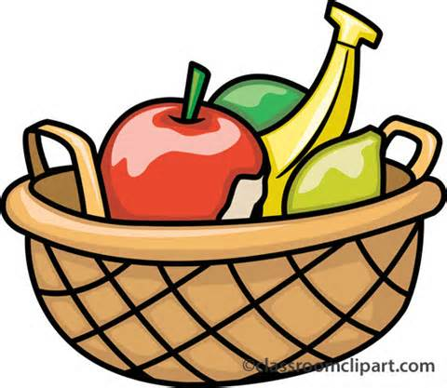
There is a three weekly menu and the children are able to pick their dinner each day. 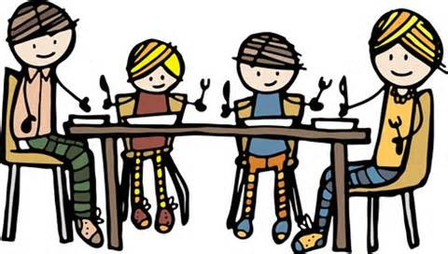
Please check the Schools Grid website to order and pay for your meals.
School Food - It's In Our System - SchoolGrid

Parent pay

Throughout this year paid educational visits may be added to Parent Pay. Remember you can add money into your account to build up credit. This can then be used later on throughout the year for paid educational visits.

Children will be given a piece of fruit or vegetables for their snack and drinks of water during the day.
All KS1 children are entitled to a free school dinner now, please take up the offer.
There is a three weekly menu and the children are able to pick their dinner each day.
Please check the school website for updates and to find out what your child’s class has been doing.
www.tanysdell.essex.sch.uk

We are all here to help.

In KS2 we all Reach for the Stars by…
Ready to learn everyday
Expand and Challenge your mind
Aim high
Creative thinking
Have pride

Stay safe and happy
Trust and be honest
Accept and respect
Remember your responsibilities
See yourself as a star!

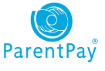
It is really important that both teachers and parents are keeping the children safe online. Online safety is something that we all need to be aware of at all times. To help keep the children safe online we follow these tips for SMART thinking online:
S: stay safe, don’t give out personal information
M: don’t meet up, never meet someone you don’t know from the internet
A: accepting files, do not accept files as this could cause problems
R: reliable, is the person or website telling the truth?
T: tell someone, tell an adult if you are worried or upset

