For Parents/ Carers
We want to make your child’s transition to their new class as smooth as we can. You can help by…

- Encouraging independence by letting them become responsible for their: bag, lunch box, homework, PE kit and coat.
- Developing resilience.
- Supporting your child to read for pleasure. This could be through a variety of genres. You can ask them questions about what they have read to increase their understanding.



Reminders:

PE Days- Tuesday and Thursday

Children must have both their class reading and library books in school every day.

Things you will need in Year 5…
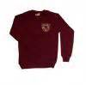Correct school uniform
*Ensure that ALL their possessions are labelled clearly with their name and check them regularly.
PE kits for indoor and outdoor PE.
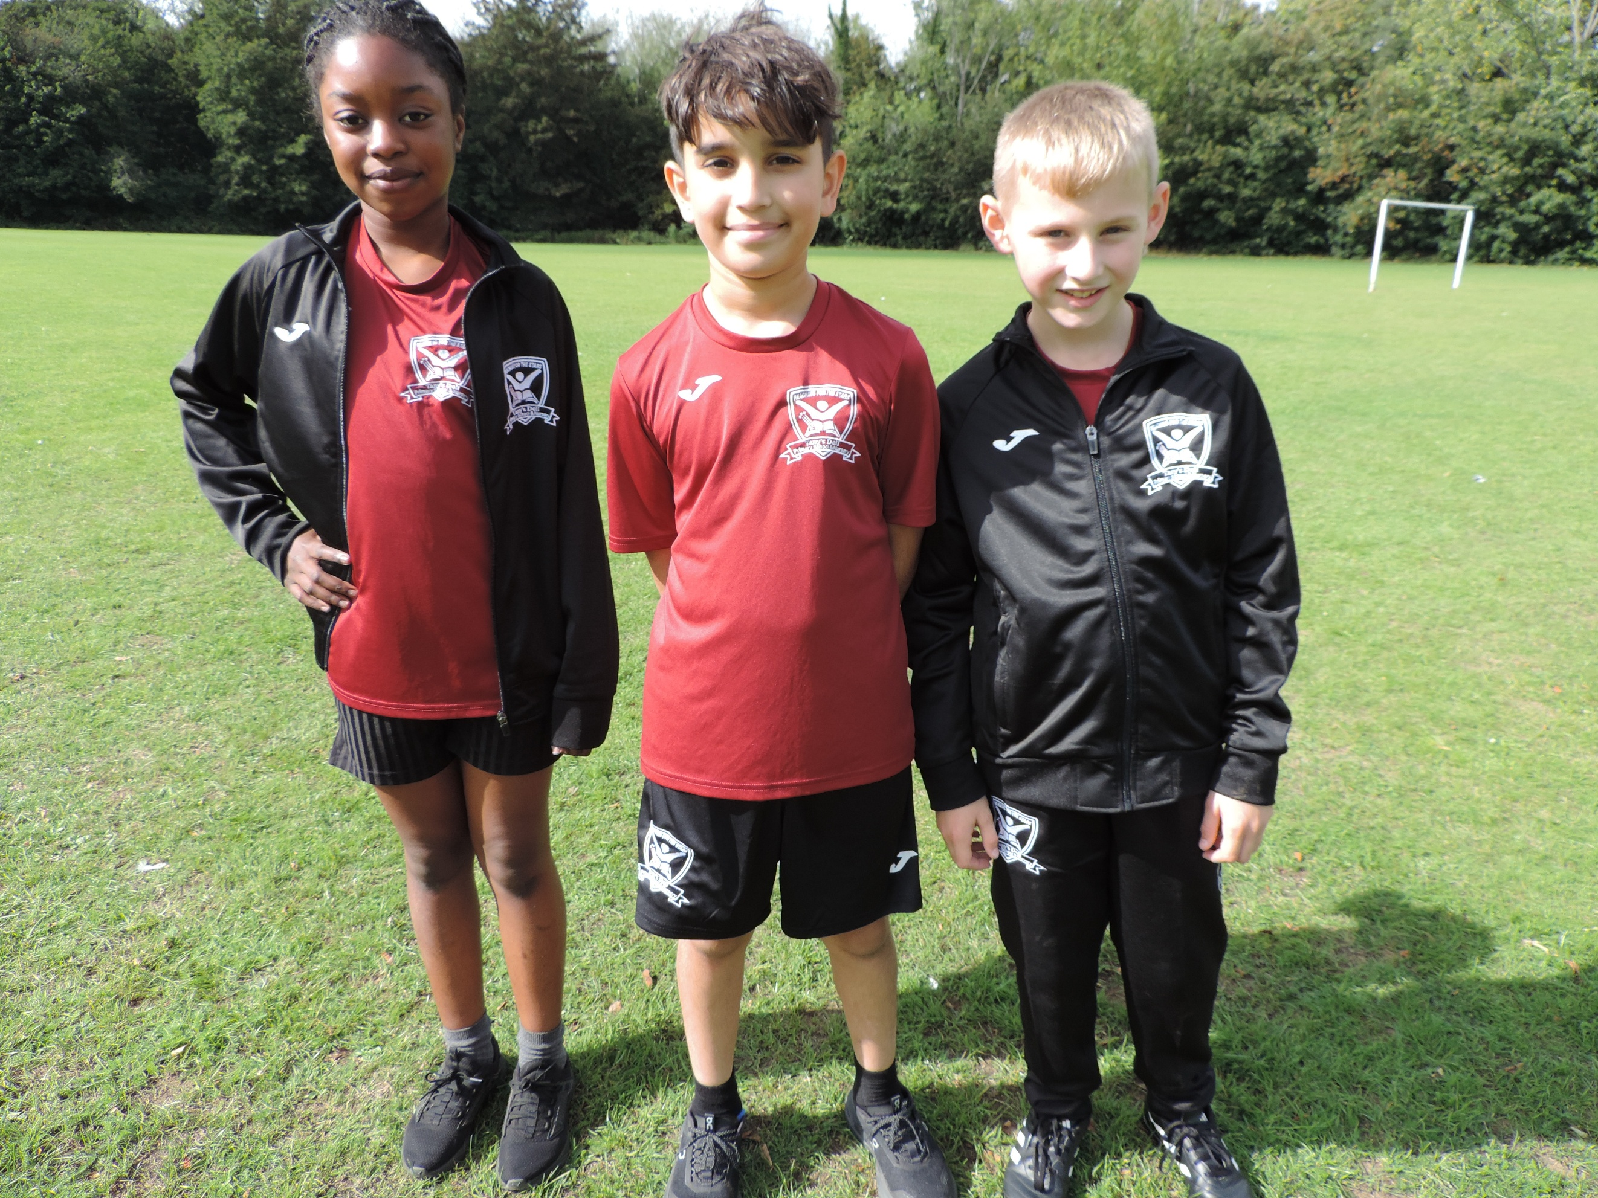
- Black shorts (Tany’s Dell logo or plain)
- Tany’s Dell burgundy round neck t-shirt
- Black trainers for PE/Games/Daily Mile
- Tany’s Dell tracksuit for cold weather
- Long hair to be tied back

PE Days are: Tuesdays & Thursdays
Please remember all earrings should be removed and hair tied back on PE days.

Please remember all earrings should be removed and hair tied back on PE days.
Please remember all earrings (small studs only) should be removed and hair tied up on PE days. A reminder that no makeup or nail varnish should be worn.
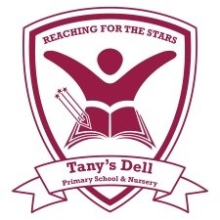

Tany’s Dell Community Primary
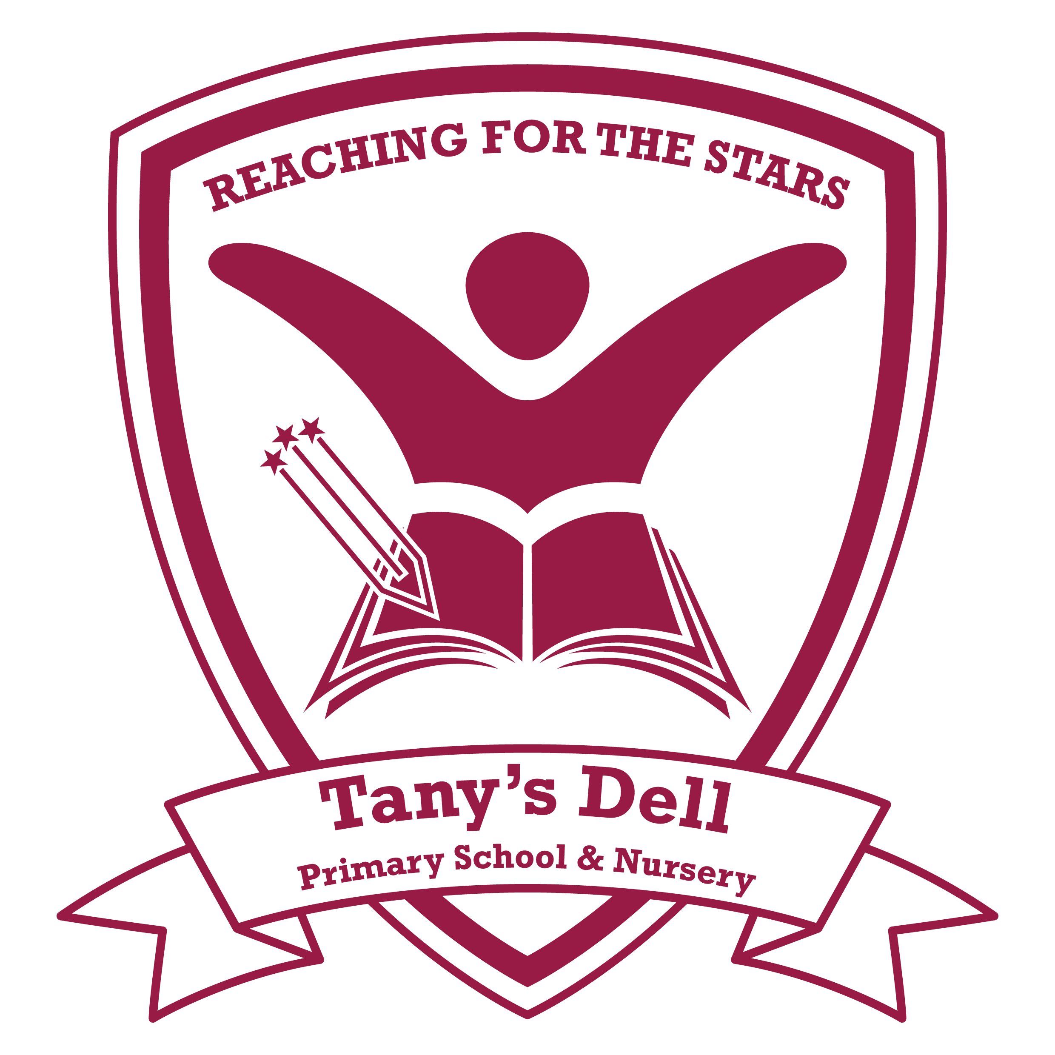
Welcome to Upper KS2

Year Five

The staff in Year 5 are:
*English- Throughout KS2 your child will be encouraged to develop their key basic writing skills, whilst engaging in a wide variety of high quality texts. We set our expectations high in KS2. When completing any written work at home, please ensure your child is working to as higher standard as they would be in school.
As children become more independent learners in Year 5, your child’s reading skills are increasingly important. Your child will be read with regularly at school during 1:1 reading and whole class guided reading sessions. We ask that you read at home with your child every day.
We learn to read so that we can read to learn.

*Wider Curriculum- Throughout the year, your child will be learning a range of fun, interesting topics including WW2, Egypt and Space.

Useful websites to support learning: http://www.ictgames.com/
http://daily10.com
www.ttrockstars.com
www.topmarks.co.uk

Your child also has access to the Purple Mash website, which has a wide range of activities for your child to do.
www.purplemash.co.uk/tanys

Online Safety

As you are aware, technology and social media have advanced over the last few years and we are finding an increasing number of issues, which often lead to friendship problems and have even had a detrimental effect on children’s mental health and wellbeing. We would be grateful if you could work with us to carefully monitor your child’s use of the internet and social media apps. Please help them not to become involved in inappropriate conversations and/or postings.


Please continue to guide your child to use the internet safely.
Mrs Smeaton, Miss Gordon, Mrs Stamp, Mrs Dellar & Miss Johnson

We are all here to help!

In KS2 we all Reach for the Stars by…
Ready to learn everyday
Expand and Challenge your mind
Aim high
Creative thinking
Have pride

Stay safe and happy
Trust and be honest
Accept and respect
Remember your responsibilities
See yourself as a star!


