year 7 induction information booklet

Contents

School Uniform Page 3

General and Essential Equipment Page 6

Breakfast Club Page 7

Homework Club Page 8

Online Payment System and Cashless Catering Page 9

Online Payments – A Brief Guide Page 11

Menu Examples Page 12

Lockers Page 15

Acceptable Use Policy & Network Use Permission Page 16

Tarleton Academy Home/School Agreement Page 17

Free School Meals Page 20

Class Charts Page 22

Chromebooks for Learning Page 23

Academy Website, School App and Social Media Page 24

Term Dates and Key Dates Page 25

Welcome to Tarleton Academy

We are very excited that your child will be joining our school community. We know that they will enjoy their learning journey with us.

This booklet and accompanying documents contain all of the information you require to assist with your child’s transition to Tarleton Academy and to complete the Year 7 induction forms.

Answering Your Questions

With this booklet you should also have the following,

- Year 7 Induction Forms Booklet;
- Bus Information Booklet;
- Privacy Notice for Students at Endeavour Learning Trust;
- Lancashire County Council Free School Meals and Pupil Premium Form;
- Uniform Information Letter
- SWI Uniform Guide;
- SWI price list and order form.

Policies
All school polices are available on the website Home / Our Academy / Policies

School Uniform

Smartness and high standards of appearance are expected at all times.

For full details of the school uniform and the way in which it should be worn please see the ‘School Uniform and Appearance Policy’ on the Academy website.

Our school uniform is important to us. It is one way in which we identify ourselves as a school family and it promotes a strong, cohesive school identity which supports high standards and expectations in all areas of school life. It promotes a genuine sense of readiness to work and a focused frame of mind.

In addition to our welcome and induction information about starting Tarleton Academy in September, please find enclosed a detailed guide on how to order our school uniform, along with a price list and order form.

The uniform consists of:
- White shirt
- V-necked school jumper (Optional)
- Black school trousers or skirt with school badge (skirts should be knee length*)
- Black blazer with school badge
- Clip-on school tie
- Plain, black socks
- If wearing the skirt, socks should be knee high, (no higher than the knee – no patterns or bows) or plain black tights (minimum 40 denier) can be worn
- Plain, black, smart, sturdy shoes (Boots, trainers, shoes with logos, flimsy ballet/court shoes, pumps, fabric or high heels are not acceptable).
- Outdoor wear should be a plain dark coloured coat. Casual outer garments such as non-school jumpers, hoodies, fleeces, cardigans, leather or denim jackets etc. are not acceptable.

*With regards the length of skirt please be advised that the skirt needs to sit half way over the knee at the start of the school year. Any student starting in September with a skirt that is too short will be required to purchase a new skirt of the correct length. This is non-negotiable.

The PE and Games kit includes:
- Purple polo shirt with school badge
- Black shorts with school badge
- Long Purple socks with school name
- Trainers; black soled not allowed
- Performance 1/4 Zip Training top with school badge
All of the above Items are compulsory.

Optional
School Performance Sports Leggings or School Performance Training Pants with Logo
PE Staff will notify in advance when students are required the following items for their lessons.
- One-piece swimming costume, swimming trunks or swimming shorts (no Bermuda shorts or PE shorts)
- Towel and hat
- Googles (Optional)
- Football / rugby boots/ shin pads/ gum shield
For all PE lessons (including indoor lessons) non-participating students must have a complete change of clothing, for example, trainers or football boots, tracksuit bottoms, T-shirt and a sweatshirt. They will be involved in the lesson in other ways to ensure that they are always supervised. Bringing a change of clothes ensures that your son/daughter still has a clean/dry uniform for school use and that they are suitably dressed to undertake a variety of roles such as sports leaders, officials and organisers. Consequently, if you send your child into school with a note explaining why they cannot participate then a change of clothing/footwear as detailed above will also be required.

All of our students are welcome to purchase and wear any items of uniform/PE kit regardless of gender.

Outdoor clothing

Outdoor wear should be a plain dark coloured coat. Casual outer garments such as non-school jumpers, hoodies, fleeces, cardigans, leather or denim jackets etc. are not acceptable. Coats must be removed on entry into school buildings and should not be worn inside school buildings during the school day. We strongly advise that expensive branded outdoor clothing is not worn for daily school use as the school will not accept responsibility for the loss or damage to these items.

Dark coloured scarves and hats may be worn during cold weather, but these should not be worn in the school buildings. Hoods should also not be worn within the school building.

Bags and belongings

Every student should have a school bag for school equipment. Bags should be sturdy and dark in colour.

Fashion Items / Other

- Earrings - no more than one piercing per ear;
- Nose studs or retainers are not allowed, and students will need to remove these in school;
- No jewellery except for earrings (as above) and a watch. If a student needs to wear a piece of jewellery for medical or religious reasons, it should be removed or covered up during physical activity or during practical learning. Jewellery worn for medical or religious reasons will only be allowed once approval has been sought and agreed in writing in advance;
- Hair should not obscure a student’s vision. Extreme hairstyles or colourings are not allowed. Hair should be cut no shorter than grade 2. If parents are unsure as to the suitability of a hairstyle, they should check with the pastoral team in school first;
- Shaved patterns in hair or eyebrows will not be permitted;
- Hair accessories should be small, plain and black. No flowers or bows should be worn.
- Any make up, including false tan worn in school should be discreet;
- Nail varnish or false nails are not allowed;
- Facial hair should be tidy and is therefore at the discretion of the Headteacher.

Arrangements for ordering uniform

Tarleton Academy uniform is available to order;

- Online at www.swischoolwear.co.uk/customer/account/login via parents online

- By telephone: 01928 752610

To guarantee delivery for September 2022 orders must be placed by Monday 1st August 2022 and items will be sent to your home address. To ensure you receive your order before the start of term please do not delay in ordering.

For additional uniform items after the 1st September, orders placed online can be delivered free to school once a week. These will be distributed to students. Orders sent to home will have a small charge for postage and packing unless they are for £70 or more.

If you have any queries or questions regarding ordering uniform, please contact Mrs Fairweather at Tarleton Academy on v.fairweather@tarletonacademy.org

General & Essential Equipment

Compulsory Equipment

Blue, Black, Green and Red Biro | Coloured Pencils | Eraser
HB Pencil | Ruler 30cm | Sharpener
Whiteboard Marker | A4 Whiteboard | Wired Headphones/Earphones

Faculty Essential Equipment

Creative
- 2B or 4B Pencil
- Apron

Mathematics & Science
- Protractor
- Compass
- Scientific Calculator (Recommended CASIO FXG83GTX available to purchase at £8.99 from school in September)

Modern Foreign Languages
- Spanish Dictionary – Small Pocket

Physical Education

Compulory:

- PE Kit (Labelled with student name) (Compulsory)
- Trainers

PE Staff will notify in advance when students are required the following items for their lessons:
- One-piece swimming costume, swimming trunks or swimming shorts (no Bermuda shorts or PE shorts)
- Towel and hat
- Googles (Optional)
- Football / rugby boots/ shin pads/ gum shield

Every morning here at Tarleton we have ‘The Breakfast Club’ from 8.00am – 8.45am every day in the Mersey Dining Room. This is one way of making extra sure that our children are fully awake and fuelled up for the day, but it is also an opportunity for them to meet their friends and start the day happy and motivated. Our current menu includes the following:
Breakfast Club: 8.00am – 8.45am
- Choice of cereal bars – 60p
- Toast – 25p
- Crumpet – 35p
- Pancake – 35p
- Waffle – 35p
- Half Bagel – 35p
- Full Bagel – 70p
- Bacon or Sausage Barm – £1.10
- Choice of fruit – 30p
- Choice of yogurts – 50p
- Pot of grapes – 70p
- Selection of cold drinks

Those students who attend receive a ‘Breakfast Club’ loyalty card which will be stamped with every purchase made. Once the loyalty card is complete with 6 stamps, your child will receive free toast and a free hot drink as well as being entered into the end of term Prize Draw with a chance to win vouchers, cinema tickets and much more!

Your child has the opportunity to sit and relax with friends or play a variety of games including air hockey, table football, pool, a variety of board games (chess, draughts etc.) or art activities.

Lunch items for later in the same day can be pre-ordered at The Breakfast Club.

Breakfast Club is available to attend from Monday 5th September 2022

Come along and ‘Start Your Day The Breakfast Club Way!’
Homework Club: 3.15pm – 5.00pm
Every evening here at Tarleton we have ‘The Homework Club’ from 3.15pm – 5.00pm in the L7 Computer Suite. This is one way of making sure that our children have the opportunity to complete their homework in plenty of time prior to the hand-in deadline.

It is also an opportunity for students to meet and work with their friends on homework and research tasks to support their learning. The club will be in a relaxed environment, with drinks and refreshments available to students. This supportive and conducive environment will allow students to end the day happy and motivated learners!

Homework Club is available to attend every day from Monday 12th September 2022

Come along and ‘End Your Day The Homework Club Way!’

The online payment system we use at Tarleton Academy is School Gateway. This enables parents to pay for trips, incidental school expenses, equipment and school meals. The introduction of online payments allowed us to install a cashless catering system with biometric identification.
Online Payment System and Cashless Catering

Online Payment System
School Gateway is the online payments system which facilitates online payments and enables a purchase history to be viewed. Similar systems have already been installed in many schools nationally, bringing a number of important benefits to students, parents and schools:

- Simple to use internet and mobile app based user system
- Payments are made through School Gateway so they are secure and reliable
- Parents can view what purchases have been made
- Reduce the risk of students losing cash
- Payments are online

Please access the system, either directly via https://login.schoolgateway.com or via the parents section of Tarleton’s website. From here you will be asked to enter the email address and mobile number that is registered with school and then you are required to press the ‘send pin’ button which, in turn, will send a text message containing your PIN. Contacts who are listed as priority 1 or 2 on their child’s record are able to make payments through School Gateway. If you have any queries then please contact the school on enquiries@tarletonacademy.org

Cashless Catering
The cashless catering facility is provided by Biostore. This is the company that manages the biometrics and canteen system. School Gateway integrates with this system.

In order to use the cashless catering system students simply place their fingertip on a scanner to make a payment for their food. The system does not record fingertips / fingerprints and an image of your child’s fingerprint is not stored. The information collected will be used solely for school purposes and held on the school system only. This technology is very secure and is commonly used within other schools across the UK and locally.

Student’s Biometric Information
The Academy wishes to use information about your child as part of the automated recognition system provided by Biostore for the purposes of using the cashless catering system. The information from your child that we wish to use, is referred to as ‘biometric information’. Under the Protection of Freedoms Act 2012 (sections 26 to 28), we are required to obtain the written consent of a parent before being able to use a child’s biometric information. Once obtained, the biometric data is used and stored in accordance with the UK General Data Protection Regulations (UK GDPR).

Please be reassured that the law places specific requirements on schools when using personal information, such as biometric information about students for the purposes of an automated biometric recognition system.

For example:
- the Academy cannot use the information for any purpose other than those for which it was originally obtained and made known to parents;
- the Academy must ensure that the information is stored securely;
- the Academy must tell you what it intends to do with the information;
- unless the law allows it, the Academy cannot disclose personal information to another person/body – you should note that the only body that the Academy wishes to share the information with is Biostore. This is necessary in order to implement the cashless catering system.

Providing your consent/objecting
As stated above, in order to be able to use your child’s biometric information, the written consent of a parent is required. However, consent given by one parent will be overridden if the other parent objects in writing to the use of their child’s biometric information. Similarly, if your child objects to the use of their biometric information, then the Academy cannot collect or use his/her biometric information for inclusion on the automated recognition system.

You can also object to the proposed processing of your child’s biometric information at a later stage or withdraw any consent you have previously given. This means that, if you give consent but later change your mind, you can withdraw this consent. Please note that any consent, withdrawal of consent or objection from a parent must be in writing.

Please note that we are a cashless school and students who are not registered on this system will not be able to use the online payment system. These students will need to bring packed lunches.
Please note that when your child leaves the Academy, or if for some other reason he/she ceases to use the biometric system, his/her biometric data will be securely deleted.

WHAT TO DO NEXT

Please complete and sign the ‘Parental Consent for the Use of Biometric Information in School’ form which is included in the Year 7 Induction Forms booklet.

Please note that the form needs to be completed if consent is given or not.

When you have received your information regarding your online account, please register in order that you can make payments on line. This information will be sent to parents during late August, before the start of term.

Online Payments – A Brief Guide

The online payment system is provided by School Gateway. In order to make a payment to Tarleton Academy, you will need to use the following website address to register your account https://login.schoolgateway.com with your email and mobile number that the school holds on record for you.

School Gateway – How Do I Sign up?
Please activate your School Gateway account as soon as possible. It is quick and easy to do. Authorised parent/guardian contacts are able to sign up a School Gateway account.
Preferred Option:
- Download the free app: If you have a smartphone, please download School Gateway from your app store (iPhone and Android). The app shows the same information as the website PLUS it saves the school money when we send you a notification.
OR
- Visit the website: www.schoolgateway.com and click on “New User”. You will receive a text message with a PIN number. Use this PIN to log into School Gateway.
The screen will open up with your Child’s Account. If you have more than one child at the school, you can select which child you are making the payment for.
You can now pick the items you want to pay for which may include school meals, calculators and school trips.
Once you have confirmed your payment your order will be displayed and you will also receive an email to confirm the payment from your bank and also to confirm the items purchased.
You can also use the system to check:
- Previous online transactions
- Catering items purchased in school
Some Frequently Asked Questions (FAQs) are available on the School Gateway login page and a Quick Reference Guide is also available on the Academy website under Parent Information. The School Gateway website has help for Parents if required at https://schoolgateway.co.uk/help/

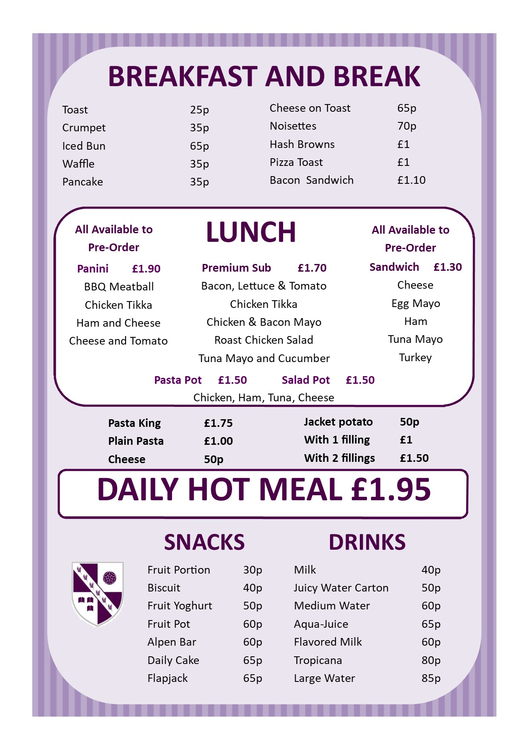
Menu Examples
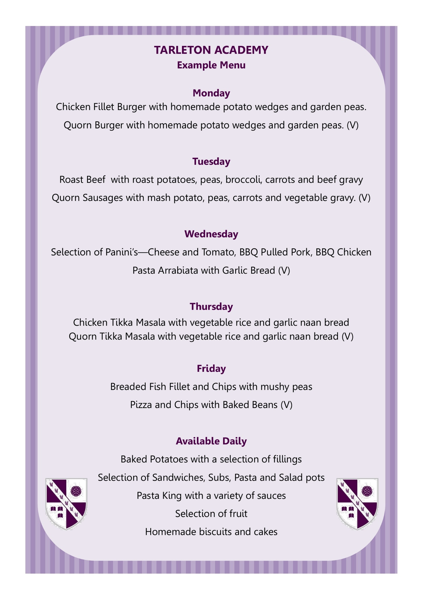

Lockers

As students move from primary to high school one of the major changes they will notice is the amount of equipment they have to carry. In order to help manage this transition and avoid the need to carry heavy bags, we have a number of lockers in school available to rent.
The lockers are located at various points across school. If your son/daughter chooses to take advantage of this storage facility, they will be allocated a locker and given a key. In order to cover the possible loss of keys, or damage caused to the locker itself, we require a refundable deposit of £10 per locker. In addition, the cost of hiring the locker will be £10 for the year. For those in receipt of Free School Meals please contact school.

As you are aware we now operate an online payment system within school and before school starts in September you will receive a letter providing you with details of how to set up an account for this online payment system. Once the account has been set up, the system will then allow parents to pay for trips, incidental school expenses including lockers and equipment. Before school starts in September, you will also receive the ‘Tarleton Academy Agreement for Rental of Locker’ form for you to complete and return to school at the start of the school term. Please note this form needs to be signed by both parent and student.

Although we have a quantity of lockers, there are insufficient for every student in school and Year 7 students are given first refusal until 12th September 2022, so if your child is keen to rent a locker then the form should be returned to school at the start of the autumn term.

In the event that the locker is in a suitable condition and the key returned at the end of the school year, deposits will be credited back to the account.

As part of the Academy’s technology programme we offer students supervised access to computers including the internal network, email and the Internet. Before being allowed to use the computers, all students must obtain parental permission and both they and you must sign the ‘Network Use Permission’ form as evidence of your approval and their acceptance of the Academy rules and associated policies. The form is included in the Year 7 Induction Forms booklet.
Acceptable Use Policy & Network Use Permission

The Acceptable Use Policy is available in the policies section of the Academy website here .
Access to computers will enable students to explore thousands of libraries, databases, and bulletin boards. Families should be warned that some material accessible via the Internet may contain items that are illegal, defamatory, inaccurate or potentially offensive to some people.
Whilst our aim for Internet use is to further educational goals and objectives, students may find ways to access other materials as well. We believe that the benefits to students from access to the Internet, in the form of information resources and opportunities for collaboration, exceed any disadvantages. But ultimately, parents and guardians of minors are responsible for setting and conveying the standards that their children should follow when using media and information sources. To that end, the Academy supports and respects each family's right to decide whether or not to apply for access.
Whilst on Academy premises, staff will guide students toward appropriate materials. Outside of school, families bear the same responsibility for such guidance as they exercise with information sources such as television, telephones, movies, radio and other potentially offensive media.

At Tarleton Academy we are very fortunate to have supportive parents who recognise that educating young people is a process that involves a strong partnership between home and school, positive working relationships and clear lines of communication. The aim of this home-school agreement is to work together to ensure a safe and positive school environment. To confirm this agreement the Tarleton Academy Home/School Agreement form is completed by both parents and students and is included in the Year 7 Induction Forms Booklet.
Tarleton Academy Home/School Agreement

‘Great schools at the heart of our communities’
Our Schools are driven by our Trust values:
Truly Collaborative - We are a proud family of schools bonded by our Trust vision, priorities and values. We work as one team in school, across our Trust and with our wider partners for the benefit of everyone in our Trust, our families and the communities we serve
People Centred - We foster authentic, positive relationships which are based on the foundations of respect, listening, kindness, support and constructive challenge. We are approachable, open and honest
Inclusive - Equity of opportunity is central to our practice, and we will invest time, training and resources so that everyone is included and has the best chance to be their very best
Unique - We are firmly committed to recognising, celebrating and investing in the individuality of all our children and young people, each staff member across the Trust and the distinct ethos and identity of each of our schools
Aspirational - We believe in the promise of each individual across the Trust and will ensure we inspire, support and challenge in proportionate measure, so that we all thrive and are able to achieve our own individual best potential

Parent Responsibilities

I/We agree to
- Ensure that my child arrives at school on time and before 8.45am and that they are prepared for lessons that start at 8.50am;
- Ensure that my child wears full school uniform appropriately;
- Ensure that my child attends regularly and provide a phone call to the attendance line with an explanation if my child is absent;
- Attend Tutor and Subject Consultation Evenings to discuss my child’s progress;
- Support my child with the organisation and completion of homework;
- Support and reinforce the school’s policies and guidelines for behaviour and regularly review my child’s achievements and behaviours through the school’s Class Charts system;
- Let the school know about any concerns or problems that might affect my child’s work or behaviour;
- Work together with academy staff for the benefit of children. This includes approaching the school to make appointments to discuss and resolve any issues of concern;
- Park with consideration and respect for others when delivering and collecting children from school.

Students Responsibilities

I agree to:
- Attend school regularly aiming to achieve an attendance of 98%;
- Arrive at school on time before 8.45am;
- Be fully prepared for lessons with the correct equipment;
- Wear school uniform properly and be tidy in my appearance;
- Adhere to the school rules and procedures;
- Do all my classwork and homework to the best of my ability and hand it in to meet the deadlines set by staff;
- Be polite and considerate to others in the school community;
- Respect the school environment and its wider community;
- Strive to reach my individual targets.

Social Media

Social media and social networking sites play an important role in the lives of many youngsters. This agreement gives clarity to the ways in which social media is used by students, school staff and parents at Tarleton Academy.

- Parents should make complaints through official school channels rather than posting them on social networking sites. Parents who do this will be requested to attend a meeting at which the relationship between school and home will be discussed and parameters set;
- Parents should not post malicious or fictitious comments on social networking sites about any member of the school community. In the event that any pupil or parent/carer of a child educated at Tarleton Academy is found to be posting libellous or defamatory comments on Facebook or other social network sites, they will be reported to the appropriate 'report abuse' section of the network site. The school will also expect that any parent/carer or pupil removes such comments. In serious cases the school will also consider its legal options to deal with any such misuse of social networking and other sites;
- Cyber-bullying and the use by any member of the school community to humiliate or intimidate another by inappropriate social network entry will be dealt with as a serious incident of bullying.

In order to support a calm and safe school environment, the school does not tolerate:-

- Disruptive behaviour which interferes with the operation of a classroom, an office area or any other part of the school grounds;
- Using loud and/or offensive language;
- Threatening harm or the use of physical aggression towards another adult or child;
- Approaching someone else’s child in order to discuss or chastise them;
- Physically damaging or destroying school property;
- Abusive, threatening, malicious or inflammatory emails, phone or social network messages;
- Smoking and the consumption of alcohol or other drugs or accessing the school site whilst intoxicated.

Free School Meals

Did you know that your child could qualify for free school meals?
There has recently been a number of changes to the criteria for the eligibility to free school meals. The current criteria and the implications are detailed below:
- Universal Credit with a household income of less than £7,400 a year (after tax and not including any benefits you get)
- Income-Based Jobseekers' Allowance
- Income-Related Employment and Support Allowance
- Child Tax Credit, not entitled to Working Tax Credit and household income less than £16,190
- Support under part VI of the Immigration and Asylum Act 1999
- Guarantee element of State Pension Credit
- Income Support
- Working Tax Credit 'run on' – the payment you receive for a further four weeks after you finish work
If your child is currently eligible for free school meals, that eligibility will be protected until Universal Credit is introduced (expected March 2022) even if your circumstances change. If your child is still in education on this date, they will be eligible until they finish the phase of schooling (primary or secondary) they are in.
If your child is eligible, it means they can enjoy delicious, healthy meals without the bills and fuss of making packed lunches. In addition to free lunches, those who are eligible can also have a free breakfast before school.
Tarleton Academy actively encourages all families entitled to free school meals to apply. No-one else will know that your child qualifies as we use a cashless system that means that payment is discreet. Your child’s catering account will be topped up daily automatically with £1.65 for breakfast and £2.20 for lunch. Please note that students cannot carry over the breakfast allowance to lunch, or ‘save up’ their allowance. Purchases beyond this amount are funded by parental 'top up'.
Claiming free school meals also helps us support your children further in school. We receive extra funding, known as the ‘pupil premium’, for every eligible pupil who is registered. The pupil premium grant is funding provided to schools to focus additional resources on helping pupils who are eligible in this category to reach their full potential, to make sure this is in line with their peers. The more pupils that are registered for free school meals, the more funding the school receives on their behalf. Please remember registering for free school meals does not mean your child has to take up free school meals if they do not want to but it does bring this ‘top up’ funding to enable us to ensure they are supported in other ways to make sure they can do their best.

If you think that you may be eligible, you can apply;
Online
By completing the form using this link - https://lancashire-self.achieveservice.com/service/Free_school_meals_and_pupil_premium

The local authority will confirm whether you are eligible by email. If you do not get an email within 5 working days, contact the South Area Education Office. Remember to also check your spam or junk email folder.

If you are eligible, the local authority will let us know that your child can have free school meals.

By phone
You can ring the South Area Education Office on 01772 532109. Please remember that it must be the person claiming the benefit that rings.
You will need to provide your:
- Name
- Date of birth
- National insurance number

The local authority will confirm whether you are entitled to free school meals over the telephone.

By post

Complete the application form provided or download the form (Free school meals and pupil premium form) and return it to:

South Area Education Office
Pupil Access Team South
Room C37
County Hall
Preston
PR1 0LD

If you apply by post the Local Authority will notify you by email, or post if you do not provide an email address.
If you have any further questions or queries regarding free school meals please contact the Trust Finance team via the General Office.

ClassCharts for Parents

ClassCharts is an online system which teachers use to track achievement and behaviour throughout the school day. We believe in working closely with parents and one of the key benefits of using Class Charts is that we are able to securely share your child(s) achievement and behaviour report with you and so keep you up to date in real-time.

ClassCharts is used to share information with parents about:
• Achievement Points;
• Behaviour Points;
• Attendance;
• Homework;
- Detentions.

What is ClassCharts for Parents?
You will be able to use Class Charts to keep track of your child's achievements, access behaviour reports, report a student absence, view assigned homework tasks and track scheduled detentions.

If you have more than one child at the school you can use the same parent account to view achievement data for all your children.

ClassCharts for parents can be accessed via the website, or iOS and Android apps.

We recommend that you allow this app to send push notifications

You can access the parent website and links to the parent apps here: https://www.classcharts.com/parent/login

You will receive your individual parental login during the first week of the autumn term.

Further information about ClassCharts and the ClassCharts Parents User Guide can be found on the academy website https://www.tarletonacademy.org/parents/class-charts

Chromebooks for Learning Project

The school recognises the importance of IT facilities and continues to invest significantly in this area to maintain an infrastructure that allows students to access high quality resources to support their learning.
Students need to be prepared for an increasingly digital world. Research has confirmed that appropriate home access to technology has a positive impact on a child’s educational achievements; it often motivates them to do school work by providing other interesting and engaging ways to learn. Research and other types of learning that do not require handwritten pieces are often better presented so their self-esteem grows and they can explore subjects that interest them in their own time.
It is recommended that a sturdy Chromebook case is used to prevent damage
Further information, support and the ‘Chromebook Acceptable Use Policy’ can be found on the Academy website (https://www.tarletonacademy.org/parents/chromebooks-for-learning-project) under the Parents section. You can also view the ‘Chromebooks FAQs and Information Booklet’ on the website.
If you have any queries about the Chromebook for Learning Project that cannot be answered by our FAQs please contact chromebook@tarletonacademy.org or the General Office.
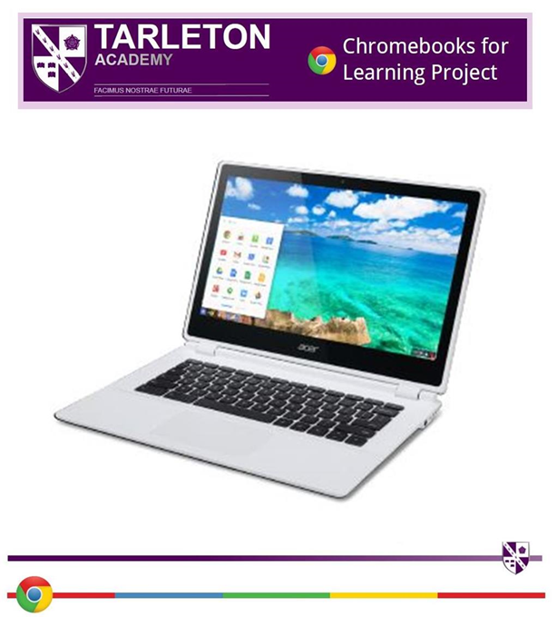

Tarleton Academy Website, School App and Social Media

Academy Website
Our Academy website is an excellent resource to see the latest news, statutory information, school letters, the school calendar and other resources and information you may need whilst your child is at Tarleton Academy.
You can also submit an enquiry online via the Contact Us page
The website can be found at this address www.tarletonacademy.org/
School App
We also have the School App which is available for Android and iOS.
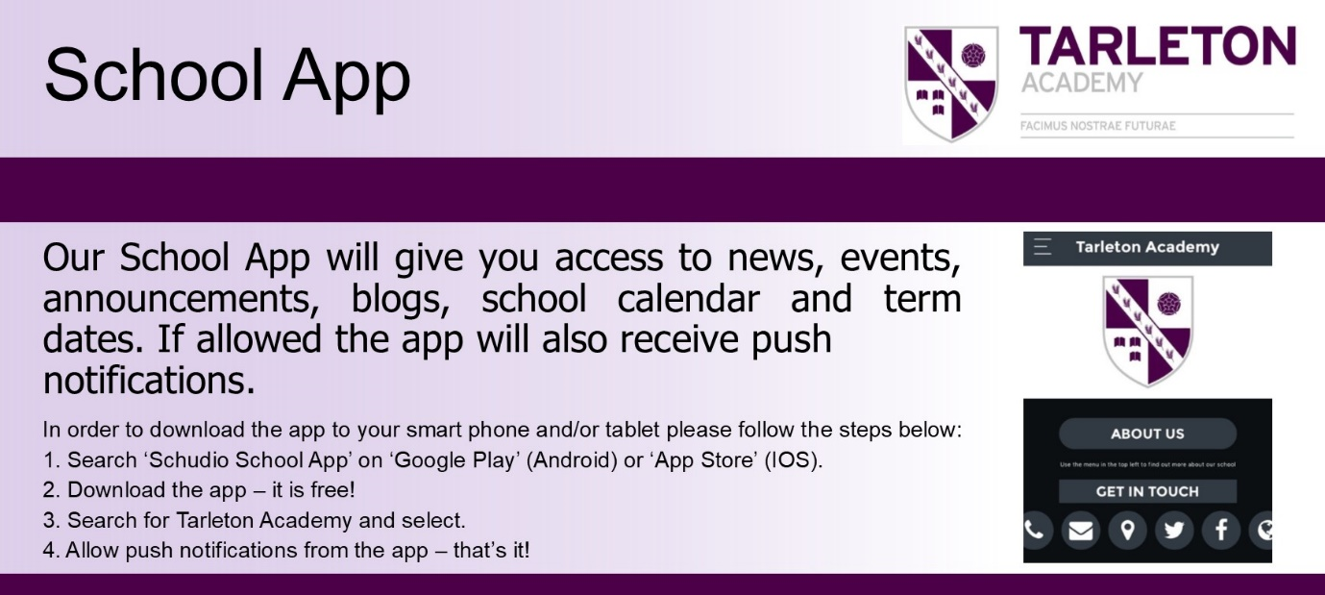
Social Media
The Academy has both Facebook and Twitter (@tarletonacademy) accounts and we use these on a regular basis to update parents and students with the latest news and messages. These accounts are a great way to keep you up to date with current events and news and celebrate the achievements of the students.
We would also politely request that if there are concerns regarding school issues that we are contacted directly rather than comments being posted through social media. Please note the relevant section of the Tarleton Academy Home/School Agreement on page 18.
You can access our Facebook and Twitter accounts from the Academy website homepage.

Term Dates 2022 2023 and Year 7 Key Dates

Autumn Term 2022

INSET day Thursday 1st September
INSET day Friday 2nd September
Term begins for students Monday 5th September
- Years 7 & 11 in school all day
- Review day for Years 8, 9 and 10 attending for Individual appointments only. (Tutors and Students only)
Open to all Students Tuesday 6th September
Half-term break Monday 24th October - Friday 28th October
End of Term Friday 16th December (12.30pm)

Spring Term 2022

INSET day Tuesday 3rd January
INSET day Wednesday 4th January
Open to all Students Thursday 5th January
Half-term break Monday 13th February – Friday 17th February
End of Term Friday 31st March (12.30pm)

Summer Term 2022

Open to all Students Monday 17th April
Bank Holiday Monday 1st May
Half-term break Monday 29th May - Friday 2nd June
End of Term for students Thursday 20th July (12.30pm)
INSET day Friday 21st July

KEY DATES

Year 7 SLT Information Evening To be confirmed

During this event you will receive information regarding key dates, reports and assessments during Year 7.

