School Bus Information
2022 – 2023

Lancashire County Council: Home to School Transport 2022-2023

Department of Education: Home to school travel and transport guidance. July 2014

Under section 508 (B) of the Education Act 1996 we must provide free transport to and from school for your child if they are aged 5 to 16 and they live outside the legal walking distance between your home and the nearest qualifying school. We must provide additional assistance for families who have a low income.

The Department for Education published statutory guidance for local Authorities in July 2014; Home to school travel and transport guidance.

Information about the Transport Assistance.

The admission information which is available for all parents from each September (online and paper where requested) provides a summary transport policy. Parents are advised to check the policy carefully if getting their child from home to school and back is a consideration. Parents are directed to a full copy of the Home to School Transport Policy on the Lancashire County Council website and to seek advice from the area education office if they have any queries.

Due to the many changes within the policy for school travel in Lancashire we asked a number of questions about how to apply for school transport passes. We would like to make parents aware of the County Councils School Transport website, which offers useful information and advice of what parents need to do:
http://www.lancashire.gov.uk/children-education-families/schools/school-transport.aspx
In addition to the website we would also like to make you aware of the dedicated school transport hotline number 0300 123 6738 and email address envschooltransport@lancashire.gov.uk which can be used to answer any queries you may have.
Current LCC Fares:

Distance Fare
0-3 miles £3.20 rtn
3-8 miles £4.40 rtn
8+ miles £5.50 rtn

Season Tickets
Term & Yearly Season tickets can be purchased where space is available on the bus service at a 20% discounted rate off the cost of a daily return fare. Lancashire County Council reserves the right to refuse season ticket applications. You can also spread the cost if you choose to pay by direct debit.

Nb. Season tickets may be withdrawn and refunded if accommodation is required for Statutory Entitled pupils.

Commercial Services
Routes, fares and weekly ticket price information can be obtained by contacting the commercial operator directly.

Low income

If you have a low income and your child is in Year 7 to 11 in secondary school, LCC may be able to provide free transport if they go to one of their three nearest schools. For your child to receive free transport, the school must be between 2 and 6 miles away from your home.

If your child is entitled to free school meals or you receive the maximum amount of Working Tax Credit, you are defined as being on a low income.

Assessments to receive assistance with transport are based solely on the distance between home and school.
Please note:
Transport eligibility assessments are undertaken by the Pupil Access Team. All assessments are undertaken within the framework of the published Home to School Transport Policy. Members of the team do not have any discretion to award assistance outside the policy. The policy is determined by the Cabinet Member for Children and Young People on an annual basis.

There is no consideration of:
- Bus routes / bus availability.
- Older siblings with entitlement.
- Parental preference for a particular school.
- Grammar school status
- Single sex / mixed cohorts.
- OFSTED findings
- Home to school distances just under three miles.

Financial Hardship
Obviously the cost of this transport, if it does apply to you, may be more than some families can afford. Consequently, we are writing to reassure you that if Tarleton Academy is still your first choice, but not your closest school, we are willing to consider subsidising this cost where there is a genuine need. All you would need to do is contact the school and your individual case will be considered confidentially and sympathetically.

SERVICE: 724 BANKS - TARLETON ACADEMY

From Banks Station Road/Water Lane via Station Road, Hoole Lane, Church Road, Chapel Lane, New Lane Pace, Marsh Road, Shore Road, Chapel Road, Station Road and Hesketh Lane to Tarleton Academy.

Return via outward route reversed.

Banks Station Rd/Water Ln 0805
Banks Church 0808
Hundred End 0815
Hesketh Bank Chapel Rd/Shore Rd 0820
Tarleton Academy 0830

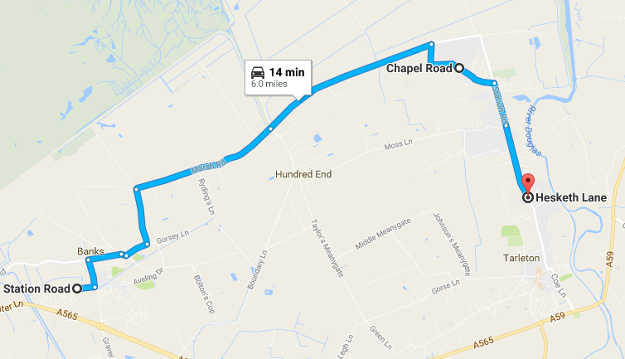
Service departs Tarleton Academy 1525
724
Operator: Don Fraser Coaches

SERVICE: 725 HUNDRED END – TARLETON SCHOOLS
From Banks, Arawa Farm, Marsh Road via Marsh Road, Hundred End Lane, Boundary Lane, Boundary Meanygate, Taylors Meanygate (turn at Hazeldene Foods), return along Taylors Meanygate, Moss Lane, Station Road, Hesketh Lane for Tarleton CEPS then to Tarleton Academy.
Reverse of outbound route.

Marsh Road, Arawa Farm 0815
Jct Marsh Rd/Hundred End Ln 0818
Hundred End, Ricadona 0820
Hesketh Bank Moss Lane 0830
Tarleton CPS 0833
Tarleton Academy 0835
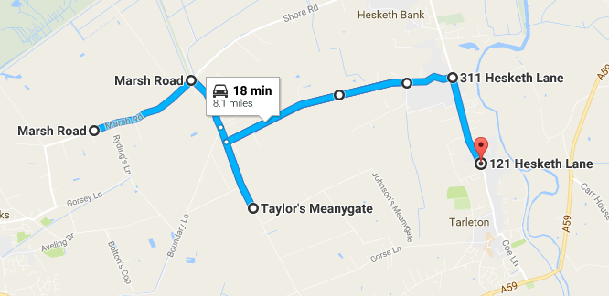
Service departs Tarleton Academy 1525
725
Operator: Saunders of Preston

SERVICE: 838 BANKS – TARLETON ACADEMY

From Banks Road (Pumping Station), via Ralph’s Wife’s Lane, Banks, Hoole Lane, Guinea Hall Lane, Gravel Lane, A565 Southport New Road, The Gravel, Mere Brow, Mere Brow Lane, Blackgate Lane, Tarleton, Church Road to Tarleton Academy.
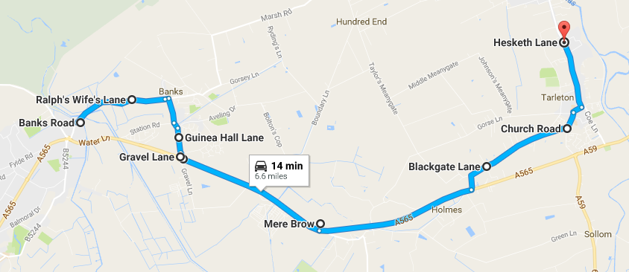
Return via outward route reversed.
Banks Banks Road 0750
Banks Church 0752
Greaves Hall 0758
838
Riverside Caravan Camp 0805
Mere Brow Legh Arms 0813
Tarleton Academy 0823

Service departs Tarleton Academy 1525
Operator: AM - Mario Coaches
PM – Holmeswood Coaches

STAGECOACH 002 PRESTON – SOUTHPORT via WALMER BRIDGE & MUCH HOOLE
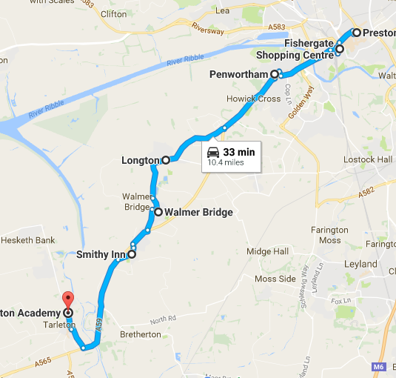
Preston Bus Station 0755
Fishergate Centre 0701
Penwortham Library 0807
Hutton Anchor Inn 0819
Longton St Andrew's Church 0811
Walmer Bridge Inn 0825
No 2
Much Hoole Smithy Inn 0829
Tarleton Academy 0840

Service departs Tarleton Academy 1530
Operator: Stagecoach in Lancashire

School Bus Information
2022 – 2023
Southport Bus

Southport and Other Areas

Tarleton Academy runs a Transport Service* (Number 146) for the Southport area. (Eligibility criteria applies)

Dobbies Garden Centre 07.45
*Tarleton Academy Safer Travel Code applies

Norwood Road 07.50
Roe Lane 08.00
Park Crescent 08.05
Cambridge Road 08.07
Botanic Road (opp Hesketh Pub) 08.10
Bankfield Lane 08.15
Preston New Road at Fairhaven Road 08.20
Tarleton Academy 08.35

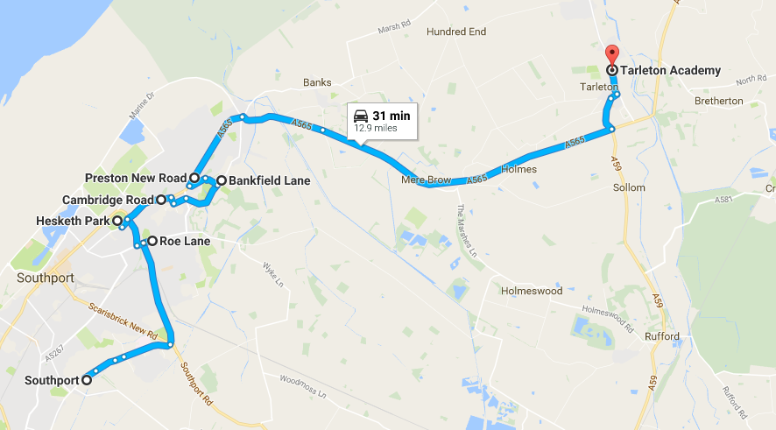

Coach

The cost for the 146 bus service for the academic year 2022/2023 is yet to be confirmed, we will have prices to parents as soon as possible.

If you have any questions about this service please do not hesitate to contact Mrs G Higham – g.higham@tarletonacademy.org

Other Areas without Current Buses

We are aware that there are families who would like to put Tarleton as first choice but who don’t have transport of their own and where there isn’t a direct service bus. In situations such as these please contact us and we will be able to put a plan together. For example, we have previously arranged for a subsidised shared taxi or an additional minibus when demand required.

