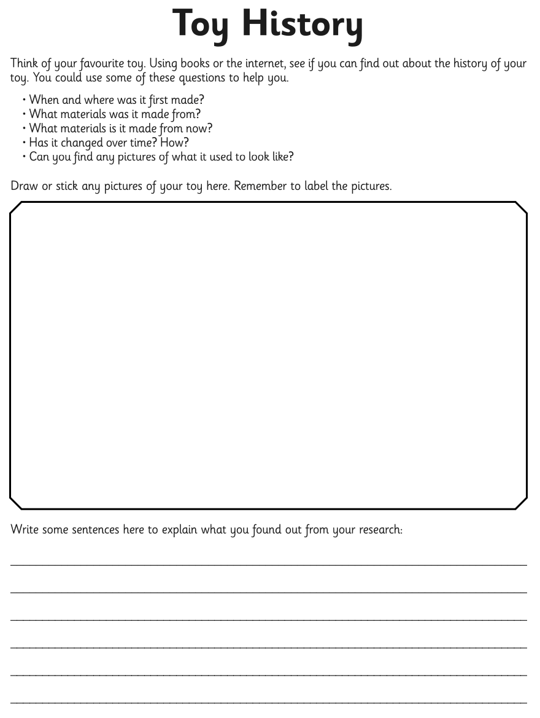
Class 2 Home Learning – Spring 2 – Due Thursday 19th March 2026

