Summer Term Edition 2023
Online Safety
Welcome to the second edition of The Acorns School Online Safety newsletter. As a school, we want to keep parents and guardians up to date with any changes that we think are useful in order to keep our students safe online.
The Acorns are on social media!
We have begun to regularly update our website and our Twitter page and we have also created an Instagram page so parents and pupils can keep updated with school and what activities are happening. Our social media accounts will not contact you, so if you see a message or comment from The Acorns, this could be a scam account.
Summer Holidays
As the summer holidays approach, we want our pupils to keep safe when accessing the internet and parents & carers to be aware of how to stay safe on the internet. With the summer holidays fast approaching children and young people will have more free time to spend with friends, family and online. For some, this will be spent using the internet to keep in touch with friends, catch up with the latest apps and online trends, and playing their favourite games.
Sit down together
For parents, the summer holidays are a great chance to sit down with your children. Together you can visit their favourite sites and play their favourite games, this is a great way to stay up to date with online lives and show them that you’re interested in what they are doing. The holidays are also a good opportunity to have positive conversations about the internet, so if something ever does upset your child online they would feel more confident in confiding in you.
Social media and staying in touch
During the summer holidays, young people may want to keep in touch with their friends through social networking sites or games. It’s a good time to ask them about what sites they use, and check any age requirements as many social media sites require users to be at least 13 years old. Encourage your children to use the privacy tools on the services they use, so that the content they post is only available to people they know and trust in real life.
Talking about their time online
The holidays are also a good opportunity to talk to your children about their online friendships, the sites they use and encourage best practices online.
Sharing holiday pictures
Some children may want to share photos and videos of what they are getting up to in their summer holidays online. Talk to your children about what types of photos are appropriate to share, and who they are okay to share with. Photos can hold clues that give away personal information. For example, if you share a selfie of you and friends, are there any landmarks or street signs that give away your location?

What is Telegram?

Description: Telegram Messenger is a cloud-based communication app usable across all devices; it allows users to send pictures, videos, stickers, texts, and other files completely free.
Secret Chats are possible on Telegram and encouraged. The app explains how to create a Secret Chat message – these messages are not available in the cloud and cannot be accessed on other devices – only the sending and receiving device can access the content of the messages.
Opportunities for connection with strangers are possible. If users decide to create a username (which is public and searchable by anyone) and are concerned with broadcasting to an unlimited number of people – because “more followers is better” to most teens, this opens the door to unexpected or unwanted contacts. This can lead to sourcing and exchanging illegal material or items ( drugs or weapons)
Telegram features adult content and pornography. Anyone is able to create content since this is an open-source platform so, though the app rating is 4+, the level of questionable content available is determined by those sending and receiving messages.
Telegram isn’t meant for teens. The secretive nature of this app lends itself to inappropriate and questionable content sharing and behaviour. We hope that much is clear from what you’ve read above.
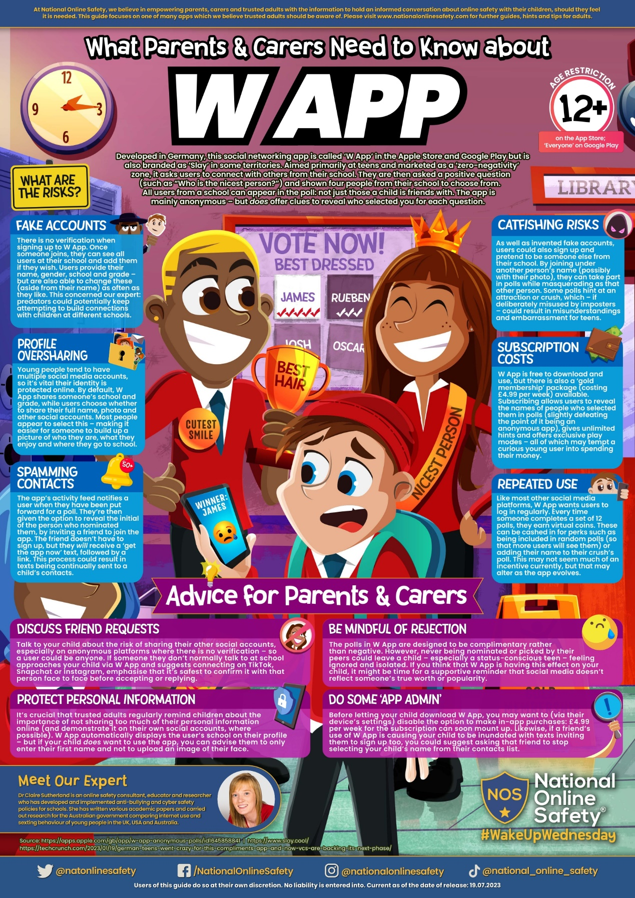

For more information, you can find out how children use social media, the apps they use, the risks they face, how to use privacy settings, and advice and tips about how to talk to your children at:
• www.childnet.com/sns
• www.internetmatters.org
• www.nspcc.org.uk/onlinesafety
• www.parentzone.org.uk
• www.thinkyouknow.co.uk/parents
• www.askaboutgames.com

If you are concerned about online grooming or sexual behaviour online, contact CEOP: www.ceop.police.uk If you stumble across criminal sexual or obscene content on the internet you should report it to the Internet Watch Foundation: www.iwf.org.uk

