Online Safety Newsletter

January 2024

WhatsApp

You must be at least 16 years old to register for and use WhatsApp. WhatsApp is a free messaging app that allows you to send messages, voice notes, photos and videos.

What should I be aware of?
Group chats: One of the key features is the group chat function. Everybody in the group, even if they are not one of your child’s phone contacts, will be able to see all messages within that group. If your child is added to a group with someone that they have previously blocked, that person can still see their messages and send them messages within the group chat. In settings, you can change who can add your child to groups. You can leave a group chat at any point so talk to your child and encourage them to leave any chat that makes them feel uncomfortable.

Location sharing: you can share your location on WhatsApp. Talk to your child about when this would be appropriate to use but also the potential danger of sharing their location, for example with strangers.

Blocking/Reporting: Show your child how to block and report other users or inappropriate content. You can find out how to do it based on your child’s device here: https://faq.whatsapp.com/1142481766359885/

Further information
NSPCC provide further advice and tips to help keep your child safe:
https://www.nspcc.org.uk/keeping-children-safe/online-safety/online-safety-blog/2023-01-12-is-whatsapp-safe-for-my-child/
New devices

If your child has a new device, have you set up parental controls?
Consoles
All consoles offer parental controls such as limiting the time spent on the device or restricting who your child can communicate with. Find out the specific settings below:
- PlayStation: https://www.playstation.com/en-gb/support/account/psn-safety-parents-guide/
- Xbox: https://www.xbox.com/en-GB/family-hub
- Nintendo Switch: https://www.nintendo.co.uk/Hardware/Nintendo-Switch-Parental-Controls/Nintendo-Switch-Parental-Controls-1183145.html
Mobiles/Tablets
You can set up parental controls and restrictions on most mobile devices, which can limit what your child can access. Additionally, make sure appropriate settings are applied on the apps your child is using.
- Apple devices: https://www.apple.com/uk/families/
- Android devices: https://families.google/familylink/

Further information
Internet Matters provide a checklist here:
https://www.internetmatters.org/resources/e-safety-checklist-getting-your-kids-tech-devices-set-up-safe

Cybersecurity

Parent Zone have partnered with the National Cyber Security Centre (NCSC) to help educate young people on how they can protect themselves from scams and hacking whilst online. They have also created a quiz with the youth platform VoiceBox to test how cybersecure your family is. The quiz is available for ages 11-12 and 13-14.

You can find out more here:
https://parentzone.org.uk/article/cyber-security

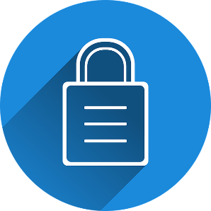

Users of this guide do so at their own discretion. No liability is entered into. Current as of the date released 01.01.24.

A Guide to the Online Safety Bill

The Online Safety Bill is a new set of laws to protect people online. The laws will make social media companies more responsible for the safety of their users on their platforms. The Government have created a guide to the new laws detailing how the laws will protect children and adults. For example, the new laws mean social media companies will have to show how they are enforcing age limits.

https://www.gov.uk/guidance/a-guide-to-the-online-safety-bill

YouTube
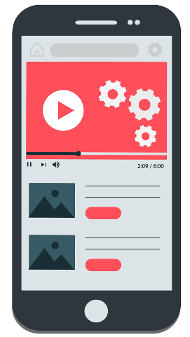
YouTube is intended for users over the age of 13 (however, children of all ages may use the Service and YouTube Kids if enabled by a parent/legal guardian).

What if my child is under the age of 13?
If your child is under the age of 13 then your child should use either YouTube Kids or a Supervised Account. Which option you choose, will depend on your child’s age and your requirements.

- YouTube Kids – this is a separate app that includes a smaller selection of videos based on the age you select:
- Preschool (ages four and under)
YouTube Content Warning

The INEQE Safeguarding Group have published a report warning about the YouTube cartoon series called Jeffy. Due to the content being animated, viewers may believe that it is suitable for children to watch when in fact the content is inappropriate. You can find out more here:

https://ineqe.com/2023/11/09/safeguarding-update-youtube-cartoon-jeffy

- Younger (ages 5–8)
- Older (ages 9–12)

- Supervised accounts – this is a parent-managed version of YouTube. You can select one of the following options, again depending on your child’s age and your requirements:
- Explore - Generally for viewers aged 9+.
- Explore more - Generally for viewers aged 13+
- Most of YouTube - This setting includes almost everything on YouTube except for videos marked as 18+ and other videos that may not be appropriate for viewers using supervised experiences.
Google have created a table to show the differences between YouTube Kids and a Supervised account to help in your decision:
https://support.google.com/youtube/answer/10315420

Posting videos
You should be over 13 to post videos. If your child does post videos on YouTube, ensure they understand what information they should keep private and what to do if they receive negative comments. Talk to them about the different settings available -

World Events

There are a lot of distressing events happening around the world, which your child may see online. Childnet have published an article discussing how you can support your child when they see something worrying or upsetting online. The article also directs you to other organisations that you can contact if you require further help and support:

https://www.childnet.com/blog/navigating-violent-online-content-from-global-events/

- Public: anyone can view the video.
- Private: video can only be viewed by users that you select.
- Unlisted: only people who have the link to the video can view it.
YouTube have produced these safety tips for teens when posting content: https://support.google.com/youtube/answer/2802244

How can I make YouTube safer?
- Explore YouTube together and see what they like to watch. Make sure your child understands that they can talk to you if they see anything that makes them feel uncomfortable online.
- Restricted mode - is an additional setting (when logged in via a Google account) to restrict the availability of mature content.
- Ensure your child knows how to report inappropriate content/comments. Find out more here: https://support.google.com/youtube/answer/2802027.

