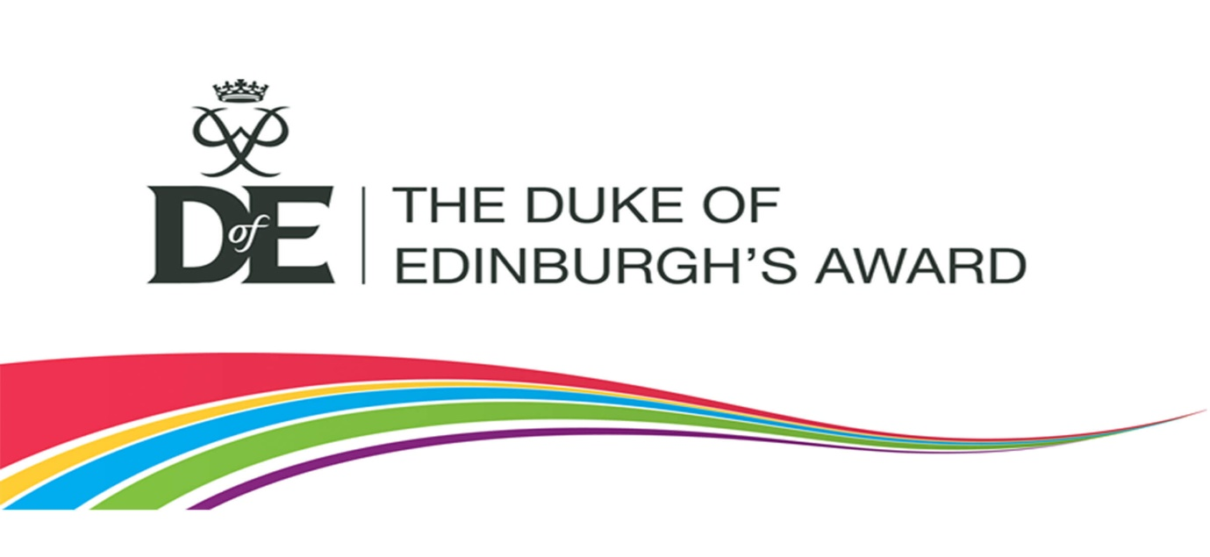
“The Duke of Edinburgh’s Award has helped countless young people on their sometimes difficult path to adulthood.” HRH The Duke of Edinburgh.
Students at The Acorns School will have the opportunity to achieve The Duke of Edinburgh’s (DofE) Bronze Award. The DofE is accessible to all young people from the ages of 14 to 25. Pupils’ will learn all about going the extra mile, gaining new skills, pushing themselves physically, helping others and exploring new territories. At the same time, they gather friendships, experiences and memories that will last a lifetime. To achieve the Duke of Edinburgh Bronze Award, learners will complete 3 months of each activity from 4 sections; Volunteering, Physical, Skills and Expedition.
