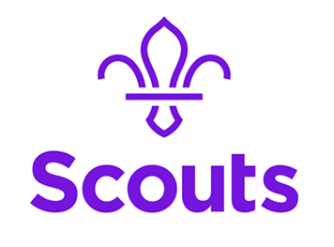
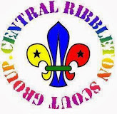
Central Ribbleton Scout Group
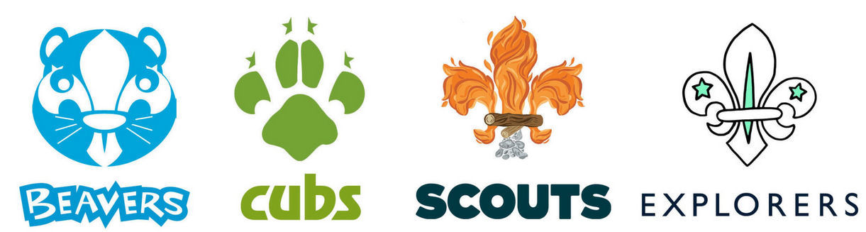
Scout HQ, Farringdon Lane, Ribbleton, Preston. Lancashire. PR2 6LX

Who we are
Central Ribbleton Scout Group consists of 3 sections, a Beaver Colony, a Cub Pack and a Scout Troop. Each of the sections has its own team of leaders and helpers who manage and lead the operation of their section.
The Scout Group is led by the Group Scout Leader and managed by a Group Executive Committee.
What we do
Scouts take part in activities as diverse as kayaking, abseiling, photography, climbing and geo caching. As a Scout, you can learn survival skills, first aid, computer programming and about space. There’s something for every young person. It’s a great way to have fun, make friends, get outdoors, express their creativity and experience the wider world.
Where do we meet?
The Group is based in Ribbleton and our Scout Hut is situated on Farringdon Lane, in The Blessed Sacrament Primary School and Church grounds. We welcome boys and girls and adults from all of the local community.
What times do we meet?
- Beavers meet on Monday evenings during term time, from 6pm until 7.15pm
- Cubs meet Thursday evenings during term time, from 7pm until 8.15pm
- Scouts meet on Tuesday evenings during term time, from 7pm until 8.30pm

Want to join the adventure?
Cubs.CentralRibbleton@PrestonScouts.org.uk
Cubs are aged 8 to 10½ years old and excitement and adventure are key. Their programme offers a huge variety of activities surrounding areas of fitness, global and beliefs; whilst allowing them to be creative and get involved in their local communities. Cubs are introduced to exciting outdoor skills and take part in adventure activities, as well as camps and residential experiences.
The Cub Pack is the second section of the Scout Group following on from Beavers.
During their time in the Pack, Cub Scouts will get a chance to try a wide range of different activities as well as going on trips, days out, and on camps. Participation and personal development, rather than meeting set standards, is the key approach, and there are a range of badges and challenge awards that Cub Scouts can gain to recognise their achievements.

