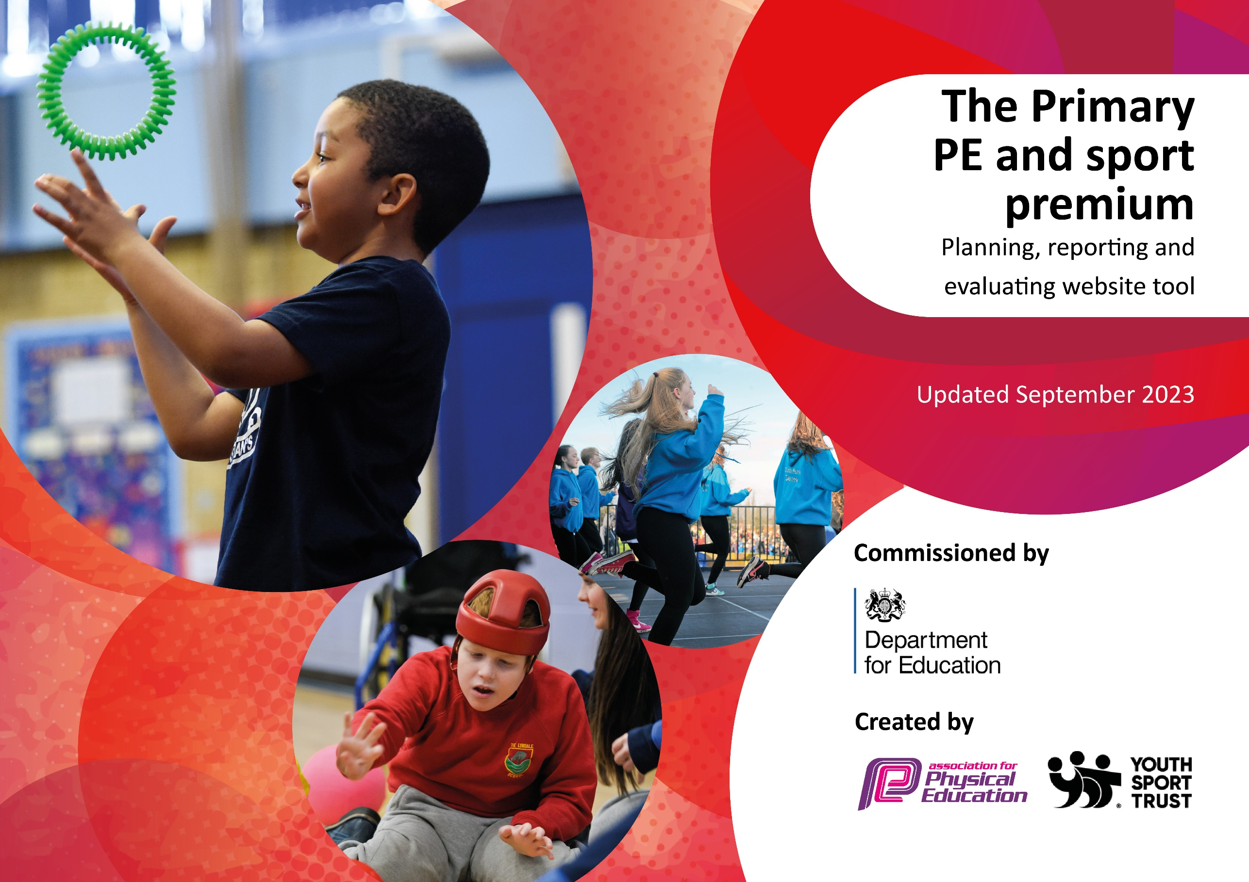

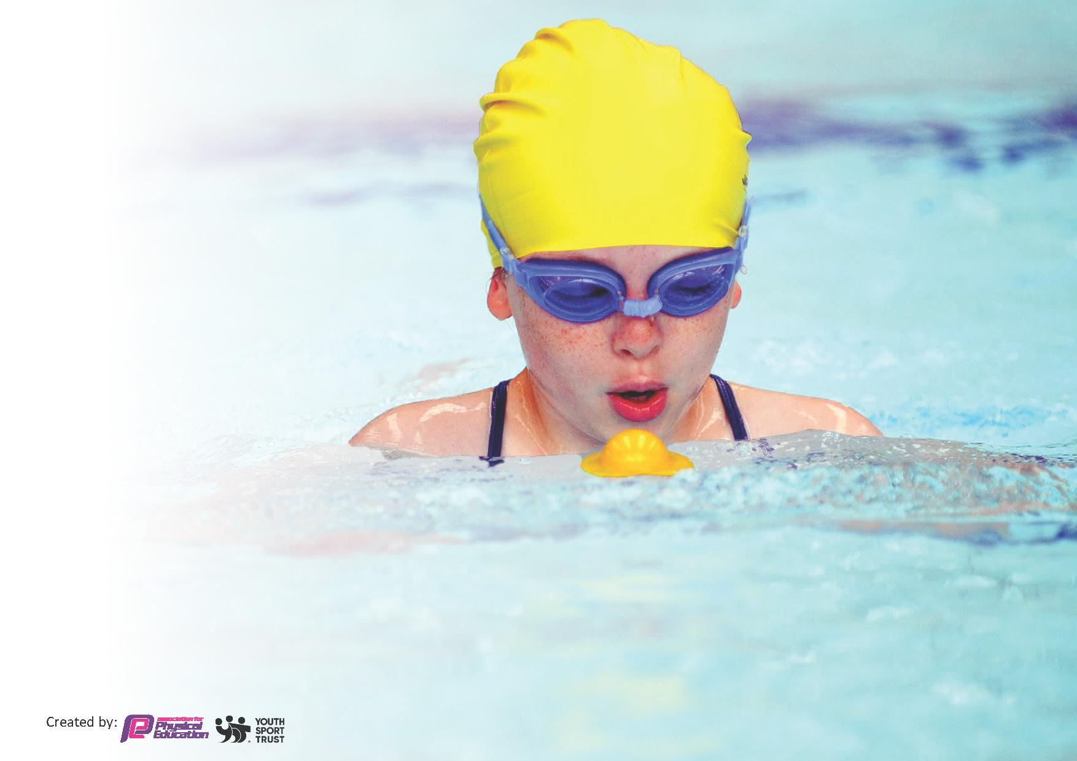
This template can be used for multiple purposes:
by:
- It enables schools to effectively plan their use of the Primary PE and sport premium
- It helps schools to meet the requirements (as set out in guidance) to publish information on their Primary PE and sport premium
- It will be an effective document to support Ofsted inspections enabling schools to evidence progress in Physical Education (PE) and evidence swimming attainment, which forms part of the PE National Curriculum. We would recommend schools consider
the Intent, Implementation and Impact of any spend, as examined within the Education Inspection Framework.

It is important that your grant is used effectively and based on school need.

Schools must use the funding to make additional and sustainable
improvements to the quality of the PE, School Sport and Physical Activity (PESSPA)
they offer. This means that you should use the Primary PE and sport premium to:

- Build capacity and capability within the school to ensure that improvements made now will benefit pupils joining the school in future years
- Develop or add to the PESSPA activities that your school already offers.

The Primary PE and sport premium should not be used to fund capital spend projects; the school’s core budget should fund these. Further detail on capital expenditure can be found in the updated Primary PE and sport premium guidance.

The Primary PE and sport premium guidance, outlines 5 key priorities that funding should be used towards. It is not

necessary that spending has to meet all the key priorities, you should select the priorities that you aim to use any funding towards.

Although completing this template is not a requirement for schools, schools are required to publish details of how they spend this funding. Schools must also outline what the impact this funding has had on pupils’ PE and sport participation and attainment and how any spending will be sustainable in the future. All funding must be spent by 31st July 2024.

The Department for Education has worked closely with the Association for Physical Education (afPE) and the Youth Sport Trust (YST) to develop this template and encourages schools to use it. This template is an effective way of meeting the reporting requirements of the Primary PE and sport premium.
Review of last year’s spend and key achievements (2023/2024)

We recommend you start by reflecting on the impact of current provision and reviewing your previous spend.

Activity/Action | Impact | Comments
- Provide children further opportunities to participate in regular physical activity  - To provide CPD to members of staff to improve the skills of teachers delivering PE and Sport in school | - More children across the school have had access to regular swimming lessons resulting in more opportunity for those children to meet the expected standard for end of KS2.  - By providing more opportunities across year groups, children who need more time to meet the standard have been identified earlier and provided with the necessary time to develop their swimming skills.  - A range of CPD was provided to PE subject leader and to members of staff moving into new year groups.  - Staff gained confidence and developed new skills required for teaching PE and this is evident in the lessons that are being delivered | - Children who have met the standard could be rewarded their certificates in an assembly to celebrate achievement but also raise the profile across school.  - PE subject lead to run school based CPD to further develop skills of teachers within school based on the external CPD received

Key priorities and Planning
This planning template will allow schools to accurately plan their spending.

Action – what are you planning to do | Who does this action impact? | Key indicator to meet | Impacts and how sustainability will be achieved? | Cost linked to the action
- To provide CPD to members of staff to improve the skills of teachers delivering PE and Sport in school  - Improve the resources available to be used at break times to increase participation in physical activity  - Provide staff with school PE kit  - Increase the participation in inter-school competitive sport  - Provide top up swimming opportunities to those children who do not meet end of KS2 expectations  - Introduce an orienteering course and provide CPD to staff on how to use | - Staff (ECTs and non PE specialists) – will be required to attend organised CPD and feedback their learning to the subject leader and school  - Pupils – children should see the benefit of receiving higher quality PE lessons based on a better trained staff  - Pupils – children will have a wider range of high quality resources available to them to use at break times and lunch times to facilitate the participation in regular physical activity.  - Staff – After feedback from the staff it was identified that not knowing/having correct kit was having a detrimental effect on their confidence in delivering PE. By providing staff with correct PE kit, their confidence will be improved resulting in an improvement in the quality of PE being delivered.  - Pupils – The pupils will recognise the importance of correct PE kit for lessons and activities as they will see the staff as role models who wear the correct PE kit for lessons  - Pupils – the number of children that will have access to participate in inter-school sports will increase with a focus on increasing the number of girls, SEND and PP children participating.  - Pupils – children who find that they need more time to meet the expected standard for end of KS2 in swimming will be provided with extra lessons to try and ensure that they leave KS2 with the skills to swim 25m and complete basic water safety activities.  - Staff – staff will be more skilled in delivering a broad curriculum including OAA.  - Pupils – children will have access to a broad range of activities and opportunity to participate in sports and activities they may not have had before | - Key Indicator 1 - Increased confidence, knowledge and skills of all staff in teaching PE and sport  - Key Indicator 4 - Broader experience of a range of sports and activities offered to all pupils  - Key Indicator 1 - Increased confidence, knowledge and skills of all staff in teaching PE and sport  - Key Indicator 5 – Increased participation in competitive sport  - Key Indicator 2 – Engagement of all pupils in regular physical activity  - Key Indicator 4 - Broader experience of a range of sports and activities offered to all pupils | - Staff will develop skills and confidence in delivering PE resulting in higher quality PE being produced across the school. This will result in a greater % of children achieving working at / above the expected standard.  - The number of children meeting the NHS guidelines of 60 minutes moderate to vigorous exercise will increase  - Improvement in the quality of PE being delivered due to increase confidence in the staff.  - More children participating in PE safely in correct kit due to impact of teachers as role models.  - The number of children who are able to participate in inter-school sport will increase.  - The aim is for 100% of children to leave the school meeting the end of KS2 expectations and then filter this down so that all children can swim before they reach UKS2.  - The resources around school will be made so that they last a long period of time and CPD provided will ensure that staff can continue to use into the future. | ^{£3000}  ^{£2000}  ^{£4000}  ^{£1000}  ^{£5000}  ^{£5880}

Key achievements 2024-2025
This template will be completed at the end of the academic year and will showcase the key achievements schools have made with their Primary PE and sport premium spending.

Activity/Action | Impact | Comments

Swimming Data
Meeting National Curriculum requirements for swimming and water safety.
Priority should always be given to ensuring that pupils can perform safe self-rescue even if they do not fully meet the first two requirements of the National Curriculum programme of study

Question | Stats: | Further context  Relative to local challenges
What percentage of your current Year 6 cohort can swim competently, confidently and proficiently over a distance of at least 25 metres? | 73%
What percentage of your current Year 6 cohort can use a range of strokes effectively [for example, front crawl, backstroke, and breaststroke]? | 58%

What percentage of your current Year 6 cohort are able to perform safe self-rescue in different water-based situations? | 100% | Use this text box to give further context behind the percentage.
If your schools swimming data is below national expectation, you can choose to use the Primary PE and sport premium to provide additional top-up sessions for those pupils that did not meet National Curriculum  requirements after the completion of core lessons. Have you done this? | Yes/No
Have you provided CPD to improve the knowledge and confidence of staff to be able to teach swimming and water safety? | Yes/No | All lessons are delivered through qualified external coaches

Signed off by:

Head Teacher: | Kelly Hannah
Subject Leader or the individual responsible for the Primary PE and sport premium: | Dan Thompson
Governor: | Ged McKevitt
Date: | 2.10.24

