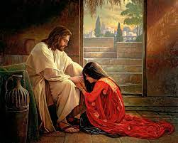
HRSE – CT1
God made each of us unique and the life we live is unique to ourselves. The experiences we go through, including bereavement, can impact on our mental health. We recognise that the way we treat others affects how they feel about themselves.
Y6:3
Accepting Others

Jesus gave us examples to follow in forgiving others and treating others equally. We have relationships with others, including those we know online and our behaviour online can impact upon their mental health.
HRSE - CT2
HOW AM I FORGIVEN?

Religious Education
We understand what is meant by being a disciple of Jesus and reflect on how we can serve others. We reflect on the consequences of wrong choices and know that sin hurts. We understand that God loves us and forgives us.

HRSE – CT3
We all experience different kinds of health – physical, emotional and mental. We learn about the work of organisations that support issues that can impact on mental health.

PSHE
There is prejudice and stereotypes surrounding those who struggle with their mental health / homelessness and it is important that we challenge this and show compassion for others. Reframing unhelpful thinking can help us change our feelings
Vocabulary

Outcomes
EXPERIENCE - A collection of events and/or activities from which an individual or group may gather knowledge, opinions, and skills.
COMPASSION - Awareness of the suffering of another, and the wish to relieve it.
BEREAVEMENT - The state of being bereaved by the loss of a loved one
MENTAL HEALTH - The way you feel on any day.
DISCIPLE - A follower of Jesus
ORGANISATION - A group of people with an explicit purpose and written rules.
PREJUDICE - An irrational hostile attitude, fear or hatred towards a particular group, race, or religion.
STEREOTYPE - An oversimplified or exaggerated conception of a person.
AT1 – How might the parable of ‘The Prodigal Son’ help you to understand the need to change and ask for forgiveness in your own life?
AT1 – How might the actions of The Prodigal Son influence the way you practice an Examination of Conscience? (Revision from Year 5)
AT2 – What does it mean to be a true disciple of Jesus?
AT2 / 3 – How can we say God loves us when so much in our life can go ‘wrong’?
AT3 – Look at the painting ‘Forgiven’ by Craig Olsen. What beliefs do you think the artist was trying to show? How does it make you feel? Refer to the picture in your answer?

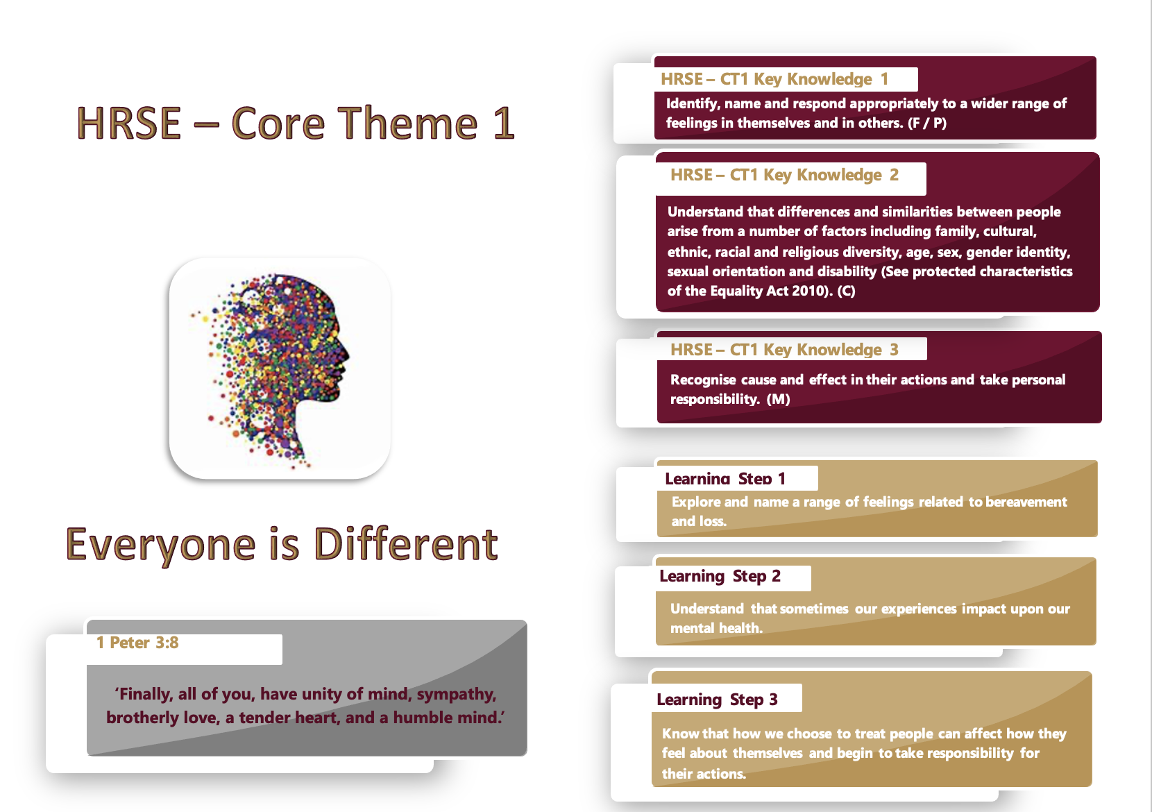
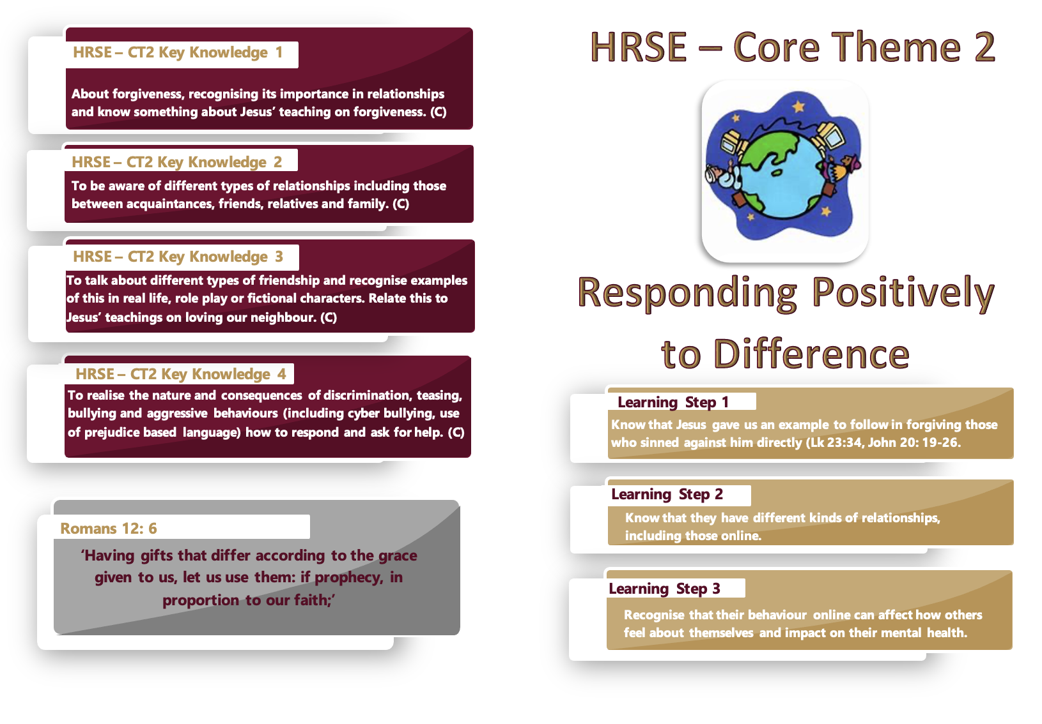
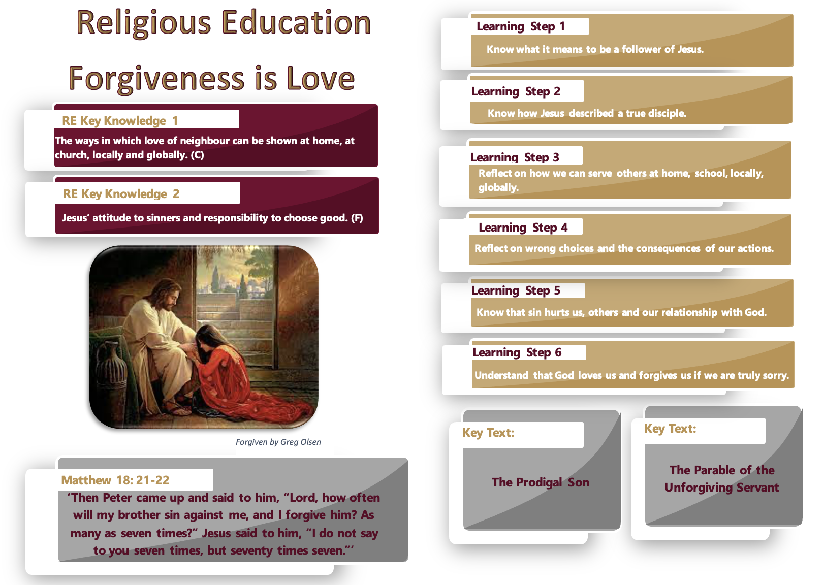
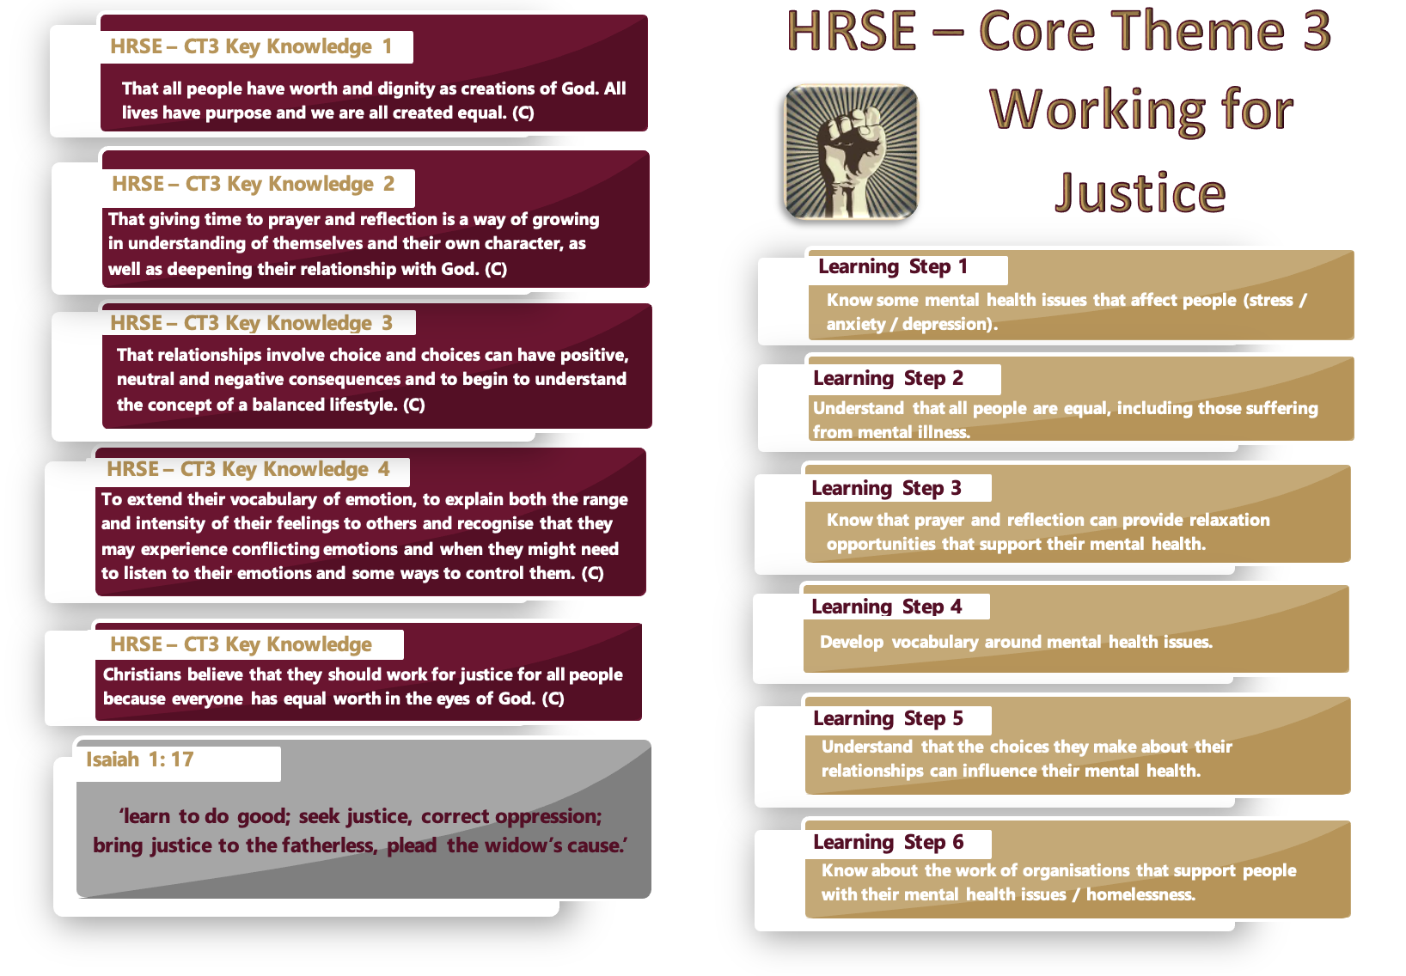
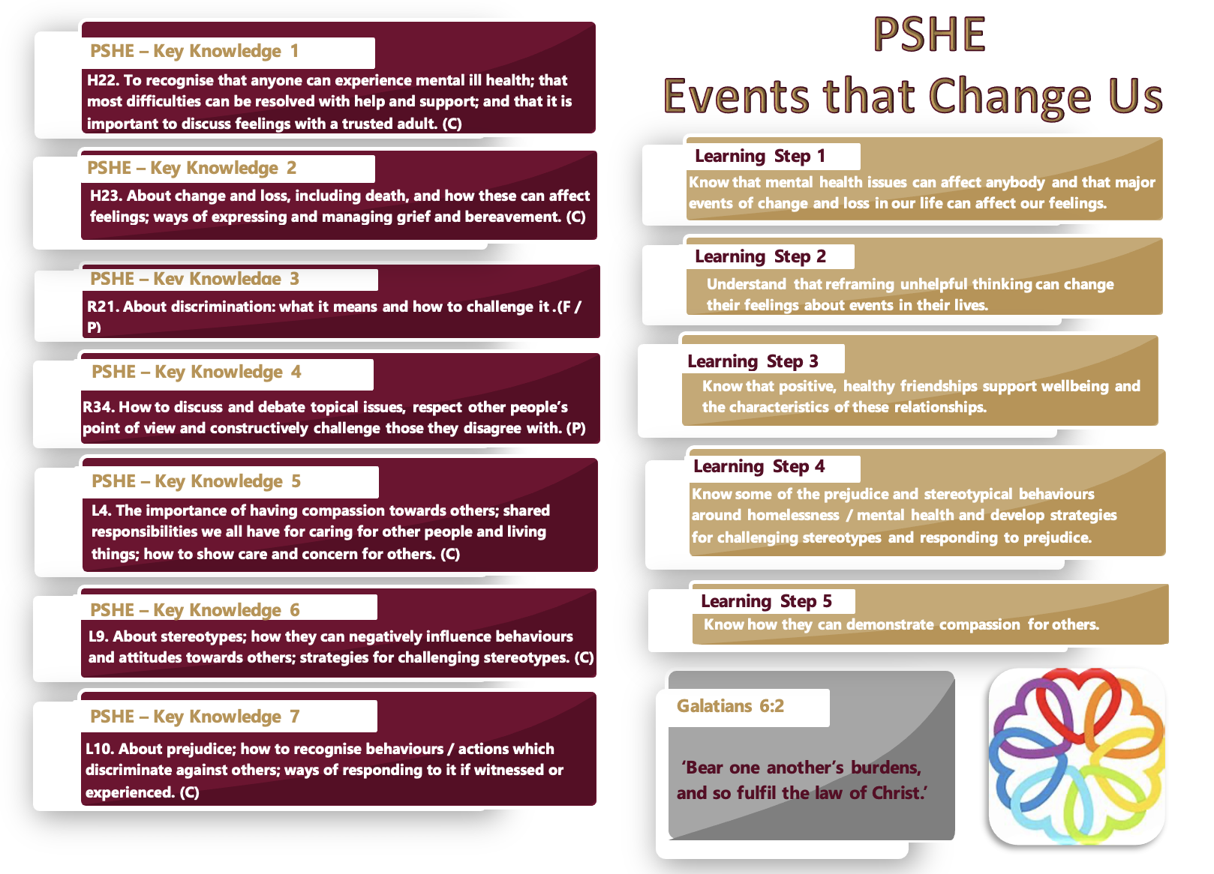
Planning Ideas:

Stunning Start:

Enrichment:

Celebration:

Resources:

