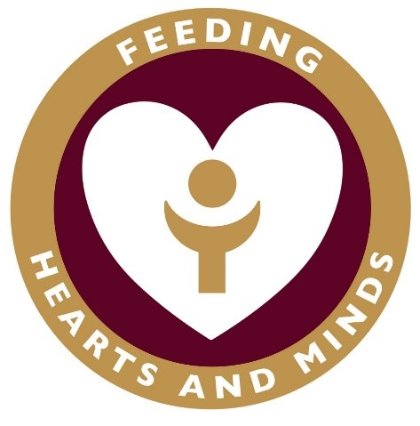

**Buddy’s guide - coming back to school**

**Hello friend,**

**School is opening soon, so we can start going back there to learn and see our friends and teachers again. It is a long time since I saw you and I can’t wait to see you in school on 7th September – I have really missed you!**

**I know that you might have some worries about coming back to school and the changes so I want to tell you all about them. I have investigated the whole school for you!**

**School may feel a little different when we go back, this is because our teachers have made some changes to keep us all safe while we learn. We are still part of the same family and all of the teachers and adults are here to keep us safe and make sure that we are following The Blessed Sacrament Way.**

**Have a lovely weekend and I will see you on Monday.**

**Lots of woof,**

**Buddy**

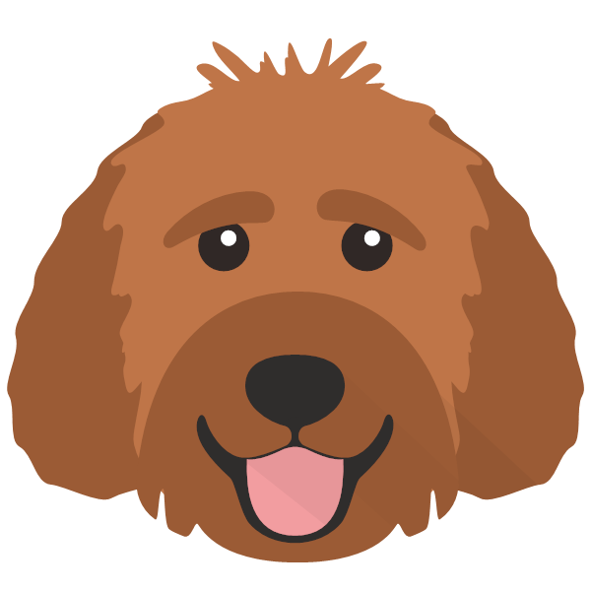



Buddy says…

We may be given our own equipment to use instead of sharing with our friends. This is so it’s easier to keep everything clean and stop the virus from spreading.

Our classrooms will look a little different as some of the furniture and toys have been taken out. Our tables will be set out a little differently to how we are used to. This is to make sure that if we cough or sneeze, we are not facing our friends.

We will work hard and have fun with our friends and teachers.

If we feel poorly at home, we will tell our family who will let school know. If we feel poorly at school, we will tell our teacher and Miss Hannah who will look after us until we are collected.

We will come into school through the same gate as everyone else on our corridor. One of our adults will be there to meet us. We will say goodbye to the person who has brought us to school at the gate.

We will stay in our classroom to eat lunch. This is to stop us from meeting too many people in the Dining Hall. We will wash our hands before and after eating.

We will play with our own class at playtime and lunchtime. Our teachers and adults will tell us where we can play and give us some equipment to play with.

We will listen carefully to our teachers and adults and do what we are asked to do straight away.

We will all wear our school uniform, reminding us that we are part of the same school family.

We will wash our hands regularly and use the hand sanitiser by the doors when we go out / come in.

We will not wear masks or face coverings in school.

We will not have assemblies in the hall but will continue to watch ‘Over and Above’ videos on Friday morning.

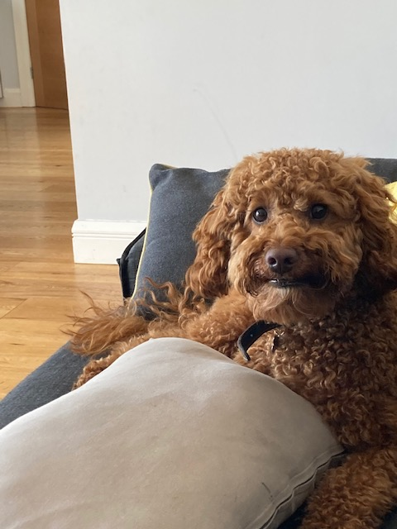

We will not get too close to each other – we will still be kind and will show we care by giving each other big smiles instead of hugs.